hline

Celestial Events –2002 (5763) and Beyond

By Rabbi Dr. Hillel ben David (Greg Killian)

hline

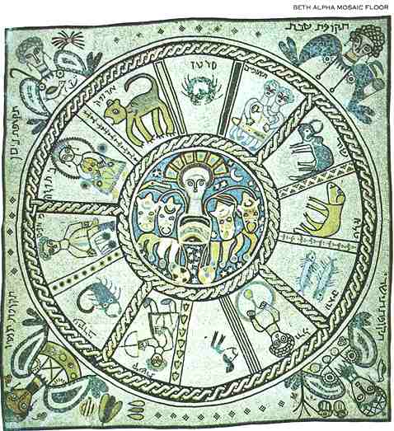

***Yeshayahu (Isaiah) 40:26*** *Lift up your* [*eyes*](body.html) *on high, and behold who hath created these [*[*stars*](mazaroth.html)*], that bringeth out their host by* [*number*](nchart.html)*: he calleth them all by names by the greatness of his might, for that [he is] strong in power; not* [*one*](one.html) *faileth.*

If you look at the [stars](mazaroth.html), you can see God's handiwork and come to [know](daat.html) Him. When you see the beauty, the majesty, and the awesomeness of the universe you can't help but be drawn to the Creator.

**The** [**Laws**](law.html) **Concerning** [**Idolatry**](idolatry.html) **1:1-2** "In the days of Enosh (before Noah), people made a serious mistake. The sages of this era erred and Enosh himself was among those who erred. They considered that since God put [stars](mazaroth.html) and heavenly [bodies](body.html) in brilliant splendor above us to regulate life on earth and to be His [first](one.html) servants, then it is fitting to honor and glorify them...When they conceived this idea, they began to erect temples to the [stars](mazaroth.html), offered up sacrifices to them, praised and glorified them in speech, and prostrated themselves before them - to obtain the Creator's favor, according to their corrupt notions. This was the root of [idolatry](idolatry.html)...So gradually the custom spread throughout the [world](worlds.html) to worship figures with various types of worship, such as [offering](korbanot) them sacrifices and bowing to them. As [time](time.html) went on, the honored and revered [Name](name.html) of God was forgotten by humanity, vanished from their lips and hearts and was no longer [known](daat.html) to them...The Creator of the universe was [known](daat.html) to none, and recognized by none, [save](salvation.html) a few solitary individuals such as Enoch, Methuselah, Noah, Shem, and Ever. The [world](worlds.html) moved on in this fashion until the 'Pillar of the [World](worlds.html)' - [Abraham](avraham.html), our father - was born.".

***Devarim (Deuteronomy) 4:19-20*** *"And lest you raise your* [*eyes*](body.html) *unto* [*heaven*](heaven.html)*, and when you see the* [*Sun*](hachama.html) *and the* [*moon*](chodesh.html) *and the* [*stars*](mazaroth.html)*, and other heavenly* [*bodies*](body.html)*, you should not be misled to worship them and serve that which the Lord God had apportioned unto all the* [*nations*](nations.html) *under the whole* [*heaven*](heaven.html)*."*

Thus says [Abraham](avraham.html) bar Samuel bar [Abraham](avraham.html) Zacuto:

“The people of Israel are compared to [stars](mazaroth.html) by [name](name.html) and [number](nchart.html), as best gold objects incrusted with precious stones. Even more so the wise and pious men, for it is said, ‘The wise men will shine like the brightness of the firmament, and those who lead others to righteousness <will shine> like [stars](mazaroth.html) for ever and ever’. That is the great difference between those who provide themselves with [merit](merit.html), and those who lead others to righteousness and provide others with [merit](merit.html). The [star](mazaroth.html) in [heaven](heaven.html) is similar to the soul in the [body](body.html), being its most important part. They, I mean the sages of [Mishna](orallaw.html) and [Talmud](orallaw.html), and those who came after them who wrote books to dispense virtues among us, they illuminate our souls.”

The [sun](hachama.html), [moon](chodesh.html), and [stars](mazaroth.html) clearly have a message:

***Bereshit (Genesis) 1:14*** *And God said, Let there be* [*lights*](lights.html) *in the firmament of the* [*heaven*](heaven.html) *to divide the day from the night; and let them be for* [*signs*](signs.html)*, and for* *seasons**, and for days, and years: And let them be for* [*lights*](lights.html) *in the firmament of the* [*heaven*](heaven.html) *to give light upon the earth: and it was so.*

There is much conjecture and speculation by some people as to the meanings of major conjunctions and alignments of the planets with the [Sun](hachama.html) and the [moon](chodesh.html). I have steadfastly refused to engage in such speculation because I do not have enough prior history to form reasonable conclusions. My current position is that I would need to understand how conjunctions and alignments were involved in major historical [events](feasts.html) that have affected Israel in the past. I do not yet have enough data to come to any conclusions.

The non-Rambam view is that there is something to astrology, but it is forbidden for [Jews](gen-jew.html) to act upon astrological predictions, as this distances the [Jew](gen-jew.html) from [HaShem](hashem.html) and the close, straightforward relationship He [wants](needs.html) between the People of Israel and Himself, and being faithful to [HaShem](hashem.html) and keeping Torah and [mitzvot](cmds613.html) allows the [Jew](gen-jew.html) to rise "above his Mazal - luck ".

The [Talmud](orallaw.html) states:

[***Shabbat***](sabbath.html) ***156a*** *"Rabbi Yochanan said: How do we* [*know*](daat.html) *that* *Israel* *is immune to planetary influence? Because it is written, 'Thus said* [*HaShem*](hashem.html)*: Do not learn the ways of the* [*nations*](nations.html) *and do not* [*fear*](fear.html) *the* [*signs*](signs.html) *of* [*heaven*](heaven.html)*, for the* [*nations*](nations.html)[*fear*](fear.html) *them (Yirmiyahu 10:2) The* [*nations*](nations.html)[*fear*](fear.html) *them, but Israel does not."*

There are [two](two.html) incidents related in the [Talmud](orallaw.html) ([Shabbat](sabbath.html) 156b) where astrologers predicted death to a certain individual. In both cases, the snake or serpent "predicted" showed up, but the individual lived. In both cases, the non-fulfillment of the prediction, so to [speak](mashal.html), was attributed to acts of kindness on the part of the individual.

[**Torah Code**](codes.html)

The very [first](one.html) place in the Torah that we find the word mazzaroth, it is spelled out every [seven](seven.html) [letters](letters.html) in:

***Genesis 4:26 – 5:1*** *And to Seth, to him also there was born a son; and he called his* [*name*](name.html) *Enos: then began men to call upon the* [*name*](name.html) *of* [*HaShem*](hashem.html)*. This [is] the book of the* [*generations*](toldot.html) *of* [*Adam*](adam.html)*. In the day that God created man, in the likeness of God made he him;*

This is curious in light of what the [Jewish](gen-jew.html) Historian. Josephus, says:

**Josephus in Antiquities Chapter 1 says**: “Now this Seth, when he was brought up, and came to those years in which he could discern what was good, became a virtuous man; and as he was himself of an excellent character, so did he leave children behind him who imitated his virtues.(9) All these proved to be of good dispositions. They also inhabited the same country without dissensions, and in a happy condition, without any misfortunes falling upon them, till they died. They also were the inventors of that peculiar sort of wisdom which is concerned with the heavenly [bodies](body.html), and their order.”

**Sefer HaYashar**

CHAPTER 8

1 And it was in the night that [Abram](avraham.html) was born, that all the servants of [Terah](stages.html), and all the wise men of Nimrod, and his conjurors came and [ate](eating.html) and drank in the house of [Terah](stages.html), and they rejoiced with him on that night.

2 And when all the wise men and conjurors went out from the house of [Terah](stages.html), they lifted up their [eyes](body.html) toward [heaven](heaven.html) that night to look at the [stars](mazaroth.html), and they saw, and behold [one](one.html) very large [star](mazaroth.html) came from the [east](east.html) and ran in the [heavens](heaven.html), and he swallowed up the [four](four.html) [stars](mazaroth.html) from the [four](four.html) sides of the [heavens](heaven.html).

3 And all the wise men of the king and his conjurors were astonished at the sight, and the sages understood this matter, and they [knew](daat.html) its import.

4 And they said to each other, This only betokens the child that has been born to [Terah](stages.html) this night, who will grow up and be fruitful, and multiply, and possess all the earth, he and his children for ever, and he and his [seed](flower.html) will slay great kings, and [inherit](inherit.html) their lands.

5 And the wise men and conjurors went home that night, and in the morning all these wise men and conjurors rose up early, and assembled in an [appointed](settimes.html) house.

6 And they [spoke](mashal.html) and said to each other, Behold the sight that we saw last night is hidden from the king, it has not been made [known](daat.html) to him.

7 And should this thing get [known](daat.html) to the king in the latter days, he will say to us, Why have you concealed this matter from me, and then we shall all suffer death; therefore, now let us go and tell the king the sight which we saw, and the interpretation thereof, and we shall then remain clear.

* * *

CHAPTER 53

16 …[Joseph](joseph.html) afterward turned to his brother [Benjamin](benyamin.html) to [speak](mashal.html) with him, and [Benjamin](benyamin.html) was still [sitting](mashal.html) upon the throne before [Joseph](joseph.html).

17 And [Joseph](joseph.html) said unto him, Hast thou begotten any children? and he said, Thy servant has [ten](ten.html) sons, and these are their names, Bela, Becher, Ashbal, Gera, Naaman, Achi, Rosh, Mupim, Chupim, and Ord, and I called their names after my brother whom I have not seen.

18 And he ordered them to bring before him his map of the [stars](mazaroth.html), whereby [Joseph](joseph.html) [knew](daat.html) all the times, and [Joseph](joseph.html) said unto [Benjamin](benyamin.html), I have heard that the [Hebrews](bereans.html) are acquainted with all wisdom, dost thou [know](daat.html) anything of this?

19 And [Benjamin](benyamin.html) said, Thy servant is knowing also in all the wisdom which my father [taught](teacher.html) me, and [Joseph](joseph.html) said unto [Benjamin](benyamin.html), Look now at this instrument and understand where thy brother [Joseph](joseph.html) is in Egypt, who you said went down to Egypt.

20 And [Benjamin](benyamin.html) beheld that instrument with the map of the [stars](mazaroth.html) of [heaven](heaven.html), and he was wise and looked therein to [know](daat.html) where his brother was, and [Benjamin](benyamin.html) divided the whole land of Egypt into [four](four.html) divisions, and he found that he who was [sitting](mashal.html) upon the throne before him was his brother [Joseph](joseph.html), and [Benjamin](benyamin.html) wondered greatly, and when [Joseph](joseph.html) saw that his brother [Benjamin](benyamin.html) was so much astonished, he said unto [Benjamin](benyamin.html), What hast thou seen, and why art thou astonished?

21 And [Benjamin](benyamin.html) said unto [Joseph](joseph.html), I can see by this that [Joseph](joseph.html) my brother sitteth here with me upon the throne, and [Joseph](joseph.html) said unto him, I am [Joseph](joseph.html) thy brother, reveal not this thing unto thy brethren; behold I will send thee with them when they go away, and I will [command](cmds613.html) them to be brought back again into the [city](city.html), and I will take thee away from them.

22 And if they dare their lives and fight for thee, then shall I [know](daat.html) that they have repented of what they did unto me, and I will make myself [known](daat.html) to them, and if they forsake thee when I take thee, then shalt thou remain with me, and I will wrangle with them, and they shall go away, and I will not become [known](daat.html) to them.

**In The** [**Talmud**](orallaw.html)

[***Rosh HaShana***](teruah.html) ***11b*** *R. Joshua and R. Eliezer are herein consistent [with views expressed by them elsewhere], as it has been* [*taught*](teacher.html)*: ‘In the* [*sixth*](six.html) *hundredth year of Noah's life, in the second month, on the seventeenth day of the month.8 R. Joshua said: That day was the seventeenth day of* [*Iyar*](feasts.html)*, when the constellation of Pleiades sets at daybreak and the fountains begin to dry up, and because they [mankind] perverted their ways, the Holy* [*One*](one.html)*, blessed be He, changed for them the work of* [*creation*](bara.html) *and made the constellation of Pleiades rise at daybreak and took* [*two*](two.html)[*stars*](mazaroth.html) *from the Pleiades and brought a flood on the* [*world*](worlds.html)*. R. Eliezer said: That day was the seventeenth of Marheshvan, a day on which the constellation of Pleiades rises at daybreak, and [the season] when the fountains begin to fill, and because they perverted their ways, the Holy* [*One*](one.html)*, blessed be He, changed for them the work of* [*creation*](bara.html)*, and caused the constellation of Pleiades to rise at daybreak and took away* [*two*](two.html)[*stars*](mazaroth.html) *[from it] and brought a flood on the* [*world*](worlds.html)*’.*

***Berachoth 58b*** *Samuel contrasted* [*two*](two.html) *texts. It is written, Who maketh the Bear, Orion, and the Pleiades. And it is written elsewhere, That maketh Pleiades and Orion. How do we reconcile these? Were it not for the heat of Orion the* [*world*](worlds.html) *could not endure the cold of Pleiades; and were it not for the cold of Pleiades the* [*world*](worlds.html) *could not endure the heat of Orion. There is a tradition that were it not that the tail of the Scorpion has been placed in the Stream of* [*Fire*](fire.html)*, no* [*one*](one.html) *who has ever been stung by a scorpion could live. This is what is referred to in the words of the All-Merciful to Job: Canst thou bind the chains of Pleiades or loose the bands of Orion?*

*What is meant by Kimah [Pleiades]? Samuel said: About a hundred [ke'me-ah]* [*stars*](mazaroth.html)*. Some say they are close together; others say that they are scattered. What is meant by ‘’Ash [the Bear]’? — Rab Judah said: Jutha. What is Jutha? — Some say it is the tail of the Ram; others say it is the* [*hand*](fourteen.html) *of the Calf. The* [*one*](one.html) *who says it is the tail of the Ram is more probably right, since it says: ‘Ayish will be comforted for her children. This shows that it lacks something, and in fact it looks like a piece torn off;1 and the reason why she follows her is because she is saying to her: Give me my children. For at the* [*time*](time.html) *when the Holy* [*One*](one.html)*, blessed be He, wanted to bring a flood upon the* [*world*](worlds.html)*, He took* [*two*](two.html)[*stars*](mazaroth.html) *from Kimah and brought a flood upon the* [*world*](worlds.html)*. And when He wanted to stop it, He took* [*two*](two.html)[*stars*](mazaroth.html) *from ‘Ayish and stopped it. But why did He not put the other* [*two*](two.html) *back? — A pit cannot be filled with its own clods; or another reason is, the accuser cannot become advocate. Then He should have created* [*two*](two.html) *other* [*stars*](mazaroth.html) *for it? — There is nothing* [*new*](new.html) *under the* [*sun*](hachama.html)*. R. Nahman said: The Holy* [*one*](one.html)*, blessed be He, will* [*one*](one.html) *day restore them to her, as it says: and ‘Ayish will be comforted for her children.*

# A [Jewish](gen-jew.html) perspective of [time](time.html).

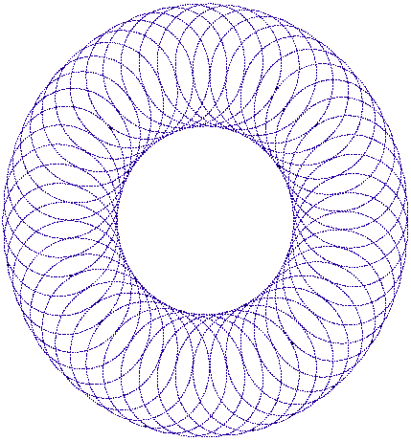

*A spiral in* [*time*](time.html)

The [Jewish](gen-jew.html) view of [time](time.html) is not that of a straight timeline, but rather a spiraling [one](one.html). Each year, we complete a turn of the circle and touch the same points, although in a slightly different way. Additionally, [Jewish](gen-jew.html) tradition holds that the yearly [cycle](cycles.html) of holidays do not just represent commemorations of past [events](feasts.html), but that the great [events](feasts.html) of our past occurred when they did because those were the appropriate [spiritual](physical.html) seasons for those holidays. This paradigm has strategic importance to our understanding of [future](future.html) [events](feasts.html) and their timing.

The Torah refers to the [festivals](festivals.html) of the [Jewish](gen-jew.html) [calendar](calendar.html) as [*moedim*](settimes.html), “[appointed times](settimes.html)”. “These are [HaShem’s](hashem.html) [appointed](settimes.html) times,” reads the introductory verse to the Torah’s listing of the [festivals](festivals.html) in the book of Vayikra, “callings of holiness, which you shall call in their [appointed](settimes.html) times.” A [festival](festival.html) is an [appointment](appointm.html) with [HaShem](hashem.html) and the past, an encounter with an [event](feasts.html) and phenomenon in our history. It is an opportunity to “call” forth the particular “holiness” of the day, to tap the [spiritual](physical.html) resources it holds.

[One](one.html) of the most important applications of Judaic Astrology is in the correct understanding of the [Jewish](gen-jew.html) holidays. Under this doctrine, we learn that the holidays are actually effects from the cosmos. For example, the [holiday](festival.html) of [Passover](passover.html) occurred with the positive assistance of the [celestial](celestal.html) realm. Celebrating [Passover](passover.html) every year is NOT because of tradition, commemoration of an [event](feasts.html) that occurred some odd years ago, or to pay our respects. Rather, every year when the earth hits that point on its revolution path around the [sun](hachama.html), an opening is created.

This opening allows us to connect to this fulfilling ENERGY or [spiritual](physical.html) Light of [Passover](passover.html) that is available only on that day. Therefore, with the proper tools and with the proper "kavannah" (thought consciousness), every [generation](toldot.html), whatever [time](time.html) frame they find themselves in, is capable of re-creating their own [Passover](passover.html). This holds true not only for [Passover](passover.html), but also for [Yom Kippur](kippur.html), [Rosh Hashanah](teruah.html), [Purim](Purim.html), [Chanukah](chanukah.html), and every other [Jewish](gen-jew.html) [holiday](festival.html).

 It is with the assistance of the [Hebrew calendar](hebrew.html) that we learn that there are positive and negative times throughout the year. What does this mean? Plain and simple, there are days in the year in which it is beneficial to begin [new](new.html) ventures (getting married, buying something [new](new.html), etc.) and there are times in the year where it is better to avoid beginning these [new](new.html) ventures. For example, the [Omer](omer.html) ([time](time.html) period from [Passover](passover.html) to [Shavuot](shavuot.html)) and the [Hebrew](hebrew.html) month of Cheshvan are examples of negative times during the year.

Under the Judaic [calendar](calendar.html), there are [twelve](twelve.html) months in a year, each month depending upon the [moon](chodesh.html)'s revolution around the earth. Each [Hebrew](hebrew.html) month, each [new moon](new.html) [cycle](cycles.html), has a specific constellation and planet that has their influence over that month. The effects from these ruling constellations and planets are felt by all. This is why we have different moods, [desires](needs.html), and inclinations at different times of the year. People born in the same [Hebrew](hebrew.html) month all share common characteristics, both good and bad. They also share a similar correction, based on their previous lifetimes. This is why they were born in that month.

A day is determined by a successful rotation of the earth. The day is divided into [three](three.html) parts: sunrise till noon, noon till sunset, and night-[time](time.html). These times of the day also have different influences on us. This is why we feel different, and have different inclinations during each of these portions of the day. This is also why there are different [prayers](prayer.html) for the different portions of the day.   
Every [Rosh Hashanah](teruah.html), every [time](time.html) the earth hits that point in which it makes a successful revolution around the [sun](hachama.html), a [new](teruah.html) year is created. A [new](teruah.html) year is a [new](new.html) revelation. Openings are created as history replays itself, yet renews itself over and over again.

**Proper Use**

Through studying the meaning behind the various aspects associated with a particular month, you can define the [spiritual](physical.html) potential for you in each [time](time.html) period. The Kabbalists looked to Astrology more to get a general feeling for what a month can offer [spiritually](physical.html) rather than to predict what will happen on any given day. They used this [knowledge](knowledge.html) for personal growth.

To predict daily or hourly [events](feasts.html) would violate a biblical prohibition:

***Yayikra (Leviticus) 19:26*** *"Do not act on the basis of auspicious times".*

Predicting [events](feasts.html) too precisely leads [one](one.html) away from the understanding that God is involved with every molecule of existence and can alter [events](feasts.html) at will. This danger appears to be the basis of all biblical injunctions against Astrology. In order for us to have a close ongoing personal relationship with God, we need to keep the perspective that He is involved with every aspect of life. Even though He designed the [heavens](heaven.html) to have a complex system of influence, He did not set it up and [walk](walking.html) away.

The Kabbalists use their understanding of the heavenly influences to see the [spiritual](physical.html) potential in each [time](time.html) period, as opposed to predicting the [future](future.html). They seek the hidden opportunities for elevation, always striving for a closer relationship with God.

[**Shmita**](shmita.html) **Year**

According to the Torah, the [land of Israel](city.html) must be allowed to lie fallow every [seventh](seven.html) year, but according to a rabbinical dispensation, [known](daat.html) as a heter mechira, which has been used for over a century, [Jewish](gen-jew.html) farmers have been allowed to symbolically sell the land to an Arab. In the year 5761 (2000), with the backing of the country's leading haredi rabbinical adjudicator, Rabbi Shalom [Yosef](joseph.html) Elyashiv, the [Jerusalem](city.html) Religious Council announced it would not recognize the heter.

**The last** [**Sabbatical**](shmita.html) **year was 5761**

"according to the way we count here"

**The next** [**Sabbatical**](shmita.html) **year is 5768**

"according to the way we count here"

[**New Years Day**](teruah.html)

**The year 5763 began on:**

[Rosh Hashanah](teruah.html) [Tishri](feasts.html) 1, 5763 Sat, Sep 7, 2002

**The year 5764 will begin on:**

[Rosh Hashana](teruah.html)h [Tishri](feasts.html) 1, 5764 Sat, Sep 27, 2003

**The year 5765 will begin on:**

[Rosh Hashana](teruah.html)h [Tishri](feasts.html) 1, 5765 Thu, Sep 16, 2004

**VISIBLE CONJUNCTIONS:**

|  |  |  |  |
| --- | --- | --- | --- |
| **Date** | **Year** | [**Hebrew**](hebrew.html) **Date** | **Planets** |
| Nov  03 | 2002 | [Heshvan](feasts.html) 28, 5763 | Mercury  Venus |
| May  27 | 2003 | [Iyar](feasts.html) 25, 5763 | Mercury  Venus |
| June  20 | 2003 | [Sivan](feasts.html) 20, 5763 | Mercury     Venus |
| June  30 | 2003 | [Sivan](feasts.html) 30, 5763 | Mercury  Saturn |
| July  08 | 2003 | [Tammuz](feasts.html) 8, 5763 | Venus  Saturn |
| July  15 | 2003 | [Tammuz](feasts.html) 15, 5763 | Mercury  Mars |
| July  25 | 2003 | [Tammuz](feasts.html) 25, 5763 | Mercury  Jupiter |
| Aug  21 | 2003 | [Av](feasts.html) 23, 5763 | Venus  Jupiter |
| Sept 06 | 2003 | [Elul](elul.html) 9, 5763 | Mercury  Venus |
| May 24 | 2004 | [Nisan](feasts.html) 2, 5764 | Mars  Saturn |
| June  12 | 2004 | [Sivan](feasts.html) 23, 5764 | Mercury  Venus |
| June 26 | 2004 | [Tammuz](feasts.html) 7, 5764 | Mercury  Saturn |
| Jul   10 | 2004 | [Tammuz](feasts.html) 21, 5764 | Mercury Mars |
| Aug 16 | 2004 | [Av](feasts.html) 29, 5764 | Mercury Mars |
| Aug 31 | 2004 | [Elul](elul.html) 14, 5764 | Venus  Saturn |
| Sep 27 | 2004 | [Tishri](feasts.html) 12, 5765 | Mars  Jupiter |
| Sep 28 | 2004 | [Tishri](feasts.html) 13, 5765 | Mercury  Jupiter |
| Sep 29 | 2004 | [Tishri](feasts.html) 14, 5765 | Mercury  Mars |
| Nov  4 | 2004 | [Heshvan](feasts.html) 20, 5765 | Venus  Jupiter |
| Dec 5 | 2004 | [Kislev](feasts.html) 22, 5765 | Venus  Mars |
| Dec 28 | 2004 | Tevet 16, 5765 | Mercury  Venus |

December 1, 2002 corresponds to:

Sunday, [Kislev](feasts.html) 26, 5763

[**Events**](feasts.html) **for this day of the year:**

[**Chanukah**](chanukah.html) Second day.

Day 39 of God's rain in Noah's day. ***Gen. 7:4***

**Torah** section is [*Numbers*](nchart.html) *7:18-23*.

[Sabbath](sabbath.html) reading: Mi-Kez, Gen 41:1-44:17

and: [Chanukah](chanukah.html) 8, Num 7:18-29

Prophets: I Kings 3:15-4:1

Replaced by: Sab2 [Chanukah](chanukah.html), I Kings 7:40-50

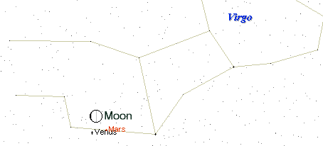

Mars and Venus very close to the old [moon](chodesh.html) during [Chanukah](chanukah.html).

[Chanukah](chanukah.html) is the only [holiday](festival.html) which crosses over the threshold of a [new](new.html) month. It seems to need to draw influence from [two](two.html) zodiac [signs](signs.html) to make itself happen.

The reason [Chanukah](chanukah.html) spans across [two](two.html) months is because the message of [Chanukah](chanukah.html) is Torah. Not just any Torah, [new](new.html) Torah! [Chanukah](chanukah.html) starts in [Kislev](feasts.html). Great, been there! Done that! It's [time](time.html) for something [new](new.html). Ah, the [new](new.html) month of Tevet. And sometimes [Rosh Chodesh](chodesh.html) Tevet is [one](one.html) day, sometimes it's [two](two.html) days. You never [know](daat.html) form year to the next. Always something [new](new.html)!

* * *

December 4, 2002 corresponds to:

Wednesday, [Kislev](feasts.html) 29, 5763

[**Events**](feasts.html) **for this day of the year:**

[**Chanukah**](chanukah.html) [Fifth](five.html) day.

Water swells on the earth in the days of Noah.

Day 1. ***Genesis 7:24***

**Torah** section is [*Numbers*](nchart.html) *7:36-41*.

[Sabbath](sabbath.html) reading:

Mi-Kez, Gen 41:1-44:17

and: [Chanukah](chanukah.html) 8, Num 7:18-29

Prophets: I Kings 3:15-4:1

Replaced by: Sab2 [Chanukah](chanukah.html), I Kings 7:40-50

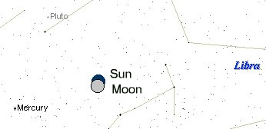

Total eclipse of the [Sun](hachama.html) during [Chanukah](chanukah.html). Not visible from Israel.

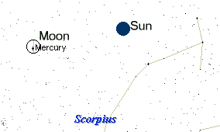

[New](new.html) [Moon](chodesh.html) occults Mercury during [Chanukah](chanukah.html).

* * *

December 19, 2002 corresponds to:

Thursday, Tevet 14, 5763

[**Events**](feasts.html) **for this day of the year:**

Water swells on the earth in the days of Noah.

Day 16. ***Genesis 7:24***

[Sabbath](sabbath.html) reading: Va-Yehi, Gen 47:28-50:26

Prophets: I Kings 2:1-12

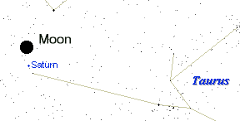

Full [moon](chodesh.html) close to Saturn VaYihi!

* * *

December 29, 2002 corresponds to:

Sunday, Tevet 24, 5763

[**Events**](feasts.html) **for this day of the year:**

Water swells on the earth in the days of Noah.

Day 26. ***Genesis 7:24***

[Sabbath](sabbath.html) reading: Va-Era, Ex 6:2-9:35

and: [Rosh Chodesh](chodesh.html), Num 28:9-15

Prophets: Ezek 28:25-29:21

Replaced by: [Rosh Chodesh](chodesh.html), Isa 66:1-24

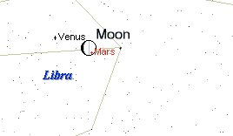

Old [Moon](chodesh.html) occults Mars whilst close to Venus

* * *

January 3, 2003 corresponds to:

Friday, Tevet 29, 5763

[**Events**](feasts.html) **for this day of the year:**

Water swells on the earth in the days of Noah.

Day 31. ***Genesis 7:24***

[Sabbath](sabbath.html) reading: Va-Era, Ex 6:2-9:35

and: [Rosh Chodesh](chodesh.html), Num 28:9-15

Prophets: Ezek 28:25-29:21

Replaced by: [Rosh Chodesh](chodesh.html), Isa 66:1-24

**January 3-5**

Quadrantids Meteor shower. The [new](new.html) [moon](chodesh.html) should ensure a great show. Look [east](east.html) after midnight.

The Gulf War started on [**Shevat**](feasts.html) **1, 5751** ([Sabbath](sabbath.html) reading: Bo, Ex 10:1-13:16 - Prophets: Jer 46:13-28), January 16 1991, when the allied forces began the aerial bombing of Iraq, following the Iraqi invasion of Kuwait the previous summer.

I have pondered the [connection](connection.html) between WWI and WWII as they compare to the Gulf war and the upcoming war with Iraq. There are an enormous [number](nchart.html) of coincidental points.

**The Gulf War ceasefire -** [**Adar**](feasts.html) **14, 5751 (February 28, 1991)**

It is the morning of February 28, 1991. Inside the synagogues, the [Book of Esther](esther.html) is read aloud. It is the story of a great turn of [events](feasts.html) for the [Jewish](gen-jew.html) people. The [wicked](wicked.html) viceroy of Persia, [Haman](esther.html), had plotted to murder all the [Jews](gen-jew.html) in the kingdom. Through a sequence of inexplicable and miraculous [events](feasts.html), the tables were turned, and through the efforts of the [Jewish](gen-jew.html) leaders Mordechai and [Esther](esther.html), [Haman](esther.html) was hanged on the very day that he chose to kill the [Jews](gen-jew.html). For 2,500 years, [Purim](Purim.html) has been a day to celebrate the triumph of good over evil.

This suggests that the war with Iraq will be a war of [Edom](edom.html) agains [Amalek](amalek.html). If this pattern hold true, then this [new](new.html) war will also end on [Purim](Purim.html):

[**Adar**](feasts.html) **II 14, 5763 is Tuesday, March 18, 2003**

The second Gulf War began on Shushan [Purim](Purim.html), II [Adar](feasts.html) 15, 5763. The war began 12 years to the day after the [first](one.html) Gulf war ended, to the day!

* * *

January 15, 2003 corresponds to:

Wednesday, [Shevat](feasts.html) 13, 5763

[**Events**](feasts.html) **for this day of the year:**

Water swells on the earth in the days of Noah.

Day 44. ***Genesis 7:24***

Moses proclaims the "second [law](law.html)"

(Deuteronomy) to the Israelites - day 13.

***Deuteronomy 1:3***

[Sabbath](sabbath.html) reading: Be-Shallah, Ex 13:17-17:16

Prophets: Judge 4:4-5:31

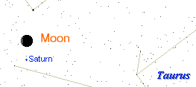

[Moon](chodesh.html) close to Saturn

* * *

January 27, 2003 corresponds to:

Monday, [Shevat](feasts.html) 24, 5763

[**Events**](feasts.html) **for this day of the year:**

Water swells on the earth in the days of Noah.

Day 55. ***Genesis 7:24***

Moses proclaims the "second [law](law.html)"

(Deuteronomy) to the Israelites - day 24.

***Deuteronomy 1:3***

Zechariah has the vision of the red, brown, and

white horses. Predicts the restoration of Zion.

***Zechariah 1:7-8***

[Sabbath](sabbath.html) reading: Mishpatim, Ex 21:1-24:18

Prophets: Jer 34:8-22, 33:25-26

Replaced by: Pre-[Rosh Chodesh](chodesh.html),I Sam 20:18-42

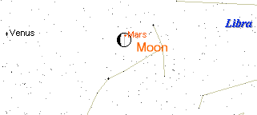

[Moon](chodesh.html) occults Mars

* * *

May 5, 2003 corresponds to:

Monday, [Iyar](feasts.html) 3, 5763

[**Events**](feasts.html) **for this day of the year:**

The [Omer](omer.html), day 18, week 2 plus 4 days.

Water swells on the earth in the days of Noah.

Day 123. ***Genesis 7:24***

Yocheved hides Moses after a 6 month and [one](one.html)

day pregnancy - day 56. Artscroll Mesorah on

Shavuos, page 61.

[Yeshua’s](yeshua.html) alive! It is [resurrection](techiyat.html) day 16.

Paul stays [seven](seven.html) days in Troas. Today is

[Sabbath](sabbath.html). **Day 6** ***Acts 20:6***

[Sabbath](sabbath.html) reading: Emor, Lev 21:1-24:23

Prophets: Ezek 44:15-31

**May 5-6**

Eta Aquarids Meteor shower. Look [east](east.html) after midnight.

* * *

May 7, 2003 corresponds to:

Wednesday, [Iyar](feasts.html) 5, 5763

[**Events**](feasts.html) **for this day of the year:**

The [Omer](omer.html), day 20, week 2 plus 6 days.

Water swells on the earth in the days of Noah.

Day 125. ***Genesis 7:24***

Yocheved hides Moses after a 6 month and [one](one.html)

day pregnancy - day 58. Artscroll Mesorah on

Shavuos, page 61.

[Yeshua](yeshua.html)’s alive! It is [resurrection](techiyat.html) day 18.

Israel independence day. Israel became a [nation](nations.html)

in 1948.

[Sabbath](sabbath.html) reading: Emor, Lev 21:1-24:23

Prophets: Ezek 44:15-31

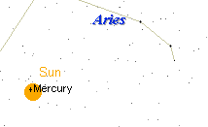

Transit of Mercury will be visiible from [Jerusalem](city.html).

* * *

**Total Lunar Eclipse on** [**Iyar**](feasts.html) **14, 5763**

**The** [**Second Passover**](passover.html)

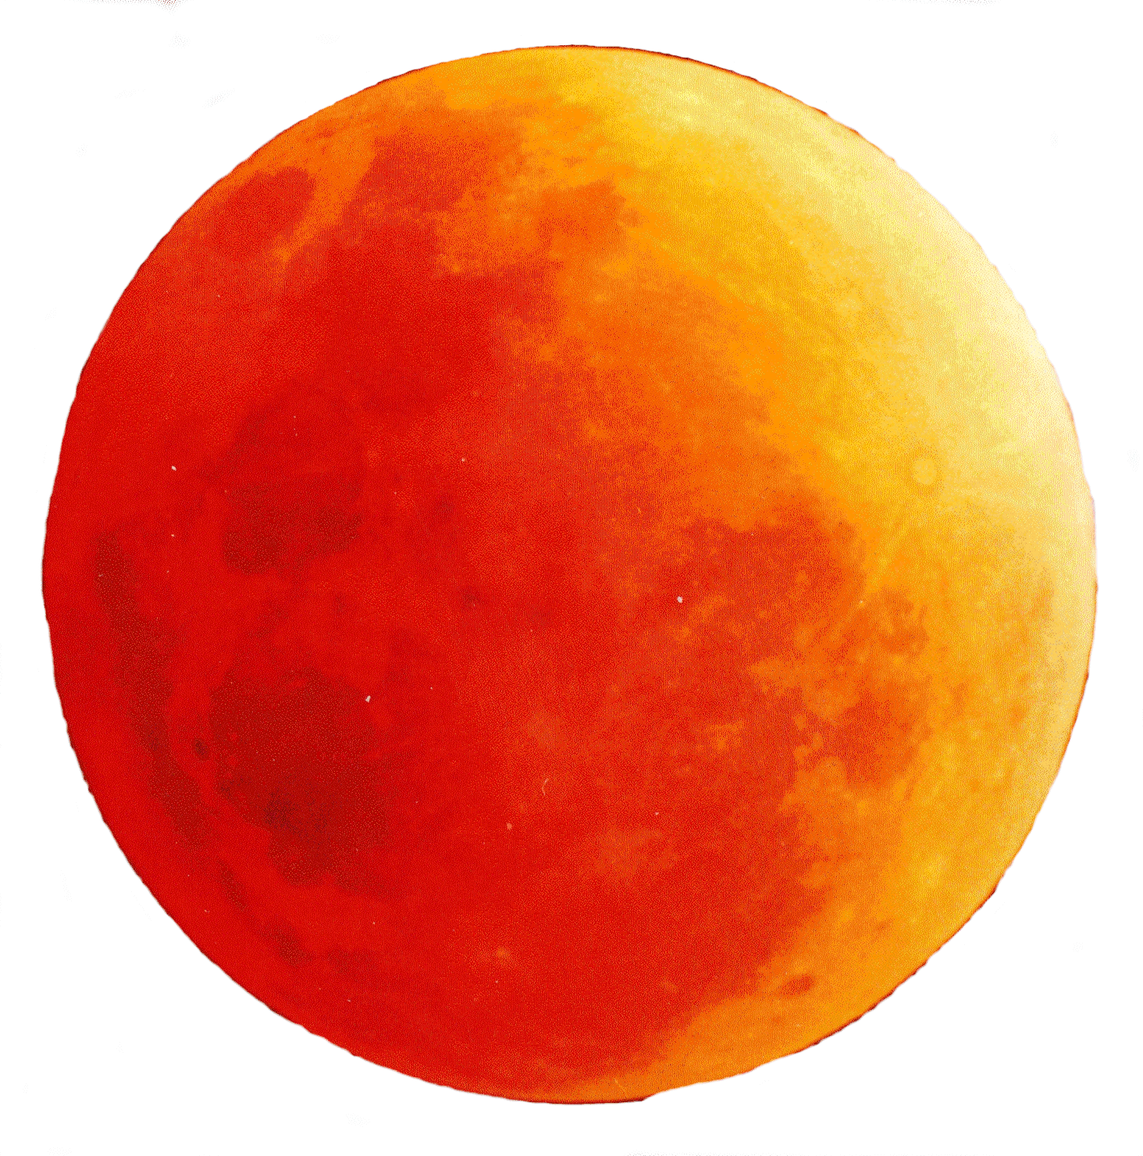

May 16, 2003 corresponds to:

Erev [Shabbat](sabbath.html), Friday, [Iyar](feasts.html) 14, 5763

[**Events**](feasts.html) **for this day of the year:**

The [Omer](omer.html), day 29, week 4 plus 1 days.

Water swells on the earth in the days of Noah.

Day 134. ***Genesis 7:24***

Yocheved hides Moses after a [six](six.html) month and [one](one.html)

day pregnancy - day 66. Artscroll Mesorah on

Shavuos, page 61.

[Yeshua’s](yeshua.html) alive! It is [resurrection](techiyat.html) day 27.

[Iyar](feasts.html) 14 is also the beginning of the second [Passover](passover.html) found in:

***Bamidbar (***[***Numbers***](nchart.html)***) 9:9-14*** *And* [*HaShem*](hashem.html) *spake unto Moses, saying,* [*Speak*](mashal.html) *unto the children of Israel, saying, If any man of you or of your posterity shall be unclean by reason of a dead* [*body*](body.html)*, or [be] in a* [*journey*](stages.html) *afar off, yet he shall keep the* [*passover*](passover.html) *unto* [*HaShem*](hashem.html)*. The* [*fourteenth*](fourteen.html) *day of the second month (*[*Iyar*](feasts.html)*) at even they shall keep it, [and]* [*eat*](eating.html) *it with* [*unleavened*](chametz.html) *bread and bitter [herbs]. They shall leave none of it unto the morning, nor break any bone of it: according to all the ordinances of the* [*passover*](passover.html) *they shall keep it. But the man that [is]* [*clean*](purity.html)*, and is not in a* [*journey*](stages.html)*, and forbeareth to keep the* [*passover*](passover.html)*, even the same soul shall be cut off from among his people: because he brought not the* [*offering*](korbanot) *of* [*HaShem*](hashem.html) *in his* [*appointed*](settimes.html) *season, that man shall bear his* [*sin*](sin.html)*. And if a stranger shall sojourn among you, and will keep the* [*passover*](passover.html) *unto* [*HaShem*](hashem.html)*; according to the ordinance of the* [*passover*](passover.html)*, and according to the manner thereof, so shall he do: ye shall have* [*one*](one.html) *ordinance, both for the stranger, and for him that was born in the land.*

A total Lunar eclipse on the second [Passover](passover.html). The [Passover](passover.html) celebrated by those who have become tamei by contact with the dead, or they are on a [journey](stages.html).

[Sabbath](sabbath.html) reading:

Torah: BeHar, Vayikra (Leviticus) 25:1-26:2:

#### [Sabbatical](shmita.html) and [Jubilee](yovel.html) years

Prophets: Yiremyahu (Jeremiah) 32:6-27:

Jeremiah buys a [field](field.html) for the end of the [Babylonian](bavel.html) [exile](galuyot.html)

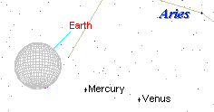

Total Eclipse of the [Moon](chodesh.html) as seen from the [moon](chodesh.html).

* * *

May 29, 2003 corresponds to:

Thursday, [Iyar](feasts.html) 27, 5763

[**Events**](feasts.html) **for this day of the year:**

The [Omer](omer.html), day 42, week 6 plus 0 days.

Water swells on the earth in the days of Noah.

Day 147. ***Genesis 7:24***

Yocheved hides Moses after a 6 month and [one](one.html)

day pregnancy - day 79. Artscroll Mesorah on

Shavuos, page 61.

Israelites [camp](stages.html) at [Rephidim](stages.html) (baluster place) in

2448 AM. This is [camp](stages.html) 10, day 5.

[*Seder*](haggada.html) *Olam 5*

Hezekiah celebrates the[**Second Hag ha-Matza**](chametz.html)

for 7 more days.[Thirteenth](thirteen.html) day. ***II Chronicles***

***30:13-22***

[Yeshua](yeshua.html)’s alive! It is [resurrection](techiyat.html) day 40.

[Messiah](mashiach.html) ascended into [heaven](heaven.html). ***Acts 1:3***

[Sabbath](sabbath.html) reading: Be-Midbar, Num 1:1-4:20

Prophets: Hos 2:1-22

Replaced by: Pre-[Rosh Chodesh](chodesh.html),I Sam 20:18-42

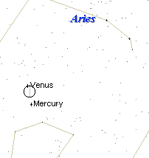

[Moon](chodesh.html) occults Venus at dawn

* * *

May 31, 2003 corresponds to:

Saturday, [Iyar](feasts.html) 29, 5763

[**Events**](feasts.html) **for this day of the year:**

The [Omer](omer.html), day 44, week 6 plus 2 days.

Water swells on the earth in the days of Noah.

Day 149. ***Genesis 7:24***

Yocheved hides Moses after a [six](six.html) month and [one](one.html)

day pregnancy - day 81. Artscroll Mesorah on

Shavuos, page 61.

Israelites, in Hezekiah's day, smash the sacred

stones and cut down the Asherah poles.

***2 Chronicles 30, 31:1***

Israelites [camp](stages.html) at [Rephidim](stages.html) (baluster place) in

2448 AM. This is [camp](stages.html) 10, day 7.

[*Seder*](haggada.html) *Olam 5*

[Yerushalayim](city.html) was liberated, including Har

Habayit and the Kotel Hamaaravi, in the [Six](six.html)

Day War, 5728 [1967]

Yahrtzeit of Shmuel Hanavi 2882 [878 BCE].

**Megillat Taanit**.

[Sabbath](sabbath.html) reading: Be-Midbar, Num 1:1-4:20

Prophets: Hos 2:1-22

Replaced by: Pre-[Rosh Chodesh](chodesh.html),I Sam 20:18-42

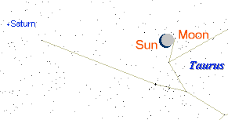

6:27am Annular solar eclipse

* * *

**June 8, 2004 Transit of Venus**

June 8, 2004 corresponds to:

Tuesday, [Sivan](feasts.html) 19, 5764

[**Events**](feasts.html) **for this day of the year:**

Moses goes up on [Sinai](stages.html), the [first](one.html) [time](time.html), to receive

the Torah - day 13. Rashi 32:1, [***Exodus***](exodus.html) ***24:18***

[Sabbath](sabbath.html) reading: Shela Lekha, Num 13:1-15:41

Prophets: Josh 2:1-24

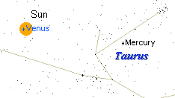

The 2004 transit of Venus will be the [first](one.html) [one](one.html) since 1882.

* * *

July 17, 2003 corresponds to:

Thursday, [Tammuz 17](tamuz17.html), 5763

[**Events**](feasts.html) **for this day of the year:**

[Joseph](joseph.html) and Samuel are born. It is [forty](forty.html) weeks after Tishrei 1.

Moses' spies search out the promised land. **Day**

**19** [***Numbers***](nchart.html) ***13, 14*** [Mishna](orallaw.html), Ta'an 29a

The [sin](sin.html) of he golden calf is committed.

Moses breaks the tablets containing the [Ten](ten.html)

[Commandments](cmds613.html), after [forty](forty.html) days on Mt. [Sinai](stages.html).

[***Exodus***](exodus.html) ***24:18 - 31:18***, Taanit 28b

Levites kill 3000 Israelites and become set apart

to [HaShem](hashem.html). [***Exodus***](exodus.html) ***32:25-29***

Cessation of the daily [sacrifice](korbanot.html) in the [first](one.html)

[temple](temple.html).

[Jerusalem](city.html) walls destroyed. Titus takes the outer

[city](city.html). Tamid [offering](korbanot) ceased.

[Talmud](orallaw.html) Erachin 11b

[Fast of Tammuz](feasts.html). the beginning of bein

ha-mezarim, a [three](three.html)-week period of

semi-[mourning](mourning.html) for the destruction of the

[Temple](temple.html). This is the fast of the [fourth](four.html) month.

***Zechariah 9:19***

[Sabbath](sabbath.html) reading: Pinhas, Num 25:10-30:1

Prophets: I Kings 18:46-19:21

Replaced by: Jer 1:1-2:3

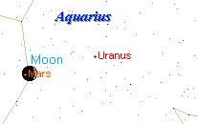

12:27pm [Moon](chodesh.html) occults Mars

* * *

July 28, 2003 corresponds to:

Monday, [Tammuz](feasts.html) 28, 5763

[**Events**](feasts.html) **for this day of the year:**

Moses goes up on [Sinai](stages.html), a second [time](time.html), to plead

for mercy after the golden calf - day 10.

[***Exodus***](exodus.html) ***32:30-35***, [Gemara](orallaw.html) 28b.

Moses' spies search out the promised land. **Day**

**30** [***Numbers***](nchart.html) ***13, 14*** [Mishna](orallaw.html), Ta'an 29a

[Sabbath](sabbath.html) reading: Devarim, Deut 1:1-3:22

Prophets: Isa 1:1-27, Hazon

**July 28-29**

Southern Delta Aquarids Meteor Shower during old [moon](chodesh.html). Look [east](east.html) after midnight.

* * *

August 13, 2003 corresponds to:

Wednesday, [Av 15](feasts.html), 5763

[**Events**](feasts.html) **for this day of the year:**

Moses goes up on [Sinai](stages.html), a second [time](time.html), to plead

for mercy after the golden calf - day 26.

[***Exodus***](exodus.html) ***32:30-35***, [Gemara](orallaw.html) 28b.

The [appointed](settimes.html) [time](time.html) for the family of Zattu ([tribe](tribes.html)

of Judah) and with them were the [priests](priests.html) and

Levites and all those who were not certain of

their [tribes](tribes.html) and the bene Gonbe'ali and

the bene Koze Kezi'oth to bring firewood for

the [Temple](temple.html). ***Nehemiah 10:34***, **Taanis 26a**

[One](one.html) of the [two](two.html) greatest days for celebration

(Yom HaKippurim was the other).

[Talmud](orallaw.html) (Mesechta Taanis 26b) Menachos 85b

[Israelites camp](stages.html) at [Divon Gad](stages.html) (sorrowing), 2488

AM. This is [camp](stages.html) 38. [Study](study.html) on [Numbers](nchart.html) 33

Taanith 30b

The last of the [exodus](exodus.html) [generation](toldot.html) died.

*Bava Batra 121a*

Inter-tribal [marriage](mashal.html) permitted, after the

parcelization of the land.

Reconciliation between of [Benyamin](benyamin.html) and the

other [tribes](tribes.html). ***Judges 21:14***

Hoshea ben Elah, King of Israel, removed the

blockades set by Yavrovam ben Nevat had

constructed to prevent the people from

ascending to [Jerusalem](city.html) for the pilgrimage

[festivals](festivals.html). *The Book of Our Heritage*,

Eliyahu Kitov

Day of courtship. Gateway to Judaism, Pg.341

[Sabbath](sabbath.html) reading: Ekev, Deut 7:12-11:25

Prophets: Isa 49:14-51:3

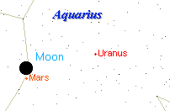

Full [moon](chodesh.html) very close to Mars on Tu B’[Av](tubav.html)

* * *

**August 27-28, 2003 - Very Close Approach of Mars:** Rising at opposition, in Aquarius, this is the Planet of War's closest approach to earth for the next 2000+ years as it shows off a disk of 25.1 arc seconds diameter. It will shine with a brilliance of magnitude -2.9, which is brighter than Jupiter at opposition.

August 27, 2003 corresponds to:

Wednesday, [Av](feasts.html) 29, 5763

[**Events**](feasts.html) **for this day of the year:**

Moses returns from after [Sinai](stages.html), a second [time](time.html), to

plead for mercy after the golden calf - day 40.

[***Exodus***](exodus.html) ***32:30-35***, [Gemara](orallaw.html) 28b.

G-d commanded Moses saying "Carve out for

yourself [two](two.html) tablets of stone like the [first](one.html)

ones." [***Exodus***](exodus.html) ***34:1***

[Sabbath](sabbath.html) reading:

Shofetim, Devarim (Deuteronomy) 16:18-21:9

Prophets:

Yeshayahu (Isaiah) 51:12-52:12

These past [events](feasts.html) suggest that the this is an auspicous [time](time.html) to begin repenting in order to be able to receive the Torah (Torah=Israel=[Messiah](mashiach.html)).

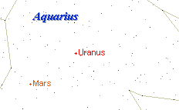

Close approach of Mars

The day after this [event](feasts.html). [Jews](gen-jew.html) all over the [world](worlds.html) will begin an intense [time](time.html) of repentance for the next [forty](forty.html) days, till Yom HaKippurim, the Day of [Atonement](kippur.html). [Av](feasts.html) 29 is Erev [Rosh Chodesh](chodesh.html) and is significant because the [moon](chodesh.html) is completely hidden - suggesting the hiddenness of the [Jewish](gen-jew.html) people who are about to be renewed. This will be a most [awesome](awesome.html) day!

If Your Excellency is sincere about taking this message to [heart](body.html), I would suggest the following approach:

Read the following passages VERY carefully at least a week before August 27. Secure some excellent [Jewish](gen-jew.html) commentaries on these [two](two.html) passages, like Me'am Loez. Note the [world](worlds.html) [events](feasts.html) that take place during this week and compare them, critically, to the [two](two.html) passages:

Shofetim, Devarim (Deuteronomy) 16:18-21:9

Yeshayahu (Isaiah) 51:12-52:12

Finally, be prepared to repent as you have never repented before. It is not altogether impossible that we should have a great war during Chol HaMoed [Succoth](succoth.html). This war will be between [Edom](edom.html) ([Edom](edom.html)=Rome=Christianity=western [nations](nations.html)) and Ishmael (Arabs in general).

* * *

September 9, 2003 corresponds to:

Tuesday, [Elul](elul.html) 12, 5763

[**Events**](feasts.html) **for this day of the year:**

Period of teshuvah / repentance day 12.

Moses goes up Mount [Sinai](stages.html), the [third](three.html) [time](time.html), to

get the second set of stone tablets to spend

[forty](forty.html) days - day 12.

[Sabbath](sabbath.html) reading: Ki Tavo, Deut 26:1-29:8

Prophets: Isa 60:1-22

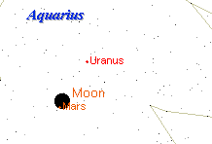

[Moon](chodesh.html) Occults Mars (during datlight)

* * *

October 21, 2003 corresponds to:

Tuesday, [Tishri](feasts.html) 25, 5764

[**Events**](feasts.html) **for this day of the year:**

I am unaware of any [events](feasts.html) for this day or the next day.

[Sabbath](sabbath.html) reading: Bereshit, Gen 1:1-6:8

Prophets: Isa 42:5-43:11

Replaced by: Pre-Rosh Hodesh,I Sam 20:18-42

October 21-22

Orionids Meteor Shower. Look [east](east.html) after midnight.

* * *

October 25, 2003 corresponds to:

Saturday, [Tishri](feasts.html) 29, 5764

[**Events**](feasts.html) **for this day of the year:**

I am unaware of any [events](feasts.html) for this day.

[Sabbath](sabbath.html) reading: Bereshit, Gen 1:1-6:8

Prophets: Isa 42:5-43:11

Replaced by: Pre-Rosh Hodesh,I Sam 20:18-42

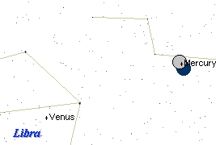

* * *

October 26, 2003 corresponds to:

Sunday, [Tishri](feasts.html) 30, 5764

[**Events**](feasts.html) **for this day of the year:**

I am unaware of any [events](feasts.html) for this day.

[Sabbath](sabbath.html) reading: No'ah, Gen 6:9-11:32

Prophets: Isa 54:1-55:5

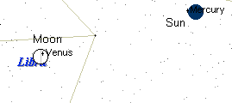

[Moon](chodesh.html) occults Venus

* * *

### A Total Lunar eclipse



**Sukkah 29a** It was [taught](teacher.html): R. Meir said, Whenever the luminaries are in eclipse, it is a bad omen for Israel since they are inured to blows. This may be compared to a school [teacher](teacher.html) who comes to school with a strap in his [hand](fourteen.html). Who becomes apprehensive? He who is accustomed to be daily punished. Our Rabbis [taught](teacher.html), When the [Sun](hachama.html) is in eclipse it is a bad omen for idolaters; when the [Moon](chodesh.html) is in eclipse, it is a bad omen for Israel, since Israel reckons by the [Moon](chodesh.html) and idolaters by the [Sun](hachama.html). If it is in eclipse in the [east](east.html), it is a bad omen for those who [dwell](dwelling.html) in the [east](east.html); if in the west, it is a bad omen for those who [dwell](dwelling.html) in the west; if in the midst of [heaven](heaven.html) it is bad omen for the whole [world](worlds.html). If its [face](body.html) is red as [blood](body.html), [it is a [sign](signs.html) that] the sword is [coming](coming.html) to the [world](worlds.html); if it is like sack-cloth, the arrows of [famine](famine.html) are [coming](coming.html) to the [world](worlds.html); if it resembles both, the sword and the arrows of [famine](famine.html) are [coming](coming.html) to the [world](worlds.html). If the eclipse is at sunset calamity will tarry in its [coming](coming.html); if at dawn, it hastens on its way: but some say the order is to be reversed. And there is no [nation](nations.html) which is smitten that its G-ds are not smitten together with it, as it is said, And against all the G-ds of Egypt I will execute judgments. But when Israel fulfill the will of the Omnipresent, they need have no [fear](fear.html) of all these [omens] as it is said, Thus saith [HaShem](hashem.html),' Learn not the way of the [nations](nations.html), and be not dismayed at the [signs](signs.html) of [heaven](heaven.html), for the [nations](nations.html) are dismayed at them, the idolaters will be dismayed, but Israel will not be dismayed.

November 9, 2003 corresponds to:

Sunday, [Heshvan](feasts.html) 14, 5764

[**Events**](feasts.html) **for this day of the year:**

Noah, his wife, [three](three.html) sons, are in the [ark](ark.html)

[mourning](mourning.html) for Methuselah. **Day 4**

***Genesis 7:4-9***

[Sabbath](sabbath.html) reading: Va-Yera, Gen 18:1-22:24

Prophets: II Kings 4:1-37

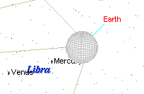

Total lunar eclipse as viewed from the [moon](chodesh.html).

* * *

November 23, 2003 corresponds to:

Sunday, [Heshvan](feasts.html) 28, 5764

[**Events**](feasts.html) **for this day of the year:**

Day 12 of God's rain in Noah's day. ***Genesis 7:4***

[Sabbath](sabbath.html) reading: Toledot, Gen 25:19-28:0

Prophets: Mal 1:1-2:7

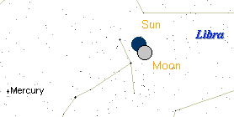

November 23, 2003 – Total solar eclipse

* * *

November 24, 2003 corresponds to:

Monday, [Heshvan](feasts.html) 29, 5764

[**Events**](feasts.html) **for this day of the year:**

Day 13 of God's rain in Noah's day. ***Genesis 7:4***

[Sabbath](sabbath.html) reading: Toledot, Gen 25:19-28:0

Prophets: Mal 1:1-2:7

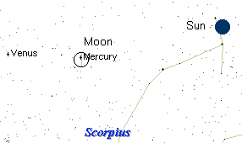

The only observed collision between a planet and another solar [body](body.html) began on [Tisha B'Ab](tishabav.html), a [Sabbath](sabbath.html). Comet Shoemaker-Levy 9 began slamming into the surface of the planet Jupiter, [known](daat.html) in [Hebrew](hebrew.html) as Zedek, the righteous [one](one.html). This [event](feasts.html) may have connections to the other [Tisha B'Ab](tishabav.html) [events](feasts.html). Beginning on [Shabbat](sabbath.html), July 17 ([Tisha B'Ab](tishabav.html)) 1994, the planet Jupiter was struck by 21 fragments of a comet. The comet (Shoemaker-Levy 9) collided with this planet... likely fulfilling [Luke](luke.html) 21:26, where [Yeshua](yeshua.html) says that, prior to his return the "heavenly [bodies](body.html) would be shaken." Is all this coincidence? I don't think so. Jupiter was the high-god of Rome, it was the [one](one.html) whose [temple](temple.html) replaced [HaShem](hashem.html)'s house in [Jerusalem](city.html) and whose [name](name.html) (Capitolina) adorned the [city](city.html) for centuries. Jupiter (also [known](daat.html) as Marduk to Babylonians) was the high god of Zoroastrianism, the religion of Nebudchenezzar (who had the [first](one.html) [temple](temple.html) burned in 586b c). See the [connection](connection.html)? [HaShem](hashem.html) had symbolic "revenge" on Rome -and- [Babylon](bavel.html) through Jupiter (high god of both empires), when the planet was pummeled on this fitting anniversary in 1994.

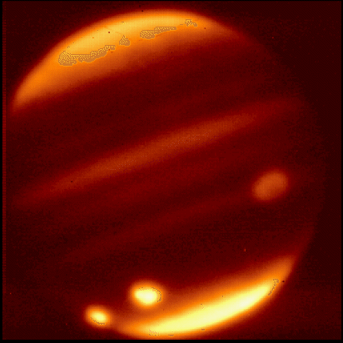

* * *

### A Total Lunar eclipse on

### [Shabbat](sabbath.html), [Adar](feasts.html) 13, 5767 – The Fast of [Esther](esther.html)

(March 3, 2007)



**Sukkah 29a** It was [taught](teacher.html): R. Meir said, Whenever the luminaries are in eclipse, it is a bad omen for Israel since they are inured to blows. This may be compared to a school [teacher](teacher.html) who comes to school with a strap in his [hand](fourteen.html). Who becomes apprehensive? He who is accustomed to be daily punished. Our Rabbis [taught](teacher.html), When the [Sun](hachama.html) is in eclipse it is a bad omen for idolaters; when the [Moon](chodesh.html) is in eclipse, it is a bad omen for Israel, since Israel reckons by the [Moon](chodesh.html) and idolaters by the [Sun](hachama.html). If it is in eclipse in the [east](east.html), it is a bad omen for those who [dwell](dwelling.html) in the [east](east.html); if in the west, it is a bad omen for those who [dwell](dwelling.html) in the west; if in the midst of [heaven](heaven.html) it is bad omen for the whole [world](worlds.html). If its [face](body.html) is red as [blood](body.html), [it is a [sign](signs.html) that] the sword is [coming](coming.html) to the [world](worlds.html); if it is like sack-cloth, the arrows of [famine](famine.html) are [coming](coming.html) to the [world](worlds.html); if it resembles both, the sword and the arrows of [famine](famine.html) are [coming](coming.html) to the [world](worlds.html). If the eclipse is at sunset calamity will tarry in its [coming](coming.html); if at dawn, it hastens on its way: but some say the order is to be reversed. And there is no [nation](nations.html) which is smitten that its G-ds are not smitten together with it, as it is said, And against all the G-ds of Egypt I will execute judgments. But when Israel fulfill the will of the Omnipresent, they need have no [fear](fear.html) of all these [omens] as it is said, Thus saith [HaShem](hashem.html),' Learn not the way of the [nations](nations.html), and be not dismayed at the [signs](signs.html) of [heaven](heaven.html), for the [nations](nations.html) are dismayed at them, the idolaters will be dismayed, but Israel will not be dismayed.

### A Total Lunar eclipse on

### [Shabbat](sabbath.html), [Adar](feasts.html) 15, 5768 – Shushan [Purim](Purim.html)

(February 21, 2008)



Feb 21, 2008 corresponds to: Thu, [Adar](feasts.html) 15, 5768

[Sabbath](sabbath.html) reading: Ki Tissa, Ex 30:11-34:35

Prophets: I Kings 18:1-39

Sunset in [New](new.html) York is at: 5:38pm EST

### A Total Lunar eclipse on

### [Nisan](feasts.html) 15, 5774 – [Passover](passover.html)

(April 15, 2014)



Apr 15, 2014 corresponds to: Tue, [Nisan](feasts.html) 15, 5774

[Sabbath](sabbath.html) reading: [Pesach](passover.html) 5, Ex 33:12-34:26, Num 28:16-25

Prophets: HH [Pesach](passover.html) 5, Ezek 36:37-37:14

Sunset in [New](new.html) York is at: 6:35pm EST

### A Total Lunar eclipse on

### [Tishri](feasts.html) 14, 5775 – [Succoth](succoth.html)

(October 8, 2014)



Oct 8, 2014 corresponds to: Wed, [Tishri](feasts.html) 14, 5775

[Sabbath](sabbath.html) reading: HH [Succoth](succoth.html) 3,Ex 33:12-34:26,Num 29:17-22

Prophets: HH [Succoth](succoth.html) 3, Ezek 38:18-39:16

Sunset in [New](new.html) York is at: 5:27pm EST

### A Total Lunar eclipse on

### [Nisan](feasts.html) 15, 5775 – [Passover](passover.html)

(April 4, 2015)



Apr 4, 2015 corresponds to: Sat, [Nisan](feasts.html) 15, 5775

[Sabbath](sabbath.html) reading: [Pesach](passover.html) 1, Ex 12:21-51, Num 28:16-25

Prophets: [Pesach](passover.html) 1, Josh 5:2-6:1, 6:27

Sunset in [New](new.html) York is at: 6:24pm EST

### A Total Lunar eclipse on

### [Tishri](feasts.html) 15, 5776 – [Succoth](succoth.html)

(September 28, 2015)



Sep 28, 2015 corresponds to: Mon, [Tishri](feasts.html) 15, 5776

[Sabbath](sabbath.html) reading: HH [Succoth](succoth.html) 6,Ex 33:12-34:26,Num 29:26-34

Prophets: HH [Succoth](succoth.html) 6, Ezek 38:18-39:16

Sunset in [New](new.html) York is at: 5:43pm EST

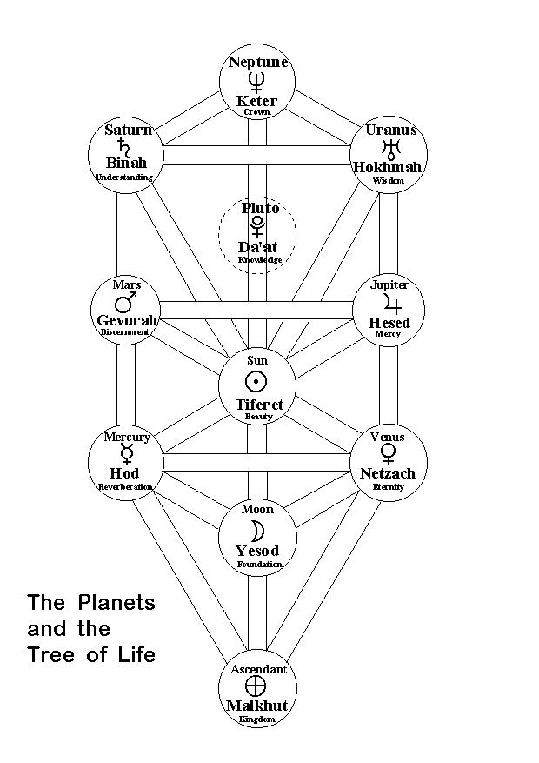

Z’ev ben Shimon Halevi who [numbers](nchart.html) among his [spiritual](physical.html) ancestors the Spanish Kabbalistic astrologer of the [twelfth](twelve.html) century, [Abraham](avraham.html) ibn Ezra, and the Spanish poet of the eleventh century, Solomon ibn Gabirol.

Ibn Gabirol, to whom Halevi’s book on astrology, *The Anatomy of Fate,* is dedicated, composed the epic poem *Keter veMalkhut* ("The Crown and the Glory" or "The Royal Crown"). This contains a litany of astrological description just pages before the list of [sins](sin.html) for which orthodox [Jews](gen-jew.html) ask repentance on the [Day of Atonement](kippur.html).

**Ending Thoughts**

Although neglected, the science of Judaic Astrology is deeply rooted in Judaism. Specifically, it roots from the Kabbalah (inner and [spiritual](physical.html), portion of the Bible). The Sefer Yetzira (the Book of Formation), written by [Abraham](avraham.html) the Patriarch, is where all the Wisdom of Judaic Astrology stems from.

It is our past actions from previous lifetimes that allow man to be susceptible to either the bad or good influences of these astrological objects. Nothing is by chance! Everything had a cause and an effect. Although astrological objects impel Man, they don't compel him. Man has, had and will always have [freedom](freedom.html) of choice.

**Reference List**

*The Anatomy of Fate* by Z’ev ben Shimon Halevi, Arkana.

*Psychology and Kabbalah* by Z’ev ben Shimon Halevi, Gateway Books.

*Kabbalah: Tradition of Hidden* [*Knowledge*](knowledge.html) by Z’ev ben Shimon Halevi, Thames and Hudson

*A Kabbalistic Universe* by Z’ev ben Shimon Halevi, Samuel Weiser Inc.

*The Beginning of Wisdom* by [Abraham](avraham.html) ibn Ezra, English Translation edited by Raphael Levy and Francisco Cantera.

Sepharial

*"The Book of The Fundamentals of the Tables"* Ibn-Ezra

**Ibn Ezra,** [**Abraham**](avraham.html) *The Book of Reasons* translated M.B.Epstein - The Golden Hind Press 1994. Available through Project Hindsight.

Ibn Ezra, A. (before 1164) Sefer ha-Yesodot (Book of Foundations), (An important [study](study.html) of Ibn Ezra’s astrological theories.)

Symbols in the [Mishkan](mikdash.html) in R. [Avraham](avraham.html) Ibn Ezra's commentary, [Sinai](stages.html), 112, 1993, p. 250-262. (Heb)

Masha-Allah also wrote a book on Lunar and Solar Eclipses, that was later translated into [Hebrew](hebrew.html) by [Abraham](avraham.html) Ibn Ezra (*"Sefer be kadrut ha levana ve ha shemesh"*")

The astrological foundation book, Ibn Ezra, trad,: J. Halbronn-Bibl. Hermetica/Retz-Paris, 1977,

* * *

**Conjunction**: The position of [two](two.html) [celestial](celestal.html) [bodies](body.html) on the [celestial](celestal.html) sphere when they have the same [celestial](celestal.html) longitude.

* * *

Astrology / Mazal

*Verses in Tanach*

Ibn Ezra Shemot 6:3, 20:1, 33:21

[*Talmud*](orallaw.html) */* [*Midrash*](orallaw.html) *and commentaries*

Bava Metzia 75  
[Moed](settimes.html) Katan 28a  
Nedarim 32a  
Sanhedrin 75b  
[Shabbat](sabbath.html) 156a-b  
Meiri [Moed](settimes.html) Katan 28a "Le'Olam Yeharher"  
Tosafot Berachot 55b s.v. Potrei  
Tosafot Kiddushin 82a s.v. Ela  
Tosafot [Moed](settimes.html) Katan 28a s.v. Ela  
Tosafot [Shabbat](sabbath.html) 156a s.v. Ein  
Tosafot Yevamot 50a s.v. Mosifin

*Post* [*Talmud*](orallaw.html) */* [*Midrash*](orallaw.html)*, Pre-Rishonim*

*Mishneh Torah and commentaries*

Hilchot Yesodei haTorah 10:3

*Rishonim [Pre-"Code of* [*Jewish*](gen-jew.html)[*Law*](law.html)*"]*

Radvaz 2:716  
Rashba 1:19, 1:148, 1:409, 1:652, 5:48  
Tashbetz 2:1  
Zichron Yehudah 91

*Tur, Shulchan Aruch ["Code of* [*Jewish*](gen-jew.html)[*Law*](law.html)*"] and Commentaries*

*Acharonim [Post-"Code of* [*Jewish*](gen-jew.html)[*Law*](law.html)*"]*

Chatam Sofer 1:Orach Chaim 160  
Maharsham 4:70

* * *

The conjunction of Jupiter and Saturn every 19.8 years which Abu 'Mashar, Masha 'Allah, Ibn Ezra and others (Circa 780 AD - 1167 AD) in the medieval Arabic era used to forecast societal changes.

The next conjunction will be in 2020 in an air [sign](signs.html) and the [cycle](cycles.html) continues in air [signs](signs.html) exclusively for the next 180 years; possibly meaning the end of this threat to American presidents.

As an interesting aside, there is a prophesy spoken by [Yeshua](yeshua.html); "When the [Sun](hachama.html) grows dark, and the [Moon](chodesh.html) does not give her light and the [stars](mazaroth.html) are falling from the sky, then you shall [know](daat.html) that the return of the son of man is imminent". Careful readers will notice that the [first](one.html) 2 conditions hint at a solar eclipse, then [one](one.html) must look for a meteor shower during a solar eclipse. It just so happens that this is the case on August 11, 1999 during the most famous Perseid meteor shower (Which is coincidentally the date of the heliacial rising of Sirius - Egyptians used this to forecast the year and used it to [time](time.html) the flooding of the Nile). The only problem is that this configuration of planets happens every 19 years and is part of the Metonic [cycle](cycles.html).

* * *

**The** [**Jewish**](gen-jew.html) **year 5763 begins on Saturday, September 7, 2002.**

It is year 6 of the 19 year [cycle](cycles.html), therefore it is a leap year.

The [type](types.html) of year is: "Full-Leap".

Month Length [First](one.html)-of-Month H O L I D A Y S

================================= ========================================

[Tishri](feasts.html) 30 Sat, Sep 7, 2002 [Rosh Hashana](teruah.html)h Tish 1, Sat, Sep 7, 2002

[Heshvan](feasts.html) 30 Mon, Oct 7, 2002 [Yom Kippur](kippur.html) Tish 10, Mon, Sep 16, 2002

[Kislev](feasts.html) 30 Wed, Nov 6, 2002 [Succoth](succoth.html) Tish 15, Sat, Sep 21, 2002

Tevet 29 Fri, Dec 6, 2002 Sh'mini Atz Tish 22, Sat, Sep 28, 2002

[Shevat](feasts.html) 30 Sat, Jan 4, 2003 [Simchat Torah](simchat.html) Tish 23, [Sun](hachama.html), Sep 29, 2002

[Adar](feasts.html) 30 Mon, Feb 3, 2003 Hanukkah Kis 25, Sat, Nov 30, 2002

AdarII 29 Wed, Mar 5, 2003 Tu B'[Shevat](tubshevt.html) Shev 15, Sat, Jan 18, 2003

[Nisan](feasts.html) 30 Thu, Apr 3, 2003 [Purim](Purim.html) [Adar](feasts.html) II 14, Tue, Mar 18, 2003

[Iyar](feasts.html) 29 Sat, May 3, 2003 [Passover](passover.html) Nis 15, Thu, Apr 17, 2003

[Sivan](feasts.html) 30 [Sun](hachama.html), Jun 1, 2003 Yom Hashoah Nis 27, Tue, Apr 29, 2003

[Tammuz](feasts.html) 29 Tue, Jul 1, 2003 Yom Haatzmaut [Iyar](feasts.html) 5, Wed, May 7, 2003

[Av](feasts.html) 30 Wed, Jul 30, 2003 [Lag B'Omer](omer.html) [Iyar](feasts.html) 18, Tue, May 20, 2003

[Elul](elul.html) 29 Fri, Aug 29, 2003 [Shavuot](shavuot.html) Siv 6, Fri, Jun 6, 2003

Tisha B'[Av](tishabav.html) [Av](feasts.html) 9, Thu, Aug 7, 2003

Erev RoshHash [Elul](elul.html) 29, Fri, Sep 26, 2003

**The** [**Jewish**](gen-jew.html) **year 5764 begins on Saturday, September 27, 2003.**

It is year 7 of the 19 year [cycle](cycles.html), therefore it is not a leap year.

The [type](types.html) of year is: "Full".

Month Length [First](one.html)-of-Month H O L I D A Y S

================================= ========================================

[Tishri](feasts.html) 30 Sat, Sep 27, 2003 [Rosh Hashana](teruah.html)h Tish 1, Sat, Sep 27, 2003

[Heshvan](feasts.html) 30 Mon, Oct 27, 2003 [Yom Kippur](kippur.html) Tish 10, Mon, Oct 6, 2003

[Kislev](feasts.html) 30 Wed, Nov 26, 2003 [Succoth](succoth.html) Tish 15, Sat, Oct 11, 2003

Tevet 29 Fri, Dec 26, 2003 Sh'mini Atz Tish 22, Sat, Oct 18, 2003

[Shevat](feasts.html) 30 Sat, Jan 24, 2004 [Simchat Torah](simchat.html) Tish 23, [Sun](hachama.html), Oct 19, 2003

[Adar](feasts.html) 29 Mon, Feb 23, 2004 Hanukkah Kis 25, Sat, Dec 20, 2003

[Nisan](feasts.html) 30 Tue, Mar 23, 2004 Tu B'[Shevat](tubshevt.html) Shev 15, Sat, Feb 7, 2004

[Iyar](feasts.html) 29 Thu, Apr 22, 2004 [Purim](Purim.html) [Adar](feasts.html) 14, [Sun](hachama.html), Mar 7, 2004

[Sivan](feasts.html) 30 Fri, May 21, 2004 [Passover](passover.html) Nis 15, Tue, Apr 6, 2004

[Tammuz](feasts.html) 29 [Sun](hachama.html), Jun 20, 2004 Yom Hashoah Nis 27, [Sun](hachama.html), Apr 18, 2004

[Av](feasts.html) 30 Mon, Jul 19, 2004 Yom Haatzmaut [Iyar](feasts.html) 5, Mon, Apr 26, 2004

[Elul](elul.html) 29 Wed, Aug 18, 2004 [Lag B'Omer](omer.html) [Iyar](feasts.html) 18, [Sun](hachama.html), May 9, 2004

[Shavuot](shavuot.html) Siv 6, Wed, May 26, 2004

Tisha B'[Av](tishabav.html) [Av](feasts.html) 9, Tue, Jul 27, 2004

Erev RoshHash [Elul](elul.html) 29, Wed, Sep 15, 2004

This [study](study.html) was written by

Rabbi Dr. Hillel ben David

(Greg Killian).

Comments may be submitted to:

Rabbi Dr. Greg Killian

12210 Luckey Summit

San Antonio, TX 78252

Internet address: [gkilli@aol.com](mailto:gkilli@aol.com)

Web page: <http://www.betemunah.org/>

(360) 918-2905

Return to [The WATCHMAN](http://www.betemunah.org) home page

Send comments to Greg Killian at his email address: [gkilli@aol.com](mailto:gkilli@aol.com)