Burial Journey
By Rabbi Dr. Hillel ben David (Greg Killian)

Timing 2
Redemption 3
Children and sheep 4
Chariots and horsemen are mentioned. 5
The routes taken to get from Egypt to Canaan 5
Canaanites react to both events. 6
Bier & Camping order 10
Mazzalot 11

In this study, I would like to examine the exodus through the lens of the burial of Yaaqob. There are many linguistic and action related connections that should help understand the exodus and, more importantly, what will happen in the future and how we should respond to those future events.

When two disparate events share many commonalities, one can use each event to examine and understand the other event, however, the later event will be the one which is illuminated the most.

Yaaqob sees his death, and even burial, as fitting into the puzzle of the Avot, a worldview that made every action in their lives critical and meaningful, as if they were very aware of the adage “Maaseh avot siman lebanim”, the actions of the forefathers are a sign to the descendants. As such, every detail should be used to interpret future events and to glean from those events the end goal as divinely appointed.

As an introduction, it is worth knowing that the death of Yaaqob (Israel) triggered a response from Paro that was quite in keeping with what we consider to be ‘excellent’ behavior. His actions went above and beyond what was required. He not only allowed Yosef to fulfill his vow to Yaaqob, but he also sent his army and his noblemen to escort Yaaqob to his burial place.

On the other hand, the Paro at the time of the exodus was literally broken with repeated lessons before he finally, grudgingly, and regretfully, did the minimum necessary. After he did this minimum requirement, he attempted to undo his permission to let HaShem’s people go. He attempted to bring the Bne Israel back into slavery.

On both the burial trip and the exodus, Yosef went up with his people. For the burial, he was alive. For the exodus, Moshe carried his bones.

Both trips were preceded by a death. The death of Yaaqob / Israel, who purchased the rights of the firstborn, preceded the burial procession, and the death of the Egyptian firstborn preceded the exodus.

Both trips focused on redemption. Yaaqob’s desire to be buried in the holy land was his demonstrated belief in the eventual redemption of the Bne Israel from Egypt, as we shall soon see. The exodus had, at its primary goal, the redemption of the Bne Israel from the slavery of Egypt.

Both trips find the protagonists, Yosef and the Bne Israel, in subjection to different Paros. Yosef was subjugated in that his role as a leader in Egypt was crucial. Further, the requirement that he obtain Paro’s permission to go and bury Yaaqob forms a crucial element of the episode. The Bne Israel were in physical subjugation as slaves. This slavery also forms a crucial element of that episode.

We will later explore other connections that need elaboration.

Let’s start by looking at a pasuk:

Shemot (Exodus) 14:17 And I will stiffen the hearts of the Egyptians so that they go in after them; and I will gain glory through Paro and all his warriors, his chariots and his horsemen.

How does HaShem gain glory through the above event, given that He does not rejoice over the destruction of His creatures?

Megillah 10b The Holy One, Blessed be He, does not rejoice over the downfall of the wicked. And Rabbi Yoḥanan said: What is the meaning of that which is written: “And the one came not near the other all the night” (Exodus 14:20)? The ministering angels wanted to sing their song, and the Holy One, Blessed be He, said: The work of My hands [the Egyptians] are drowning at sea, and you wish to say songs?

However, a close reading of Shemot (Exodus) 14:17 shows that the verse never says that HaShem gets glory and honor from their deaths, it simply says that HaShem will be glorified through the Egyptian warriors, chariots, and horsemen. These Egyptians soldiers were there to honor and escort the Israelites, despite what Paro had commanded them to do. They were there to honor HaShem, the Father of all, including the Egyptians!

Timing

The Midrash teaches that Yaaqob is both born and died on the first day of Succoth. The first time the word “Succoth” is mentioned in the Torah is immediately after Yaaqob and Esau have their reconciliation and Yaaqob journeys to a place he calls “Succoth”. Our Sages taught that Yaaqob experiences God in buildings and structure, and he is the one who understands how to manifest and create changes in the physical world based on spirituality (as demonstrated in Bereshit (Genesis) 30:37 where he causes sheep to be born with spots or speckles).

The Holy Temple, may it be rebuilt in our time, is often referred to as the “House of Yaaqob”, and our Sages teach repeatedly of how Yaaqob knew the mystical secrets of imbuing physical creations with Divine spirituality. And there are few more mystical structures than the Succah, which is the basis for the Holy Temple. Our liturgy even says that all 613 commandments come from and are dependent on the Succah.

But there is an even deeper teaching that we can all use during these next weeks to manifest our dreams. To understand this aspect, we need to look at the relationship between Succoth and Chanukah, Yaaqob’s influence on both; and the power of the days in between.

We all know Chanukah is about the re-dedicating of the Temple by the Maccabees in 167 B.C.E. Most of us also know that Chanukah is a time to rededicate ourselves, and that it is a time of bringing light into the darkness of the world and our own lives. Chanukah is even called a “second Succoth” in the Talmud and the Book of Maccabees. But what is the connection, and why does it matter in the 21st century and in our personal lives?

We find the first part of the answer in the Book of Genesis, Chapter 50, Verse 3. There it says that when Yaaqob died in Egypt, the Egyptians mourned him for 70 days (he was so honored because he was the father of Joseph, who was a leader in Egypt).

There is then a day of travel to Atar, and Joseph ordains a memorial holiday of seven days for Yaaqob.

Bereshit (Genesis) 50:10 And they came to the threshing-floor of Atad, which is beyond the Jordan, and there they wailed with a very great and sore wailing; and he made a mourning for his father seven days.

Midrash Rabbah - Deuteronomy IX:1 For it is said, And I will turn your feasts into mourning. As the Feast [of Tabernacles] lasts for seven days, so too the days of mourning are seven.

We know that Yaaqob died on Succoth, the 15th of the Hebrew month of Tishrei.

70 days after that (the time of mourning in Egypt) is the 25th of Kislev - Chanukah.

Based on the calendar, the ancient Hebrews observed an 8 day festival (including the one day of travel) beginning on the 25th of Kislev…the same day that we now begin our Chanukah celebration. This festival of mourning Yaaqob was “ordained”, meaning that it was to be observed for all time by Yaaqob’s descendants. As opposed to a yahrzeit which is only observed by immediate family members; because of Yaaqob’s status as a Patriarch, all of his descendants are to observe Yaaqob’s yahrzeit as an 8 day festival in perpetuity.

When we mourn our dead, like many other cultures we light candles. This means that our ancestors were observing an 8 day festival (that included candles) 1500 years before the Maccabees on the same days we now observe Chanukah! Whether the Chanukah miracle of the oil lamps actually happened on the same date or whether our ancestors just overlaid the miracle of the Maccabees on to the same date is inconsequential: the point is that the holidays are entwined together going back to biblical times.

Redemption

Yaaqob knew that there will be a redemption from Egypt, and commanded his descendants to bury him in Eretz Canaan. When we read the story of Yaaqob we find that he actually made his request on two separate occasions. In Bereshit (Genesis) 47:29-31 he summons Yosef and makes him swear that he will not bury him in Egypt but rather that he will be taken to be buried with his forefathers. In chapter 49, right after he finishes blessing each and every one of his children, he commands them all to bury him in the Mearat HaMachpelah, the site of the burial of Avraham, Sarah, Yitzchak, Rivka and Leah. He stresses the exact location of the cave and the legal rights that were purchased by the family.

It is Israel, not Yaaqob, who discovers the secret of the exile and the redemption, expressing it in the words:

Bereshit (Genesis) 48:21 And Israel said to Yosef: Behold, I am going to die, but G-d will be with you and restore you to the land of your forefathers.

Yaaqob had received this prophecy several years previously, on his journey down to Egypt to see his long-lost son Yosef:

Bereshit (Genesis) 46:2-4 And G-d spoke unto Israel in the visions of the night, and said: ‘Yaaqob, Yaaqob.’ And he said: ‘Here am I.’ 3 And He said: ‘I am G-d, the G-d of thy father; fear not to go down into Egypt; for I will there make of thee a great nation. 4 I will go down with thee into Egypt; and I will also surely bring thee up again; and Joseph shall put his hand upon thine eyes.’

It is not Yaaqob’s death that prophesies the redemption, but his burial in Israel. The verses depict in detail Avraham’s attainment of land for Sarah’s burial plot, not her death. The Midrash focuses specifically on Rachel’s place of burial, not her death. In all cases, burial, and not death, surfaces as the harbinger of redemption. Jewish burial laws are fairly clear. All dead must be buried in the ground. The action, central to the Jewish funeral, mirrors the act of planting. We place a seed in the ground, and then cover it with earth. Farmers expect with fair certainty that their seeds, with water and fertilizer will bear fruit; yet the unredeemed are often less sure of their redemption. The Halacha insists that all dead be buried. Rather than treating a lifeless body as something that needs to be disposed of, we treat it like a seed, planted in the ground and representing a hope of redemption. Leaving a body unburied rejects its future potential; burying it in the ground, however, declares a belief in redemption and resurrection.

Sefer Bereshit does not end with the descent to Egypt and the settling there that represents the beginning of the exile. Rather, it ends with the story of two burials, which express the hope for redemption. One story is the procession of Bne Israel to Eretz Canaan, to bury their father Yaaqob. The burial of Yaaqob in the land of Israel concludes the stories of the patriarchs, all of whom were buried in the land of Israel. The second burial was that of Yosef. Yosef’s burial provides the transition between The Fathers and The Sons, between the Patriarchs and the tribes.

Children and sheep

Children and sheep are mentioned in the context of who is/is not going.

The burial party did not include the ‘little ones. | Note that the exodus did not initially include the ‘little ones.
Bereshit (Genesis) 50:8 and all the house of Yosef, and his brethren, and his father’s house; only their little ones, and their flocks, and their herds, they left in the land of Goshen. | Shemot (Exodus) 10:8-11 And Moses and Aaron were brought again unto Paro; and he said unto them: ‘Go, serve HaShem your G-d; but who are they that shall go?’ 9 And Moses said: ‘We will go with our young and with our old, with our sons and with our daughters, with our flocks and with our herds we will go; for we must hold a feast unto HaShem.’ 10 And he said unto them: ‘So be HaShem with you, as I will let you go, and your little ones; see ye that evil is before your face. 11 Not so; go now ye that are men, and serve HaShem; for that is what ye desire.’ And they were driven out from Paro’s presence.
 | This requirement is mentioned again in:
 | Shemot (Exodus) 10:24 And Paro called to Moshe and he said: Go, worship the Lord. Let only your flocks and your cattle remain; let your children, too, go with you.

When Yaaqob’s sons go to bury him in the holy land, they leave their children behind, along with their animals. These are the anchor ensuring their return, and indeed, the sons return to Egypt.

When Bne Israel are subjugated in Egypt, Paro does not allow them to leave with their children and with their flocks and cattle. So long as they leave their children and their livestock behind, they will still have a connection with Egypt and will have to return there.

In the exodus, Paro insists that only the men will go, while Moshe insists that everyone must go. In contrast, in the burial of Yaaqob, the brothers leave their children and their livestock in Egypt voluntarily. No one tells them to do so. They leave them behind because Egypt is their home; they have every intention of returning there. This is not real subjugation, but it represents the beginning of the Egyptian exile, for they have become so entrenched in Egypt that they cannot imagine leaving.

Chariots and horsemen are mentioned.

Burial  We see Horsemen, and chariot, at Yaaqob’s burial, where they are honoring Yaaqob, a national father. | Exodus  We also see horsemen, and chariots at the exodus, where they chasing the Bne Israel. At the same time, the Egyptians were also escorting and keeping track of the Bne Israel.
Bereshit (Genesis) 50:9 Chariots, too, and horsemen went up with him; it was a very large troop. | Shemot (Exodus) 14:17 And I will stiffen the hearts of the Egyptians so that they go in after them; and I will gain glory through Paro and all his warriors, his chariots and his horsemen.
 | Shemot (Exodus) 14:5 And it was told the king of Egypt that the people were fled; and the heart of Pharaoh and of his servants was turned towards the people, and they said: ‘What is this we have done, that we have let Israel go from serving us?

In both cases, the horsemen and the chariots are escorting the Bne Israel. In the first case they are acting as an honor guard and defense for Yaaqob’s burial procession, in the second case they are trying to escort the Bne Israel back to slavery in Egypt.

The routes taken to get from Egypt to Canaan

The route to Canaan taken by Yaaqob’s burial party was the same route which will later be taken by the Bne Israel when they came out of Egypt in the days of Moshe. The following table depicts these two routes.

Burial Route | Exodus Route
Bereshit (Genesis) 50:10 When they came to Goren ha-Atad, which is beyond the Jordan, they held there a very great and solemn lamentation; and he observed a mourning period of seven days for his father. | Bamidbar (Numbers) chapter 33
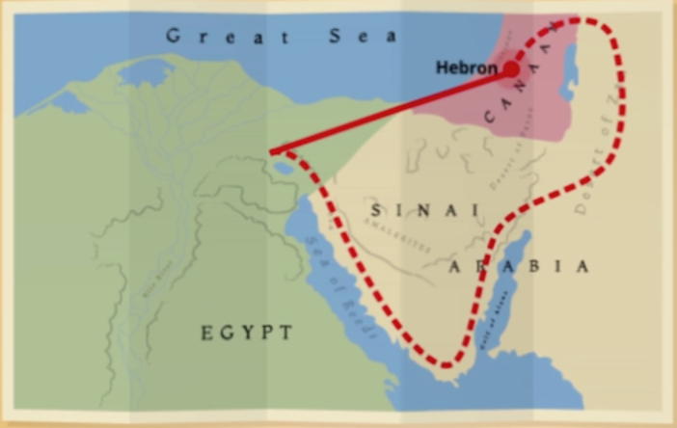 | 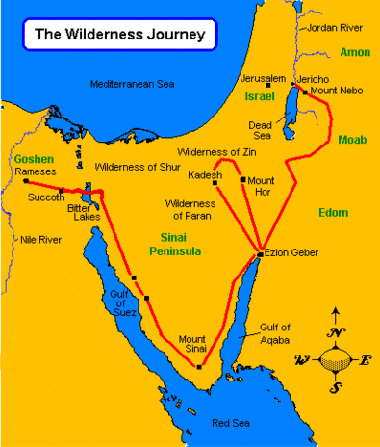

What was the burial procession doing on the east bank of the Jordan?

R’ Meyuchas suggests that the cortege traversed the same desert route east of the Jordan that the Israelites would later take at the exodus, and entered Canaan westward, across the Jordan.

What was the burial procession doing on the east bank of the Jordan?

The shortest route from Egypt to Hebron is to head northwest in a straight line. If the burial party traveled to Canaan via Goren Ha’atad, it means they went seriously out of their way. Leaving Egypt, they’ve had to swoop down to the south of Canaan, traverse the Sinai desert, swing up and around the Dead Sea, travel due north for the entire length of the sea, then hook left to cross the Jordan River, probably somewhere near Jericho. And that would really be taking the long way. [See image above]

This is very intriguing. Besides the fact that this isn’t the expected route, it is also the route that the Children of Israel took during the Exodus from Egypt.

Canaanites react to both events.

Burial | Exodus
Bereshit (Genesis) 50:11 And when the Canaanite inhabitants of the land saw the mourning at Goren ha-Atad, they said, “This is a solemn mourning on the part of the Egyptians.” That is why it was named Abel-mizraim, which is beyond the Jordan. | Shemot (Exodus) 15:15 Now are the clans of Edom dismayed; The tribes of Moab—trembling grips them; All the dwellers in Canaan are aghast.

Notice that the Canaanites were witness to the burial of Yaaqob and considered it to be a significant event.

The Canaanites viewed this as mourning for Egypt, even though it was really mourning for Yaaqob. On the one hand, Paro and Egypt had “adopted” Yaaqob as a kind of national father for Egypt itself; that’s why they mourned him so deeply. It really was a mourning for Egypt, like the Canaanites said.

Here we see that the Canaanites were amazed at the honor and the mourning that the Egyptians gave to Yaaqob. Further, the Canaanites witnessed a single camp of both Egyptians and Israelites:

Bereshit (Genesis) 50:9 And there went up with him both chariots and horsemen; and it was a very great camp.

Later, the Canaanites would see two camps, at the exodus:

Clearly things had changed. The Egyptians had become estranged from the Israelites and from HaShem. Instead of honoring The National Father, they would be denigrating Him. The world had become upside down, V’nahapoch hu. That said, if we look closely we can still see a unified camp of Israelites and Egyptians:

Shemot (Exodus) 12:37-38 And the children of Israel journeyed from Rameses to Succoth, about six hundred thousand men on foot, beside children. 38 And a mixed multitude went up also with them; and flocks, and herds, even very much cattle.

Sadly, the Egyptian honor guard was not among the camp. Now see that the Canaanites were also witnesses of the miracle of the splitting of the Reed Sea.

Shemot (Exodus) 15:15 Now are the clans of Edom dismayed; The tribes of Moab—trembling grips them; All the dwellers in Canaan are aghast.

At the exodus, however, we again see the Canaanites were witnesses not of the Egyptian’s mourning, but rather of the rejoicing of the Israelites at their deliverance which also included the death of the Egyptians. There were no mourning Egyptians. Instead, the Egyptians would become the subject of mourning.

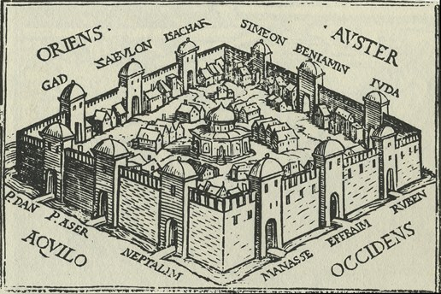

Sefer Yetzirah

Month | Mazzalot  Hebrew | Mazzalot  Latin | Sign | Tribe | Faculty | Gem
Nisan | Toleh | Aries | Ram | Yehuda | Speech | Nofech / Carbuncle
Iyar | Shor | Taurus | Bull | Issachar | Thought | Safir / Sapphire / Lapz Lazuli
Sivan | Teomim | Gemini | Twins | Zebulun | Motion | Yahalom / Pearl / Diamond
Tammuz | Sartan | Cancer | Crab | Reuven | Sight | Odem / Ruby
Av | Ari | Leo | Lion | Shimon | Hearing | Pitdah / Emerald
Elul | Betula | Virgo | Virgin | Gad | Action | Achlama / Crystal
Tishri | Moznaim | Libra | Scales | Ephraim | Coition | Shoham / Onyx ??
Cheshvan | Akrab | Scorpio | Scorpion | Menashe | Smell
Kislev | Keshet | Sagittarius | Archer | Benyamin | Sleep | Yashpheh / Jasper
Tevet | Gedi | Capricorn | Kid | Dan | Anger | Leshem / Topaz
Shevat | Dli | Aquarius | Water Drawer | Asher | Taste | Tarshish
Adar | Dagim | Pisces | Fishes | Naftali | Laughter | Shevo / Turquoise

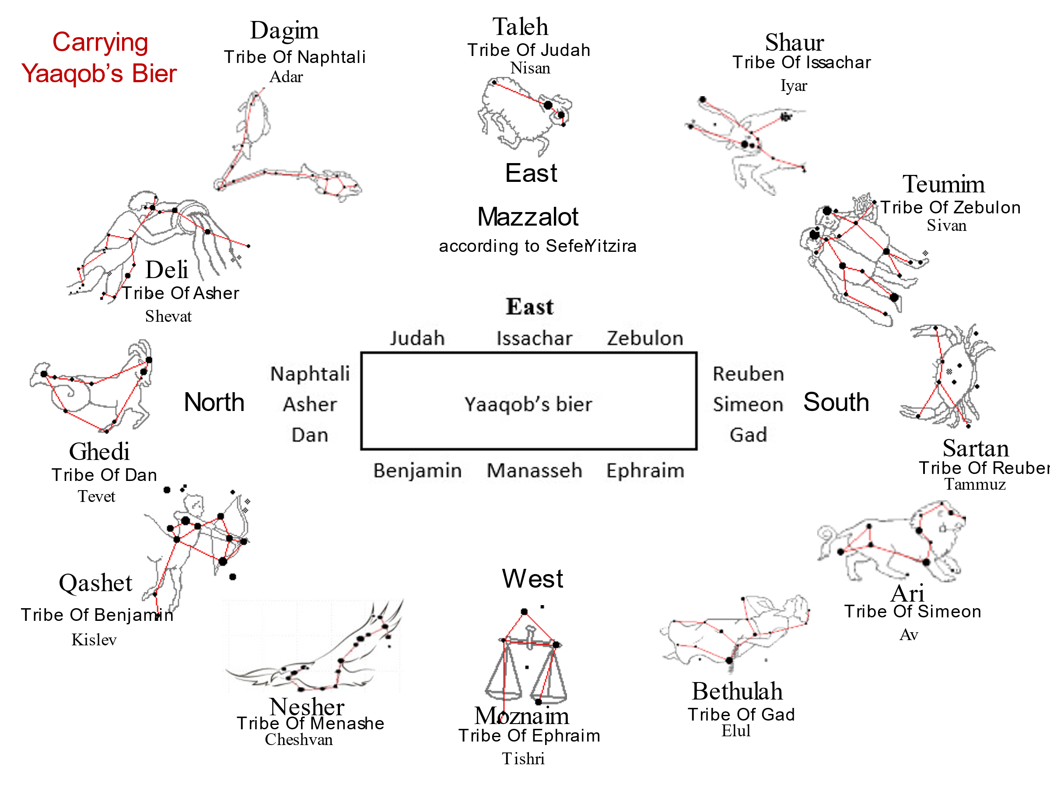

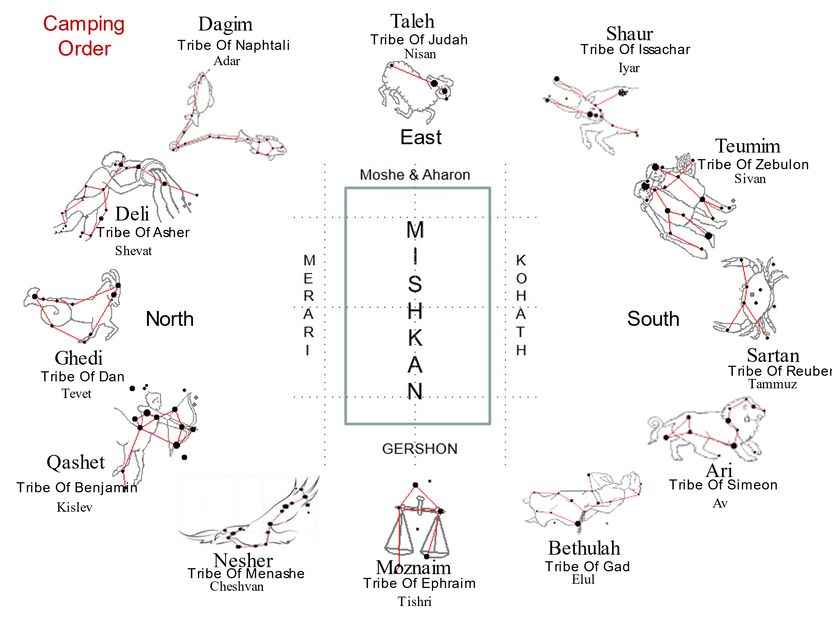

Bier & Camping order

Arrangement of Tribes Carrying Yaaqob’s Bier | Exodus Camping Order
East  Judah Issachar Zebulon  Naphtali Reuben  Asher Yaaqob’s bier Simeon  Dan Gad  Benjamin Manasseh Ephraim | 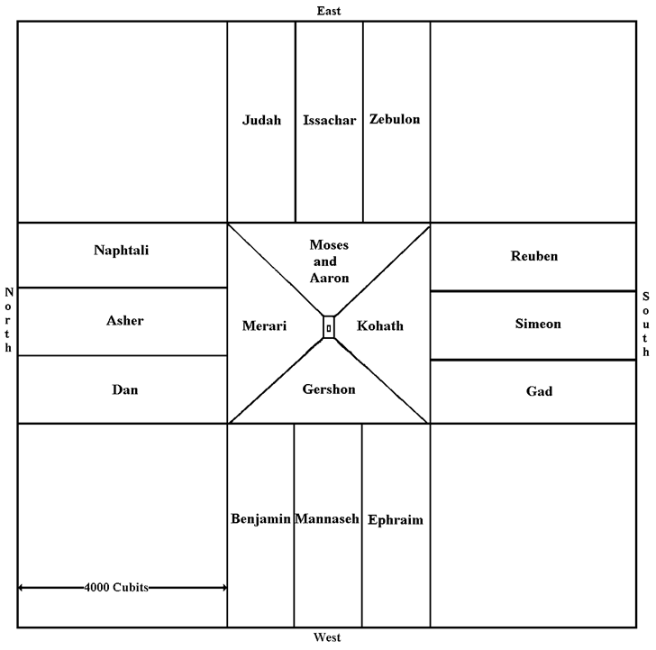
Midrash Rabbah - Numbers II:8 ACCORDING TO THEIR FATHER'S HOUSE. … For this reason Scripture says, And his sons did unto him according as he commanded them; his ‘sons’ but not his ‘grandsons’. And his sons carried him (ib. 13). How did he command them to do it? He said to them: ‘My children, when my bier is being carried, Judah, Issachar, and Zebulun shall be on the east side; Reuben, Simeon, and Gad shall be on the south side; Ephraim, Manasseh, and Benjamin shall be on the west side; Dan, Asher, and Naphtali shall be on the north side; Joseph shall not carry at all, for he is a king and must be shown due honour; neither shall Levi carry because he will carry the ark, and he that is to carry the ark of Him who is the life of all worlds must not carry the coffin of the dead. If you will comply with these orders and carry my bier as I have commanded you, God will in the future cause you to camp beneath standards. | Rashi to Bamidbar (Numbers) 2:2 - Each banner shall have [as] its insignia a colored cloth hanging from it. Each one’s color was not like the other’s, each color corresponded with the hue of its gem set in the breastplate. Thusly, everyone could recognize his banner. Another interpretation [of] “with the insignia of their fathers’ houses”; By the sign their forefather Yaaqob gave them When they carried him from Egypt [for burial in Canaan], as it is said, “And his sons did to him just as he had commanded them”. ‘Yehudah, Yissachar, and Zevulun shall carry him from the east, Reuven, Shimon, and Gad from the south; etc.,’ as stated by Tanchuma to this portion.

Rashi explains that their positions surrounding the Mishkan were the same as the positions that Yaaqob assigned his sons when he instructed them on how to escort his bier to his ancestral burial place in the Land of Israel. He informed them that their formation around him would be identical to the tribal formation that would take place later, during the forty-year sojourn of the Jewish people in the desert. Each banner had a colored insignia as assigned to that tribe by Yaaqob, as it is written: “According to the insignias of their paternal households.” The banners included the distinct colors of the three tribes in the group. Moreover, the colors corresponded with the color of each tribe’s gem that was set in the breastplate of the high priest.

We also find that Israel’s camp below, in this world, had its spiritual counterpart in the heavenly realm, where the throne of HaShem is surrounded in all four directions by four armies of angels. Each army of angels consists of one leading angel and two additional ones, for a total of twelve angels, three on each side.

The banners and their leaders were organized as follows: In the East the leader was the tribe of Yehudah, corresponding to the angel Uriel above; in the South the leader was the tribe of Reuven, corresponding to the angel Michael above; in the West the leader was the tribe of Ephraim, corresponding to the angel Rafael, and in the North the leader was the tribe of Dan, corresponding to the angel Gavriel. The camp of the Levites was in the middle, surrounding the Mishkan, which represented the Throne of HaShem, the resting place of the Divine Presence (The Holy Shechinah) on earth. The very same tribal formation was also represented by the twelve stones that Yaaqob put around his head on Mount Moriah, when he was traveling to Charan and had his famous dream.

The Midrash tells us that when HaShem revealed Himself on Mount Sinai, He was accompanied by 220,000 Angels, each with its own banner. When the children of Israel beheld them, they had a strong desire to be arranged in the same formation. Out of love for the Jewish people, HaShem said, “They are My children and My armies below. I will grant them their wish.” He instructed Moshe to pattern the encampment of Israel after the Heavenly formation. HaShem informed Moshe that once the children of Israel would build the Mishkan, He would come to dwell among them below, just as He dwells above, as it is written, “They shall make a Sanctuary for Me and I will dwell amongst them”.
Curiously, this same order is observed in the Mazzalot.

Mazzalot

When we observe the constellations on the ecliptic we see an arrangement of the constellations which are similar to the camping order, bier order, Ezekiel order, and the Revelation order. The four banners that head the tribes and front the Mishkan line up with the tekufot, the turning points of the year (seasons).

- Tekufat Nisan, the vernal equinox, when the sun enters Toleh (Aries); this is the beginning of spring, when day and night are equal. Banner is lion for the tribe of Yehuda.

- Tekufat Tammuz, the summer solstice, when the sun enters Sartan (Cancer); this is the summer season, when the day is the longest in the year. Banner are the man-like dudaim of the tribe of Reuben.

- Tekufat Tishre, the autumnal equinox, when the sun enters Moznayim (Libra), and autumn, begins, and when the day again equals the night. Banner is the ox of tribe of Ephraim.

- Tekufat Tevet, the winter solstice, when the sun enters Ghedi (Capricorn); this is the beginning of winter, when the night is the longest during the year. Banner is the eagle for the tribe of Dan.

The following table shows that the tekufot contain the same tribes that we see on the banners in the wilderness, which match the faces in Yehezchel and Revelation.

Note: Most depict the standard of Dan as having a snake or serpent on it. I am adopting the Abarbanel’s perspective that this standard depicted an eagle as intimated by the Midrash.

Yaaqob’s blessing to Dan, in Bereshit 49:17, symbolizes him by a type of snake called shefifon - שְׁפִיפֹן, which had wings in order to fly swiftly; Abarbanel explains that this is an eagle.

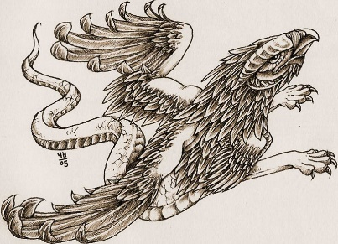

Each camp (i.e., each group of three tribes, located on one of the sides of the Mishkan) has a flag with a drawing symbolizing its tribes. According to the Midrash, these were the four images of the Merkava (Chariot) in Ezekiel’s vision (l:10): a lion, a man, an ox and an eagle. The camp of Israel is arranged into four forces, corresponding to the four creatures comprising the Chariot of the Shechinah.

Midrash Rabbah - Exodus XXIII:13 I WILL SING UNTO THE LORD, FOR HE IS HIGHLY EXALTED (XV, 1). It is written, Deck thyself now with majesty and excellency (Job XL, 10). All things exalt themselves over something else; darkness exalts itself over the deep, because it is above it, and the wind exalts itself over the water because it is above it; fire exalts itself above the wind because it is above it,1 and the heavens exalt themselves over the fire, because they are above it, but God is exalted over everything--hence: FOR HE IS HIGHLY EXALTED. R. Abin said: Four kinds of exalted beings have been created in the world. The most exalted of all living creatures is man; of birds, the eagle; of cattle, the ox; and of wild beasts, the lion. All of these received royalty and had greatness bestowed upon them, and they are set under the chariot of God, as it says, As for the likeness of their faces, they had the face of a man; and they four had the face of a lion... and... also the face of an eagle (Ezek. I, 10). Why was this? So that they should not exalt themselves in the world and they should know that the Kingdom of Heaven is over them. For this reason does it say, For one higher than the high watcheth, and there are higher than they (Eccl. V, 7). This is the meaning of FOR HE IS HIGHLY EXALTED.
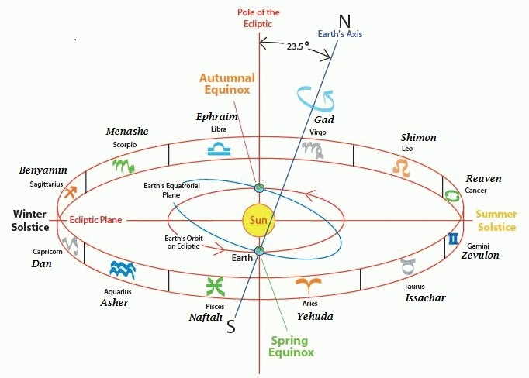

It wasn’t a given that Yaaqob would be buried in Canaan...

Bereshit (Genesis) 47:30-31 When I lie down with my fathers, take me up from Egypt and bury me in their burial-place.” He replied, “I will do as you have spoken.” 31 And he said, “Swear to me.” And he swore to him. Then Israel bowed at the head of the bed.

Yaaqob asks to be buried in Canaan, Yosef says he will do it, and then Yaaqob makes him promise.

Did Yaaqob not trust his son to fulfill his last dying wish?

Yosef promises and then Yaaqob bows to him.

Why does Yaaqob bow?

Rashi on Genesis 47:31:2 UPON THE BED’S HEAD — ...[He prostrated himself to G-d] because his legacy was whole, insofar as not one of [his children] was wicked – for Yosef was [Egyptian] royalty, and furthermore, he had been captured [and lived] among heathens, and yet he remained steadfast in his righteousness.

Yaaqob bowed because now he knew that all of his children, especially Yosef who was immersed in a foreign culture, were righteous. To Yaaqob, Yosef’s acceptance of his request was confirmation of his righteousness.

Why did it take Yaaqob 17 years of living in Egypt to realize that Yosef hadn’t assimilated?

Was there something that cause Yaaqob to be suspicious that maybe Yosef’s loyalty lay somewhere else?

Let’s take a look at what happened when Yaaqob died...

Bereshit (Genesis) 50:2-3 Then Yosef ordered the physicians in his service to embalm his father, and the physicians embalmed Israel. 3 It required forty days, for such is the full period of embalming. The Egyptians bewailed him seventy days;

Instead of mentioning his father’s burial request right after his passing, Yosef directs his servants to have him embalmed. This is weird..., not exactly a Jewish practice. Additionally, the embalmment process takes 40 days and Yosef didn’t speak up at all.

Is there a reason for Yosef’s delaying?

Let’s understand how Egypt viewed Yaaqob ...

Bereshit (Genesis) 50:3 It required forty days, for such is the full period of embalming. The Egyptians bewailed him seventy days;

The Egyptians cried for Yaaqob for 70 days! This is more that the Children of Israel cried for both Moses and Aaron combined!!

Think about it: Yaaqob is the father of the person that saved them from famine, the father of their second-in-command--and the father of royalty is treated as royalty. Plus, with Yaaqob’s arrival, the famine was cut short by five whole years! Yaaqob is a national figure.

How would Egypt feel about their royalty being buried in Canaan?

Probably not great...

We see that it’s not so simple. Yaaqob had to make his son swear that he would bury him in Canaan. When Yosef accepted, Yaaqob knew he was righteous because he accepted Yaaqob’s will over the will of Paro, the most powerful man in the world.

Was that all Paro was to Yosef? A powerful monarch?

Maybe Paro also played a fatherly role in Yosef’s life. Let’s compare Yosef’s interaction with Paro to his interaction with Yaaqob :

Bereshit (Genesis) 41:14-45 Thereupon Paro sent for Yosef, and he was rushed from the dungeon. He had his hair cut and changed his clothes, and he appeared before Paro. 15 And Paro said to Yosef, “I have had a dream, but no one can interpret it. Now I have heard it said of you that for you to hear a dream is to tell its meaning.”
...
40 You shall be in charge of my court, and by your command shall all my people be directed; only with respect to the throne shall I be superior to you.”
...
42 And removing his signet ring from his hand, Paro put it on Yosef’s hand; and he had him dressed in robes of fine linen, and put a gold chain about his neck.
...
45 Paro then gave Yosef the name Zaphenath-paneah; and he gave him for a wife Asenath daughter of Poti-phera, priest of On. Thus Yosef emerged in charge of the land of Egypt.

Paro took Yosef out of jail and gave him a job, a name, and a wife. Those are things that a father provides for his son. Paro made Yosef second in command like he was in Yaaqob’s house. Paro dressed Yosef in beautiful clothes very similar to the way Yaaqob dressed Yosef in a beautiful, special coat. Yosef also discussed his interpretation of dreams with both men.

It is clear that Paro played a significant fatherly role to the young exiled Yosef. Their relationship was strong.

Yosef is loyal to both his “fathers”, as long as their desires are in line with each other. As soon as they want two different things, as soon as Yaaqob wants to be buried in Canaan and Paro wants him to be buried in Egypt, Yosef has to decide where his loyalty lies.

Bereshit (Genesis) 47:30-31 When I lie down with my fathers, take me up from Egypt and bury me in their burial-place.” He replied, “I will do as you have spoken.” 31 And he said, “Swear to me.” And he swore to him. Then Israel bowed at the head of the bed.
Yosef chooses Yaaqob!

How does Yosef approach Paro to ask if he can bury Yaaqob in Canaan?

Bereshit (Genesis) 50:4 and when the wailing period was over, Yosef spoke to Paro’s court, saying, “If I have found favor in your eyes, please lay this appeal before Paro:

Yosef asks the Egyptian servant to beseech Paro for him. He is avoiding a direct discussion with Paro. He also says “If I have found favor in your eyes”. Yosef is above everyone!! Why is he begging some removed people to speak to Paro for him?

Makes sense. This is a pretty awkward request after all Egypt has done for Yaaqob . They spent 40 days embalming his body and now he wants to return it to dust? This is not just a matter of the effort they put in but also of belief! The Egyptians were horrified at the idea of burying royalty.

Paro himself would also have reason to be mad: why didn’t Yosef bring this up before Egypt spent 40 days embalming and 70 days crying?? Big waste of time. It is understandable that Yosef didn’t want a private audience with Paro.

What message did Yosef decide to send?

Bereshit (Genesis) 50:5 ‘My father made me swear, saying, “I am about to die. Be sure to bury me in the grave which I made ready for myself in the land of Canaan.” Now, therefore, let me go up and bury my father; then I shall return.’”

He says two things:

- He makes it very clear that he is bound by an oath. This creates distance between himself and his request, saying that if it was not for his promise, he wouldn’t want this.

- He says he will return, as if to say “I am still loyal to you and Egypt”

Bereshit (Genesis) 50:6 And Paro said, “Go up and bury your father, as he made you promise on oath.”

Rashi on Genesis 50:6:1 ACCORDING AS HE ADJURED THEE — For except for that oath I would not permit you to do so.

Paro says yes, but reluctantly. Only allowing this because Yosef is bound by his word. One would assume the story ends here. Yosef goes, buries, and come back. Everyone is happy. But no!

Bereshit (Genesis) 50:7-9 So Yosef went up to bury his father; and with him went up all the officials of Paro, the senior members of his court, and all of Egypt’s dignitaries,

...

9 Chariots, too, and horsemen went up with him; it was a very large troop.
Yosef is accompanied by an entire procession of Egyptians! A delegation of stature that must’ve been sent by Paro himself. This is not the cold response we saw before.

Why were there chariots and horsemen if there was no threat of war?

They were an honor guard!

This procession must’ve been a pretty peculiar sight. It surely caught the eyes of the Canaanites. They saw it as mourning for Egypt:

Bereshit (Genesis) 50:11 And when the Canaanite inhabitants of the land saw the mourning at Goren ha-Atad, they said, “This is a solemn mourning on the part of the Egyptians.” That is why it was named Abel-mizraim, which is beyond the Jordan.

The fact that Paro sent an honorable party to accompany Yosef in the fulfilling of his father’s request is an amazing occurrence, totally not a given!

This is a story of two heroes:

Yosef, for risking everything to fulfill his father’s request.

Paro, for putting Yaaqob’s will before his own, for still valuing him and honoring him as a national father despite their differences.
Having looked at the story of Yaaqob’s Burial, we can now come back to the questions we asked earlier about the way in which the Exodus seems to parallel that story.

What can we make of the connections in the texts?
What does a burial story have to do with the Exodus?

There is a prologue to the Exodus from Egypt: The particular desire of Yaaqob and Yosef to be buried specifically in the land of Israel. Passion, desire, and overwhelming obsession plague the mind of Yaaqob Abinu at the end of his life. Fixated on ultimate burial in the land of Israel, Yaaqob demands of his favored son. Joseph, “dare not bury him in the land of Egypt”. Indeed, Yaaqob’s insistence inspires his son Yosef as well “you will raise up my bones from here”.

For our Rabbis, Yosef’s insistences that the Israelites, upon the Exodus, carry with them his bones, emerges from an eschatological vision. The Midrash HaGadol declares that the oath that Yosef insists upon is meant not only to guarantee his own burial, but signal a commitment, received through Yaaqob, that G-d shall certainly redeem His people. The Netziv, in his Ha-Emek Davar, adds that the mere presence of Yosef’s bones represented a source of hope for the Israelites as they suffered in Egypt.

Focusing only on the passing of Yaaqob and Yosef, with their subsequent resolve about being buried in Israel, we conclude that burial in Israel represented for them that the future of Israel lay beyond existence in Egypt; the sojourn in Paro’s land was a temporal existence for the Jewish people, whose destiny lay not on the shores of the Nile river, but of the Jordan, near their buried forefathers.

Viewed more globally, burial in Israel represents an ideal throughout Judaism. The Torah expends numerous verses depicting Avraham’s purchase Ma’arat ha-Machpelah in Hebron as a burial plot for Sara. So too, Ishmael and Yitzchak converge oddly to bury their father Avraham. The Midrash depicts even Esav’s desire to be buried with his father. In all cases, the burial of dead is associated with ultimate redemption. Perhaps most affective, is the Midrash Raba’s declaration that Yaaqob buried Rachel, B‘Derech Ephrata (on the way to Efrat), so that she may cry for her exiled children and greet them at the redemption.

As Jews, we are not jarred by the association of death and redemption. Our funerals close with an expression of belief in G-d’s justice and exaltation of His name, with a powerful belief in the resurrection. Yom HaAtzmaut, Israel’s Independence Day, is closely related to Yom HaShoah and Yom Ha-Zikaron. In our tradition and history, death and redemption are often intimately intertwined.

Yaaqob and Yosef’s insistence on a burial in Israel, a tradition handed down from Avraham, represents his commitment to the future of the nation of Israel in the land of Israel. His body will represent the seed that flowers into a holy nation. Rachel is planted on the “path to Efrat,” symbolizing as well that there her nation will once again grow and prosper.

The burial procession of Yaaqob, a beloved national father of Egypt, was designed to honor a father of Egypt, by his actual sons. It also presages the exodus procession which went up to honor HaShem, our Father, by His firstborn son Israel!.

* * *

This study was written by
Rabbi Dr. Hillel ben David (Greg Killian).
Comments may be submitted to:

Rabbi Dr. Greg Killian
12210 Luckey Summit
San Antonio, TX 78252

Internet address: gkilli@aol.com
Web page: https://www.betemunah.org/

(360) 918-2905

Return to The WATCHMAN home page
Send comments to Greg Killian at his email address: gkilli@aol.com

This study is based on a shiur given by Rabbi David Fohrman.
in Shemot (Exodus) chapter 50.
Ramban ; Bereshit (Genesis) 12:6
Bereshit (Genesis) 25:31ff.
In the year 2255 AM.
Bereshit (Genesis) 33:17
Commentaries on the Amidah.
Amos 8:10
‘Feast’ is generally applied to Tabernacles.-The eighth day (v. Lev. 23:39; Num. 29:35) counted as a separate festival.
Israel is the bearer of the national mission.
YD 362:1
Goren Atad roughly translates as ‘Bramble Barn’.
The Commentary of Rabbi Meyuchas b. Elijah on the Pentateuch (Exodus).
Bereshit (Genesis), 50:12
‘Coffin’ and ‘ark’ are expressed by the same word in Hebrew.
The breastplate was one of the vestments worn by the Kohen gadol. It was set with twelve gems representing the twelve tribes. Vayikra (Leviticus) 28:15--21.
Bereshit (Genesis), 50:12
Bamidbar (Numbers) 2:1-2 (from Tanchuma Bamidbar 12,13, and 14).
The Mishkan, the Tabernacle in the wilderness was like a mini-Temple and was the precursor to the Temple.
Bereshit Rabbah 100:2.
Bamidbar (Numbers) 2:1.
Zohar, Vayechi 241a, Zohar, Shemot (Exodus) 5b, and Bamidbar (Numbers) Rabbah 2:6,8,10.
See Bamidbar (Numbers) 2:1-34 for detailed description of the tribal formation around the Mishkan.
Zohar, Vayeitzei 148a.
Tanchuma, Bamidbar (Numbers) 12,13,14, Bamidbar (Numbers) Rabbah 2:6,8,10.
Terumah 25:8.
Based on information in the old Jewish Encyclopedia.
The solstices and equinoxes. These are the times when the seasons change: spring, summer, fall, winter.
I do not yet understand why the actual pictures made by the stars do not line up.
Sifré 31 VaEthanan
Bereshit (Genesis) 47:29
Bereshit (Genesis) 50:25

