hline

**The Mazzaroth (Zodiac)**

By Rabbi Dr. Hillel ben David (Greg Killian)

hline

**The Mazzaroth (Zodiac)** 1

I. Definitions and explanation: 2

[II. What is HaShem’s purpose? 4](hashem.html)

RAMBAM 6

[Avraham Ibn Ezra 7](avraham.html)

Do the stars control us? Are we under a mazel? 8

III. Origins 11

IV. Interesting scriptures: 12

V. Star and Constellation Names 13

VI. The Urim and Tummim 13

[VII. Josephus and the celestial bodies? 17](celestal.html)

[VIII. Book of Jubilees and the celestial bodies? 18](celestal.html)

**The Works of Flavius Josephus** 18

[IX. The Number Ten 18](ten.html)

X. Interesting Talmudic Passages: 19

[XI. Relationship to the twelve tribes: 22](twelve.html)

XII. Miscellaneous Thoughts 26

**Appendix A Other Sources** 44

hline

The Mazzaroth, also [known](daat.html) as the zodiac, is the [name](name.html) given to the pattern of stars found on the [celestial](celestal.html) equator, or ecliptic. The ecliptic is an imaginary zone of the [heavens](heaven.html) containing the [twelve](twelve.html) [signs](signs.html) within which lie the paths of the principal planets, and through which the [sun](hachama.html) passes in its [annual](annual.html) course.

Mazzaroth is the [Hebrew](hebrew.html) word for *constellation*. There is also a related [Hebrew](hebrew.html) word: mazzaloth.

In this paper I would like to explore the wealth of information that relates to the [celestial](celestal.html) [bodies](body.html). I will examine the Scriptures, the oral [law](law.html), and the wisdom of the [Jewish](gen-jew.html) Sages in my quest to understand the purpose of the [celestial](celestal.html) [bodies](body.html).

The Sages [teach](teacher.html) us that the primary use of the astronomical [bodies](body.html) is for calculating times and seasons and to serve as [signs](signs.html). The torah also emphasises this idea:

***Bereshit (Genesis) 1:14*** *And God said, Let there be* [*lights*](lights.html) *in the firmament of the* [*heaven*](heaven.html) *to divide the day from the night; and let them be for* [*signs*](signs.html)*, and for seasons, and for days, and years:*

The Torah emphasises the importance of [time](time.html) and keeping track of [time](time.html). Therefore, keep this in mind as we [study](study.html). The astronomical [bodies](body.html) are to serve as:

1. [**Signs**](signs.html)
2. and for **seasons**
3. and for **days**
4. and for **years**

Rashi says the following about ‘[signs](signs.html)’:

**2 [If there will arise among you a prophet...] and he gives you a** [**sign**](signs.html) [Hebrew](hebrew.html) אוֹת , [meaning a [sign](signs.html)] in the [heavens](heaven.html), as it is stated in the case of Gideon [who said to the [angel](angels.html)]: “then show me a [sign](signs.html) (אוֹת) “ (Shoftim [Judges] 6:17), and then it says [further], “let it be dry only upon the fleece [and upon all the ground let there be dew]” (Shoftim [Judges] 6:39).

Thus we learn that anytime we see an *ot*, a [sign](signs.html), we are looking at a reference to the [celestial](celestal.html) object.

In the Sanctum of the Holy [Temple](temple.html) there were [two](two.html) major holy vessels, the *menorah* and the *shulchan* [Table] upon which the *lechem hapanim* were arranged. The *menorah* consisted of [seven](seven.html) candles, corresponding to the [seven](seven.html) “moving stars” [from our earthly perspective]– the [sun](hachama.html), the [moon](chodesh.html), and the [five](five.html) planets closest to the earth. Arranged upon the Table were [twelve](twelve.html) loaves of showbread, corresponding to the [twelve](twelve.html) constellations used as astrological [signs](signs.html) of the Zodiac. These loaves are arranged in [two](two.html) tiers of [six](six.html) because of the [twelve](twelve.html) [signs](signs.html), [six](six.html) are always ascending and [six](six.html) are in decline. Thus, the *menorah* stood for the heavenly [lights](lights.html) and the table for the astrological [signs](signs.html).[1]

The very [first](one.html) [mitzva](cmds613.html) given to the [Jewish](gen-jew.html) people concerned [time](time.html) and it’s calculation:

***Shemot (***[***Exodus***](exodus.html)***) 12:1-4*** *And* [*HaShem*](hashem.html) *spake unto Moses and Aaron in the land of Egypt, saying, This month [shall be] unto you the beginning of months: it [shall be] the* [*first*](one.html) *month of the year to you.* [*Speak*](mashal.html) *ye unto all the congregation of Israel, saying, In the tenth [day] of this month they shall take to them every man a lamb, according to the house of [their]* [*fathers*](fathers.html)*, a lamb for an house: And if the* [*household*](househld.html) *be too little for the lamb, let him and his neighbour next unto his house take [it] according to the* [*number*](nchart.html) *of the souls; every man according to his* [*eating*](eating.html) *shall make your count for the lamb.*

Such is the importance of [time](time.html) and the astronomical [bodies](body.html)!

The [Talmud](orallaw.html)[2] speaks about the influence of the constellations on a person’s destiny. Being born under a certain constellation can predispose a person to certain personality traits, but it’s up to the individual into which area to channel these predilections. For example, someone who is influenced by Mars (the “red planet”) will have a tendency to shed [blood](body.html). This can express itself in becoming a murderer or a surgeon, a butcher or a mohel (who performs circumcisions). The choice is up to the individual. Any talent, character trait or aptitude can be used for the highest good or the basest evil. We are the ones who make the choice.

# I. Definitions and explanation:

4216 **Mazzarah**, maz-zaw-raw’; appar. from 5144 in the sense of distinction; some noted constellation (only in the plur.), perh. collect. the zodiac:- Mazzaroth. Comp. 4208.

------------------- Dictionary Trace -------------------

5144 **nazar**, naw-zar’; a prim. root; to hold aloof, i.e. (intrans.) abstain (from [food](food.html) and drink, from [impurity](purity.html), and even from divine worship [i.e. apostatize]); spec. to set apart (to sacred purposes), i.e. devote:- consecrate, separate (-ing, self).

4208 **mazzalah**, maz-zaw-[law](law.html)’; appar. from 5140 in the sense of raining; a constellation, i.e. Zodiacal [sign](signs.html) (perh. as affecting the weather):- planet. Comp. 4216.

Mazzaroth occurs twice in scripture. The [first](one.html) is in:

***Iyov (Job) 38:31-33*** *“Can you bind the beautiful Pleiades? Can you loose the cords of Orion? Can you bring forth the constellations in their seasons or lead out the Bear with its cubs? Do you* [*know*](daat.html) *the* [*laws*](law.html) *of the* [*heavens*](heaven.html)*? Can you set up [God’s] dominion over the earth?*

The second [time](time.html) it is in a slightly different form:

***II Melakim (Kings) 23:3-5*** *The king stood by the pillar and renewed the* [*covenant*](covenant.html) *in the presence of* [*HaShem*](hashem.html)*--to follow* [*HaShem*](hashem.html) *and keep his* [*commands*](cmds613.html)*, regulations and decrees with all his* [*heart*](body.html) *and all his soul, thus confirming the words of the* [*covenant*](covenant.html) *written in this book. Then all the people pledged themselves to the* [*covenant*](covenant.html)*. The king ordered Hilkiah the* [*high priest*](priests.html)*, the* [*priests*](priests.html) *next in rank and the doorkeepers to remove from the* [*temple*](temple.html) *of* [*HaShem*](hashem.html) *all the articles made for Baal and Asherah and all the starry hosts. He burned them outside* [*Jerusalem*](city.html) *in the fields of the Kidron Valley and took the ashes to Bethel. He did away with the pagan* [*priests*](priests.html)[*appointed*](settimes.html) *by the kings of Judah to burn* [*incense*](ketoret.html) *on the high places of the towns of Judah and on those around* [*Jerusalem*](city.html) *-- those who burned* [*incense*](ketoret.html) *to Baal, to the* [*sun*](hachama.html) *and* [*moon*](chodesh.html)*, to the constellations and to all the starry hosts.*

CONSTELLATION[3]. For untold thousands of years men have traced the outlines of familiar things among the stars. These patterns in the night sky are called constellations, from Latin words meaning together and stars.

Many of the constellations have names that are very old. The Sumerian shepherds and farmers of Mesopotamia 7,000 years ago may have called the Bull, the Ram, the Lion, and many other constellations by the same names we use. Students of history are sure these names started in Mesopotamia because the choice of animals suggests this. If the names had [first](one.html) been used in Egypt, there should be a hippopotamus or elephant among the stars. If they had started in ancient India, there should be a tiger or crocodile.

The later people of Mesopotamia took over the old Sumerian names for the constellations and still later the Greeks adopted them. The Greeks added many names of heroes and demigods to the list of constellations. The Romans used the Greek list but translated the names into Latin.

About AD 150 the Egyptian astronomer Ptolemy listed the 48 constellations [known](daat.html) to him in his book the ‘Almagest’. His list did not cover the entire sky. There were blank spaces between constellations; and there were no constellations at all for the southernmost stars because these could not be seen from the Mediterranean region. In later centuries astronomers added constellations to Ptolemy’s list. Some of these later constellations are named for scientific instruments, such as the Sextant, the Compasses, and the Microscope. Others bear the names of birds and beasts in tropical regions (the Giraffe, the Chameleon, the Toucan). Today 88 constellations are recognized by astronomers.

To most people a constellation is a group of bright stars, but to an astronomer it is a definite area in the sky. Thus every star, no matter how dim, lies in [one](one.html) constellation or another, just as any point in the [world](worlds.html) is in [one](one.html) country. Although all the stars in the same constellation look close together in the sky, they are not necessarily close in space because some may be much farther out in space than others. The boundaries of the constellations used to be very irregular and had many curved lines. In 1928 astronomers straightened them out so that the outline of any constellation includes only straight lines running north and south or [east](east.html) and west. Astronomers use the constellation names to identify most bright stars and all variable stars, so it was important to make the boundaries clear and precise.

The constellations are useful to astronomers today, not for their connections with ancient myths, but for telling where in the sky different stars can be found. Many of the brightest stars have individual names that come from Greek, Latin, or Arabic, and the navigators of ships and aircraft call them by these names. Astronomers, however, find it more convenient to [name](name.html) them by their constellations, with a Greek [letter](letters.html) to distinguish the different stars in each constellation. For example, Polaris, the Pole Star, in the Northern Hemisphere, is the brightest star in the constellation Ursa Minor, the Little Bear, and the astronomers’ [name](name.html) for it is alpha Ursae Minoris.

The path of the [sun](hachama.html) among the stars is called the ecliptic. The [twelve](twelve.html) constellations that lie along the ecliptic form the Zodiac. The other constellations are divided into those north of the Zodiac and those south of it.

From [one](one.html) place on the Earth different constellations are seen at different times of the year. This happens because, as well as turning on its axis, the Earth is always moving around the [sun](hachama.html), making [one](one.html) orbit each year. A star that is visible at night during [one](one.html) part of the year may appear close to the [sun](hachama.html) [six](six.html) months later; it would not then be seen at night.

Some constellations can be seen only from the Northern Hemisphere and some only from the Southern Hemisphere. The constellations of the Zodiac can be seen from both hemispheres.

**The equator system**[4] is based on the concept of the [celestial](celestal.html) sphere. All the stars and other heavenly [bodies](body.html) can be imagined to be located on a huge sphere that surrounds Earth. The sphere has several imaginary lines and points. [One](one.html) such line is the [celestial](celestal.html) equator, which is the projection of Earth’s equator onto the [celestial](celestal.html) sphere. Another is the line of the ecliptic, which is the [sun](hachama.html)’s apparent yearly path along this sphere. The [celestial](celestal.html) equator and the ecliptic intersect at [two](two.html) points, called the vernal equinox and the autumnal equinox. (When the [sun](hachama.html) is at either point, day and night on Earth are equally long.) The north and south [celestial](celestal.html) poles are extensions of the North and South poles of Earth along Earth’s axis of rotation.

In the equator system, the position of a star is given by the declination and the right ascension. The declination locates the star from the [celestial](celestal.html) equator, and the right ascension locates the star from the vernal equinox. Since this system is attached to the [celestial](celestal.html) sphere, all points on Earth (except the poles) are continually changing their positions under the coordinate system.

# II. What is [HaShem](hashem.html)’s purpose?

***Bereshit (Genesis) 1:14-19*** *And God said, “Let there be* [*lights*](lights.html) *in the expanse of the sky to separate the day from the night, and let them serve as* [*signs*](signs.html) *to mark seasons and days and years, And let them be* [*lights*](lights.html) *in the expanse of the sky to give light on the earth.” And it was so. God made* [*two*](two.html) *great* [*lights*](lights.html)*--the greater light to govern the day and the lesser light to govern the night. He also made the stars. God set them in the expanse of the sky to give light on the earth, To govern the day and the night, and to separate light from darkness. And God saw that it was good. And there was evening, and there was morning--the* [*fourth*](four.html) *day.*

**Season:**

4150 **mow`ed**, mo-ade’; or mo`ed, mo-ade’; or (fem.) mow`adah (2 Chron. 8:13), mo-aw-daw’; from 3259; prop. an [appointment](appointm.html), i.e. a fixed [time](time.html) or season; spec. a [festival](festival.html); conventionally a year; by implication, an assembly (as convened for a definite purpose); technically the congregation; by extension, the place of meeting also a signal (as [appointed](settimes.html) beforehand):-[appointed](settimes.html) ([sign](signs.html), [time](time.html)), (place of, solemn) assembly, congregation, (set, solemn) feast, ([appointed](settimes.html), due) season, solemn (-ity), [synagogue](synagog.html), (set) [time](time.html) ([appointed](settimes.html)).

**Govern:**

4910 [mashal](mashal.html), maw-shal’; a prim. root; to rule:-(have, make to have) dominion, governor, X indeed, reigh, (bear, cause to, have) rule (-ing, -r), have power.

**Years:**

8141 shaneh (in plur. only), shaw-neh’; or (fem.) shanah, shaw-naw’; from 8138; a year (as **a revolution of** [**time**](time.html)):-+ whole age, X long, + old, year (X -ly).

------------- Dictionary Trace ---------------

8138 shanah, shaw-naw’; a prim. root; to fold, i.e. duplicate (lit. or [fig](bethphag.html).); by impl. to transmute (trans. or intrans.):-do ([speak](mashal.html), strike) again, alter, double, (be given to) change, disguise, (be) diverse, pervert, prefer, repeat, return, do the second [time](time.html).

In the account of the [fourth](four.html) day of [creation](bara.html), the [sun](hachama.html) and [moon](chodesh.html) are referred to as the “great luminaries”, but then, within the same verse, the [sun](hachama.html) retains that title, but the [moon](chodesh.html) is called the “small luminary”. In fact, both descriptions are correct. When considered from our human perspective, both the [sun](hachama.html) and the [moon](chodesh.html) are large. They are the only [two](two.html) sources of light that appear to the naked eye as more than a point oflight in the sky. (Planets appear as disks only when viewed with telescopes; stars, even giant ones, remain “points” even under very high magnification.) In fact, the [sun](hachama.html) and the [moon](chodesh.html) appear to be almost exactly the same size, as seen from Earth. This results from the [sun](hachama.html) having a diameter approximately [four](four.html) hundred times that of the [moon](chodesh.html), while being approximately [four](four.html) hundred times as distant. On the other [hand](fourteen.html), the [moon](chodesh.html) is actually quite small in comparison to the [sun](hachama.html). [One](one.html) commentator noted that when the [sun](hachama.html) and [moon](chodesh.html) are referred to as “M’orot birkiya hashamayim”, luminaries in the [heavens](heaven.html), the word “M’orot” is spelled “deficiently”, without a “vav”, indicating that in the [heavens](heaven.html), they are not on equal footing. The [moon](chodesh.html) doesn’t even provide its own light. There really is only [one](one.html) (major) luminary in the [heavens](heaven.html). However, when the phrase used is “M’orot birkiya hashamayim l’ha’ir al ha-aretz”, luminaries to illuminate the Earth, then the word “M’orot” has a “vav[5]”, since from our perspective, there are [two](two.html) (major) sources of light in our sky. The Torah speaks (mostly) in terms that fit our perspective.

Compare also:

***Tehillim (***[***Psalms***](psalms1.html)***) 136:1-9*** *Give thanks to* [*HaShem*](hashem.html)*, for he is good. <His love endures forever.> Give thanks to the God of gods. <His love endures forever.> Give thanks to the Lord of lords: <His love endures forever.> To him who alone does great wonders, <His love endures forever.> Who by his understanding made the* [*heavens*](heaven.html)*, <His love endures forever.> Who spread out the earth upon the waters, <His love endures forever.> Who made the great* [*lights*](lights.html)*--<His love endures forever.> The* [*sun*](hachama.html) *to govern the day, <His love endures forever.> The* [*moon*](chodesh.html) *and stars to govern the night; <His love endures forever.>*

***Tehillim (***[***Psalms***](psalms1.html)***) 19:1-6*** *{For the director of music. A* [*psalm*](psalms1.html) *of David.} The* [*heavens*](heaven.html) *declare the glory of God; the skies proclaim the work of his* [*hands*](fourteen.html)*. Day after day they pour forth speech; night after night they display* [*knowledge*](knowledge.html)*. There is no speech or language where their* [*voice*](voice.html) *is not heard. Their* [*voice*](voice.html) *goes out into all the earth, their words to the ends of the* [*world*](worlds.html)*. In the* [*heavens*](heaven.html) *he has pitched a tent for the* [*sun*](hachama.html)*, Which is like a bridegroom* [*coming*](coming.html) *forth from his pavilion, like a champion rejoicing to run his course. It rises at* [*one*](one.html) *end of the* [*heavens*](heaven.html) *and makes its circuit to the other; nothing is hidden from its heat.*

The “[heavens](heaven.html)“ seem to be outer space.

***Tehillim (***[***Psalms***](psalms1.html)***) 97:1-6***[*HaShem*](hashem.html) *reigns, let the earth be glad; let the distant shores rejoice. Clouds and thick darkness surround him; righteousness and justice are the foundation of his throne.* [*Fire*](fire.html) *goes before him and consumes his foes on every side. His lightning* [*lights*](lights.html) *up the* [*world*](worlds.html)*; the earth sees and trembles. The mountains melt like wax before* [*HaShem*](hashem.html)*, before the Lord of all the earth. The* [*heavens*](heaven.html) *proclaim his righteousness, and all the peoples see his glory.*

***Tehillim (***[***Psalms***](psalms1.html)***) 50:1-6*** *{A* [*psalm*](psalms1.html) *of Asaph.} The Mighty* [*One*](one.html)*, God,* [*HaShem*](hashem.html)*, speaks and summons the earth from the rising of the* [*sun*](hachama.html) *to the place where it sets. From Zion, perfect in beauty, God shines forth. Our God comes and will not be silent; a* [*fire*](fire.html) *devours before him, and around him a tempest rages. He summons the* [*heavens*](heaven.html) *above, and the earth, that he may judge his people: “*[*Gather*](gather.html) *to me my consecrated ones, who made a* [*covenant*](covenant.html) *with me by* [*sacrifice*](korbanot.html)*.” And the* [*heavens*](heaven.html) *proclaim his righteousness, for God himself is judge. <Selah>*

Notice that the [heavens](heaven.html) and the earth are witnesses against us.

**Proclaim**:

5046 nagad, naw-gad’; a prim. root; prop. to front, i.e. stand boldly out opposite; by impl. (causat.), to manifest; [fig](bethphag.html). to announce (always by word of [mouth](body.html) to [one](one.html) present); spec. to expose, predict, explain, praise:-bewray, X certainly, certify, declare (-ing), denounce, expound, X fully, messenger, plainly, profess, [rehearse](rehearse.html), report, shew (forth), [speak](mashal.html), X surely, tell, utter.

***Devarim (Deuteronomy) 4:14-19*** *And* [*HaShem*](hashem.html) *directed me at that* [*time*](time.html) *to* [*teach*](teacher.html) *you the decrees and* [*laws*](law.html) *you are to follow in the land that you are crossing the* [*Jordan*](stages.html) *to possess. You saw no form of any kind the day* [*HaShem*](hashem.html)[*spoke*](mashal.html) *to you at Horeb out of the* [*fire*](fire.html)*. Therefore watch yourselves very carefully, So that you do not become corrupt and make for yourselves an* [*idol*](idolatry.html)*, an image of any shape, whether formed like a man or a woman, Or like any animal on earth or any bird that flies in the air, Or like any creature that moves along the ground or any fish in the waters below. And when you look up to the sky and see the* [*sun*](hachama.html)*, the* [*moon*](chodesh.html) *and the stars--all the heavenly array--do not be enticed into bowing down to them and worshiping things* [*HaShem*](hashem.html) *your God has apportioned to all the* [*nations*](nations.html) *under* [*heaven*](heaven.html)*.*

The “heavenly array” could also be translated the “heavenly army”. This is a military term!

***Devarim (Deuteronomy) 4:25-27*** *After you have had children and grandchildren and have lived in the land a long* [*time*](time.html)*--if you then become corrupt and make any kind of* [*idol*](idolatry.html)*, doing evil in the* [*eyes*](body.html) *of* [*HaShem*](hashem.html) *your God and provoking him to anger, I call* [*heaven*](heaven.html) *and earth as witnesses against you this day that you will quickly perish from the land that you are crossing the* [*Jordan*](stages.html) *to possess. You will not live there long but will certainly be destroyed.* [*HaShem*](hashem.html) *will scatter you among the peoples, and only a few of you will survive among the* [*nations*](nations.html) *to which* [*HaShem*](hashem.html) *will drive you.*

***Devarim (Deuteronomy) 30:19*** *This day I call* [*heaven*](heaven.html) *and earth as witnesses against you that I have set before you life and death, blessings and curses. Now choose life, so that you and your children may live*

***Devarim (Deuteronomy) 31:24-30*** *After Moses finished writing in a book the words of this* [*law*](law.html) *from beginning to end, He gave this* [*command*](cmds613.html) *to the Levites who carried the* [*ark*](ark.html) *of the* [*covenant*](covenant.html) *of* [*HaShem*](hashem.html)*: “Take this Book of the* [*Law*](law.html) *and place it beside the* [*ark*](ark.html) *of the* [*covenant*](covenant.html) *of* [*HaShem*](hashem.html) *your God. There it will remain as a witness against you. For I* [*know*](daat.html) *how rebellious and stiff-necked you are. If you have been rebellious against* [*HaShem*](hashem.html) *while I am still alive and with you, how much more will you rebel after I die! Assemble before me all the elders of your* [*tribes*](tribes.html) *and all your officials, so that I can* [*speak*](mashal.html) *these words in their hearing and call* [*heaven*](heaven.html) *and earth to testify against them. For I* [*know*](daat.html) *that after my death you are sure to become utterly corrupt and to turn from the way I have commanded you. In days to come, disaster will fall upon you because you will do evil in the sight of* [*HaShem*](hashem.html) *and provoke him to anger by what your* [*hands*](fourteen.html) *have made.” And Moses recited the words of this song from beginning to end in the hearing of the whole assembly of Israel:*

[*Midrash*](orallaw.html) *Rabba[6]* writes: “The [sun](hachama.html) and the [moon](chodesh.html) shed light upon the [world](worlds.html). What is their source of light? Sparks of light from the [heavens](heaven.html), as it is written, “From the light of Your arrows as they speed, and at the shining of Your glittering spear’.[7] The light above is so intense that creatures cannot bear to see it; only [one](one.html) in a hundred” (a fraction of a percent). Perhaps an example is the [sun](hachama.html) during an eclipse, which can only be viewed through smoked glass. Similarly, the tremendous light released during atomic fission or fusion.

The [sun](hachama.html) and [moon](chodesh.html) are, therefore, creations which serve as a medium for the illumination of the [spiritual](physical.html) light. They are the fallout, the residue of a very mighty [spiritual](physical.html) light that penetrates everything, a light that illuminates from [one](one.html) end of the [world](worlds.html) to the other.

If these luminaries transmit a [spiritual](physical.html) light, then they must be [spiritual](physical.html) themselves, as well. This leads us to what the Rambam [taught](teacher.html).

RAMBAM[8]

The [heavens](heaven.html) are made up of spheres. There are [nine](nine.html) spheres. The closest to us is that of the [moon](chodesh.html). Above it, the second sphere contains the planet *Kochav* (Mercury). Above this, the [third](three.html) sphere contains the planet *Nogah* (Venus). The [fourth](four.html) sphere contains the [Sun](hachama.html). The [fifth](five.html) contains the planet *Ma’dim* (Mars). The [sixth](six.html) sphere contains the planet *Tzedek* (Jupiter). The [seventh](seven.html) contains the planet *Shabbtai* (Saturn). The [eighth](eight.html) sphere contains all the stars we see in the sky. The [ninth](nine.html) sphere revolves from [east](east.html) to west every day. It surrounds and encompasses everything. The planets and stars all appear to be in a single sphere even though [one](one.html) is higher than another. This is because the spheres themselves are pure and refined like glass or sapphire.... This is why the stars in the [eighth](eight.html) sphere may appear lower than the [first](one.html) sphere.

Each of the [eight](eight.html) main spheres containing the planets and stars is itself divided into many individual spheres, [one](one.html) above the other like the layers of an onion. Some of these spheres revolve from west to the [east](east.html), others from [east](east.html) to west... There is no empty space between any of them.

None of the spheres are light or heavy. They are neither red, black nor any other color. Although we see them as blue, this is only our perception because of the height of the atmosphere. Similarly they have neither taste nor smell, because those qualities are present only in lower forms of matter. All these [nine](nine.html) spheres surrounding the [world](worlds.html) are spherical like a ball, and the Earth is suspended in the middle...

From knowing the daily movements of the stars and planets, their positions north or south in the sky and their distance from or closeness to Earth, it is possible to [know](daat.html) the total [number](nchart.html) of spheres and the way they revolve. This is the science of astronomy. Many books about these subjects were written by the wise men of Greece.

The Zodiac

The [ninth](nine.html) sphere, which encompasses all the others, was divided by the sages of the early [generations](toldot.html) into [twelve](twelve.html) sections. They gave each of these sections a [name](name.html) based on the shapes that appeared to be formed by the stars in the corresponding section of the [eighth](eight.html) sphere just below it. These are the mazalot (lit. sources of influence): the Ram (Aries), the Ox (Taurus), the Twins (Gemini), the Crab (Cancer), the Lion (Leo), the [Virgin](virgin.html) (Virgo), the Scales (Libra), the Scorpion (Scorpio), the Bow (Sagittarius), the Goat (Capricorn), the Bucket (Aquarius) and the Fish (Pisces).

The [ninth](nine.html) sphere itself has no divisions and does not possess any of these shapes or stars. Rather, the larger stars in the constellations of the [eighth](eight.html) sphere are seen in the shape of these forms or in a form resembling them. These [twelve](twelve.html) forms corresponded to these divisions only at the [time](time.html) of the flood, which is when they were given these names. However at present they have already moved slightly, because all the stars in the [eighth](eight.html) sphere move just like the [sun](hachama.html) and the [moon](chodesh.html). It is just that these stars move more slowly...

All the stars and spheres possess a soul, [knowledge](knowledge.html) and intellect. They are alive and stand in recognition of the [One](one.html) who [spoke](mashal.html) and brought the [world](worlds.html) into being.

According to their size and level, they all praise and glorify their Creator, just like the [angels](angels.html). And just as they are aware of the Holy [One](one.html), blessed-be-He, they are also conscious of themselves and of the [angels](angels.html) above them. The level of consciousness of the stars and spheres is less than that of the [angels](angels.html) but greater than of humans.

[Avraham](avraham.html) Ibn Ezra

Especially influential is [Avraham](avraham.html) Ibn Ezra’s astrological treatise called *Sefer HaOlam* (The Book of the [World](worlds.html)). Its main message is to warn users against wrong applications of astrology. Of course, like most scholars until modern times, he was an ardent believer in astrology, but only when it is practiced correctly.

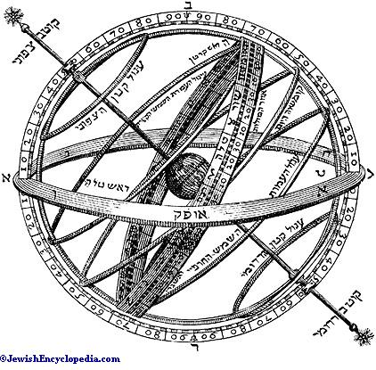

In particular, he warned that all the astronomical tables predicting the times of planetary conjunctions are erroneous, because they assume uniform motion of the planets. He also made a very good point on the accumulation of errors, and for the need to account for experimental errors, and how unreasonable it is to extrapolate from ancient data. Hence, he only relied on astronomical observations made by contemporary ‘sages of experiments’.

Do the stars control us? Are we under a mazel?

The “[eighth](eight.html) day,” the [eighth](eight.html) day of the inauguration of the [Mishkan](mikdash.html). It was on this day that the Divine Presence finally descended and “inhabited” the [Mishkan](mikdash.html). For, the [number](nchart.html) [eight](eight.html) always alludes to a departure from the “natural” [world](worlds.html), and entry into the supernatural [world](worlds.html) (which is why [Chanukah](chanukah.html) also is [eight](eight.html) days long). Therefore, [brit mila](circumcz.html)h acts as a threshold of sorts for the [new](new.html) baby, over which he crosses to enter into the [world](worlds.html) **ABOVE** mazel.

There is a discussion in the [Talmud](orallaw.html) about whether or not a [Jew](gen-jew.html) is subject to mazel, that is, destiny[9]. We believe that, for the most part, [events](feasts.html) are predetermined as part of a master plan for [creation](bara.html). Within the stars is encoded [six](six.html) thousand years of history, and a true astrologer can peek into the stars and foretell the [future](future.html), as [Avraham](avraham.html) did when he told [HaShem](hashem.html) that he saw that he was to remain childless through his wife Sarah; Hagar bore Yishmael for him.

However, [HaShem](hashem.html) told [Avraham](avraham.html) that he was not necessarily correct, for, he could by choice rise above his mazel, and beat his destiny, so-to-[speak](mashal.html). And as history and the Torah testifies, [Avraham](avraham.html) did precisely that with the [birth](thebirth.html) of his son [Yitzchak](isaac.html), something, apparently, he could only achieve **AFTER** he had performed [brit mila](circumcz.html)h ([first](one.html) he was commanded to perform [brit mila](circumcz.html)h, and then [Yitzchak](isaac.html) was conceived).

Hence, [brit mila](circumcz.html)h is far more than an initiation rite into Judaism; it is a mystical door through which the [Jewish](gen-jew.html) [nation](nations.html) passes on the way to [freedom](freedom.html) from nature.

Ramban tells us some very interesting things about [angels](angels.html):

**Ramban’s Commentary for:** **Vayiqra (Leviticus) 17:7** [Know](daat.html) that just as the formation at the original [Creation](bara.html) of man's [body](body.html) as well as that of all living creatures, vegetation and minerals, was from the [four](four.html) elements,[10] which were combined by Divine power to form material [bodies](body.html) which as a result of their thickness and coarseness could be perceived by the [five](five.html) senses,[11] even so there was a [creation](bara.html) from only [two](two.html) elements, [fire](fire.html) and air, resulting in a [body](body.html) which cannot be felt, nor perceived by any of the [[five](five.html)] senses, just as the soul of an animal cannot be perceived by human senses because of its delicacy. The [body](body.html) [of these creatures of [two](two.html) elements] is of a [spiritual](physical.html) nature; on account of its delicacy and lightness it can fly through [fire](fire.html) and air. And just as the combination of the [four](four.html) elements in any object is the cause of its existence and its destruction [since everything that is composite must ultimately revert to its original components],[12] so is it with these beings created from a combination of only [two](two.html) elements; when the elements combine, the creature lives, and when they separate [decompose], it is like the dead. It is for this reason that our Rabbis have said:[13] "[Six](six.html) characteristics have been said of ***sheidim****,* in [three](three.html) they are comparable to the ministering [angels](angels.html) and in [three](three.html) to human beings. **The** [**three**](three.html) **things in which they are comparable to the ministering** [**angels**](angels.html) **are that they have wings, they fly, and they** [**know**](daat.html) **what is about to happen, as do the ministering** [**angels**](angels.html). [On this statement the [Gemara](orallaw.html) asked: ] 'How can it enter your mind to say that the ***sheidim***[know](daat.html) the [future](future.html) [when even the ministering [angels](angels.html) do not [know](daat.html) it]! Say rather thus: They hear [from behind ***the Curtain of*** [***heaven***](heaven.html)]what is about to happen.' **The** [**three**](three.html) **things in which they are comparable to human beings are that they** [**eat**](eating.html) **and drink, procreate, and die as do human beings."** [14] Now the cause of death generally is the separation [decomposition] of the components of the [body](body.html), this being true of all kinds of [bodies](body.html) [whether they are composed of the [four](four.html) elements like humans or of only [two](two.html), like ***sheidim***].The reason for their ability to fly is because of the lightness of the [[two](two.html)] elements [[fire](fire.html) and air] of which they are composed, as may also be seen in the case of a fowl, in which, because the elements of [fire](fire.html) and air dominate over the small parts of the other [two](two.html) elements [earth and water], the fowl can hover in the air and fly [although it is composed of all [four](four.html) elements]. Surely, then, the above-mentioned creatures that have nothing in them of the heavy elements [earth and water], possess great hovering power in the air, to be able to fly tirelessly. The matter of "[eating](eating.html)" [mentioned above in [connection](connection.html) with these creatures] means their deriving nourishment from the moisture of water and the odors of [fire](fire.html), something like the [fire](fire.html) that ***licked up the water that was in the trench****.[15]* This is the purpose of the burnings which necromancers perform to the [demons](demons.html). The reason [for their need to "[eat](eating.html)"] is that the [fire](fire.html) in the air causes the drying up of their [bodies](body.html), which must therefore be restored just as man's need for [food](food.html) is due to depletion in his [body](body.html). As for that which has been said concerning their "hearing what is about to happen," it is because in the course of their flying on high they become aware of things that are about to happen from the powerful forces contained in the atmosphere, these being ***"the princes of the quiver."*** [16] It is also from there that "those who have wings tell matters" [17] of the [future](future.html), as has been tested by enchanters,[18] and as I will explain in its place[19] with the help of G-d. But neither of them [know](daat.html) what is to happen ***for many days to come and for times that are far off****;[20]* **but they can only inform of that which is to happen in the near** [**future**](future.html)**, as we** [**know**](daat.html) **from their encounters [i.e., those of enchanters], that they gain** [**knowledge**](knowledge.html) **from the *sheidim* as to what has been decreed to come.** Therefore Onkelos rendered the verse, ***They sacrificed unto*** [***demons***](demons.html)***, 'lo eloha' (no gods)****, [21]* as "they sacrificed unto [demons](demons.html) in which there is no utility," meaning that there is no need for them, as they do not prevent harm that is destined to come, neither do they do anything productive, nor do they inform of times far off so that a person may knowingly guard himself. It is this which is the sense of the expression, ***lo eloha****,* which is as if it said, **"no power or rulership,"** for the word ***Elohim***is an expression of strength and power, [a composite word consisting of the words] ***e-il heim****.[22]* Thus the verse is stating that [demons](demons.html) have no strength or power whatsoever, and hence there is no need for them, ***for they cannot do evil, neither is it in them to do good****.[23]*

But there is a [secret](sod.html) to this matter. We have already made [known](daat.html) that the constellations have lords that lead them, these being "the souls" of the circuits of the spheres, and the lords of the tail and [[head](body.html) of] Aries (the Ram) are near the earth, these being termed "the princes of the quiver," that make the [future](future.html) [known](daat.html). It is through them that the [signs](signs.html) in the birds indicate things to come, not for long duration or distant [future](future.html) do they tell, but only of [events](feasts.html) that are about to happen. Some make them [known](daat.html) by utterance of bitter sounds [resembling wailing] over the dead, and some by spreading their wings. This is what has been said, for a bird of the air shall carry the [voice](voice.html) - a reference to those who suggest by their wings.   
  
According to Ramban there is some truth in Divination, sooth-saying and astrology but we [Jews](gen-jew.html) are only to believe in G-d alone and inquire through prophecy and the Urim VeTummim of the Supreme being who is in control over the whole system and not through His [celestial](celestal.html) deputies who he [appointed](settimes.html) under Him. Ramban utilized the idea that the [Jews](gen-jew.html) are directly under G-d's Providence and are therefore not subject to the [celestial](celestal.html) constellations as are other [nations](nations.html) to explain a large variety of biblical verses and [laws](law.html). Yet, he maintained that this idea also assumed a universe determined by the stars.

[One](one.html) of the most important factors in astrology is the [time](time.html) and date of a person’s [birth](birth.html). The [Talmud](orallaw.html) states that there is a “*Mazal* of the hour.” The [time](time.html), day, and date when a person is born has an important influence on his destiny. The stars in the sky also form an important link in G-d’s providence over the [physical](physical.html) [world](worlds.html). Between G-d and Man, there are many levels of interaction, the lowest being those between the [angels](angels.html) and stars. The [*Midrash*](orallaw.html) and [Zohar](orallaw.html) state, “There is no blade of grass that does not have a “constellation”—*Mazal*—over it, telling it to grow.” This means that G-d’s providence works through the [angels](angels.html), but these [angels](angels.html) in turn work through the stars and planets. In a sense, we could [speak](mashal.html) of the [angels](angels.html) as souls to the stars. Some sources [speak](mashal.html) of the stars as having intelligence, but the commentaries note that this is actually [speaking](mashal.html) of the [angels](angels.html) that are associated with them. The [Zohar](orallaw.html) [teaches](teacher.html) that every star in the universe has a [name](name.html), and the [*Midrash*](orallaw.html) indicates that the names of the stars correspond to the names of the different [angels](angels.html). We see that the Divine influence and flow comes through the [angels](angels.html), through the stars, and finally to earth. We may also now understand why they started to worship the stars in the days of Enosh. Although the founders of star worship [knew](daat.html) about G-d, they mistakenly believed that G-d is far beyond the vanities of this [world](worlds.html) and they felt it would be better to serve the underling stars, who seemed to be more of an influencing presence. In [time](time.html), the underlings became the principal and the notion of monotheism was lost until [Abraham](avraham.html) (see Ch.2). It must be clear that despite the seeming influence of the stars upon human life, the concept of *Mazalot* (constellations) is essentially a [physical](physical.html) concept. It is a channel through which [spiritual](physical.html) forces flow down to the [world](worlds.html). A person can establish direct contact with G-d through [prayer](prayer.html), and bypass the influence of the stars.

Influence extends only from the visible members of our solar system. The distant planets such as Uranus, Neptune, and Pluto, which are invisible to the unaided eye, are not considered to have any significant astrological influence.

The Torah states[24] “There shall not be found among you [one](one.html) who calculates times.” The [Talmud](orallaw.html), in the [name](name.html) of Rabbi Akiva, specifically applies this prohibition to [one](one.html) who calculates auspicious times, meaning that [one](one.html) should not make astrology a dominant influence in [one](one.html)’s daily life and predictions through astrology are forbidden. Therefore [one](one.html) should not use horoscopes to determine [one](one.html)’s [future](future.html) actions, though it is permitted to do character analyzes through astrology.

It is the prevalent custom that on a happy occasion such as a [birth](birth.html), [one](one.html) wishes “Mazal tov” indicating the wish that the planetary influence on the child should be a good [one](one.html). Yet we are not slaves to the planets, as the Torah states, “You shall be perfect with the L-rd your G-d” (The Torah states[25] “There shall not be found among you [one](one.html) who calculates times.” The [Talmud](orallaw.html), in the [name](name.html) of Rabbi Akiva, specifically applies this prohibition to [one](one.html) who calculates auspicious times, meaning that [one](one.html) should not make astrology a dominant influence in [one](one.html)’s daily life and predictions through astrology are forbidden. Therefore [one](one.html) should not use horoscopes to determine [one](one.html)’s [future](future.html) actions, though it is permitted to do character analyzes through astrology.

It is the prevalent custom that on a happy occasion such as a [birth](birth.html), [one](one.html) wishes “Mazal tov” indicating the wish that the planetary influence on the child should be a good [one](one.html). Yet we are not slaves to the planets, as the Torah states, “You shall be perfect with the L-rd your G-d”.[26] This means that the more we perfect our relationship with the [spiritual](physical.html) dimension, the more G-d is going to aid us in changing the natural course of [events](feasts.html). This makes any action based on astrological predictions needless. It states clearly in the [Talmud](orallaw.html) that “*Ein* *Mazal* *LeYisroel*” or “there is no*Mazal* for the [Jewish](gen-jew.html) people.” This simply means that the [Jewish](gen-jew.html) people as a whole were lifted above the *Mazalot* by virtue of their receiving the Torah.

This means that the more we perfect our relationship with the [spiritual](physical.html) dimension, the more G-d is going to aid us in changing the natural course of [events](feasts.html). This makes any action based on astrological predictions needless. It states clearly in the [Talmud](orallaw.html) that “*Ein* *Mazal* *LeYisroel*” or “there is no *Mazal* for the [Jewish](gen-jew.html) people.” This simply means that the [Jewish](gen-jew.html) people as a whole were lifted above the *Mazalot* by virtue of their receiving the Torah.

# III. Origins

***Tehillim (***[***Psalms***](psalms1.html)***) 147:1-5*** *Praise* [*HaShem*](hashem.html)*. How good it is to sing praises to our God, how pleasant and fitting to praise him!* [*HaShem*](hashem.html) *builds up* [*Jerusalem*](city.html)*; he gathers the* [*exiles*](galuyot.html) *of Israel. He heals the brokenhearted and binds up their wounds. He determines the* [*number*](nchart.html) *of the stars and calls them each by* [*name*](name.html)*. Great is our Lord and mighty in power; his understanding has no limit.*

[HaShem](hashem.html) gives them their names?

***Revelation 8:10-11*** *The* [*third*](three.html)[*angel*](angels.html) *sounded his trumpet, and a great star, blazing like a torch, fell from the sky on a* [*third*](three.html) *of the rivers and on the springs of water-- The* [*name*](name.html) *of the star is Wormwood. A* [*third*](three.html) *of the waters turned bitter, and many people died from the waters that had become bitter.*

***Yeshayah (Isaiah) 40:25-26*** *“To whom will you compare me? Or who is my equal?” says the Holy* [*One*](one.html)*. Lift your* [*eyes*](body.html) *and look to the* [*heavens*](heaven.html)*: Who created all these? He who brings out the starry host* [*one*](one.html) *by* [*one*](one.html)*, and calls them each by* [*name*](name.html)*. Because of his great power and mighty strength, not* [*one*](one.html) *of them is missing.*

***Iyov (Job) 9:7-10*** *He speaks to the* [*sun*](hachama.html) *and it does not shine; he seals off the light of the stars. He alone stretches out the* [*heavens*](heaven.html) *and treads on the waves of the sea. He is the Maker of the Bear and Orion, the Pleiades and the constellations of the south. He performs wonders that cannot be fathomed, miracles that cannot be counted.*

***Iyov (Job) 38:28-33*** *Does the rain have a father? Who* [*fathers*](fathers.html) *the drops of dew? From whose* [*womb*](thebirth.html) *comes the ice? Who gives* [*birth*](birth.html) *to the frost from the* [*heavens*](heaven.html) *When the waters become hard as stone, when the surface of the deep is frozen? “Can you bind the beautiful Pleiades? Can you loose the cords of Orion? Can you bring forth the constellations in their seasons or lead out the Bear with its cubs? Do you* [*know*](daat.html) *the* [*laws*](law.html) *of the* [*heavens*](heaven.html)*? Can you set up [God’s] dominion over the earth?*

***Amos 5:6-10*** *Seek* [*HaShem*](hashem.html) *and live, or he will sweep through the house of* [*Joseph*](joseph.html) *like a* [*fire*](fire.html)*; it will devour, and Bethel will have no* [*one*](one.html) *to quench it. You who turn justice into bitterness and cast righteousness to the ground (He who made the Pleiades and Orion, who turns blackness into dawn and darkens day into night, who calls for the waters of the sea and pours them out over the* [*face*](body.html) *of the land--*[*HaShem*](hashem.html) *is his* [*name*](name.html)*-- He flashes destruction on the stronghold and brings the fortified* [*city*](city.html) *to ruin), You hate the* [*one*](one.html) *who reproves in court and despise him who tells the truth.*

# IV. Interesting scriptures:

***Shoftim (Judges) 5:19-20*** *Kings came, they fought; the kings of Canaan fought at Taanach by the waters of Megiddo, but they carried off no silver, no plunder. From the* [*heavens*](heaven.html) *the stars fought, from their courses they fought against Sisera.*

***Yeshayah (Isaiah) 13:6-10*** *Wail, for the* [*day of HaShem*](hashem.html) *is near; it will come like destruction from the Almighty. Because of this, all* [*hands*](fourteen.html) *will go limp, every man’s* [*heart*](body.html) *will melt. Terror will seize them, pain and anguish will grip them; they will writhe like a woman in labor. They will look aghast at each other, their faces aflame. See, the* [*day of HaShem*](hashem.html) *is* [*coming*](coming.html)*--a cruel day, with wrath and fierce anger--to make the land desolate and destroy the sinners within it. The stars of* [*heaven*](heaven.html) *and their constellations will not show their light. The rising* [*sun*](hachama.html) *will be darkened and the* [*moon*](chodesh.html) *will not give its light.*

**Constellation:**

*3685 Keciyl, kes-eel’; the same as 3684; any notable constellation; spec. Orion (as if a burly* [*one*](one.html)*):-constellation, Orion.*

*------------- Dictionary Trace ---------------*

*3684 keciyl, kes-eel’; from 3688; prop. fat, i.e. (*[*fig*](bethphag.html)*.) stupid or silly:- fool (-ish).*

***Bamidbar (***[***Numbers***](nchart.html)***) 24:15-19*** *Then he uttered his oracle: “The oracle of Balaam son of Beor, the oracle of* [*one*](one.html) *whose eye sees clearly, The oracle of* [*one*](one.html) *who hears the words of God, who has* [*knowledge*](knowledge.html) *from the Most High, who sees a vision from the Almighty, who falls prostrate, and whose* [*eyes*](body.html) *are opened: “I see him, but not now; I behold him, but not near. A star will come out of* [*Jacob*](israelja.html)*; a scepter will rise out of Israel. He will crush the foreheads of* [*Moab*](stages.html)*, the skulls of all the sons of Sheth.* [*Edom*](edom.html) *will be conquered; Seir, his enemy, will be conquered, but Israel will grow strong. A ruler will come out of* [*Jacob*](israelja.html) *and destroy the survivors of the* [*city*](city.html)*.”*

What does this mean?

# V. Star and Constellation Names

***Iyov (Job) 9:9*** *He is the Maker of the Bear and Orion, the Pleiades and the constellations of the south.*

**Bear:**

5906 `Ayish, ah’-yish; or `Ash, awsh; from 5789; the constellation of the Great Bear (perh. from its migration through the [heavens](heaven.html)):-Arcturus. Ayath. See 5857.

------------- Dictionary Trace ---------------

5789 `uwsh, oosh; a prim. root; to hasten:-assemble self.

5857 `Ay, ah’-ee; or (fem.) `Aya’ (Neh. 11:31), ah-yaw’; or `Ayath

(Isa. 10:28), ah-yawth; for 5856; Ai, Aja or Ajath, a place in Pal.:-Ai, Aija, Aijath, Hai.

**Orion:**

*3685 Keciyl, kes-eel’; the same as 3684; any notable constellation; spec. Orion (as if a burly* [*one*](one.html)*):-constellation, Orion.*

*------------- Dictionary Trace ---------------*

*3684 keciyl, kes-eel’; from 3688; prop. fat, i.e. (*[*fig*](bethphag.html)*.) stupid or silly:- fool (-ish).*

**Pleiades is the Septuagint translation of:**

3598 Kiymah, kee-maw’; from the same as 3558; a cluster of stars, i.e. the Pleiades:-Pleiades, [seven](seven.html) stars.

--------------- Dictionary Trace -------------

3558 kuwmaz, koo-mawz’; from an unused root mean. to store away; a jewel (prop. gold beads):-tablet.

***II Luqas (Acts) 28:11*** *After* [*three*](three.html) *months we put out to sea in a ship that had wintered in the island. It was an Alexandrian ship with the figurehead of the twin gods Castor and Pollux.*

Constellation: **Bethulah**

Meaning......: [Virgin](virgin.html)

Star...: **Tsemech**

Meaning: Branch. Used exclusively of the [Messiah](mashiach.html). Jer 23:5-6, Zech 3:8, Zech 6:12 Isa 4:2.

Star...: **Zavijaveh**

Meaning: Gloriously beautiful. Isa 4:2

Constellation: **Mozanaim**

Meaning......: Scales. Iyov (Job) 31:6, Eze 45:10

# VI. The Urim and Tummim

**Ibn Ezra** (From “The [Secret](sod.html) of the Torah”, A translation of [Abraham](avraham.html) ibn Ezra’s Sefer Yesod Mora Ve-[Sod](sod.html) Ha-Torah, by H. Norman Strickman.)

The [secret](sod.html) of the *ephod[27]* is extremely precious[28], for [six](six.html) names[29] were inscribed on each [one](one.html) of the [two](two.html) sapphire stones that were on the *ephod*. [One](one.html) stone was on its right, and [one](one.html)[30] was on its left[31].

Observe: There was no image on the stones [of the *ephod*]. This alludes[32] [to the [twelve](twelve.html) sections of the sky]. These sections can be perceived only by the mind[33]. They correspond to the [number](nchart.html) of the [tribes](tribes.html) of Israel.

The breastplate was *like the work of the ephod* (Shemot ([Exodus](exodus.html)) 28:15)[34]. It was square[35], corresponding to the [four](four.html) compass points. Each [one](one.html) of its stones[36] was therefore[37] unlike the other.[38] The boxes and the rings that were permanently set in the breastplate[39] allude to the [celestial](celestal.html) equator.

The *urim[40]* are to be taken at [face](body.html) value.[41] So is the *tummim*.[42] The *tummim* corresponds to the cubed [number](nchart.html).[43] Moses [first](one.html) placed them[44] on the breastplate, in accordance with the position of the heavenly [bodies](body.html)[45], on the day that he erected the [tabernacle](mikdash.html). The wise will understand.

**B.** [**Talmud**](orallaw.html)

***Yoma 73b****... And although the decree of a prophet could be revoked, the decree of the ‘Urim and Thummim’ could not be revoked, as it is said: By the judgment of the Urim. Why were they called ‘Urim and Thummim’? ‘Urim’ because they made their words enlightening.[46] ‘Thummim’ because they fulfil their words. ...*

***Yoma 73b*** *... in wrong order and received his answer in right order.[47] And as soon as he* [*knew*](daat.html) *that he had asked in wrong order, he asked again in right order, as it is said: Will the men of Keilah deliver up me and my men in to the* [*hand*](fourteen.html) *of Saul? And the Lord said.’ They will deliver thee up.[48] But if the occasion required both questions, both were answered, as it is said: And David inquired of the Lord, saying: Shall I pursue after this troop? Shall I overtake them? And He answered him: pursue; for thou shalt surely overtake them and shalt without fail recover all.[49] And although the decree of a prophet could be revoked, the decree of the ‘Urim and Thummim’ could not be revoked, as it is said: By the judgment of the Urim. Why were they called ‘Urim and Thummim’? ‘Urim’ because they made their words enlightening.[50] ‘Thummim’ because they fulfil their words. And if you should ask: Why did they not fulfil their words in Gibeah* [*Benjamin*](benyamin.html)*?[51] It is because they did not inquire[52] [whether the result would be] victory or defeat.[53] But at last, when conquered, they [the Urim and Thummim] approved their action, as it is said: And Phinehas, the son of Eleazar, the son of Aaron, stood before it in those days, saying: ‘Shall I yet again go out to battle against the children of* [*Benjamin*](benyamin.html) *my brother, or shall I cease?’ and the Lord said: Go up, for tomorrow I will deliver him into thy* [*hand*](fourteen.html)*.[54]*

*How was it effected? — R. Johanan said: [The* [*letters*](letters.html)*] stood forth.[55] Resh Lakish said: They joined each other. But the ‘Zade’ was missing?[56] R. Shmuel (Samuel) b.* [*Isaac*](isaac.html) *said: They contained also the names of* [*Abraham*](avraham.html)*,* [*Isaac*](isaac.html) *and* [*Jacob*](israelja.html)*. But the ‘Teth’, too, was missing? — R. Aha b.* [*Jacob*](israelja.html) *said: They contained also the words: The ‘*[*tribes*](tribes.html)*’[57] of Jeshurun.*

*An objection was raised: No* [*priest*](priests.html) *was inquired of who does not* [*speak*](mashal.html) *by means of the Holy Spirit and upon whom the Divine Presence does not rest, for Zadok inquired and succeeded, whilst Abiathar inquired and failed, as it is said: But Abiathar went up until all the people had done passing out of the* [*city*](city.html)*?[58] — He helped along.[59]*

*AND* [*ONE*](one.html) *INQUIRED ONLY FOR A KING. Whence do we* [*know*](daat.html) *these things? — R. Abbahu said: Scripture said, And he shall stand before Eleazar the* [*priest*](priests.html)*, who shall inquire for him by the judgment of the Urim;[60] ‘he’ i.e., the king, ‘and all the children of Israel with him’, i.e., the [*[*priest*](priests.html)*] Anointed for Battle, ‘even all the congregation’, that is the Sanhedrin.*

**\* * \***

A prophet [needs](needs.html) no “tools” to [speak](mashal.html) the word of [HaShem](hashem.html), but I would point out to you that the oracle of Urim and Thummin was used by [HaShem](hashem.html)’s prophets and [priests](priests.html) to divine the will of [HaShem](hashem.html), dozens of times in the Tanakh, the Old Testament. See for example: Shemot ([Exodus](exodus.html)) 28:30. Interestingly the words Urim and Thummin are of Chaldean origin and translate as “perfects [lights](lights.html)”. [Lights](lights.html) could be taken as a reference to the heavenly hosts. Is it mere coincidence that the modern hymn of the [three](three.html) wise men sung at Christmas should go “guide us to thy perfect light.”?

Ur (same root as Urim) of the Chaldees, birthplace of [Abraham](avraham.html), translates “Light of the Astrologers.”:

***Yirimiyah (Jeremiah) 50:10*** *And Chaldea shall be a spoil: all that spoil her shall be satisfied, saith* [*HaShem*](hashem.html)*.*

*+------------------------------------------------+*

3778 Kasdiy, kas-dee’ (occasionally with enclitic Kasdiymah, kas-dee’-maw; towards the Kasdites:-into Chaldea), patron. from 3777 (only in theplur.); a Kasdite, or desc. of Kesed; by impl. a Chaldean (as if so descended); also an astrologer (as if proverbial of that people):- Chaldeans, Chaldees, inhabitants of Chaldea.

-------------- Dictionary Trace -----------------

3777 Kesed, keh’-sed; from an unused root of uncert. mean; Kesed, a relative of [Abraham](avraham.html):-Chesed.

The Urim and Thummin oracle was thought to be [two](two.html) distinct objects fastened to the breastplate of the [high priest](priests.html) for discerning [HaShem](hashem.html)’s will. This bares a remarkable resemblance to a legend recalled in the Torah[61] concerning a large astrological tablet which [Abraham](avraham.html), the Chaldean, bore on his chest at times when he was consulted as a prophet by kings of the [east](east.html).

[Jacob](israelja.html)’s son [Joseph](joseph.html) who is a prophet of God makes use of a prophetic tool called a “cup of divination”:

***Bereshit (Genesis) 44:1-5*** *Now* [*Joseph*](joseph.html) *gave these instructions to the steward of his house: “Fill the men’s sacks with as much* [*food*](food.html) *as they can carry, and put each man’s silver in the* [*mouth*](body.html) *of his sack. Then put my cup, the silver* [*one*](one.html)*, in the* [*mouth*](body.html) *of the youngest* [*one*](one.html)*’s sack, along with the silver for his grain.” And he did as* [*Joseph*](joseph.html) *said. As morning dawned, the men were sent on their way with their donkeys. They had not gone far from the* [*city*](city.html) *when* [*Joseph*](joseph.html) *said to his steward, “Go after those men at once, and when you catch up with them, say to them, ‘Why have you repaid good with evil? Isn’t this the cup my master drinks from and also uses for divination? This is a* [*wicked*](wicked.html) *thing you have done.’”*

And has predictive [dreams](dreams.html) with what is clearly astronomical meaning. The only way to correctly interpret his [dream](dreams.html) is my means of astronomy. His father immediately understands [Joseph](joseph.html)’s [dream](dreams.html) of the [sun](hachama.html) and the [moon](chodesh.html) being references to himself and his wife:

***Bereshit (Genesis) 37:5-10***[*Joseph*](joseph.html) *had a* [*dream*](dreams.html)*, and when he old it to his brothers, they hated him all the more. He said to them, “Listen to this* [*dream*](dreams.html) *I had: We were binding sheaves of grain out in the* [*field*](field.html) *when suddenly my sheaf rose and stood upright, while your sheaves* [*gathered*](gather.html) *around mine and bowed down to it.” His brothers said to him, “Do you intend to reign over us? Will you actually rule us?” And they hated him all the more because of his* [*dream*](dreams.html) *and what he had said. Then he had another* [*dream*](dreams.html)*, and he told it to his brothers. “Listen,” he said, “I had another* [*dream*](dreams.html)*, and this* [*time*](time.html) *the* [*sun*](hachama.html) *and* [*moon*](chodesh.html) *and* [*eleven*](eleven.html) *stars were bowing down to me.” When he told his father as well as his brothers, his father rebuked him and said, “What is this* [*dream*](dreams.html) *you had? Will your mother and I and your brothers actually come and bow down to the ground before you?”*

This further suggests that [Jacob](israelja.html) himself understood astronomy. These predictions of [Joseph](joseph.html) are fulfilled EXACTLY, see: Bereshit (Genesis) 45:9-12. [Joseph](joseph.html) is further described in scripture as a “God fearing man” Bereshit (Genesis) 42:18, who receives the blessing of his father [Jacob](israelja.html) after his prophesy with its astronomical symbolism concerning him comes to pass.

Scripture clearly states that Daniel was “learned” in the [knowledge](knowledge.html) of the Chaldean astrologers and in fact was made “Chief of the astrologers”:

***Daniel 4:4-9*** *I, Nebuchadnezzar, was at home in my palace, contented and prosperous. I had a* [*dream*](dreams.html) *that made me afraid. As I was lying in my bed, the images and visions that passed through my mind terrified me. So I commanded that all the wise men of* [*Babylon*](bavel.html) *be brought before me to interpret the* [*dream*](dreams.html) *for me. When the magicians, enchanters, astrologers and diviners came, I told them the* [*dream*](dreams.html)*, but they could not interpret it for me. Finally, Daniel came into my presence and I told him the* [*dream*](dreams.html)*. (He is called Belteshazzar, after the* [*name*](name.html) *of my god, and the spirit of the holy gods is in him.) I said, “Belteshazzar, chief of the magicians, I* [*know*](daat.html) *that the spirit of the holy gods is in you, and no mystery is too difficult for you. Here is my* [*dream*](dreams.html)*; interpret it for me.*

He was obviously a different kind of prophet from the other royal advisers. At no point does he explicitly condemn Astronomy as such. Only that [HaShem](hashem.html) alone provides the “inspiration” (ie. Holy Spirit) for correct prophesy. Indeed, He even intervenes to prevent the execution of the pagan astrologers and is kindly towards them.

[First](one.html) century historian of the [Jews](gen-jew.html), Herodias asserts that the Patriarch [Abraham](avraham.html) was the inventor of astrology. There is widespread misconception that Astrology started solely with the “pagan” Greeks when it actually started with the Chaldeans. The [Midrash](orallaw.html) supports the notion that [Abraham](avraham.html) was an astrologer. Biblical evidence of this may be found in Bereshit (Genesis) 17:15 where [HaShem](hashem.html) orders [Abraham](avraham.html) to change this wife’s [name](name.html) from Sarai to Sarah in order that she conceive a child. It is a [Jewish](gen-jew.html) custom that changing or adding a [name](name.html) blesses that person with a “[new](new.html)” [new](new.html) beginning. [HaShem](hashem.html) has supreme [knowledge](knowledge.html) of the [future](future.html) because he is the [first](one.html) cause in [creation](bara.html), and hence has complete [knowledge](knowledge.html) of all subsequent beginnings following from that as it is written “declaring the end from the beginning. “Yeshayahu (Isaiah) 46:11.

# VII. Josephus and the [celestial](celestal.html) [bodies](body.html)?

THE ANTIQUITIES OF THE [JEWS](gen-jew.html), Book 3, Chapter 6:7

7. Over against this table, near the southern wall, was set a candlestick of cast gold, hollow within, being of the weight of [one](one.html) hundred pounds, which the [Hebrews](bereans.html) call Chinchares, if it be turned into the Greek language, it denotes a talent. It was made with its knops, and lilies, and pomegranates, and bowls (which ornaments amounted to [seventy](seventy.html) in all); by which means the shaft elevated itself on high from a single base, and spread itself into as many branches as there are planets, including the [sun](hachama.html) among them. It terminated in [seven](seven.html) heads, in [one](one.html) row, all [standing](mashal.html) parallel to [one](one.html) another; and these branches carried [seven](seven.html) lamps, [one](one.html) by [one](one.html), in imitation of the [number](nchart.html) of the planets. These lamps looked to the [east](east.html) and to the south, the candlestick being situate obliquely.

THE ANTIQUITIES OF THE [JEWS](gen-jew.html), Book 3, Chapter 7:7

7. Now here [one](one.html) may wonder at the ill-will which men bear to us, and which they profess to bear on account of our despising that Deity which they pretend to honor; for if any [one](one.html) do but consider the fabric of the [tabernacle](mikdash.html), and take a view of the garments of the [high priest](priests.html), and of those vessels which we make use of in our sacred ministration, he will find that our legislator was a divine man, and that we are unjustly reproached by others; for if any [one](one.html) do without prejudice, and with judgment, look upon these things, he will find they were every [one](one.html) made in way of imitation and representation of the universe. When Moses distinguished the [tabernacle](mikdash.html) into [three](three.html) parts, and allowed [two](two.html) of them to the [priests](priests.html), as a place accessible and common, he denoted the land and the sea, these being of general access to all; but he set apart the [third](three.html) division for God, because [heaven](heaven.html) is inaccessible to men. And when he ordered [twelve](twelve.html) loaves to be set on the table, he denoted the year, as distinguished into so many months. By branching out the candlestick into [seventy](seventy.html) parts, he secretly intimated the Decani, or [seventy](seventy.html) divisions of the planets; and as to the [seven](seven.html) lamps upon the candlesticks, they referred to the course of the planets, of which that is the [number](nchart.html). The veils, too, which were composed of [four](four.html) things, they declared the [four](four.html) elements; for the fine linen was proper to signify the earth, because the flax grows out of the earth; the purple signified the sea, because that color is dyed by the [blood](body.html) of a sea shell-fish; the blue is fit to signify the air; and the scarlet will naturally be an indication of [fire](fire.html). Now the vestment of the [high priest](priests.html) being made of linen, signified the earth; the blue denoted the sky, being like lightning in its pomegranates, and in the noise of the bells resembling thunder. And for the ephod, it showed that God had made the universe of [four](four.html) elements; and as for the gold interwoven, I suppose it related to the splendor by which all things are enlightened. He also [appointed](settimes.html) the breastplate to be placed in the middle of the ephod, to resemble the earth, for that has the very middle place of the [world](worlds.html). And the girdle which encompassed the [high priest](priests.html) round, signified the ocean, for that goes round about and includes the universe. Each of the sardonyxes declares to us the [sun](hachama.html) and the [moon](chodesh.html); those, I mean, that were in the nature of buttons on the [high priest](priests.html)’s [shoulders](body.html). And for the [twelve](twelve.html) stones, whether we understand by them the months, or whether we understand the like [number](nchart.html) of the [signs](signs.html) of that circle which the Greeks call the Zodiac, we shall not be mistaken in their meaning. And for the mitre, which was of a blue color, it seems to me to mean [heaven](heaven.html); for how otherwise could the [name](name.html) of God be inscribed upon it? That it was also illustrated with a crown, and that of gold also, is because of that splendor with which God is pleased. Let this explication suffice at present, since the course of my narration will often, and on many occasions, afford me the opportunity of enlarging upon the virtue of our legislator.

# VIII. Book of Jubilees and the [celestial](celestal.html) [bodies](body.html)?

**Jubilees, Chapter 12:15**... And [Terah](stages.html) went forth from Ur of the Chaldees, he and his sons, to go into the land of Lebanon and into the land of Canaan, and he dwelt in the land of Haran, and [Abram](avraham.html) dwelt with [Terah](stages.html) his father in Haran [two](two.html) weeks of years. And in the [sixth](six.html) week, in the [fifth](five.html) year thereof, [1951 A.M.] [Abram](avraham.html) sat up throughout the night on the [new](new.html) [moon](chodesh.html) of the [seventh](seven.html) month to observe the stars from the evening to the morning, in order to see what would be the character of the year with regard to the [rains](rains.html), and he was alone as he sat and observed. And a word came into his [heart](body.html) and he said: All the [signs](signs.html) of the stars, and the [signs](signs.html) of the [moon](chodesh.html) and of the [sun](hachama.html) are all in the [hand](fourteen.html) of the Lord. Why do I search (them) out?

**The Works of Flavius Josephus**

Antiquities of the [Jews](gen-jew.html):

Book 1 - Chapter 3:9. Now when Noah had lived [three](three.html) hundred and fifty years after the Flood, and that all that [time](time.html) happily, he died, having lived the [number](nchart.html) of [nine](nine.html) hundred and fifty years. But let no [one](one.html), upon comparing the lives of the ancients with our lives, and with the few years which we now live, think that what we have said of them is false; or make the shortness of our lives at present an argument, that neither did they attain to so long a duration of life, for those ancients were beloved of God, and [lately] made by God himself; and because their [food](food.html) was then fitter for the prolongation of life, might well live so great a [number](nchart.html) of years: and besides, God afforded them a longer [time](time.html) of life on account of their virtue, and the good use they made of it in astronomical and geometrical discoveries, which would not have afforded the [time](time.html) of foretelling [the periods of the stars] unless they had lived [six](six.html) hundred years; for the great year is completed in that interval. Now I have for witnesses to what I have said, all those that have written Antiquities, both among the Greeks and barbarians; for even Manetho, who wrote the Egyptian History, and Berosus, who collected the Chaldean Monuments, and Mochus, and Hestieus, and, besides these, Hieronymus the Egyptian, and those who composed the Phoenician History, agree to what I here say: Hesiod also, and Hecatseus, Hellanicus, and Acusilaus; and, besides these, Ephorus and Nicolaus relate that the ancients lived a thousand years. But as to these matters, let every [one](one.html) look upon them as he thinks fit.

# IX. The [Number](nchart.html) [Ten](ten.html)

The following text is quoted from: [Abraham](avraham.html) Ibn Ezra’s Sefer Yesod Mora Ve-[Sod](sod.html) Ha-Torah

[Ten](ten.html) is the foundation of all sums,[62] for all sums that follow [ten](ten.html)[63] are made up of a part[64] or parts of [ten](ten.html),[65] or [one](one.html) come into being by doubling [ten](ten.html),[66] multiplying [ten](ten.html)[67] or by a combination of the [two](two.html).[68] Furthermore, it is well [known](daat.html) that wind and [fire](fire.html) form [one](one.html) sphere, and water and earth a second sphere.[69] There is indisputable proof that these spheres are circled by [eight](eight.html) other spheres.[70] All of this clearly adds up to [ten](ten.html). The yod[71] therefore has the shape of the periphery of a circle that encompasses everything in it.[72]

The word yod means a gathering.[73] It comes from the same root[74] as the words todah [company[75] and todot [companies][76] in And the other company (Ezra-Nechemiah (Nehemiah)-Nechemiah (Nehemiah) 12:38)

Now if [one](one.html) starts counting the spheres from the [first](one.html) sphere,[77] then the [first](one.html) sphere is the holy sphere.[78] On the other [hand](fourteen.html), if [one](one.html) starts the count of the spheres from the lunar sphere,[79] then the tenth sphere is the holy sphere. Both the firstborn and the tenth born are there fore holy.[80]

However, from another point of view, the integers end with [nine](nine.html).[81] For [ten](ten.html) is the [first](one.html) of the tens, and [one](one.html) is not considered a [number](nchart.html). There are thus only [eight](eight.html) [numbers](nchart.html).[82] [Four](four.html) of them-namely, [two](two.html), [three](three.html), [five](five.html), and [seven](seven.html), are prime [numbers](nchart.html).[83]

When we add [one](one.html), which is a root, and a square, a foundation[84] and a cube, to the square of the [first](one.html) of the even [numbers](nchart.html),[85] we get [five](five.html)[86] If we add [one](one.html) to the square of the [first](one.html) of the odd [numbers](nchart.html),[87] we get [ten](ten.html).[88]

We thus have the revered [name](name.html) of God.[89] If we add [one](one.html) to the square of [five](five.html), we get the sum of God’s entire [name](name.html).[90] The same is also the case if we add up the [letters](letters.html) that spell out yod, heh.[91] If we add [one](one.html) to the square of [seven](seven.html), we get fifty, [which alludes to] the holy [jubilee](yovel.html) year[92] and the day when the [festival](festival.html) of [Shavuot](shavuot.html) is observed.[93]

# X. Interesting Talmudic Passages:

***Berachoth 58b*** *OVER SHOOTING-STARS [ZIKIN]. What are ZIKIN? Shmuel (Samuel) said: A comet.[94] Shmuel (Samuel) also said: I am as familiar with the paths of* [*heaven*](heaven.html) *as with the streets of Nehardea, with the exception of the comet, about which I am ignorant. There is a tradition that it never passes through the constellation of Orion, for if it did, the* [*world*](worlds.html) *would be destroyed. But we have seen it pass through? — Its brightness passed through, which made it appear as if it passed through itself. R. Huna the son of R. Yahoshua (Joshua) said: Wilon[95] was torn asunder and rolled up,[96] showing the brightness of Rakia.[97] R. Ashi said: A star was removed from* [*one*](one.html) *side of Orion and a companion star appeared on the other side, and people were bewildered and thought the star had crossed over.[98]*

*Shmuel (Samuel) contrasted* [*two*](two.html) *texts. It is written, Who maketh the Bear, Orion, and the Pleiades.[99] And it is written elsewhere, That maketh Pleiades and Orion.[100] How do we reconcile these? Were it not for the heat of Orion the* [*world*](worlds.html) *could not endure the cold of Pleiades; and were it not for the cold of Pleiades the* [*world*](worlds.html) *could not endure the heat of Orion. There is a tradition that were it not that the tail of the Scorpion has been placed in the Stream of* [*Fire*](fire.html)*,[101] no* [*one*](one.html) *who has ever been stung by a scorpion could live. This is what is referred to in the words of the All-Merciful to Iyov (Job): Canst thou bind the chains of Pleiades or loose the bands of Orion?[102]*

*What is meant by Kimah [Pleiades]?6 Shmuel (Samuel) said: About a hundred [ke’me-ah] stars. Some say they are close together; others say that they are scattered. What is meant by ‘‘Ash [the Bear]’?6 — Rab Judah said: Jutha. What is Jutha? — Some say it is the tail of the Ram; others say it is the* [*hand*](fourteen.html) *of the Calf.[103] The* [*one*](one.html) *who says it is the tail of the Ram is more probably right, since it says: ‘Ayish will be comforted for her children .[104] This shows that it lacks something, and in fact it looks like a piece torn off;[105] and the reason why she follows her is because she is saying to her: Give me my children. For at the* [*time*](time.html) *when the Holy* [*One*](one.html)*, blessed be He, wanted to bring a flood upon the* [*world*](worlds.html)*, He took* [*two*](two.html) *stars from Kimah and brought a flood upon the* [*world*](worlds.html)*. And when He wanted to stop it, He took* [*two*](two.html) *stars from ‘Ayish and stopped it. But why did He not put the other* [*two*](two.html) *back? — A pit cannot be filled with its own clods;[106] or another reason is, the accuser cannot become advocate. Then He should have created* [*two*](two.html) *other stars for it? — There is nothing* [*new*](new.html) *under the* [*sun*](hachama.html)*.[107] R. Nahman said: The Holy* [*one*](one.html)*, blessed be He, will* [*one*](one.html) *day restore them to her, as it says: and ‘Ayish will be comforted for her children.[108]*

***Shabbath 146a*** *the serpent came upon Eve he injected a lust into her:[109] [as for] the Israelites who stood at Mount* [*Sinai*](stages.html)*, their lustfulness departed; the idolaters, who did not stand at Mount* [*Sinai*](stages.html)*, their lustfulness did not depart.[110] R. Aha son of Raba asked R. Ashi. What about proselytes? Though they were not present, their guiding stars[111] were present, as it is written, [Neither with you only do I make this* [*covenant*](covenant.html) *and this oath], but with him that standeth here with us this day before the Lord our God, and also with him that is not here with us this day.[112] Now he differs from R. Abba b. Kahana, for R. Abba b. Kahana said: Until* [*three*](three.html)[*generations*](toldot.html) *the lustful [strain] did not disappear from our Patriarchs:* [*Abraham*](avraham.html) *begat Ishmael,* [*Isaac*](isaac.html) *begat* [*Esau*](edom.html)*, [but]* [*Jacob*](israelja.html) *begat the* [*twelve*](twelve.html)[*tribes*](tribes.html) *in whom there was no taint whatsoever.[113]*

[***Rosh HaShana***](teruah.html) ***11b*** *R. Yahoshua (Joshua) and R. Eliezer are herein consistent [with views expressed by them elsewhere], as it has been* [*taught*](teacher.html)*: ‘In the* [*sixth*](six.html) *hundredth year of Noah’s life, in the second month, on the seventeenth day of the month.[114] R. Yahoshua (Joshua) said: That day was the seventeenth day of* [*Iyar*](feasts.html)*, when the constellation of Pleiades sets at daybreak and the fountains begin to dry up, and because they [mankind] perverted their ways, the Holy* [*One*](one.html)*, blessed be He, changed for them the work of* [*creation*](bara.html) *and made the constellation of Pleiades rise at daybreak and took* [*two*](two.html) *stars from the Pleiades and brought a flood on the* [*world*](worlds.html)*. R. Eliezer said: That day was the seventeenth of Marheshvan, a day on which the constellation of Pleiades rises at daybreak, and [the season] when the fountains begin to fill , and because they perverted their ways, the Holy* [*One*](one.html)*, blessed be He, changed for them the work of* [*creation*](bara.html)*, and caused the constellation of Pleiades to rise at daybreak and took away* [*two*](two.html) *stars [from it] and brought a flood on the* [*world*](worlds.html)*’.[115]*

***Baba Bathra 16b*** *The Lord had blessed* [*Abraham*](avraham.html) *in all things[116] [ba-*[*kol*](voice.html)*].What is meant by ‘in all things’? R. Meir said: In the fact that he had no daughter; R. Judah said: In the fact that he had a daughter. Others say that* [*Abraham*](avraham.html) *had a daughter whose* [*name*](name.html) *was ba-*[*kol*](voice.html)*. R. Eliezer the Modiite said that* [*Abraham*](avraham.html) *possessed a power of reading the stars[117] for which he was much sought after by the potentates of* [*East*](east.html) *and West.[118]*

***Shabbath 156a*** *It was stated. R. Hanina said: The planetary influence gives wisdom, the planetary influence gives wealth, and Israel stands under planetary influence. R. Johanan maintained: Israel is immune from planetary influence.[119] Now, R. Johanan is consistent with his view, for R. Johanan said: How do we* [*know*](daat.html) *that Israel is immune from planetary influence? Because it is said, Thus saith the Lord, Learn not the way of the* [*nations*](nations.html)*, and be not dismayed at the* [*signs*](signs.html) *of* [*heaven*](heaven.html)*, for the* [*nations*](nations.html) *are dismayed at them:[120] they are dismayed but not Israel.[121] Rab too holds that Israel is immune from planetary influence. For Rab Judah said in Rab’s* [*name*](name.html)*: How do we* [*know*](daat.html) *that Israel is immune from planetary influence? Because it is said, and he brought him forth from abroad.[122]* [*Abraham*](avraham.html) *pleaded before the Holy* [*One*](one.html)*, blessed be He, ‘Sovereign of the Universe!* [*one*](one.html) *born in mine house is mine heir.’[123] ‘Not so,’ He replied, ‘but he that shall come forth out of thine own bowels.’[124] ‘Sovereign of the Universe!’ cried he, ‘I have looked at my constellation and find that I am not fated to beget child.’ ‘Go forth from [i.e., cease] thy planet [gazing], for Israel is free from planetary influence. What is thy calculation?*

***Shabbath 156a*** *R. Hanina said to then, [his disciples]: Go out and tell the son of Levi, Not the constellation of the day but that of the hour is the determining influence. He who is born under the constellation of the* [*sun*](hachama.html)*[125] will be a distinguished[126] man: he will* [*eat*](eating.html) *and drink of his own and his secrets will lie uncovered; if a thief, he will have no success. He who is born under Venus will be wealthy and unchaste [immoral]. What is the reason? Because* [*fire*](fire.html) *was created therein.[127] He who is born under Mercury will be of a retentive memory and wise. What is the reason? Because it [Mercury] is the* [*sun*](hachama.html)*’s scribe. He who is born under the* [*Moon*](chodesh.html) *will be a man to suffer evil, building and demolishing, demolishing and building.* [*eating*](eating.html) *and drinking that which is not his and his secrets will remain hidden: if a thief, he will be successful.[128] He who is born under Saturn (Shabbtai) will be a man whose plans will be frustrated.[129] Others say: All [nefarious] designs against him will be frustrated. He who is born under Zedek [Jupiter] will be a right-doing man [zadkan] R. Nahman b.* [*Isaac*](isaac.html) *observed: Right-doing in good deeds. ‘He who is born under Mars will be a shedder of* [*blood*](body.html)*. R. Ashi observed: Either a surgeon, a thief, a slaughterer, or a circumciser. Rabbah said: I was born under Mars.[130] Abaye retorted: You too inflict punishment and kill.[131]*

***Shabbath 156b*** *Because Zedek [Jupiter][132] stands in the West?[133] I will turn it back and place it in the* [*East*](east.html)*.’ And thus it is written, Who hath raised up Zedek from the* [*east*](east.html)*?[134] He hath summoned it for his sake.[135]*

[***Midrash***](orallaw.html) ***Rabbah - Bamidbar (***[***Numbers***](nchart.html)***) X:8*** *Wine and intelligence have been compared to Kimah[136] and to Scorpio. Whenever Kimah is visible in the sky, Scorpio is invisible, and as soon as Scorpio appears Kimah goes out of sight. So wine is like Scorpio and* [*knowledge*](knowledge.html) *is like Kimah. As the scorpion injures with its tail so wine injures in the end; as it says, At the last it biteth like a serpent (ib. XXIII, 32). And as Kimah ripens the fruit and gives it flavour, so intelligence imparts fragrance and relish to a man’s words. When the wine goes in intelligence takes its leave. Wherever there is wine there is no intelligence. ‘When the wine enters, the* [*secret*](sod.html) *(*[*sod*](sod.html)*) comes out’; the numerical total of wine (yayin) is seventy2 and the total of* [*sod*](sod.html) *(*[*secret*](sod.html)*) is* [*seventy*](seventy.html)*.3*

# XI. Relationship to the [twelve](twelve.html) [tribes](tribes.html):

***Devarim (Deuteronomy) 32:1-9*** *Listen, O* [*heavens*](heaven.html)*, and I will* [*speak*](mashal.html)*; hear, O earth, the words of my* [*mouth*](body.html)*. Let my* [*teaching*](teacher.html) *fall like rain and my words descend like dew, like showers on* [*new*](new.html) *grass, like abundant rain on tender plants. I will proclaim the* [*name*](name.html) *of* [*HaShem*](hashem.html)*. Oh, praise the greatness of our God! He is the* [*Rock*](rock.html)*, his works are perfect, and all his ways are just. A faithful God who does no wrong, upright and just is he. They have acted corruptly toward him; to their shame they are no longer his children, but a warped and crooked* [*generation*](toldot.html)*. Is this the way you repay* [*HaShem*](hashem.html)*, O foolish and unwise people? Is he not your Father, your Creator, who made you and formed you? Remember the days of old; consider the* [*generations*](toldot.html) *long past. Ask your father and he will tell you, your elders, and they will explain to you. When the Most High gave the* [*nations*](nations.html) *their* [*inheritance*](inherit.html)*, when he divided all mankind, he set up boundaries for the peoples according to the* [*number*](nchart.html) *of the sons of Israel. For* [*HaShem*](hashem.html)*’s portion is his people,* [*Jacob*](israelja.html) *his allotted* [*inheritance*](inherit.html)*.*

**The stars, too, were bounded according to the** [**number**](nchart.html) **of the sons of Israel.**

[***Midrash***](orallaw.html) ***Rabbah - Bamidbar (***[***Numbers***](nchart.html)***) II:7*** *7. ACCORDING TO THE ENSIGNS (II, 2).[137] There were distinguishing* [*signs*](signs.html) *for each prince; each had a flag and a different color for every flag, corresponding to the precious stones on the breast[138] of Aaron. It was from these that governments[139] learned to provide themselves with flags of various colors. Each* [*tribe*](tribes.html) *had its own prince and its flag whose color corresponded to the color of its stone. [In Aaron’s breast-plate]*

***Reuben’s*** *stone was ruby and the color of his flag was red; and embroidered thereon were mandrakes.[140]*

***Simeon’s*** *was topaz and his flag was of a green color; the town of* [*Shechem*](city.html) *was embroidered thereon.[141]*

***Levi’s****[142] was smaragd and the color of his flag was a* [*third*](three.html) *white, a* [*third*](three.html) *black, and a* [*third*](three.html) *red; embroidered thereon were the Urim and Thummim.[143]*

***Judah’s*** *was a carbuncle and the color of his flag was something like the* [*heavens*](heaven.html)*; embroidered on it was a lion.[144]*

***Issachar’s*** *was a sapphire and the color of his flag was black like stibium, and embroidered thereon was the* [*sun*](hachama.html) *and* [*moon*](chodesh.html)*, in allusion to the text, And of the children of Issachar, men that had understanding of the times[145] (I Chron. XII, 33).*

***Zebulun’s*** *was an emerald and the color of his flag was white,[146] with a ship embroidered thereon, in allusion to the text, Zebulun shall* [*dwell*](dwelling.html) *at the shore of the sea (Gen. XLIX, 13).*

***Dan’s*** *was jacinth and the color of his flag was similar to sapphire,[147] and embroidered on it was a serpent, in allusion to the text, Dan shall be a serpent in the way (Gen. XLIX, 17).*

Rabbenu Bachya says that the image was an eagle*.*[148]

***Gad’s****[149] was an agate and the color of his flag was neither white nor black but a blend of black and white; on it was embroidered a* [*camp*](stages.html)*, in allusion to the text, Gad[150], a troop shall troop upon him (ib. 19).*

***Naphtali’s*** *was an amethyst and the color of his flag was like clarified wine of a not very deep red; on it was embroidered a hind, in allusion to the text, Naphtali is a hind let loose (ib. 21).*

***Asher’s*** *was a beryl and the color of his flag was like the precious stone with which women adorn themselves; embroidered thereon was an olive-tree, in allusion to the text, As for Asher, his bread shall be fat (ib. 20).*

[***Joseph***](joseph.html)***’s*** *was an onyx and the color of his flag was jet black; the embroidered design thereon for both princes, Ephraim and Manasseh, was Egypt, because they were born in Egypt.*

*On the flag of* ***Ephraim*** *was embroidered a bullock, in allusion to the text, His firstling bullock (Deut. XXXIII, 17), which applies to Yahoshua (Joshua)[151] who came from the* [*tribe*](tribes.html) *of Ephraim.*

*On the flag of the* [*tribe*](tribes.html) *of* ***Manasseh*** *was embroidered a wild ox, in allusion to the text, And his horns are the horns of the wild-ox (Deut. XXXIII, 17), which alludes to Gideon son of Joash who came from the* [*tribe*](tribes.html) *of Manasseh.[152]*

[***Benjamin***](benyamin.html)***’s*** *was jasper and the color of his flag was a combination of all the* [*twelve*](twelve.html) *colors; embroidered thereon was a wolf, in allusion to the text,* [*Benjamin*](benyamin.html) *is a wolf that raveneth (Gen. XLIX, 27). The reason, then, why it is said, ACCORDING TO THE ENSIGNS is because each prince had his own distinguishing* [*sign*](signs.html)*.*

For pictures and more information please see the [study](study.html) titled, “<tribes.html>”.

[***Midrash***](orallaw.html) ***Rabbah -*** [***Esther***](esther.html) ***VII:11*** *With* [*Kislev*](feasts.html) *came the* [*merit*](merit.html) *of Hanukah,[153] with Tebeth the* [*merit*](merit.html) *of Nehemiah, as it says, And the children of the captivity did so. And Nehemiah the* [*priest*](priests.html)*... were separated... in the* [*first*](one.html) *day of the tenth month... and they were finished with all the men that had married foreign women, etc. Nehemiah X, 16 f.). With Shebat came up the* [*merit*](merit.html) *of the Men of the Great* [*Synagogue*](synagog.html)*; for on the* [*twenty*](twenty.html)*-*[*third*](three.html) *of that month all Israel* [*gathered*](gather.html) *together to take counsel about the concubine of Gibeah and the graven image of Micah.[154] When the month of* [*Adar*](feasts.html) *came up, he found no* [*merit*](merit.html) *in it and he began to rejoice. He then turned to examining the* [*signs*](signs.html) *of the Zodiac. In the* [*sign*](signs.html) *of the Lamb[155] he found the* [*merit*](merit.html) *of* [*Passover*](passover.html)*, as it says, Every man a lamb, according to their* [*fathers*](fathers.html)*’ houses (Ex. XII, 3). In that of Taurus (ox) was found the* [*merit*](merit.html) *of* [*Joseph*](joseph.html) *who was called ox, as it says, His firstling bullock, majesty is his (Deut. XXXIII, 17); and also the* [*merit*](merit.html) *of the* [*offering*](korbanot)*, as it says, When a bullock, or a sheep, or a goat is brought forth, etc. (Lev. XXII, 27). In Gemini (twins) was found the* [*merit*](merit.html) *of Peretz and Zerach[156] who were called twins, as it says, Behold, twins were in her* [*womb*](thebirth.html) *(Gen. XXXVIII, 27). In Leo (lion) was found the* [*merit*](merit.html) *of Daniel who was from the* [*tribe*](tribes.html) *of Judah which is called lion, as it says, Judah is a lion’s whelp (ib. XLIX, 9). In Virgo (*[*virgin*](virgin.html)*) there was the* [*merit*](merit.html) *of Hananiah, Mishael, and Azariah, who were like a maiden that knows no man except her husband; so they did not change their God or their* [*law*](law.html) *and clung to their Judaism. Libra (scales) is Iyov (Job), as it says, O that my vexation we weighed, and my calamity laid in the balances (Iyov (Job) VI, 2). Scorpio is Yechezkel (Ezekiel), as it says, Thou dost* [*dwell*](dwelling.html) *among scorpions (Ezek., 6).[157] Sagittarius (bowman) is* [*Joseph*](joseph.html)*, as it says, But his bow abode firm (Gen. XLIX, 24). Capricornus (kid) is* [*Jacob*](israelja.html)*, as it says, And she put the skins of the kids of the goats upon his* [*hands*](fourteen.html) *(ib. XXVII, 16). Aquarius (water-carrier) is Moses, as it says, And moreover he drew water for us (Ex. II, 19).[158] On reaching the* [*sign*](signs.html) *of Pisces (fishes) which shines in the month of* [*Adar*](feasts.html)*, he found no* [*merit*](merit.html) *in it and rejoiced saying, ‘*[*Adar*](feasts.html) *has no* [*merit*](merit.html)*, its* [*sign*](signs.html) *has no* [*merit*](merit.html)*, and what is more, in* [*Adar*](feasts.html) *Moses their master died.’ He, however, did not* [*know*](daat.html) *that on the* [*first*](one.html)*[159] of* [*Adar*](feasts.html) *Moses died and on the* [*first*](one.html) *of* [*Adar*](feasts.html) *he was born. He said: ‘Just as fishes swallow* [*one*](one.html) *another, so I will swallow them.’ Said the Holy* [*One*](one.html)*, blessed be He, to him: ‘ Wretch! Fishes sometimes swallow and sometimes are swallowed, and now it is you who will be swallowed.’ Said R. Hanan: The same thing is intimated by the verse, Whereas it was turned to the contrary, that the* [*Jews*](gen-jew.html) *had rule over them that hated them (Est. IX, 1). R. Tanhuma said: And the Lord said not that He would blot out the* [*name*](name.html) *of Israel (II Melakim (Kings) XIV, 27), but what He said was, For I will utterly blot out the remembrance of* [*Amalek*](amalek.html) *(Ex. XVII, 14)*

[***Midrash***](orallaw.html) ***Rabbah - Vayikra (Leviticus) XXIX:8*** *8. R. Hiyya b. Abba in the* [*name*](name.html) *of R. Levi opened his discourse with the text, Sons of* [*Adam*](adam.html)*[160] are vanity, and sons of man[161] are a lie; if they be laid in the balances, they are together from nothingness (Ps. LXII, 10).[162] In the ordinary way, what do people say? Such-and-such a man shall marry such-and-such a woman; but ‘Sons of* [*Adam*](adam.html) *are vanity’; such-and-such a woman shall be married to So-and-so, but ‘Sons of man are a lie; they are together from nothingness’.[163] R. Hiyya explained this to mean that while they are still composed of nothing in the* [*womb*](thebirth.html) *of their mother they are united. R. Nahman explained the verse to mean: In spite of all the vanities and lying acts which the children of* [*Abraham*](avraham.html) *our father commit in this* [*world*](worlds.html)*, he is sufficiently worthy to make* [*atonement*](atonemen.html) *for them all. Hence it is written, He was the greatest man among the Anakim (Josh. XIV, 15).[164] If they be laid in the balances’-- (be-moznayim): they are granted* [*atonement*](atonemen.html) *during ‘moznayim’; that is to say, in the month whose constellation is Libra (moznayim). Which month is that? It is the month of* [*Tishri*](feasts.html)*, which signifies: Mayest Thou dissolve (tishre), pardon, and atone for the* [*sins*](sin.html) *of Thy people. When? IN THE* [*SEVENTH*](seven.html) *MONTH. Another exposition: It is called ‘the* [*seventh*](seven.html) *(hashebi’i) month’ because it is full[165] (mesubba’) of everything; in it the wine-vats are full, in it there are blessings, there is* [*atonement*](atonemen.html) *in it, there is the festive booth, the palm-branch and the willow’ in it.*

* * *

The [sign](signs.html) of [Nisan](feasts.html) is T’leh / Aries / Ram corresponding to Judah and the faculty of speech. This is the month the [Jews](gen-jew.html) overcame the Egyptian

deity of the ram. Judah means “thanks”, related to speech and on [Passover](passover.html) of this month the Pascal lamb was offered and we recite the [haggada](haggada.html).

[Iyar](feasts.html) is Shor / Taurus / Bull corresponding to Issachar (Torah scholars) and the faculty of thought. In this month we must be as strong and stubborn as a bull in preparation to receive the Torah.

[Sivan](feasts.html) is Te’umim / Gemini / Twins corresponding to Zevulun (Torah supporters) and the faculty of motion. This is the month of [Shavuot](shavuot.html) when we received the double tablets and should strengthen our efforts to support Torah.

Tamuz is Sartan / Cancer / Crab corresponding to Reuven (means “see”) and the faculty of sight. Just as the crab hides, so we should refrain from the distractions of this summer month and direct our sights toward [spiritual](physical.html) pursuits.

[Av](feasts.html) is Ari / Leo / Lion corresponding to Shimon (means “hear”) and the faculty of hearing. In this month, the lion-like [nations](nations.html) of [Babylon](bavel.html) and Rome destroyed the [Temple](temple.html) and we must listen to the lesson and return to G-d.

[Elul](elul.html) is Bethulah / Virgo / [Virgin](virgin.html) corresponding to Gad and the faculty of action. This is the month of repenting, to [purify](purity.html) our thoughts and deeds in preparation of [Rosh Hashana](teruah.html).

[Tishri](feasts.html) is Moznaim / Libra / Scales corresponding to Ephraim (fruitful) and the faculty of coition. In this month is [Rosh Hashana](teruah.html) on which we are judged, and hope to [merit](merit.html) a productive [new](teruah.html) year.

Cheshvan is Akrav / Scorpio / Scorpion corresponding to Menashe and the faculty of smell. This month lacks a [holiday](festival.html) and may be [spiritually](physical.html) cold as venom, yet [one](one.html) must work hard to change the [letters](letters.html) of Menashe to “neshama” - spirituality.

[Kislev](feasts.html) is Kashet / Sagittarius / Archer corresponding to [Benjamin](benyamin.html) (warriors) and the faculty of [sleep](mashal.html). Here we must direct and propel the inspiration from [Chanukah](chanukah.html) through the rest of the winter to overcome [spiritual](physical.html) slumber.

Tevet is Gedi / Capricorn / Kid corresponding to Dan (judge) and the faculty of anger. The siege against [Jerusalem](city.html) began in this month as a result of baseless hatred among [Jews](gen-jew.html). Here we must be as steadfast as a goat to refrain from judging unfavorably which leads to anger and destruction.

[Shevat](feasts.html) is D’li / Aquarius / Water Drawer corresponding to Asher (wealth) and the faculty of taste. By this month most of the rain in Israel has fallen and we celebrate Tu b’[Shevat](tubshevt.html) by [eating](eating.html) bountiful fruits.

[Adar](feasts.html) is Dagim / Pisces / Fish corresponding to Naftali and the faculty of [laughter](mashal.html). Just as fish are covered by the sea, in this month we observe [Purim](Purim.html) which celebrates the hidden miracles of G-d which bring [salvation](salvation.html) and joy to the [Jewish](gen-jew.html) people.

* * *

***Pesiqta de Rab Kahana, Pisqa*** [***Twenty***](twenty.html)***-***[***Three***](three.html)***:The*** [***New***](teruah.html) ***Year, XXIII:VIII*** *2. Said R. Nahman, “All of the vanities and lies that the Israelites do in this* [*world*](worlds.html) *—* [*Abraham*](avraham.html)*, our father, is worthy of effecting* [*atonement*](atonemen.html) *for all of them, What is the Scriptural proof text? He was the greatest man among the Anakim (Joshua 14:15).*

*“If they are placed in the balance, when does he effect* [*atonement*](atonemen.html) *for them in the scales? It is in the month that is subject to the constellation of the scales [of Libra]. And which month is subject to the constellation of Libra? It is* [*Tishri*](feasts.html)*.*

# XII. Miscellaneous Thoughts

According to the Smag (an acronym for the Medieval index of [commandments](cmds613.html) called: Large Book of [Mitzvot](cmds613.html)), this is [one](one.html) of the 613 [commandments](cmds613.html). In his words: “It is a positive [commandment](cmds613.html) to compute tekufot and mazalot and moladot….” These [three](three.html) words “tekufot, mazalot, moladot” refer to the various [cycles](cycles.html) of the stars and planets (today, we call this astrophysics).

On the verse, “for it is your wisdom and your understanding in the [eyes](body.html) of the [nations](nations.html),” Rashi writes that science is “recognizable wisdom,” because all the [nations](nations.html) of the [world](worlds.html) can recognize it. Science has an advantage over the wisdom of the Torah because it predicts. The Torah does not appear to predict anything and only the [Jewish](gen-jew.html) mind fully appreciates it. Torah is like concealed wisdom compared to science. As we [know](daat.html), the strength of any scientific theory is its power of prediction. So, according to the sages, the most important scientific endeavor is astrophysics, which it is a [commandment](cmds613.html) to pursue.

Now, tekufot, which literally means “[cycles](cycles.html),” are a [time](time.html) image and mazalot, which literally mean “star constellations,” or “galaxies” are a space image, which also implies that it is a [mitzva](cmds613.html) to unite [time](time.html) and space. This appears at the end of the discussion in the [Talmud](orallaw.html) regarding the tearing of the fabric of the tapestry of the [Tabernacle](mikdash.html), which corresponds to the fabric of space-[time](time.html).

This is all written here in short, but the lesson in that according to the Smag it is a positive [commandment](cmds613.html) to compute the various [cycles](cycles.html) of the stars and planets, to learn astrophysics.

* * *

The word *Mazal* does not literally mean “luck.” The [Hebrew](hebrew.html) word *Mazal*, which literally means the astrological zodiac [sign](signs.html) or the luck which comes from the stars, has been said to really be composed of [three](three.html) words: *makom*, *z’man*, *limmud*, being in the right place at the right [time](time.html) and knowing how to utilize opportunities.

“*Mazal*” is literally associated with the [twelve](twelve.html) [signs](signs.html) of the Zodiac, which are called the “*Mazalot,*” but we use the word in a way which means more than just the Zodiac. Rabbi Moshe Chaim Luzatto explains that there is a multi-leveled conceptual system through which [HaShem](hashem.html) interacts with the [physical](physical.html) [creation](bara.html). In other words, “energy” which originates with [HaShem](hashem.html) travels through this system and eventually reaches us. At some point along the way, this energy is said to pass through the *Mazalot*, the stars and the planets, which then transfer it to the rest of [creation](bara.html). This explains how people trained in astrology may [know](daat.html) what will happen to an individual in the [future](future.html). They are “reading,” through the configuration of the *Mazalot*, the energy that is yet to be delivered. However, we are actually forbidden to engage in the prediction of the [future](future.html) via astrology even though it may work. The source of this prohibition is, “You shall be *tamim* (pure, perfect, simple) with [HaShem](hashem.html) your G-d.”

***Mazal*** (“[sign](signs.html),” pl. *mazalot*):

1. a [spiritual](physical.html) conduit of Divine beneficence (from the [Hebrew](hebrew.html) root “to flow” [*nozel*]).

2. specifically, the [thirteen](thirteen.html) tufts of the “[beard](hair.html)“ of Arich Arpin.

3. a [physical](physical.html) embodiment of such a [spiritual](physical.html) conduit, such as a star, planet, constellation, etc.

4. specifically, the [twelve](twelve.html) constellations of the zodiac.

5. According to our sages, the [Jewish](gen-jew.html) People are not under the influence of the *mazalot[166]*.

[HaShem](hashem.html) chose not to give the Torah in [Nisan](feasts.html) or [Iyar](feasts.html), for the mazal of [Nisan](feasts.html) is a lamb and the mazal of [Iyar](feasts.html) is a bull and neither is capable of singing praise. Rather, He gave the Torah in [Sivan](feasts.html), for the mazal of [Sivan](feasts.html) is twins, who have [hands](fourteen.html) with which to clap and [legs](body.html) with which to dance.[167]

In Kabbala and Chasidut*,* it is explained that the [thirteenth](thirteen.html) *mazal* transforms the entire set of *mazalot* into attributes of mercy. This is because numerically, [twelve](twelve.html) is a closed, rigid, perfect system; reflected in the [physical](physical.html) [world](worlds.html) by the [twelve](twelve.html) lunar months and the [twelve](twelve.html) [signs](signs.html) of the zodiac; in the [Jewish](gen-jew.html) people, by the [twelve](twelve.html) [tribes](tribes.html); in the [spiritual](physical.html) realm, by the [twelve](twelve.html) permutations of the [letters](letters.html) of the Divine [Name](name.html) *Havaya*, and so on. In each of these sets, however, there is a (sometimes hidden) [thirteenth](thirteen.html) element that adds the flexibility and adaptive quality that makes the set alive, pliable and viable. This is perhaps most clearly evident with regard to the [twelve](twelve.html) lunar months. In the [Jewish](gen-jew.html) [calendar](calendar.html), a [thirteenth](thirteen.html) month is added in [seven](seven.html) out of every nineteen years in order to align the lunar year with the solar year. Here, the [thirteenth](thirteen.html) lunar month makes the [twelve](twelve.html) original ones into an empathic system that can coexist with its solar “mate.” Similarly, the [thirteenth](thirteen.html) [tribe](tribes.html), Levi, officiates at the [Temple](temple.html), reconciling the [twelve](twelve.html) [tribes](tribes.html) of the [Jewish](gen-jew.html) people with their “mate,” [HaShem](hashem.html).

**By Rabbi** [**Yaakov**](israelja.html) **Bernstein and Bereshit (Genesis), ‘97**

To Rashi, the meaning of the verses becomes: “If you will struggle diligently in Torah [study](study.html) in order to guard and perform the [commandments](cmds613.html), I will give rain in its season the earth will give forth its produce and the tree will yield its fruit...”

The reward is difficult to understand... for keeping the [commandments](cmds613.html) there will be tangible reward in this material [world](worlds.html)? Didn’t the [Talmud](orallaw.html) say: “The reward for [mitzvot](cmds613.html) is not in this [world](worlds.html)?”[168]

Similarly, the [Talmud](orallaw.html) states[169]: “Children, Length of days and wealth are not dependent on [merit](merit.html) [alone] but on ‘mazal’ (fortune).”

However, the Tosafot commentary there mentions that “a great [mitzva](cmds613.html) is different,” and can change [one](one.html)’s “mazal.” The legal commentary Elya Rabba explains that this is Rashi’s meaning here, as well. Amailot Batorah, diligent application to Torah studies, is a “great [mitzva](cmds613.html)” that can help inspire a change in [one](one.html)’s mazal.

Indeed, Torah [study](study.html) is unlike any other [study](study.html). In [Midrash](orallaw.html) Tanchuma to Parshat Noach, the Hakhamim describe to what lengths the Torah Scholars must go: “The people who walked in darkness, saw a great light,” refers to them, because they deny themselves [sleep](mashal.html), struggling over obscure passages in the [Talmud](orallaw.html), until the great light of understanding comes. They deny themselves [food](food.html) and drink and pleasures in this [world](worlds.html), instead spending their [time](time.html) toiling, struggling to understand the Torah.

***Mishlei (Proverbs) 16*** *“The soul of the working man works for him, for his* [*mouth*](body.html) *forces him.”*

***Sanhedrin 99b*** *The soul of the man striving for Torah works for him, for while he works in* [*one*](one.html) *area of Torah* [*study*](study.html)*, his soul strives for him in another area.*

The Elya Rabba explains: [One](one.html) who constantly reviews his learning, it will become orderly for him. This is the meaning of the [prayer](prayer.html) (in the daily blessings over Torah [study](study.html)): “Please, [HaShem](hashem.html), make the words of Your Torah sweet in our [mouths](body.html)... so that we... may all [know](daat.html) Your [name](name.html) and learn Torah for Your [name](name.html)’s sake...”

“So that we may all [know](daat.html) Your [name](name.html):” All the Torah is the [Name](name.html) of [HaShem](hashem.html). Another explanation: The [Zohar](orallaw.html) states (like Rashi and Tosaphot quoted above), that diligent [study](study.html) of Torah can change a heavenly decree. Therefore, we will [know](daat.html) [HaShem](hashem.html)’s [name](name.html), and not the [name](name.html) of the “mazal” (literally, a constellation).

(c) Rabbi [Yaakov](israelja.html) Bernstein and Bereshit (Genesis), ‘97

**\* * \***

The Egyptians worshiped Capricorn (toleh) which was the “[first](one.html)-born” of the zodiac. When the Israelites saw that Capricorn had fallen, they assumed that the [sign](signs.html) of Taurus (shor), which comes after Capricorn, was now foremost and had conquered Capricorn. Because of this error they made the Calf, which parallels the [sign](signs.html) of Taurus. Therefore, whatever they did, they learned from the Egyptians. It is not surprising that they followed what they were accustomed to.

**[Hakham Yitschaq Magriso (Constantinople, 1746) of blessed memory and form part of the Yalkut MeAm Lo’ez (Comentario delPueblo Ladinador)]**

**\* * \***

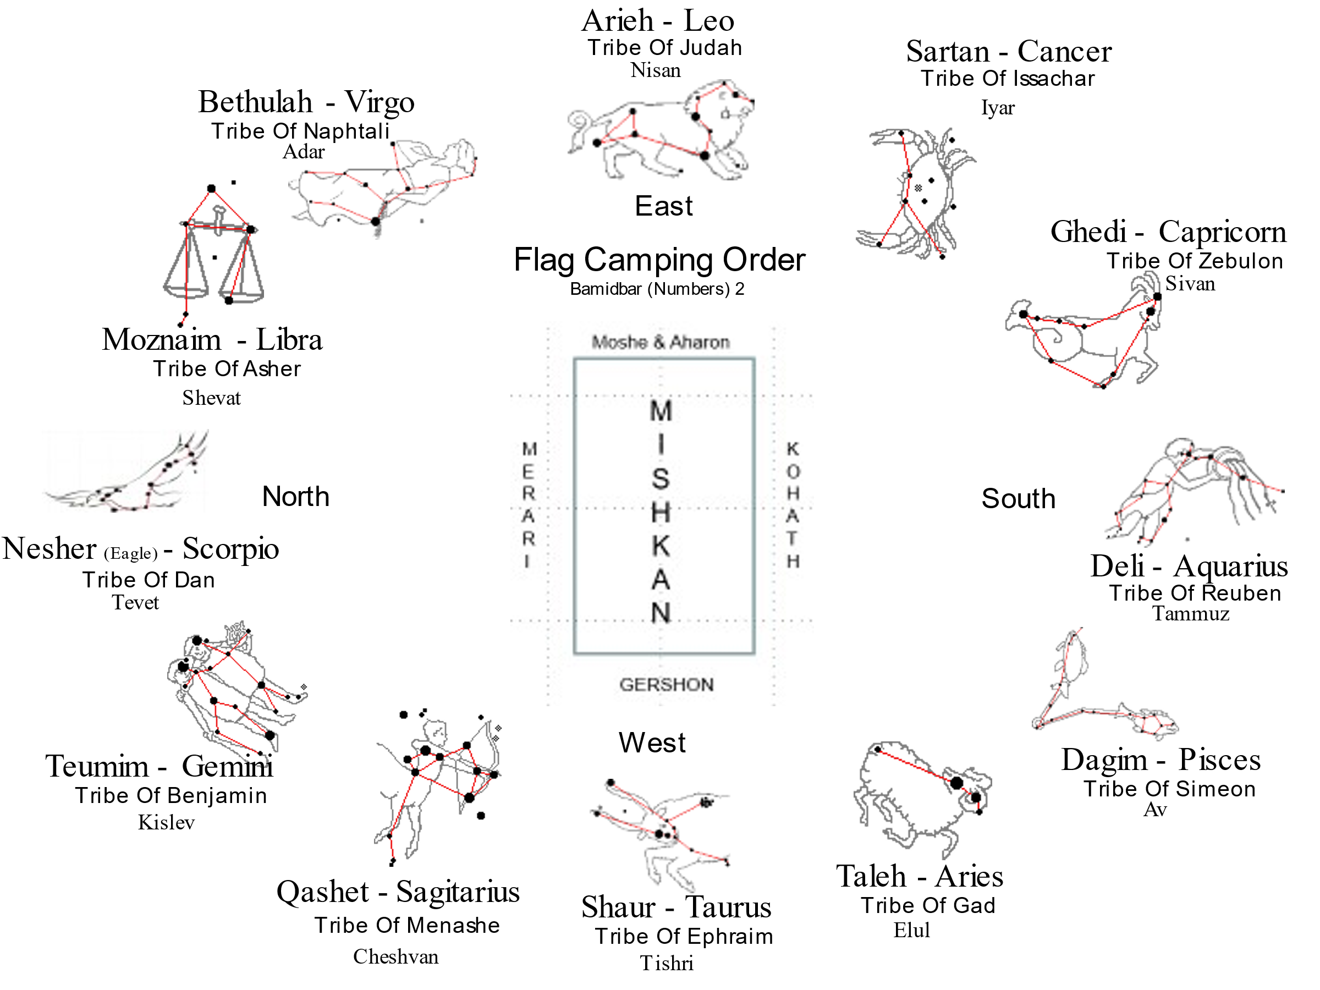

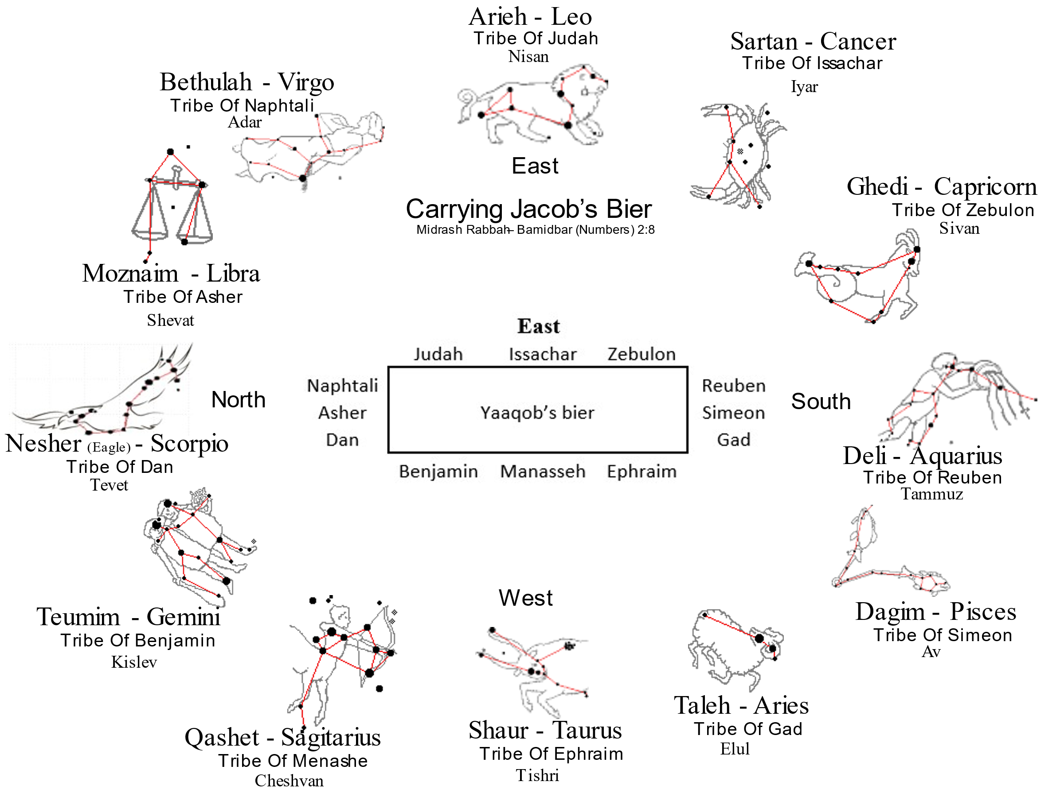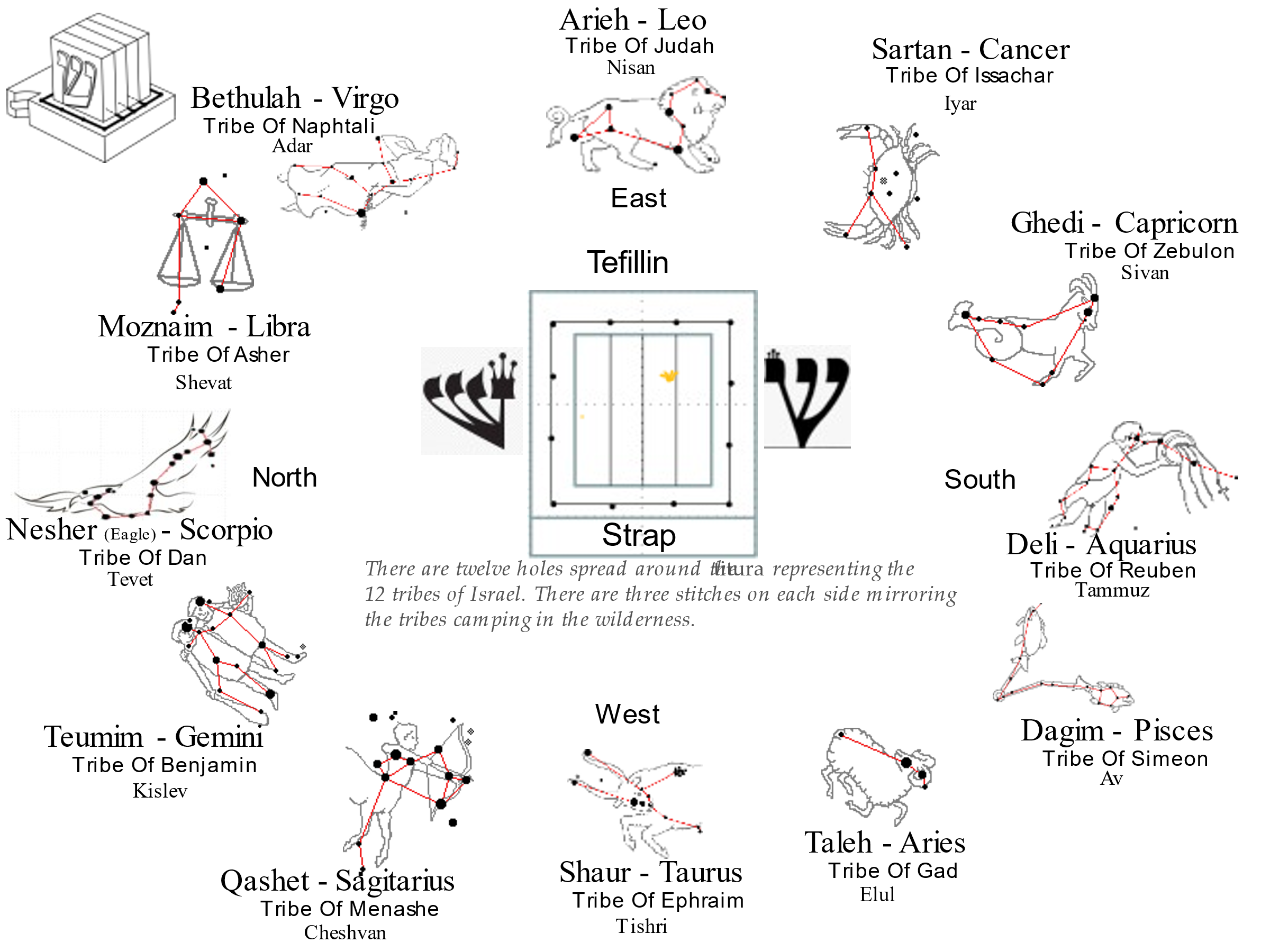

The [Camp](stages.html): Bamidbar ([Numbers](nchart.html)) 2:2 “The Israelites are to [camp](stages.html) around the Tent of Meeting some distance from it, each man under his standard with the banners of his family.”

W

The [camp](stages.html) of Reuben The [Camp](stages.html) of Ephraim

-------------

Reuben 46,500 | Bull | Ephraim 40,500

Simeon 59,300 | | Manasseh 32,200

Gad 45,600 | E | [Benjamin](benyamin.html) 35,400

------ | P | ------

151,400 | H | 108,100

| R |

[Numbers](nchart.html) 2:10-16 | A | [Numbers](nchart.html) 2:18-24

| I |

| M |

| |

-------------

-------------- ------------- --------------

| | | L E V I | | |

The [Camp](stages.html) of Levi | Man | |L ----- L| | Eagle |

[Numbers](nchart.html) 1:44-53 | | |E | * | E| | |

S | REUBEN | |V | | V| | DAN[170] | N

| | |I ----- I| | |

| | | L E V I | | |

-------------- ------------- --------------

-------------

| |

| Lion |

| |

The [Camp](stages.html) of Judah | | The [Camp](stages.html) of Dan

| |

Judah 74,600 | J | Dan 62,700

Issachar 54,400 | | Naphtali 53,400

Zebulon 57,400 | U | Asher 41,500

------ | | ------

186,400 | D | 157,600

| |

[Numbers](nchart.html) 2:3-9 | A | [Numbers](nchart.html) 2:25:31

| |

| H |

| |

| |

| |

| |

| |

| |

| |

-------------

E

If the above image is scrambled, then the following image may be viewable:

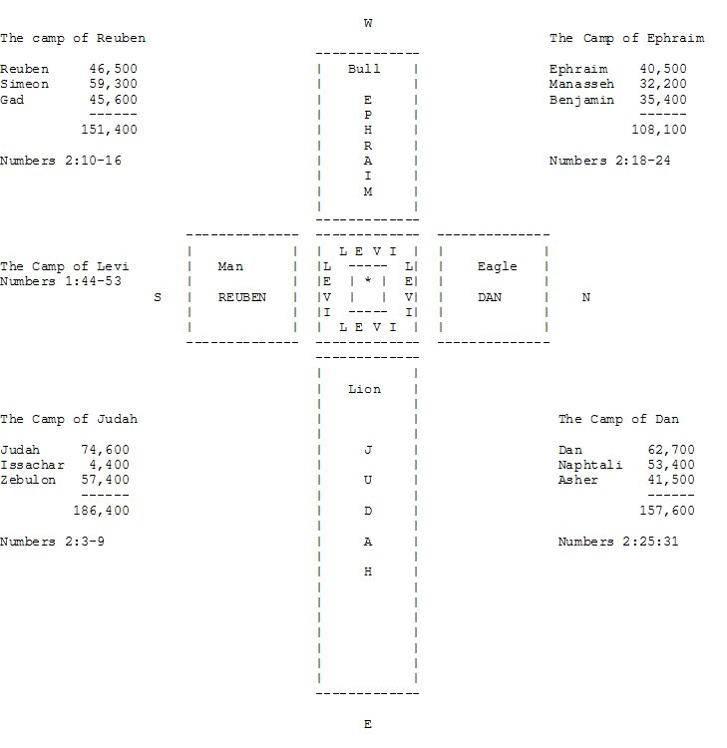

***Yechezkel (Ezekiel) 1:4-13*** *I looked, and I saw a windstorm* [*coming*](coming.html) *out of the north--an immense* [*cloud*](important.html) *with flashing lightning and surrounded by brilliant light. The center of the* [*fire*](fire.html) *looked like glowing metal, And in the* [*fire*](fire.html) *was what looked like* [*four*](four.html) *living creatures. In appearance their form was that of a man, But each of them had* [*four*](four.html) *faces and* [*four*](four.html) *wings. Their* [*legs*](body.html) *were straight; their* [*feet*](heel.html) *were like those of a calf and gleamed like burnished bronze. Under their wings on their* [*four*](four.html) *sides they had the* [*hands*](fourteen.html) *of a man. All* [*four*](four.html) *of them had faces and wings, And their wings touched* [*one*](one.html) *another. Each* [*one*](one.html) *went straight ahead; they did not turn as they moved. Their faces looked like this: Each of the* [*four*](four.html) *had the* [*face*](body.html) *of a man, and on the right side each had the* [*face*](body.html) *of a lion, and on the left the* [*face*](body.html) *of an ox; each also had the* [*face*](body.html) *of an eagle. Such were their faces. Their wings were spread out upward; each had* [*two*](two.html) *wings,* [*one*](one.html) *touching the wing of another creature on either side, and* [*two*](two.html) *wings covering its* [*body*](body.html)*. Each* [*one*](one.html) *went straight ahead. Wherever the spirit would go, they would go, without turning as they went. The appearance of the living creatures was like burning coals of* [*fire*](fire.html) *or like torches.* [*Fire*](fire.html) *moved back and forth among the creatures; it was bright, and lightning flashed out of it. The creatures sped back and forth like flashes of lightning.*

## Sefer Yitzirah (Camping order)

|  |  |  |  |  |  |  |
| --- | --- | --- | --- | --- | --- | --- |
| **Month** | **Mazzalot**  [**Hebrew**](hebrew.html) | **Mazzalot**  **Latin** | [**Sign**](signs.html) | [**Tribe**](tribes.html) | **Faculty** | **Gem** |
| [Nisan](feasts.html) | Toleh | Aries | Ram | Yehuda | Speech | Nofech / Carbuncle |
| [Iyar](feasts.html) | Shor | Taurus | Bull | Issachar | Thought | Safir / Sapphire / Lapz Lazuli |
| [Sivan](feasts.html) | Teumim | Gemini | Twins | Zebulun | Motion | Yahalom / Pearl / Diamond |
| [Tammuz](feasts.html) | Sartan | Cancer | Crab | Reuven | Sight | Odem / Ruby |
| [Av](feasts.html) | Ari | Leo | Lion | Shimon | Hearing | Pitdah / Emerald |
| [Elul](elul.html) | Betula | Virgo | [Virgin](virgin.html) | Gad | Action | Achlama / Crystal |
| [Tishri](feasts.html) | Moznaim | Libra | Scales | Ephraim | Coition | Shoham / Onyx ?? |
| Cheshvan | Akrav | Scorpio | Scorpion | Menashe | Smell |  |
| [Kislev](feasts.html) | Kashet | Sagittarius | Archer | [Benyamin](benyamin.html) | [Sleep](mashal.html) | Yashpheh / Jasper |
| Tevet | Gedi | Capricorn | Kid | Dan | Anger | Leshem / Topaz |
| [Shevat](feasts.html) | Dli | Aquarius | Water Drawer | Asher | Taste | Tarshish |
| [Adar](feasts.html) | Dagim | Pisces | Fishes | Naftali | [Laughter](mashal.html) | Shevo / Turquoise |

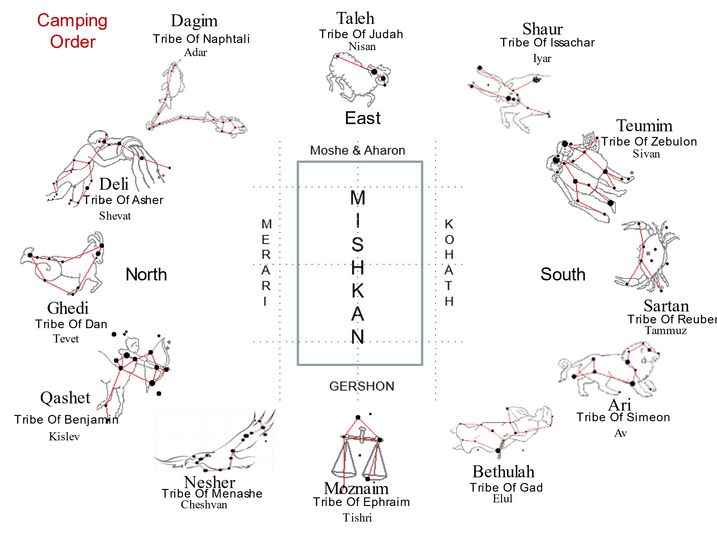

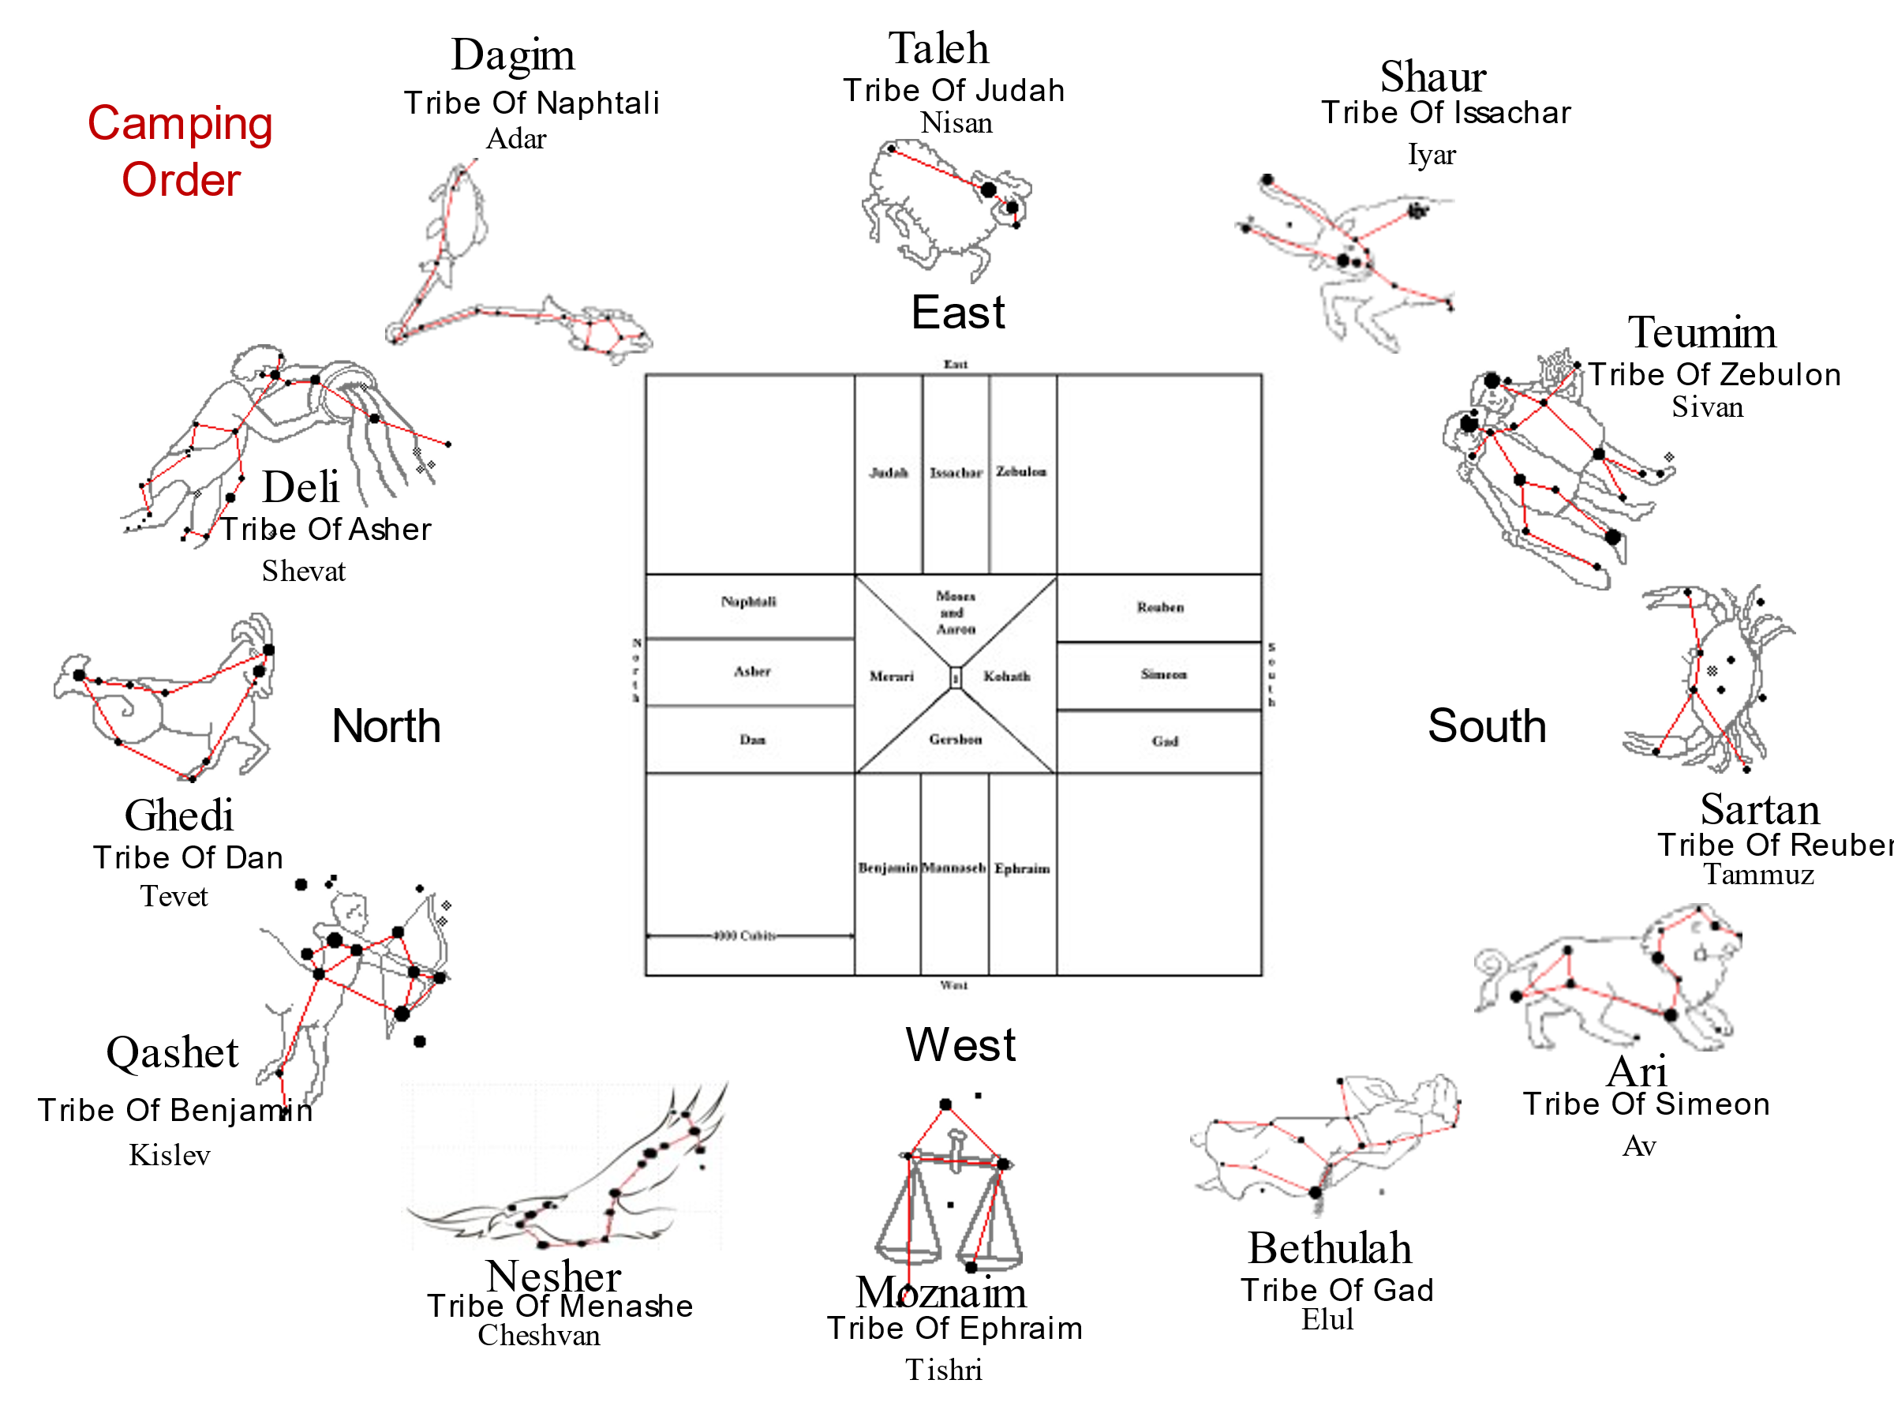

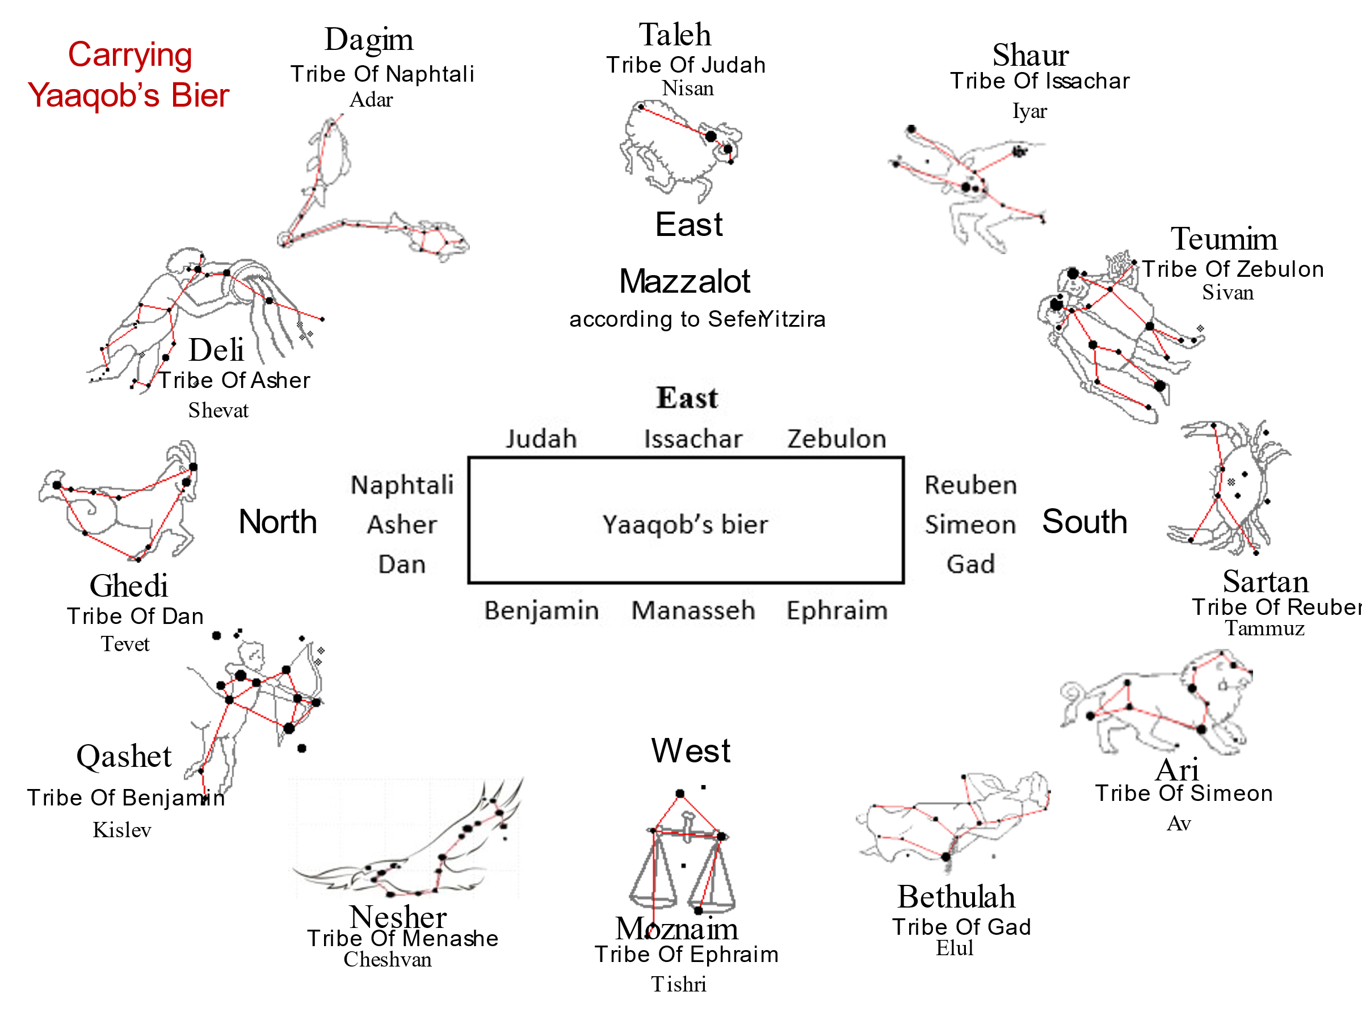

Constellation order, [birth](birth.html) order, numerical order, and alephbet order:

|  |  |  |  |  |  |  |
| --- | --- | --- | --- | --- | --- | --- |
| **Month** | **-4k Years**  **Greek** | [**Tribe**](tribes.html) | **-4K Years**  [**Hebrew**](hebrew.html) | [**Hebrew**](hebrew.html) | [**Letter**](letters.html) | **Value** |
| [Nisan](feasts.html) | Taurus | Reuben | Shaur | Toleh | Hay | 5 |
| [Iyar](feasts.html) | Gemini | Simeon | Teomaim | Shaur | Vav | 6 |
| [Sivan](feasts.html) | Cancer | Levi | Sartan | Teomaim | Zayin | 7 |
| [Tammuz](feasts.html) | Leo | Judah | Arieh | Sartan | Het | 8 |
| [Av](feasts.html) | Virgo | Zebulon | Bethulah | Arieh | Tet | 9 |
| [Elul](elul.html) | Libra | Issachar | Meoznaim | Bethulah | Yod | 10 |
| Tishrei | Scorpio | Dan | Aqurav | Meoznaim | Lamed | 30 |
| Cheshvan | Sagitarius | Gad | Qashot | Aqurav | Nun | 50 |
| [Kislev](feasts.html) | Capricorn | Asher | Ghedi | Qashot | Samnkh | 60 |
| Tevet | Aquarius | Napthali | Deli | Ghedi | Ayin | 70 |
| [Shevat](feasts.html) | Pisces | [Joseph](joseph.html) | Dagim | Deli | Tzadi | 90 |
| [Adar](feasts.html) | Aries | [Benjamin](benyamin.html) | Toleh | Dagim | Koph | 100 |

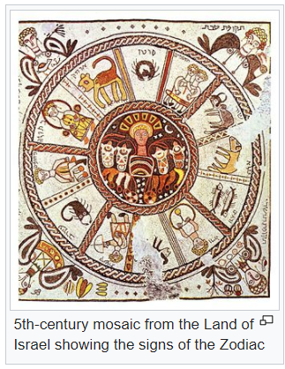

Permutes (4 factorial minus [two](two.html) factorial) to 12 different combinations:

|  |  |  |  |  |  |
| --- | --- | --- | --- | --- | --- |
| **Month** | [**HaShem**](hashem.html) | [**Tribe**](tribes.html) | [**Hebrew**](hebrew.html) | **Latin** | **Composition** |
| [Nisan](feasts.html) | יהוה | Reuben | Toleh - טלה‎ | Aries | represented by 13 stars |
| [Iyar](feasts.html) | יההו | Simeon | Shaur - שור‎ | Taurus | represented by 33 stars |
| [Sivan](feasts.html) | יוהה | Levi | Teomaim - תאומים‎ | Gemini | represented by 18 stars |
| [Tammuz](feasts.html) | הוהי | Judah | Sartan - סרטן‎ | Cancer | represented by 9 stars |
| [Av](feasts.html) | הויה | Zebulon | Arieh - אריה‎ | Leo | represented by 60 stars |
| [Elul](elul.html) | ההיו | Issachar | Bethulah - בתולה‎ | Virgo | represented by 25 stars |
| Tishrei | והיה | Dan | Meoznaim - מאזנים‎ | Libra | represented by 8 stars |
| Cheshvan | וההי | Gad | Aqurav - עקרב‎ | Scorpio | represented by 21 stars |
| [Kislev](feasts.html) | ויהה | Asher | Qashet - קשת‎ | Sagitarius | represented by 31 stars |
| Tevet | היהו | Napthali | Ghedi - גדי‎ | Capricorn | represented by 28 stars |
| [Shevat](feasts.html) | היוה | [Joseph](joseph.html) | Deli - דלי‎ | Aquarius | represented by 42 stars |
| [Adar](feasts.html) | ההוי | [Benjamin](benyamin.html) | Dagim - דגים‎ | Pices | represented by 34 stars |

**Mazzorah** according to Rabbi Yoel (Joel) C. Dobin: (in Massaroth order and in [birth](birth.html) order)

|  |  |
| --- | --- |
| Reuben | Taurus |
| Simeon | Gemini |
| Levi | Cancer |
| Judah | Leo |
| Zebulon | Virgo |
| Issachar | Libra |
| Dan | Scorpio |
| Gad | Sagitarius |
| Asher | Capricorn |
| Napthali | Aquarius |
| [Joseph](joseph.html) | Pices |
| [Benjamin](benyamin.html) | Aries |

Dobin also says that “Magen” as in “Magen David” is a technical term meaning the “position of the stars at a fixed point in [time](time.html)”.

**Mazzorah** according to A.E. Partridge[171]:

|  |  |  |
| --- | --- | --- |
| Reuben | Aquarius | [Shevat](feasts.html) |
| Simeon | Pisces | [Adar](feasts.html) |
| Levi |  |  |
| Judah | Leo | [Av](feasts.html) |
| Zebulon | Capricorn | Tevet |
| Issachar | Cancer | [Tammuz](feasts.html) |
| Dan | Scorpio / Eagle[172] | [Heshvan](feasts.html) |
| Gad | Aries | [Nisan](feasts.html) |
| Asher | Libra | Tishrei |
| Napthali | Virgo | [Elul](elul.html)/Tree with goodly branches |
| [Joseph](joseph.html) | Taurus | [Iyar](feasts.html) |
| [Benjamin](benyamin.html) | Gemini | [Sivan](feasts.html) |
| Manasseh | Sagitarius | [Kislev](feasts.html) |

|  |  |
| --- | --- |
| **יז**  יְהִי-דָן נָחָשׁ עֲלֵי-דֶרֶךְ, שְׁפִיפֹן עֲלֵי-אֹרַח--הַנֹּשֵׁךְ, עִקְּבֵי-סוּס, וַיִּפֹּל רֹכְבוֹ, אָחוֹר. | **17** Dan shall be a serpent in the way, a horned snake in the path, that biteth the horse's heels, so that his rider falleth backward. |

[Babylonian](bavel.html) Cuniform from before 500 B.C.:[173]

|  |  |  |
| --- | --- | --- |
| **Month** | [**Sign**](signs.html) | **Meaning** |
| [Nisan](feasts.html) | Agaru (Aries) | The messenger of the [new](teruah.html) year |
| [Iyar](feasts.html) | Temennu (Plieiades) | The fountain |
|  | Alap-same (Taurus) | The bull of [heaven](heaven.html) |
| [Sivan](feasts.html) | Ri-u-but-same (Orion) | The shephard |
|  | Tuame (Gemini) | The Spirit of [Heaven](heaven.html) |
|  | rabuti (Gemini) | The great twins |
| [Tammuz](feasts.html) | Namgaru (Cancer) | The Crab |
|  | Nagar-asurra | Workman of the river bed. |
| [Av](feasts.html) | Aru rabu (Leo) | The Great Lion |
| [Elul](elul.html) | Siru (Spica) | The ear of corn |
| [Tishri](feasts.html) | Ziba [lacuna] (Libra) | The claws |
| [Heshvan](feasts.html) | Aqrabu (Scorpio) | The Scorpion |
| [Kislev](feasts.html) | Qesheth[bow] (Sagitarius) | Winged [Fire](fire.html)-[head](body.html) |
| Tevet | Enzu (Capricorn) | The Goat |
| [Shevat](feasts.html) | Ka-d (Aquarius) | The Urn |
| [Adar](feasts.html) | Riksu (Pisces) | The Cord |

|  |  |  |  |  |  |  |  |  |  |  |  |  |  |  |  |  |  |  |  |  |  |  |  |  |  |  |  |  |  |  |  |  |  |  |  |  |  |  |  |  |  |  |  |  |  |  |  |  |  |  |  |  |  |  |  |  |  |  |  |  |  |  |  |  |  |  |  |  |  |  |  |
| --- | --- | --- | --- | --- | --- | --- | --- | --- | --- | --- | --- | --- | --- | --- | --- | --- | --- | --- | --- | --- | --- | --- | --- | --- | --- | --- | --- | --- | --- | --- | --- | --- | --- | --- | --- | --- | --- | --- | --- | --- | --- | --- | --- | --- | --- | --- | --- | --- | --- | --- | --- | --- | --- | --- | --- | --- | --- | --- | --- | --- | --- | --- | --- | --- | --- | --- | --- | --- | --- | --- | --- |
| **Zodiacal Guardians and their symbols:** 1   |  |  |  | | --- | --- | --- | | **Mazzaroth** | [**Tribe**](tribes.html) | **Symbol** | |  |  |  | | Aries | Gad | Tent | | Taurus | Issachar | [Ass](chamor.html) | | Gemini | Simeon/Levi | Sword and Pitcher | | Cancer | [Benjamin](benyamin.html) | Wolf | | Leo | Ephraim | Bull/ox or grapes | | Virgo | Asher | Olive branch or cup | | Libra | Manasseh | Palm tree or vine | | Scorpio | Dan | Serpent or apple | | Sagitarius | Judah | Lion | | Capricorn | Naphtali | African deer | | Aquarius | Reuben | Man or a Sunburst above water | | Pisces | Zebulon | Ship | | **Candle Box pictures:**   |  |  | | --- | --- | | [**Tribe**](tribes.html) | **Symbol** | |  |  | | Gad | Tents | | Issachar | [Sun](hachama.html) with [eight](eight.html) stars | | Simeon | Castle | | [Benjamin](benyamin.html) | Wolf | | [Joseph](joseph.html) | Sheaf of wheat | | Asher | Tree | | Levi | Breastplate | | Dan | Scales | | Judah | Lion | | Naphtali | African deer | | Reuben | Branch with flowers | | Zebulon | Sailing Ship with oars | |

**The Mazzaroth according to E.W. Bullinger:**

|  |  |  |
| --- | --- | --- |
| **Mazzaroth** | [**Tribe**](tribes.html) | **Scripture** |
| Taurus | [Joseph](joseph.html)(Ephraim and Manasseh) | Devarim (Deuteronomy) 33:17 |
| Gemini | [Benjamin](benyamin.html) |  |
| Sagitarius | Asher |  |
| Scorpio | Dan |  |
| Capricorn | Naphtali |  |
| Cancer ([Ass](chamor.html)) | Issachar |  |
| Leo | Judah |  |
| Virgo | Zebulon |  |
| Pices | Simeon |  |
| Aquarius | Reuben |  |
| Aries | Gad |  |
| Libra | Levi |  |

The Mazzaroth according to the [Jewish](gen-jew.html) Encyclopedia:

|  |  |  |  |  |  |  |
| --- | --- | --- | --- | --- | --- | --- |
| **Latin Names** | [**Hebrew**](hebrew.html)[**Name**](name.html) | **Approximate Date** | [**First**](one.html) **of** [**Hebrew**](hebrew.html) **Month** | **Approximate** [**Hebrew**](hebrew.html) **Date** | [**Jewish**](gen-jew.html) | [**Signs**](signs.html) |
| Aries | Toleh | March 21 | [Nisan](feasts.html) | March 27 |  |  |
| Taurus | Shor | April 21 | [Iyar](feasts.html) | April 26 |  |  |
| Gemini | Teomim | May 22 | [Sivan](feasts.html) | May 25 |  |  |
| Cancer | Sartan | June 22 | [Tammuz](feasts.html) | June 24 |  |  |
| Leo | Aryeh | July 23 | [Av](feasts.html) | July 23 |  |  |
| Virgo | Bethulah | August 24 | [Elul](elul.html) | August 23 |  |  |
| Libra | Moznayim | September 24 | Tishrei | September 22 |  |  |
| Scorpio | Akrab | October 24 | Cheshvan | October 22 |  |  |
| Saggitarius | Keshet | November 23 | [Kislev](feasts.html) | November 19 |  |  |
| Capricorn | Ghedi | December 22 | Tevet | December 18 |  |  |
| Aquarius | Deli | January 20 | [Shevat](feasts.html) | January 16 |  |  |
| Pisces | Dagim | February 19 | [Adar](feasts.html) | February 15 |  |  |

The Mazzaroth according to the Encyclopedia Judaica, Volume 3, page 798

|  |  |
| --- | --- |
| **Mazzaroth** | **Month** |
| Aries | [Nisan](feasts.html) |
| Taurus | [Iyar](feasts.html) |
| Gemini | [Sivan](feasts.html) |
| Cancer | [Tammuz](feasts.html) |
| Leo | [Av](feasts.html) |
| Virgo | [Elul](elul.html) |
| Libra | [Tishri](feasts.html) |
| Scorpio | Marsheshvan |
| Saggitarius | [Kislev](feasts.html) |
| Capricorn | Tevet |
| Aquarius | [Shevat](feasts.html) |
| Pices | [Adar](feasts.html) |

*According to Sefer Yetzirah:*

|  |  |
| --- | --- |
| [**Tribe**](tribes.html) | **Month** |
| Judah | [Nisan](feasts.html) |
| Issachar | [Iyar](feasts.html) |
| Zebulun | [Sivan](feasts.html) |
| Reuben | [Tammuz](feasts.html) |
| Shimon | [Av](feasts.html) |
| Gad | [Elul](elul.html) |
| Ephraim | [Tishri](feasts.html) |
| Menashe | Marsheshvan |
| [Benjamin](benyamin.html) | [Kislev](feasts.html) |
| Dan | Tevet |
| Asher | [Shevat](feasts.html) |
| Naftali | [Adar](feasts.html) |

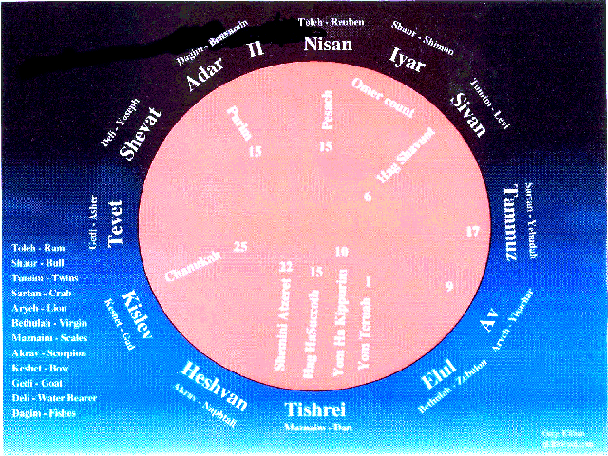

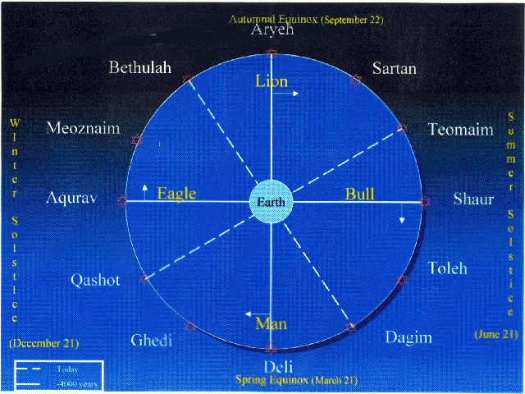

The encyclopedia Judaica also indicates that there is a relationship between the mazzaroth and the [tribes](tribes.html) that is detailed in: **Yal., Ex.418; Yal., I Melakim (Kings) 185**

The Encyclopedia Judaica indicates that “mazalot” in 2 Melakim (Kings) 23:5 indicates “planets”.

***II Melakim (Kings) 23:5*** *He did away with the pagan* [*priests*](priests.html)[*appointed*](settimes.html) *by the kings of Judah to burn* [*incense*](ketoret.html) *on the high places of the towns of Judah and on those around* [*Jerusalem*](city.html)*--those who burned* [*incense*](ketoret.html) *to Baal, to the* [*sun*](hachama.html) *and* [*moon*](chodesh.html)*, to the constellations and to all the starry hosts.*

The planets as mentioned in scripture:

**Saturn** (ht,ca – Shabtai - Kevan) is found in:

***Amos 5:26****. But you shall carry Sikuth your king, and iyun, your images, your star-god, which you made for ourselves.*

The planet that influences **Tevet**, Shabbtai (Saturn), symbolizes the power of contemplation which characterizes the [Shabbat](sabbath.html) [experience](experience.html): Refraining from the mundane, the [world](worlds.html) of the transcendent is revealed... (Seasons of the [Moon](chodesh.html) - Tevet)

**Venus** – (vdub - Nogah, Meleket haShamayim, the queen of [heaven](heaven.html)). This is understood from from the fact that cakes are baked for her. Among the Assyro-Babylonians the cake-offerings were called “the bread of Ishtar” (Venus).[174] This usage is found in:

***Yirimiyah (Jeremiah) 7:18****. The children* [*gather*](gather.html) *wood, and the* [*fathers*](fathers.html) *kindle the* [*fire*](fire.html)*, and the women knead their dough, to make cakes to the queen of* [*heaven*](heaven.html)*, and to pour out drink offerings to other gods, that they may provoke me to anger.*

**Jupiter** (esm – tzedek - Gad “fortune”). This is a supposition. It is found in:

***Yeshayah (Isaiah) 65:11*** *“But as for you who forsake* [*HaShem*](hashem.html) *and forget my holy mountain, who spread a table for Fortune and fill bowls of mixed wine for Destiny,*

There is some speculation that “Destiny”, in the above verse refers to **Venus**.

|  |  |  |
| --- | --- | --- |
| **Planet Names** | | |
| **Greek** | [**Hebrew**](hebrew.html) | **Transliteration** |
|  |  |  |
| Saturn | ht,ca | Shabbtai |
| Jupiter | esm | Zedek |
| Mars | ohstn | Madim |
| [Sun](hachama.html) | vnj | Chamah |
| Venus | vdub | Nogah |
| Mercury | cfuf | Kokav |
| [Moon](chodesh.html) | vbck | Lavanah |
|  |  | (Sefer Yetzirah) |

|  |  |
| --- | --- |
| **PLANET** | **INFLUENCE** |
| **Saturn** | Poverty, destruction, internal injury, and sickness |
| **Mars** | [Blood](body.html), [wickedness](wicked.html), strife, external injury, war, hatred, and jealousy |
| **Jupiter** | Life, peace, good, prosperity, religious feelings, joy, wealth, and political advance |
| **Venus** | [Grace](grace.html), love, lust, children, and fruitfulness |
| **Mercury** | Wisdom, skill, writing, and language |
| [**Sun**](hachama.html) | Light, darkness, work, accomplishment, [travel](mashal.html), and [exile](galuyot.html) |
| [**Moon**](chodesh.html) | Holds keys to [heaven](heaven.html) and earth, surrogate for good and evil |

(Sefer Yetzirah)

Mars, Madim, is not to be found in the Tanakh. The root, though, is found[175]. The root is [Edom](edom.html):

123 ‘[Edom](edom.html), ed-ome’; or (fully) ‘Edowm, edome’; from 122; red [see Gen. 25:25]; [Edom](edom.html), the elder twin-brother of [Jacob](israelja.html); hence the region (Idumaea) occupied by him:-[Edom](edom.html), Edomites, Idumea.

This word means: (very) red or (very) mad. The red [connection](connection.html) with Mars is obvious. The use of this root in the understanding of “mars” is in:

***Yeshayah (Isaiah) 63:1-6*** *Who [is] this that cometh from* [*Edom*](edom.html)*, with dyed garments from Bozrah? this [that is] glorious in his apparel, travelling in the greatness of his strength? I that* [*speak*](mashal.html) *in righteousness, mighty to* [*save*](salvation.html)*. Wherefore [art thou] red in thine apparel, and thy garments like him that treadeth in the winefat? I have trodden the winepress alone; and of the people [there was] none with me: for I will tread them in mine anger, and trample them in my fury; and their* [*blood*](body.html) *shall be sprinkled upon my garments, and I will stain all my raiment. For the day of vengeance [is] in mine* [*heart*](body.html)*, and the year of my* [*redeemed*](redemption.html) *is come. And I looked, and [there was] none to help; and I wondered that [there was] none to uphold: therefore mine own arm brought* [*salvation*](salvation.html) *unto me; and my fury, it upheld me. And I will tread down the people in mine anger, and make them drunk in my fury, and I will bring down their strength to the earth.*

Dobin says: “Mars is the planet of intense energy, and the word takes it’s meaning from astrological understanding of the nature of the planet, Mars. Both intensity of action and redness are implied in the [Hebrew](hebrew.html) [name](name.html) of the planet. Mars was [known](daat.html) to be the planet which causes strife and war...”

**\* * \***

Dobin’s translations:

***Chavakkuk (Habakkuk) 3:11***[*Sun*](hachama.html) *and* [*moon*](chodesh.html) *stood still in the* [*heavens*](heaven.html) *at the glint of your flying arrows, at the lightning of your flashing spear.*

Should be:

***Chavakkuk (Habakkuk) 3:11*** *The* [*sun*](hachama.html) *and the* [*moon*](chodesh.html) *stand still in their habitation; Thine arrows go towards the* [*Sun*](hachama.html)*, Thy glittering spear towards the* [*Moon*](chodesh.html)*.*

***Chavakkuk (Habakkuk) 3:2-4***[*HaShem*](hashem.html)*, I have heard of your fame; I stand in* [*awe*](fear.html) *of your deeds,* [*HaShem*](hashem.html)*. Renew them in our day, in our* [*time*](time.html) *make them* [*known*](daat.html)*; in wrath remember mercy. God came from Teman, the Holy* [*One*](one.html) *from Mount Paran. <Selah> His glory covered the* [*heavens*](heaven.html) *and his praise filled the earth. His splendor was like the sunrise; rays flashed from his* [*hand*](fourteen.html)*, where his power was hidden.*

Should be translated:

***Chavakkuk (Habakkuk) 3:2-4*** *O Lord, I have heard the report of Thee, and am afraid; O Lord, Thy work has its life in the midst (or by means of) of the years, It shall be* [*known*](daat.html) *by means of the years. God cometh from (the direction of) Capricorn-Aquarius, And the Holy* [*One*](one.html) *(from the direction of) Mount Paran. Selah. And the* [*Moon*](chodesh.html) *(or Venus), like the* [*sun*](hachama.html)*, will be rays at His side, and therein will lie the* [*secret*](sod.html) *of His power.*

***Bamidbar (***[***Numbers***](nchart.html)***) 24:17*** *“I see him, but not now; I behold him, but not near. A star will come out of* [*Jacob*](israelja.html)*; a scepter will rise out of Israel. He will crush the foreheads of* [*Moab*](stages.html)*, the skulls of all the sons of Sheth.*

***Bamidbar (***[***Numbers***](nchart.html)***) 24:17*** *What I see for them is not yet, What I behold will not be soon; A star rises from* [*Jacob*](israelja.html)*, a meteor comes forth from Israel, It smashes the brow of* [*Moab*](stages.html)*, The foundation of all the children of Seth.*

The [Mishna](orallaw.html) states: “On comets, earth tremors, thunder, storm winds and lightning, say: ‘Blessed is He whose strength and might fill the [world](worlds.html).’ On mountains, hills, rivers, oceans and desserts, say: ‘Blessed is He who makes the works of [creation](bara.html).’”

The [Talmud](orallaw.html) explains the [Mishna](orallaw.html) as follows: On mountains, hills, etc., there is only [one](one.html) possible blessing which can be said - namely, “Who makes the works of [creation](bara.html).” But on comets, earth tremors, etc., you can say *either* blessing you want. You can say either “Whose strength and might fill the [world](worlds.html)” or you can say “Who makes the works of [creation](bara.html).” The custom is to say “Who makes the works of [creation](bara.html),” but the other [one](one.html) is also acceptable.

Some commentaries understand the [Mishna](orallaw.html) as referring to meteors (‘shooting stars’), not comets. In practice, you say a blessing on both comets and meteors.

Sources:

Tractate Berachot 54a, 59a

[Mishna](orallaw.html) Berurah 227:1

What ever happened to the meteors that were left suspended in the sky in 2448?

Some of the miraculous hailstones stayed suspended in space until Yehoshua`s war with the Emori, when they came crashing down on their enemy, [forty](forty.html)-[one](one.html) years later. There are still many more meteors which will come crashing down on Gog and Magog when [Mashiach](mashiach.html) battles with them soon!

Meteors seem to be designed to provide light as we see from the following [Midrash](orallaw.html):

[***Midrash***](orallaw.html) ***Rabbah - Genesis LX:1*** *Another interpretation: ‘Who is among you that feareth the Lord’ alludes to Eliezer; ‘ Who heareth the* [*voice*](voice.html) *of his servant,’ for he was* [*Abraham*](avraham.html)*’s servant.’ Who walked in darkness’ when he went to fetch Rebekah. ‘And hath no light’: who then gave him light? The Holy* [*One*](one.html)*, blessed be He, illumined his path with meteors and lightnings. ‘Let him trust in the* [*name*](name.html) *of the Lord, and stay on his God: thus it is written, AND HE SAID: O LORD, THE GOD OF MY MASTER* [*ABRAHAM*](avraham.html)*, SEND ME, I* [*PRAY*](prayer.html) *THEE, GOOD SPEED THIS DAY.*

* * *

Says the [Zohar](orallaw.html) HaKodesh.

I will show you, but not for now, for these things will only come to be at that [time](time.html), some after [time](time.html) and some in the Days of King [Mashiach](mashiach.html). “A star has gone forth from Ya’akov [[Jacob](israelja.html)] ...” (Bamidbar [[Numbers](nchart.html)] 24:17). This [teaches](teacher.html) us that in the [future](future.html), The Holy [One](one.html), Blessed is He, will build [Jerusalem](city.html) and [one](one.html) star will spark within [seventy](seventy.html) pillars of [fire](fire.html) and [seventy](seventy.html) sparks will receive light from it in the middle of the sky. The other [seventy](seventy.html) stars will be swallowed within it. It will give off light and blaze for [seventy](seventy.html) days. At the end of the [sixth](six.html) day [6,000 years] it will become visible at the beginning of the [twenty](twenty.html)-[fifth](five.html) day of the [sixth](six.html) month [25 [Elul](elul.html) 5761, September13, 2001]. It will be [gathered](gather.html) in at the end of [seventy](seventy.html) complete days [November 20, 2001] and be visible in the [city](city.html) of Rome, and on that day, [three](three.html) great walls will fall and great hail will fall [Leonid meteor shower? November 14-21, 2001], and the power of that [city](city.html) will die. Then this star will become visible in the [world](worlds.html), and it will instigate a great war from all [four](four.html) sides. When [Mashiach](mashiach.html) becomes revealed the people of the [world](worlds.html) will be suffering trouble after trouble, and the enemies of the [Jewish](gen-jew.html) people will be prevailing. Then the spirit of [Mashiach](mashiach.html) will be aroused and the evil [Edom](edom.html) [[Esau](edom.html), [Jacob](israelja.html)’s brother] will be destroyed and the Land of Seir [[Esau](edom.html)’s land] will be burned with [fire](fire.html) ... ([Zohar](orallaw.html), Balak, 212b)

Talmudic teachings can be divided into [two](two.html) categories: [Halacha](walking.html) and Aggada. While the halachic teachings are always meant to be taken literally, the aggadic teachings are not always meant to be taken literally.

According to the Maharal of Prague, [one](one.html) of the most authoritative commentators on the aggadic portions of the [Talmud](orallaw.html), they are always, with only a few exceptions, meant as metaphors. He writes that the Talmudic statements in Tractate Berachot 58b regarding astronomical [events](feasts.html) should be understood as metaphors as well.

Some commentaries explain that this Talmudic passage is not referring to comets at all, but rather to meteors (‘shooting stars’). If so, this passage is irrelevant to the Hale-Bopp comet.

This is not to say that comets have no ‘gravity.’ According to traditional sources, a [new](new.html) star appeared in the sky 4,100 years ago. That was the year the [world](worlds.html) was destroyed by a flood in the [time](time.html) of Noah. This star, apparently a comet, traveled through all the constellations in a month’s [time](time.html). It was an omen for the people in the [world](worlds.html) to reconsider their [wicked](wicked.html) lifestyles and practices. (Interestingly, NASA reports that Hale-Bopp last appeared about 4,200 years ago [Astronomy Magazine Feb. ‘97].)

Whether or not this comet is a [sign](signs.html) of destruction, I think it’s important to point out another Talmudic [teaching](teacher.html): “When the People of Israel do the will of [HaShem](hashem.html), they need [fear](fear.html) none of these astronomical omens, as indicated by the following verse: ‘So says [HaShem](hashem.html): Don’t imitate the ways of the [wicked](wicked.html), and don’t be afraid of heavenly omens.’”

Sources:

[Talmud](orallaw.html) Berachot 58b

Be’er Hagolah, Rabbi Yehuda Loewe of Prague

Netzach Yisrael, Chapter 60

[Mishna](orallaw.html) Berurah 227:1

[Seder](haggada.html) Hadorot

[Talmud](orallaw.html) Sukkah 29a

Research Credit: Rabbi Zev Rosen

**\* * \***

***Bereshit (Genesis) 11:27-32*** *This is the account of* [*Terah*](stages.html)*.* [*Terah*](stages.html) *became the father of* [*Abram*](avraham.html)*, Nahor and Haran. And Haran became the father of Lot. While his father* [*Terah*](stages.html) *was still alive, Haran died in Ur of the Chaldeans, in the land of his* [*birth*](birth.html)*.* [*Abram*](avraham.html) *and Nahor both married. The* [*name*](name.html) *of* [*Abram*](avraham.html)*’s wife was Sarai, and the* [*name*](name.html) *of Nahor’s wife was Milcah; she was the daughter of Haran, the father of both Milcah and Iscah. Now Sarai was barren; she had no children.* [*Terah*](stages.html) *took his son* [*Abram*](avraham.html)*, his grandson Lot son of Haran, and his daughter-in-*[*law*](law.html) *Sarai, the wife of his son* [*Abram*](avraham.html)*, and together they set out from Ur of the Chaldeans to go to Canaan. But when they came to Haran, they settled there.* [*Terah*](stages.html) *lived 205 years, and he died in Haran.*

“Ur of the Chaldeans” literally means “Light of the Astrologers”.

**\* * \***

The Encyclopedia Judaica indicates that 1 Divrei HaYamim (Chronicles) 12:33 indicates that the [tribe](tribes.html) of Issachar were the astronomers of Israel:

***1 Divrei HaYamim (Chronicles) 12:33*** *of the Issacharites, men who* [*knew*](daat.html) *how to interpret the* [*signs*](signs.html) *of the times, to determine how Israel should act; their chiefs were 200, and all their kinsmen followed them;[176]*

The blesssing of Bereshit (Genesis) 24:1 is interpreted as the gift of astronomy[177].

***Bereshit (Genesis) 24:1***[*Abraham*](avraham.html) *was now old and well advanced in years, and* [*HaShem*](hashem.html) *had blessed him in every way.*

**\* * \***

**SHOR**

7794 showr, shore; from 7788; **a bullock** (as a traveller):-bull (-ock), cow, ox, wall [by mistake for 7791].

----------------- Dictionary Trace ---------------------

7788 shuwr, shoor; a prim. root; prop. to turn, i.e. [travel](mashal.html) about (as a harlot or a merchant):-go, sing. See also 7891.

7791 shuwr, shoor; from 7788; a wall (as going about):-wall.

**TE’OMIM**

8380 ta’owm, taw-ome’; or ta’om, taw-ome’; from 8382; **a twin** (in plur. only), lit. or [fig](bethphag.html).:-twins.

**ARIEH**

738 ‘ariy, ar-ee’; or (prol.) ‘aryeh, ar-yay’; from 717 (in the sense of violence); a lion:-(young) **lion**, + pierce [from the marg.].

The [sign](signs.html) of [Av](feasts.html) is Aryey, the lion, while the [sign](signs.html) of [Elul](elul.html) is Bethulah, the [virgin](virgin.html). Our sages thus [taught](teacher.html) us that [one](one.html) should go in the right way “after a lion,” which represents the month of [Av](feasts.html). We should not go “after a woman,” this being the [virgin](virgin.html), the [sign](signs.html) of [Elul](elul.html). [One](one.html) should not wait until [Rosh HaShana](teruah.html)h [which follows [Elul](elul.html)] to begin repenting, but should do so “after a lion,” at the end of [Av](feasts.html). The entire month of [Elul](elul.html) should then be spent in repentance, so that [one](one.html) will approach [Rosh HaShana](teruah.html)h in [purity](purity.html).

**BETHULAH**

1330 bethuwlah, beth-oo-[law](law.html)’; fem. pass. part. of an unused root mean. to separate; a [**virgin**](virgin.html) (from her privacy); sometimes (by continuation) a bride; also ([fig](bethphag.html).) a [city](city.html) or state:-maid, [virgin](virgin.html).

**MOZNAYIM**

* * *

**THOUGHTS ON THE DAILY DAF**

brought to you by Kollel Iyun Hadaf of Har Nof

Rosh Kollel: Rav Mordecai Kornfeld

[Rosh Hashana](teruah.html)h 11b

**2) THE RISE AND DESCENT OF THE MAZALOT**

**QUESTION:** The Beraita says that according to Rebbi Yehoshua, the flood occurred in the month of [Iyar](feasts.html), when the constellation of Kimah is “sinking” or descending (Shoke’a) during the daytime. However, in order to bring the flood upon the [world](worlds.html), [Hashem](hashem.html) changed its pattern and made it “rise” (Oleh) during the daytime. According to Rebbi Eliezer, the flood occurred in Marcheshvan, when Kimah is rising, and thus Kimah was rising as usual and it was not necessary for [HaShem](hashem.html) to change its pattern.

Rashi explains that Kimah is the tail of the constellation Tleh (Aries), which is also the [head](body.html) of Shor (Taurus). The Mazal of the month of [Iyar](feasts.html) is the constellation Shor. This means that in [Iyar](feasts.html), Shor is in the background behind the [sun](hachama.html) (and thus Shor is not visible at night the entire month - precession not being taken into consideration). Consequently, the constellation Tleh, which travels ahead of Shor, rises just before the [sun](hachama.html) rises (and thus is visible at the end of the night), and travels through the daytime sky, setting at the western horizon just before sunset. Therefore, during the entire month of [Iyar](feasts.html), Kimah, which is the tail of Tleh, is up in the sky the entire day, until a moment before sunset when it sets (since it is [traveling](mashal.html) directly in front of the [sun](hachama.html)). If so, how can the Beraita say that the constellation of Kimah is “Shoke’a” during the day in [Iyar](feasts.html), which implies that it sinks, or sets, during the day. In [Iyar](feasts.html), it is rising during the day!

Similarly, Rashi (near the end of 11b) writes concerning Tleh that in [Iyar](feasts.html), “the entire day it is Shoke’a.” How can he write that it is Shoke’a during the day in the month of [Iyar](feasts.html)? It is *rising* during the day (at least during the [first](one.html) half of the day). In fact, not only does Kimah not “sink” during the day in [Iyar](feasts.html), but it *does* “sink” in Marcheshvan. Why does the [Gemara](orallaw.html) say that according to Rebbi Eliezer Kimah rises during the day!

Rebbi Eliezer says that the flood occurred in the month of Marcheshvan. The Mazal of Marcheshvan is Akrav (Scorpio), which is [six](six.html) Mazalot away from Shor, just like Marcheshvan is [six](six.html) months away from [Iyar](feasts.html), and at the opposite point in the sky. This means that in Marcheshvan, Kimah (the tail of Tleh) will be a little over [six](six.html) Mazalot ahead of the [sun](hachama.html) ([six](six.html) more Mazalot than Akrav is Shor, and a bit more is the tail of Tleh). Accordingly, Kimah is setting by the [time](time.html) the [sun](hachama.html) rises, because there are only [six](six.html) Mazalot in the sky at a [time](time.html), and Kimah is more than [six](six.html) Mazalot away from the [sun](hachama.html). Kimah rises again 12 hours later, or just before the [sun](hachama.html) sets. If so, according to Rebbi Eliezer, the Beraisa should say that Kimah is *Shoke’a* the entire day! Why does it say that Kimah is *Oleh* during the day according to Rebbi Eliezer, and *Shoke’a* during the day according to Rebbi Yehoshua? It should say the opposite!

**ANSWERS:**

(a) **RASHI** learns that when the Beraita says that Kimah is Shoke’a in [Iyar](feasts.html), it means that it has already made its appearance in the sky. From the moment that the Mazal fully appears in the sky, it is considered to be descending (i.e. it is heading towards the western horizon) until it sets and completely disappears beneath the horizon. At that point, after it has set, it is considered to be beginning its ascent (i.e. it is heading towards the [eastern](east.html) horizon) and is “Oleh.” It completes its ascent the moment that it rises and fully appears in the sky. This also explains why the Beraita says that according to Rebbi Eliezer, Kimah is considered to be rising during the day in the month of Marcheshvan, because by sunrise it has completely disappeared below the horizon, and therefore it is considered to be “Oleh” the entire day, as it makes its way up towards the horizon in order to rise and appear in the sky.

Rashi apparently learns that a Mazal is able to influence the [world](worlds.html) only during the [time](time.html) that it is Oleh (that is, when it is beneath the [world](worlds.html)), and more specifically, while it is rising over the [eastern](east.html) horizon. After it has completely risen and it begins to cross the sky, its power wanes. Hence the only [time](time.html) that the flood could begin was while the Mazal Kimah was rising and above the [world](worlds.html), at which [time](time.html) the floodwaters could pour forth through the [two](two.html) stars that were removed from it and inundate the [world](worlds.html) (as Rashi says, the rain came through the holes that were made when [two](two.html) stars in Kimah were removed from their places). Therefore, according to Rebbi Yehoshua who says that the flood occurred in [Iyar](feasts.html) when Kimah rises before sunrise, the Mabul could not have occurred because Kimah was already on its way down by the [time](time.html) that the day began (sunrise). Therefore, [HaShem](hashem.html) had to change the pattern of the [world](worlds.html) and make Kimah rise later than usual, so that in would rise when it was already day.

According to Rebbi Eliezer, there was a moment at the end of the day, right before sunset, at which Kimah was in the process of rising, and therefore the flood could come to the [world](worlds.html) through Kimah at that [time](time.html).

(b) **TOSFOT, BA’AL HA’ME’OR** and others reverse the Girsa, so that according to Rebbi Eliezer, Kimah is *Shoke’a* during the day (in Marcheshvan), and according to Rebbi Yehoshua, it is *Oleh* during the day (in [Iyar](feasts.html)). As such, the [Gemara](orallaw.html) works out simply, because Kimah is indeed rising in the sky during the days in [Iyar](feasts.html) and it is descending beneath the [world](worlds.html) during the days in Marcheshvan, as we explained in our question.

The Me’or expresses wonderment at why Rashi found it necessary to change this Girsa and insist on his own Girsa, which just complicates matters. Perhaps Rashi was bothered by the wording of the Beraita in the [Gemara](orallaw.html). Tosfot says that Kimah is up during the day in [Iyar](feasts.html) and it is down during the day in Marcheshvan. According to that explanation, the words “Shoke’a” and “Oleh” are inappropriate; it should say instead that Kimah is either “above” the earth or “below” it.

(c) The **ARUCH** (Erech Kimah, and as recorded in the addendum of Talmidei Rashi that is printed at the end of the Maseches, on Daf 35a) had the Girsa of Tosfot, but did not give the same explanation as Tosfot. Rather, he explains that the Mazalot of this Sugya have nothing to do with the actual position of the stars relative to the [sun](hachama.html). Rather, these Mazalot are just an astrological formula which express a method for predicting [world](worlds.html) [events](feasts.html). It is similar to the [seven](seven.html) Mazalot of the hours (Sha’os) as described in the [Gemara](orallaw.html) in [Shabbat](sabbath.html) (156a), whereby each hour is represented by a different planet which has power over that hour, and they rotate in [cycles](cycles.html) of [seven](seven.html) on an hourly basis.

According to this method of astrology, all [twelve](twelve.html) Mazalot serve during the daytime, as well as during the nighttime, each [one](one.html) “serving” [one](one.html) hour during the day and [one](one.html) hour during the night. Each month the night (and day) begins with a different Mazal. When the [Gemara](orallaw.html) says that a Mazal is “Shoke’a,” it is referring to the Mazal whose turn comes right after midday or after midnight. A Mazal that is “Oleh” refers to a Mazal whose hour comes during the [first](one.html) half of the day or night. Therefore, according to Rebbi Eliezer who says that the flood occurred in Marcheshvan, when Akrav is the leading Mazal, the hour of Shor (which includes Kimah, the tail of Tleh) comes [six](six.html) hours later, which is the [first](one.html) hour after midday, and therefore it is said to be “Shoke’a,” because it only comes to power after midday. According to Rebbi Yehoshua, the flood occurred in [Iyar](feasts.html), when the leading Mazal is Shor, and thus the hour of Kimah occurred when the [sun](hachama.html) was on the rise, in the [first](one.html) half of the day, and thus it is said to be “Oleh.”

moon1moon2moon3moon4moon5moon6moon7moon8moon9moon10

**Appendix A Other Sources**

Sefer Yezirah - more material on mazzaroth.

Frances Rolleston “**Mazzaroth**” or “**The Constellations**” . In London by Rivingtons, 1876.

[Joseph](joseph.html) A. Seiss “**The** [**Gospel**](mishna1.html) **in the Stars**” . In Philadelphia by J.B.Lippincott, 1885.

Admon, Bo’smat *Sefer Mishpete Kokhavim: Astrologyah lefi ha-Yahadut* (Hod ha Sharon: Astrolog, 1996)

Bakal, Meir, (ed.) [*Seder*](haggada.html) *12 ha-Mazalot* ([Jerusalem](city.html): Hotsa`at Bakal, 1994)

Erlanger, Gad, [*Signs*](signs.html) *of the Times: the Zodiac in* [*Jewish*](gen-jew.html) *Tradition* ([New](new.html) York, NY: Feldheim, 2001)

Glazerson, Matityahu, *Above the Zodiac: Astrology in* [*Jewish*](gen-jew.html) *Thought* (Northvale, NJ: J. Aaronson, 1997)

Glazerson, Matityahu, *En Mazal le-Yisrael* (Israel: M. Glazerson, 1980, 1985)

Ibn Ezra, [Abraham](avraham.html) ben Meir *Le Livre des fondements astrologiues: (precede de) Le Commencement de la*

*sapience des signes* [introduction, traduction et notes de Jacques Halbronn] (Paris, Retz, 1977)

*Megilat Ta’anit: Baraita de-13 midot de-Rabi Yishma`ek. Baraita di-Shmu’el Yarhina’ah. `Inyan ha-Tekufot* (Israel: 1980)

Solomon ben [Isaac](isaac.html), *Shene Sefarim Niftahim: Isur ver-Heter le-Rashi* (1973)

Altmann, A., “Astrology,” *Encyclopedia Judaica* (Jeruslaem: Keter, 1973), vol. 3, pp. 788-795

Blau, L., & Kohler, K., “Astrology,” [*Jewish*](gen-jew.html) *Encyclopedia* (NY: Fink & Wagnells, 1901-1905), vol. 2, pp. 241-245

Sarfatti, G.B., “An Introduction to ‘Barayta de-Mazzalot’,” *Bar-Ilan Yearbook* 3 (1965), 56-82 [Heb]

Dobin, Joel C., *The Astrological Secrets of the* [*Hebrew*](hebrew.html) *Sages: to Rule Both Day and Night* ([New](new.html) York, NY: Inner Traditions International, 1983)

Dobin, Joel C., *To Rule Both Day and Night: Astrology in the Bible,* [*Midrash*](orallaw.html)*, and* [*Talmud*](orallaw.html)([New](new.html) York, NY: Inner Traditions International, 1977)

Dobin, Joel C., *Kabbalistic Astrology: the Sacred Tradition of the* [*Hebrew*](hebrew.html) *Sages* (Rochester, NY: Inner Traditions, 1999)

Levy, R., *Astrological Works of* [*Abraham*](avraham.html) *ibn Ezra* (Baltimore, Md., Paris, Johns Hopkins University Press; Les Presses Universitaires, 1927)

Jospe, Raphael, “The Torah and Astrology According to [Abraham](avraham.html) ibn Ezra,” [*World*](worlds.html) *Congress of* [*Jewish*](gen-jew.html) *Studies* 11, C2 (1994), pp. 17-24

This [study](study.html) was written by

Rabbi Dr. Hillel ben David

(Greg Killian).

Comments may be submitted to:

Greg Killian

12210 Luckey Summit

San Antonio, TX 78252

Internet address: [gkilli@aol.com](mailto:gkilli@aol.com)

Web page: <https://www.betemunah.org>

(360) 918-2905

Return to The [WATCHMAN](https://www.betemunah.org/) home page

Send comments to Greg Killian at his email address: [gkilli@aol.com](mailto:gkilli@aol.com)

1. From *“Menorat Hamaor*” by Rabbi Yitzchak Abuhav
2. Shabbat 156a
3. Compton’s Living Encyclopedia
4. Compton’s Living Encyclopedia
5. A vav is used to connect two things.
6. Bamidbar 15
7. Chavakuk 3:11
8. From Rambam’s Mishneh Torah, Hilkhot Yesodei HaTorah (Laws Relating to the Fundamentals of Torah) Chapter 4.
9. Shabbat 156a
10. Fire, water, earth, and air. See Vol. I, p. 26. These basic elements were first created by G-d, and out of a combination of them. He made man, etc.
11. Sight, hearing, taste, smell and touch.
12. See Ramban on Genesis 2:17, Vol. I, p. 75.
13. Chagigah 16a.
14. Ramban now begins to explain the text quoted on the basis of certain scientific concepts that were prevalent in his times. A prefatory word is in place. The serious student will not look upon these concepts with an eye for criticism. The theory that the whole physical world is founded upon various combinations of four elements, was an Aristotelian legacy which ruled man's minds for a millenium. The extension of that theory into the elusive world of the spirit was logical. That scientists today have moved to other theories to explain the universe and the various phenomena of life, has no bearing upon the explanations which were accepted in the past, for who can foretell what knowledge will do to "the established truths" of today? The important thing in Ramban's presentation of this whole obstruse subject is his final conclusion that only G-d in His Providence exercises power over man's destiny.
15. I Kings 18:38.
16. A reference to the forces involved in the movement of the constellations. See my Hebrew commentary p. 96.
17. The expression is based on Ecclesiastes10:20: ***For a bird of the air will carry the voice, and that which has wings will tell the matter.***
18. See Maimonides' "The Commandments," Vol. II, pp. 30-35.
19. Deuteronomy 18:9.
20. Ezekiel 12:27.
21. Deuteronomy 32:17.
22. See Ramban, Genesis 1 : 3 (Vol. I, p. 25) where he explains the name to mean: ***e-il*** (Force), ***heim*** (they), the word "they" alluding to all other forces. Thus ***Elohim*** means ***"the Force of all forces."***
23. Jeremiah 10:5.
24. Devarim (Deuteronomy) 18:10
25. Devarim (Deuteronomy) 18:10
26. Devarim (Deuteronomy) 18:13
27. Exodus 28:6-12
28. According to I.E., the ephod was an astrological instrument that the High Priest used to predict the future. See I.E. on Exodus 28:6 and Nahmanides on Exodus 28:6.
29. Corresponding to the twelve constellations.
30. Lit. and one also.
31. The twelve names on the two stones of the ephod correspond to the twelve constellations, six of which are found in the northern part of the sky and six in the southern part of the sky. The twelve names on the ephod are divided into two groups.
32. Lit., corresponds
33. Lit., to thought. The sky is divided into twelve sections containing the twelve constellations. The lines marking off these sections can not be seen by the eye. They can be conceived only by the mind.
34. It had similiar astrological significance. Its function, however, was not identical to that of the ephod. For heavenly beneficence descended upon Israel through the breastplate and not through the ephod. See I.E. on Exodus 28:6
35. Exodus 28:16
36. Exodus 28:17-20
37. Because heavenly beneficence descended upon Israel through the breastplate.
38. For each one of the twelve tribes was unique.
39. Exodus 28:23-25
40. Exodus 28:30
41. The word Urim means “lights” and corresponds to the sun and moon.
42. They too allude to heavenly bodies. For the Tummim see Exodus 28:30.
43. Five. Tummim means “whole” or “complete”. All numbers, with the exception of five, disappear when cubed or squared. For example 22 = 4; 52 = 25; 23 = 8; 53 =125. Hence five is a whole number. The tummim corresponds to the number five and alludes to the five moving stars (planets). It should be noted that the ancients were aware of only the five visible planets, namely, Venus, Mars, Jupiter, Saturn, and Mercury.
44. The urim and tummim.
45. The constellations.
46. Etym. ‘Urim’- lights. ‘Thummim’-tam-to be complete, perfect; here true, fulfilled.
47. He should have asked first: Will Saul come down? Then, Will they deliver me up?
48. I Sam. XXIII, 12.
49. Ibid. XXX, 8.
50. Etym. ‘Urim’- lights. ‘Thummim’-tam-to be complete, perfect; here true, fulfilled.
51. Judg. XX.
52. [The text of cur. edd. is not clear and the rendering follows the reading of MS.M. Rashi, on the basis of the present text, explains: They (the Urim and Thummim) did not state clearly, etc.].
53. The single question was who should lead them.
54. Judg. XX, 28.
55. The names of the twelve sons of Jacob were inscribed on the Urim and Thummim. The answer always came through the letters which stood in relief.
56. The names of the twelve sons did not include that letter.
57. The Hebrew of which includes a teth.
58. II Sam. XV, 24. [This is explained, that he retired from the priesthood because he received no reply from the Urim and Thummim. This in turn would indicate that it is the Holy Spirit resting on the priest that gives that reply and not the letters of the Oracle].
59. By the priests’ merit the oracle came forth.
60. Num. XXVII, 21.
61. Ab Zarah 5a
62. The ten numbers are the foundation of all sums.
63. Thus, there are really no new numbers beyond ten.
64. For example 15 = 10 + 10 / 2
65. For example 17 = 10 + 10 / 2 + 10 / 5
66. 20 is 10 x 2.
67. According to Creizenach.
68. Multiplying ten and adding a part or parts of ten to it. Thus: 65 = 6 x 10 + 10 / 2; 68 6 x 10 + 10 / 2 + 10 / 10
69. According to Aristotle, the sublunar world consists of four elements: earth, water, wind (air), and fire.
70. The sphere of the moon, the sphere of the sun, the spheres of each of the five planets, and the sphere of the constellations. I.E. omits the diurnal sphere and the sphere of the active intellect because they do not contain any body.
71. The yod is numerically equivalent to ten.
72. According to the Pythagoreans, the number ten was sacred. It was symbolized by the dotted triangle, the tatractys, “source and root of everlasting nature.” See Encyclopedia of Philosophy, vols. 7 and 8, p. 38.
73. For it encompasses and gathers everything into one company.
74. Hence, it has a similar meaning.
75. From the root yod, dalet, heh.
76. The plural of todah.
77. From the sphere of the active intellect. There are ten spheres surrounding the earth, namely, the lunar sphere, the solar sphere, the five spheres of the planets, the sphere of the constellations, the ninth sphere-which moves all of the above-mentioned spheres-and the sphere of the active intellect.
78. The sphere of the active intellect is known as the kisse ha-kavod, God’s glorious throne, and is thus holy.
79. Lit. its counterpart.
80. They allude to the sphere of the active intellect, which is both the first and the tenth sphere.
81. Rather than with ten. Lit. There are nine ones.
82. That is two through nine.
83. A prime number is a number that can be evenly divided only by itself and by one.
84. Another word for root. One is the root and square of one and the root and cube of one.
85. Two.
86. That is, 1 + 22 = 5
87. Three.
88. That is, 1 + 32 = 10
89. The numbers making up the divine name Yah, spelled yod, heh. Yod = 10, heh = 5.
90. YHVH comes to 26. For yod = IO, heh = 5, and vav = 6.
91. The divine name Yah. Yah is spelled yod, heh. Yod is enuciated yod, vav, dalet. Heh is sounded heh, alef,. Yod, vav, dalet, heh, and alef = 26. Lit. The same is also the case if we add the sum of the two letters.
92. The fiftieth year. See Leviticus 25:10-12
93. Which falls fifty days from the day on which the Omer is brought. See Leviticus 23:15, 17.
94. Kokeba di-Shabi Lit., ‘Star that draws’. What exactly is meant is a matter of dispute. Rashi explains as ‘shooting-stars’.
95. The lowest of the seven firmaments, which is a kind of ‘Veil’ to the others.
96. Rashi and Tosaf. omit ‘and rolled up’.
97. Lit., ‘firmament’. The next of the seven firmaments.
98. I.e., mere error of perspective, v. on the passage Brodetsky, Jewish Review July, 1909, p. 167 ff.
99. Job IX, 9.
100. Amos V, 8. The order is here reversed.
101. Mentioned in Dan. VII, 10, denoting probably the Milky Way.
102. Job. XXXVIII, 31.
103. This constellation follows that of the Ram.
104. Ibid. 32. E.V. ‘or canst thou guide the Bear with her sons’.
105. And then stuck on artificially.
106. V. supra, p. 10, n. 1.
107. Eccl. 1, 9.
108. Job. XXXVIII, 32. E.V. ‘or canst thou guide the Bear with her sons’.
109. Cf. II Esdras IV, 30.
110. The idea is that the serpent infected Eve (i.e., the human race) with lust, from which, however, those who accept the moral teachings of the Torah are freed. Cf. B.B. 16a: The Holy One, blessed be He, created the evil passions, but He also created the Torah as their antidote. Thus this passage does not teach the doctrine of ‘Original Sin’, which Judaism rejects; v. Hertz, Genesis, pp. 59-60, ‘Jewish view on the “Fall of Man,’’. V. also Weiss, Dor, II, p. 9.
111. On mazzal v. Sanh., Sonc. ed., p. 629, n. 10.
112. Deut. XXIX, 14f. The teachings of Judaism and its spiritual ennoblement were freely meant for all mankind.
113. Even before the Revelation at Sinai.
114. Gen. VII, 11.
115. There seems to be some confusion in the text here. To make it astronomically correct we should read (with the Seder Olam) in the dictum of R. Joshua, ‘When Pleiades rises at daybreak’, and in the dictum of R. Eliezer, ‘sets at daybreak’.
116. Gen. XXIV, 1.
117. [A variant rendering: ‘He possessed an astrological instrument’. Current texts have ‘in his heart’ — Tosef. Kid. V, reads ‘in his hand’. V. Bacher, Agada der Tanaiten, I, 200.]
118. Lit., ‘the potentates . . . used to attend early at his gate’.
119. Lit., there is no mazzal (planetary influence) to Israel.
120. Jer. 10:2.
121. Israel being uninfluenced by ‘the signs of heaven’.
122. Gen. 15:5, q.v.
123. Cf. n. 3.
124. Meat that has gone so hard and dry that there are splits in it.
125. I.e., when the sun, as one of the planets, wields its influence on man.
126. Or: bright, handsome.
127. During the hours ruled over by Mercury.
128. Just like the moon, which waxes and wanes, has no light of its own but merely reflects the sun’s light, and is in general dark.
129. kyc (to frustrate) is the Chaldaic equivalent of ,ca. (10) Rash: charitable.
130. And am none of these.
131. Not to be taken literally. of course. V. supra 153a.
132. Which is thy constellation.
133. Which is an unpropitious combination for begetting children.
134. E.V. ‘righteousness’.
135. Sc. for the sake of Abraham: Isa. XLI. 2.
136. Name of a constellation, either Pleiades or Draco.
137. Like the very angels.
138. Lit. ‘by signs’.
139. So Warsaw ed. The Vilna ed. has the singular and ‘the state’, which might refer to Rome.
140. V. Gen. XXX, 14: And Reuben went tn the days of wheat harvest, and found mandrakes in the field; and cf. Gen. R.LXXII, 5.
141. His prowess and his self-sacrifice in the interest of morality were demonstrated at Shechem (cf. Gen. XXXIV, 25 f.).
142. Perhaps the reference to Levi should, with R. Bechaye, be deleted, since he was not included among the twelve tribes (Rad.).
143. Cf. Deut. XXXIII, 9.
144. To which he was likened by Jacob in his final blessings (cf. Gen. XLIX, 9).
145. They were the astronomers and calendar experts.
146. Like silver, symbolical, according to R. Bechaye, of their great wealth;
147. Rad.; they were the great merchants and seafaring traders; v. Rashi on Gen. XLIX, 13.
148. Midrash Rabbeinu Bachya, Torah commentary by Rabbi Bachya ben Asher, volume 6, page 1891
149. Rad. prefers the reading ‘black’, adopted by R. Bechaye.
150. Though Naphtali’s birth is recorded before Gad’s (v. Gen. XXX, 8-1l), Gad precedes Naphtali in the present enumeration of the tribes (see vv. 14, 29) and also in the blessings of both Jacob and Moses (v. Gen. XLIX, 19, 21; Deut. XXXIII, 20, 23). There is consequently no need to assume with Rashi, that we have a printer’s error here.
151. Firstling bullock is taken to mean ‘first in rank and power’.
152. This passage on Joseph is not quite clear. Reference is made to Joseph’s flag, though, in fact, there was no separate tribe of Joseph; nor is the meaning of the phrase ‘the embroidered design thereon for both princes, Ephraim and Manasseh, was Egypt’ quite certain. It apparently means that Ephraim and Manasseh were both included in one twin flag. Egypt was depicted across the whole of it, the background of which was entirely black, yet the flag was divided into two (perhaps by a vertical or horizontal line), and each part bore a device representing its particular tribe. Another explanation might be that they each had a separate flag, placed side by side, while a third flag represented Joseph as a whole. This seems rather less likely.
153. This also was in the future.
154. Judg. XX. The date of the twenty-third of Shebat is given in Megillath Ta’anith. Radal emends: ‘With Tebeth came up the merit of Ezra and the men of the great Synagogue,etc.; with Shebat came up the merit of the twenty-third day thereof on which all Israel, etc.
155. Judg. XX. The date of the twenty-third of Shebat is given in Megillath Ta’anith. Radal emends: ‘With Tebeth came up the merit of Ezra and the men of the great Synagogue,etc.; with Shebat came up the merit of the twenty-third day thereof on which all Israel, etc.
156. Sons of Judah and Tamar.
157. I.e. wardest off the evil from the constellation Scorpio (Mah.).
158. The sign of Cancer is omitted.
159. Y.’A. corrects to ‘seventh’, in accordance with the Rabbinical tradition, Kid. 38a.
160. E.V.: ‘Men of low degree.’
161. E.V.: ‘Men of high degree.’
162. E.V.: ‘Lighter than vanity.’
163. This apparently means that when men imply that marriage is the result of present agreement of the parties concerned they are ‘vanity’ and ‘ a lie ‘ for it was decreed that they should be ‘together’--married--’from nothingness’--before they were born.
164. This is taken to allude to Abraham.
165. Cf. Lev. XXIII, 40.
166. Shabbat 156a
167. *The Book of Our Heritage* by Eliyahu Kitov.
168. Kidushin 39b
169. Moed Katan 28a
170. Rabbi Joel C Dobin, DD in his book, Kabblistic Astrology, informs the reader that in ancient times, Scorpios were depicted as being either eagles or serpents.
171. “The Story of the Heavens” by A.E. Partridge
172. Many have said that Dan’s banner contained the image of a snake according to Yaakov’s blessing. **But Rabbi Abraham ibn Ezra commented:** "There were signs on each of the [four main] standards. Thus the ancient’s sages said that on Reuben's standard there was a figure of a man decorated with mandrakes, and on Judah's standard there was the form of a lion, to which Jacob had compared him, and on Ephraim's standard was the figure of an ox, based upon [the expression that Moses used in speaking of that tribe], "the firstborn of his ox", **and on Dan's standard was the figure of an eagle. Thus**[the four signs on the four main standards]**were similar to the four figures that the prophet Ezekiel saw**[in the Divine Charriot]." It was understood that each tribe had it’s own banner in addition to the four main banners. The eagle was on the main banner and the snake was on Dan’s banner. [Adapted from Rabbi Dr. Charles Chavel's annotated translation of Rabbi Moshe ben Nachman's (Ramban) commentary on the Torah. (Numbers 2:2]
173. “Outer Space: Myths, Name Meanings, Calendars” by Gertrude and James Jobes
174. “The Jewish Encyclopedia” under ‘Astronomy’, page 246
175. Astrological Secrets of the Hebrew Sages, by Rabbi Dbin
176. “TANAK - The Holy Scriptures”. The Jewish publication society.
177. Tosefta Kid. 5:17