The Merkava
By Rabbi Dr. Hillel ben David (Greg Killian)

Introduction 1
Scorpion vs. Eagle 2
The Patriarchs 3
Yaaqob’s Bier 4
The Mishkan in the Wilderness 6
At Sinai 6
Ezekiel’s Merkava 6
Merkava in Revelation 7
In The Mazzalot 7
Contact Info: 7

Introduction

The merkava, chariot, that we read about in Yechezchel (Ezekiel) chapter 1 tells us that in the center, around the throne, were four living creatures, and they were covered with eyes, in front and in back. (These are the 4 cardinal signs of the Mazzaroth/Zodiac as you can see surrounding the throne in the image. Note that Scorpio (Akrab – עַקרָב) can be symbolized as an eagle) The first living creature was like a lion, (Leo) the second was like an ox, (Taurus) the third had a face like a man, (Aquarius) the fourth was like a flying eagle.

The Ramban, in his introduction to the book of Shemot, explains that the Avot, the Patriarchs and the Matriarchs, were the Merkava, the mystical “chariot” through which HaShem’s presence rests in this world. With the Egyptian exile, the Jewish People lost this spiritual elevation.

These four forms are graven on the divine chariot, thus: on the right side, the face of a man; on the left, that of an eagle; on the front, of a lion; and behind, of an ox. These forms are likewise graven on the four quarters of the world.

While we are forbidden from making a picture of the images in Ezekiel’s vision, we have some earthly images that we are premitted to draw. These earthly examples are the subjct of this paper. A couple of examples are superimposed in the following illustration:
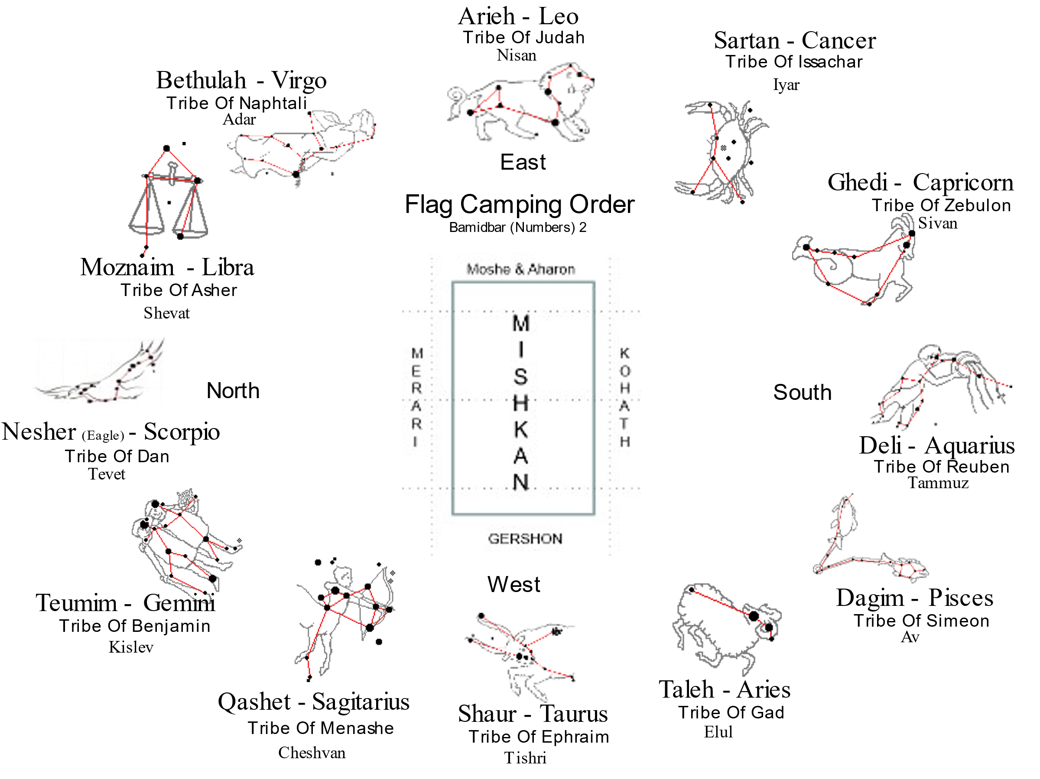

In the above example we have pictured the mazzalot, the constellations, on the ecliptic (aka zodiac). The mazzalot are surrounding the Mishkan, the Tabernacle in the wilderness. We will see an actual depiction of the camping order a bit later.

Rambam teaches us how our holy Sages taught the Maaseh merkava, the chariot:

Yesodei haTorah – 2:12 The Sages of the early generations commanded that these matters should not be explained except to a single individual [at a time]. He should be a wise man, who can reach understanding with his [powers of] knowledge. In such an instance, he is given fundamental points, and an outline of the concepts is made known to him. He [is expected to continue to contemplate] until he reaches understanding with his powers of knowledge and knows the ultimate meaning and depth of the concept.

These concepts are extremely deep, and not every [person has] the knowledge necessary to appreciate them. In his wisdom, Solomon described them with the metaphor [Proverbs 27:26]: "Lambs for your clothing." [The root kevas - "lamb" - also has the meaning "hide."] Thus, our Sages interpreted this metaphor [to mean]: Matters which are the secrets of the world will be your clothing - i.e., they will be for you alone, and you should not discuss them in public.

Concerning them, [Proverbs 5:17] teaches: "They shall be for you and not for others with you." [Similarly, the Song of Songs 4:11] states: "Honey and milk will be under your tongue." The Sages of the early generations interpreted this [as a metaphor]: Subjects that are like honey and milk should be [kept] under your tongue.

* * *

Chagigah 11b MISHNAH THE [SUBJECT OF] FORBIDDEN RELATIONS MAY NOT BE EXPOUNDED IN THE PRESENCE OF THREE, NOR THE WORK OF CREATION IN THE PRESENCE OF TWO, NOR [THE WORK OF] THE CHARIOT7 IN THE PRESENCE OF ONE, UNLESS HE IS A SAGE AND UNDERSTANDS OF HIS OWN KNOWLEDGE. WHOSOEVER SPECULATES UPON FOUR THINGS, A PITY8 FOR HIM! HE IS AS THOUGH HE HAD NOT COME INTO THE WORLD, [TO WIT], WHAT IS ABOVE,9 WHAT IS BENEATH,10 WHAT BEFORE, WHAT AFTER.11 AND WHOSOEVER TAKES NO THOUGHT FOR THE HONOUR OF HIS MAKER,12 IT WERE A MERCY13 IF HE HAD NOT COME INTO THE WORLD.

GEMARA. You say at first: NOR [THE WORK OF] THE CHARIOT IN THE PRESENCE OF ONE; and then you say: UNLESS HE IS A SAGE AND UNDERSTANDS OF HIS OWN KNOWLEDGE! — This is the meaning: the forbidden relations may not be expounded to three, nor the work of creation to two, nor [the work of] the chariot to one, unless he is a Sage and understands of his own knowledge.

Scorpion vs. Eagle

Scorpio is one of the water signs. Scorpio is associated with three different animals: the scorpion, the snake, and the eagle.

Many have said that Dan’s banner contained the image of a snake according to Yaakov’s blessing. But Rabbi Abraham ibn Ezra commented: "There were signs on each of the [four primary] standards. Thus the ancient’s sages said that on Reuben's standard there was a figure of a man decorated with mandrakes, and on Judah's standard there was the form of a lion, to which Jacob had compared him, and on Ephraim's standard was the figure of an ox, based upon [the expression that Moses used in speaking of that tribe], "the firstborn of his ox", and on Dan's standard was the figure of an eagle. Thus [the four signs on the four main standards] were similar to the four figures that the prophet Ezekiel saw [in the Divine Charriot]." It was understood that each tribe had its own banner in addition to the four main banners. The eagle was on the main banner and the snake was on Dan’s banner. [Adapted from Rabbi Dr. Charles Chavel's annotated translation of Rabbi Moshe ben Nachman's (Ramban) commentary on the Torah (Numbers 2:2).

Sir William Drummond asserted that in the zodiac which the patriarch Abraham knew it was an Eagle.

Unger’s Bible Dictionary: 'Dan's position in the journey was on the north of the Tabernacle, with Asherand Naphtali. The standard of the tribe was of white and red, and the crest upon it, an eagle, the great foeto serpents, which had been chosen by the leader instead of a serpent, because Jacob had compared Dan to a serpent. Ahiezer substituted the eagle, the destroyer of serpents, as he shrank from carrying an adder upon his flag.’

Yaaqob’s blessing to Dan, in Bereshit 49:17, symbolizes him by a type of snake called shefifon, which had wings in order to fly swiftly; Abarbanel explains that this is an eagle.
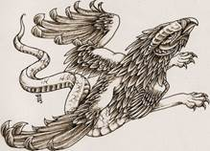
Rabbi Joel C Dobin, in his book, Kabblistic Astrology, teaches that in ancient times, Scorpios were depicted as being either eagles or serpents.

Rabbi Dobin was likely in part referring to the well known vision of 6th century BC Old Testament prophet Ezekiel - the "wheel within the wheel":

Yechezkel (Ezekiel) 1:4-10, 15-21 As I looked, a stormy wind came out of the north: a great cloud with brightness around it and fire flashing forth continually, and in the middle of the fire, something like gleaming amber. In the middle of it was something like four living creatures. This was their appearance: they were of human form. Each had four faces, and each of them had four wings... As for the appearance of their faces: the four had the face of a human being, the face of a lion on the right side, the face of an ox on the left side, and the face of an eagle...

As I looked at the living creatures, I saw a wheel on the earth beside the living creatures, one for each of the four of them. As for the appearance of the wheels and their construction: their appearance was like the gleaming of beryl; and the four had the same form, their construction being something like a wheel within a wheel. When they moved, they moved in any of the four directions without veering as they moved.

Their rims were tall and awesome, for the rims of all four were full of eyes all round. When the living creatures moved, the wheels moved beside them; and when the living creatures rose from the earth, the wheels rose. Wherever the spirit would go, they went, and the wheels rose along with them; for the spirit of the living creatures was in the wheels. When they moved, the others moved; when they stopped, the others stopped; and when they rose from the earth, the wheels rose along with them; for the spirit of the living creatures was in the wheels.

Jewish rabbinical scholars have historically tended to interpret Ezekiel's wheels in a grand cosmological sense, with certain rabbinical traditions teaching that Ezekiel was referring to the wheel of the Zodiac.

The four astrological elements of the Zodiac form a cross represented by the four creatures: Lion (Leo - fire), Eagle (Scorpio - water), Man (Aquarius - air), and Ox (Taurus - earth).

Torah Connections

When Yechezkel describes the movement of the creatures he emphasizes that as they rest, so they move: they have no need to turn in the direction in which the Merkava is headed: "And they went, each one straight ahead; to wherever their spirit was headed – there they would go; they did not turn as they went". The same interesting detail appears in connection with the Israelite camp and journeying: "As they camped, so did they journey: each person at his place, by their banners".

However, the Tannaim and Rishonim are divided in their interpretation of the above verse. The question is how this verse, according to which it appears that the order of the journey was the same order in which they encamped ("like an ark" – square formation), relates to the description of the journey in 10:11-28, where the text seems to describe a special order for journeying that is different from the order of encampment ("like a beam" – a long line). Either way, though, the formulation of the verse in chapter 2 ("as they camped, so did they journey") closely resembles the description of the creatures and the wheels of the Divine Chariot in Yechezkel's vision.

Finally, it should be noted that just as the camp of Israel was – as mentioned above – a military camp, so Yechezkel describes the bearers of the Merkava and the sound that they make: "And I heard the sound of their wings… like the sound of a [military] camp".

On the basis of this connection, I believe, we can begin to understand the profound significance of the camp of Israel. The tribes of Israel accompany the Divine Presence on its journey as a chariot for the Shekhina. So long as the Shekhina is on high, it is the holy creatures and wheels that accompany the Shekhina on its journeys, and they comprise its Chariot. But when HaShem chooses to make His Shekhina rest in the world, new escorts – an alternative Merkava – are required. HaShem's seat is the keruvim and the Mishkan that Israel builds by HaShem's command, and His escort is the nation of Israel, encamped "around the Mishkan," each person with his clan and by his banner.

The Patriarchs

Midrash Rabbah - Genesis XLVII:6 The Patriarchs are [God's] Heavenly Chariot. Thus it is written, AND GOD WENT UP FROM UPON ABRAHAM; again, And God went up from upon him; further, And, behold, the Lord stood upon him.

Bereshit (Genesis) 35:13 And God rose up over him.

Iggerot HaRambam, Iggeret Teiman 12

So did Abraham of blessed memory, who was designated the Pillar of the World, discover the First Cause of the entire universe, and demonstrated the central importance of the principle of the Unity of God for all mankind. He, Isaac and Jacob, all three of them, carry the throne of glory in their hearts, to make use of a rabbinical metaphor "The patriarchs are the chariots," (Genesis Rabbah 82:7), which in turn was suggested by the verse, "And God rose up over him." (Genesis 35:13).

The meaning is that they have attained a true conception of the Deity. Now the three patriarchs lived during the earthly trigon.This matter will become clear if the following facts are borne in mind. There is first, the smaller conjunction, that is, the meeting of Saturn with Jupiter, which occurs once in approximately twenty solar years. These conjunctions continue to take place twelve times within the same trigon, covering a period of two hundred and forty years. Then conjunctions take place in the second trigon, which occur every two hundred and forty solar years. The shift to the next trigon is known as the medium conjunction. According to this calculation an interval of nine hundred and sixty years will elapse between the first and second meeting of two planets in the same point of the Zodiac.13 This is termed the great conjunction, and occurs once in nine hundred and sixty years. This is the time that must elapse between the first and second meeting of Saturn and Jupiter in the same degree of Aries. If you will calculate back, you will understand my statement above that Abraham, Isaac and Jacob as well as David lived during the earthly trigon. My purpose in going into details was to dispel any suspicion of yours that the trigon exercises any influence upon human affairs. Furthermore you write that some people have calculated the forthcoming conjunction and have determined that all the seven planets will meet in one of the constellations of the Zodiac. This forecast is untrue, for no meeting of the seven planets will occur in the next conjunction, nor in the following ones. For such an event will not happen even in ten thousand years, as is well known to those who are familiar with the astronomical law of equation.

Yaaqob’s Bier

The Midrashim preserve some of the additional instructions Jacob gave his sons as his death approached:

"When you carry me up, do so reverently and respectfully; no one who is uncircumcised may touch my bier so as not to drive away the Divine Presence. Also, let no one of my descen- dants who married a Canaanite woman touch my bier. Let Judah, Issachar, and Zebulun be its bearers on the east; Reuben, Simeon, and Gad on the south; Ephraim, Manasseh, and Ben- jamin on the west; and Dan, Asher, and Naftali on the north. In a similar order will your tribes be grouped some time in the future under four standards in the desert with the Divine Presence in the center."

Jacob insisted that Joseph not carry his bier since he was a monarch; also that it would be improper for Levi — whose descendants were destined to carry the Holy Ark — to carry Jacob's remains.

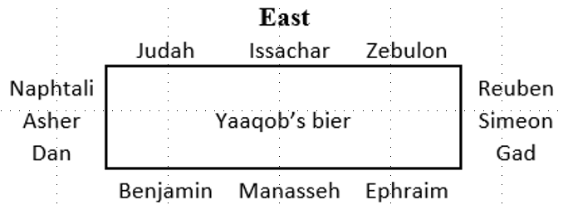
Midrash Rabbah - Numbers II:8 When the Holy One, blessed be He, told Moses, ‘Organise them [Israel] under standards in accordance with their desire,’ Moses began to feel distressed. He thought, ‘Now strife will arise among the tribes; for if I bid the tribe of Judah camp on the east side of the Tabernacle and he says, "I will accept only the south," and the same applies to Reuben and the same to Ephraim and to each of the other tribes, what am I to do?’ The Holy One, blessed be He, therefore said to him, ‘Moses, why should that trouble you? They have no need of you. They know their places full well themselves. They are in possession of a testament left them by Jacob their father, which tells them how to camp under their standards. I am not going to make any changes. They already have a traditional order from Jacob their father: in the same way that they disposed themselves round his bier, when they carried him, so shall they dispose themselves round the Tabernacle.’ For R. Hama, son of R. Hanina, said: When our father Jacob was about to depart from the world he summoned his sons--as it is written, And Jacob called unto his sons--and he blessed them and commanded them concerning the ways of God, and they acknowledged the Divine sovereignty. Having concluded his address, he said to them, ‘When you carry me to my last resting-place you must escort me with proper reverence and respect. No other man shall touch my bier; neither an Egyptian nor any of your children, because you have taken wives from the daughters of Canaan’ For this reason Scripture says, And his sons did unto him according as he commanded them; his ‘sons’ but not his ‘grandsons’. And his sons carried him. How did he command them to do it? He said to them: ‘My children, when my bier is being carried, Judah, Issachar, and Zebulun shall be on the east side; Reuben, Simeon, and Gad shall be on the south side; Ephraim, Manasseh, and Benjamin shall be on the west side; Dan, Asher, and Naphtali shall be on the north side; Joseph shall not carry at all, for he is a king and must be shown due honour; neither shall Levi carry because he will carry the ark, and he that is to carry the ark of Him who is the life of all worlds must not carry the coffin of the dead. If you will comply with these orders and carry my bier as I have commanded you, God will in the future cause you to camp beneath standards.’ When he died, they bore him as he had commanded them, as it is said, ‘And his sons did unto him according as he commanded them.’ Thus we can explain the verse [quoted above], ’I will fetch my knowledge from afar, and will ascribe righteousness to my Maker’; for it was from Jacob that they had obtained the knowledge how they were to camp under their standards. ’And will ascribe righteousness to my Maker,’ that is, to the Holy One, blessed be He, Who acted beneficently with Israel, and Who, in order to give them good reward for having fulfilled the command of their father, bade them camp under standards only in the manner in which their father had commanded them. Therein He acted with righteousness toward them, since He made no alteration, so as not to cause strife among them. This is the reason why it is said, ACCORDING TO THEIR FATHER'S HOUSE; in the same manner as they had disposed themselves around the bier of their father, so shall they camp. This explains the text, ACCORDING TO THEIR FATHER'S HOUSE SHALL THE CHILDREN OF ISRAEL CAMP.

Midrash Rabbah - Genesis XCVII AND WHEN JACOB MADE AN END OF CHARGING HIS SONS. What did he charge them? That three should carry his bier on the east side, three on the west, three on the north, and three on the south. Let none of your grandsons born from Canaanitish women carry my bier, he bade them. His sons accepted their father's charge, and his blessing was with perfect love, as it says, Every one according to his blessing he blessed them.

Midrash Rabbah - Genesis C:2 JACOB MADE AN END OF CHARGING HIS SONS; And his sons did unto him according as he commanded them. The first was an exhortation against idolatry, as in the verse, Because he willingly walked after zaw- idolatry; the second against blasphemy, as you read, And he that blasphemeth the name of the Lord, he shall surely be put to death. The third was in connection with the carrying of his bier: ‘See to it,’ he bade them, ‘that no uncircumcised person carries my bier, so that the Shechinah may not depart from me. Perform your offices for me in this order: Do three of you carry me on the north [of my bier], three on the south, three on the east, and three on the west. Even as ye will do for me, so will ye be formed into standards in the wilderness with the Shechinah in the middle.’

The Mishkan in the Wilderness

The camping order for the Bne Israel in the wilderness, mirrored the merkava, the chariot of Yechezkel’s vision. The four faces of the merkava were represented by the pictures on the standards, the banners, of the four main tribes. The four faces were:

"The likeness of their faces was like the face of a man (= flag of Reuven) with a

face of a lion on the right side of all four (= flag of Yehuda) and the

face of an ox on the left side of the four (= flag of Efraim) and all four also had the

face of an eagle (= flag of Dan)."

As we can see in the Torah, these faces matched the pitures on the standards of the four main tribes:

Bamidbar (Numbers) 2:2 'The children of Israel shall pitch by their fathers' houses; every man with his own standard, according to the ensigns; a good way off shall they pitch round about the tent of meeting. 3 Now those that pitch on the east side toward the sunrising shall be they of the standard (דֶּגֶל) of the camp of Judah, according to their hosts… 5 and those that pitch next unto him shall be the tribe of Issachar; … 7 and the tribe of Zebulun; … 9 all that were numbered of the camp of Judah being a hundred thousand and fourscore thousand and six thousand and four hundred, according to their hosts; they shall set forth first. … 10 On the south side shall be the standard (דֶּגֶל) of the camp of Reuben according to their hosts; … 12 and those that pitch next unto him shall be the tribe of Simeon; … 14 and the tribe of Gad; … 16 all that were numbered of the camp of Reuben being a hundred thousand and fifty and one thousand and four hundred and fifty, according to their hosts; and they shall set forth second. … 18 On the west side shall be the standard (דֶּגֶל) of the camp of Ephraim according to their hosts; … 20 and next unto him shall be the tribe of Manasseh; … 22 and the tribe of Benjamin; … 25 On the north side shall be the standard (דֶּגֶל) of the camp of Dan according to their hosts; … 27 and those that pitch next unto him shall be the tribe of Asher; … 29 and the tribe of Naphtali;

Ibn Ezra, discussing the special signs drawn on the
flags of the tribes, teaches:

"Our early sages taught that the banner of Reuven featured the figure of a man, symbolizing the deeper meaning of the 'dudaim;' the flag of Yehuda had the picture of a lion, for that was the image that Yaakov
used to describe him; the flag of Efraim showed an ox, since he was the 'eldest of an ox;' and the flag of Dan was decorated with the picture of an eagle. THUS THEY APPEARED LIKE THE KERUVIM SEEN BY THE PROPHET YECHEZKEL."
The tribes of Israel accompany the Divine Presence on its journey as a chariot for the Shekhina. So long as the Shekhina is on high, it is the holy creatures and wheels that accompany the Shekhina on its journeys, and they comprise its Chariot. But when HaShem chooses to make His Shekhina rest in the world, new escorts – an alternative Merkava – are required. HaShem's seat is the keruvim and the Mishkan that Israel builds by HaShem's command, and His escort is the nation of Israel, encamped "around the Mishkan," each person with his clan and by his banner.

The following illustration shows how Rabbi Aryeh Kaplan pictured the in his book, The Living Torah:

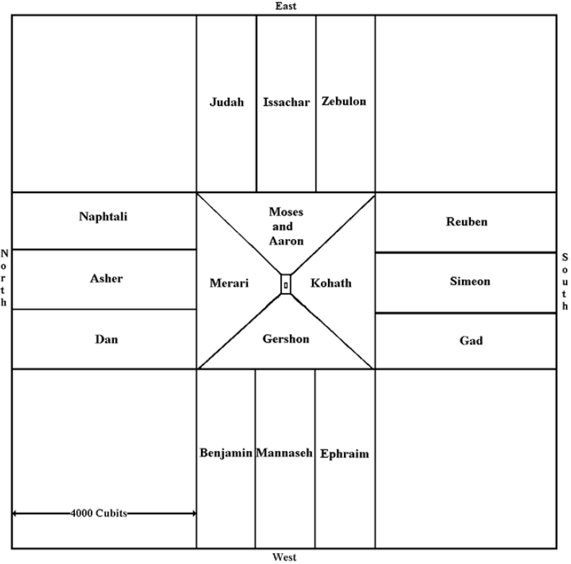

At Sinai

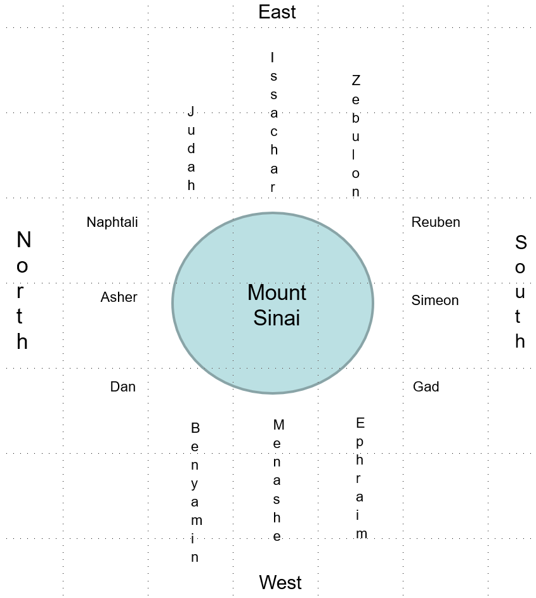

Ezekiel’s Merkava

Yechezkel (Ezekiel) 1:5-10 This was their appearance: they were human figures, but each one had four faces, and each one had four wings…. Their faces and their wings were alike on the four of them…. As for the likeness of their faces: each one had a human face [in the front]; each of the four had a lion's face to the right; each of the four had an ox's face to the left; and each of the four had an eagle's face [in the back].

Midrash Rabbah - Exodus XXIII:13 R. Abin said: Four kinds of exalted beings have been created in the world. The most exalted of all living creatures is man; of birds, the eagle; of cattle, the ox; and of wild beasts, the lion. All of these received royalty and had greatness bestowed upon them, and they are set under the chariot of God, as it says, As for the likeness of their faces, they had the face of a man; and they four had the face of a lion... and... also the face of an eagle (Ezek. I, 10).

Midrash Rabbah - The Song of Songs III:23 R. Berekiah and R. Bun in the name of R. Abbahu said: There are four lordly creatures. The lord among the birds is the eagle; the lord among cattle is the ox; the lord among beasts is the lion; and the lord over all of them is man. The Holy One, blessed be He, took them and engraved them the Throne of Glory …

On the 5th of Tammuz of the year 3332 from creation (429 BCE), Ezekiel, among the only prophets to prophesy outside of the Holy Land, beheld a vision of the Divine "Chariot" representing the spiritual infrastructure of creation.

The "Holy Creatures" here are the four celestial beings that bear the Divine Chariot.

Merkava in Revelation

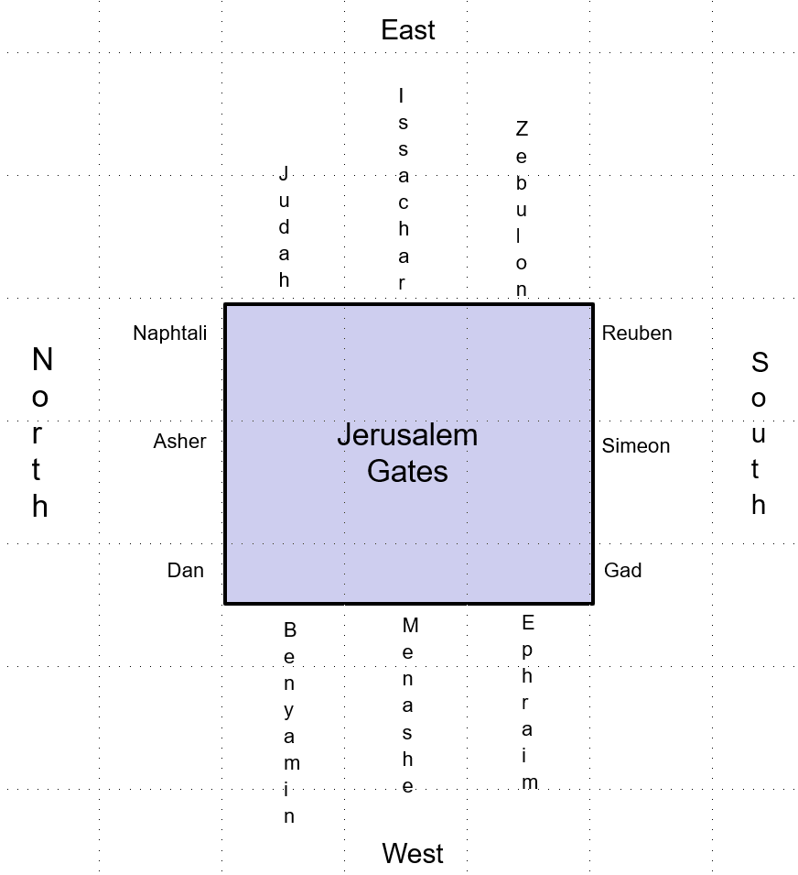
While the text of Revelation 21:12-13 does not tell us the names of the tribes for each gate, we can surmise, based on what we have learned, that the tribes must be arranged in the same manner that they were arranged around Yaaqob’s bier and around the Mishkan in the wilderness.

In The Mazzalot

Each of the Chariot faces also parallels the major constellations of the Zodiac: first is dli, “Aquarius”, with the face of a human. Three months later comes shor, “Taurus”, the bull or ox. Three months after that is aryeh, “Leo”, the lion. Finally, after another three months is ‘akrab, “Scorpio”, which in ancient times was alternately referred to as the “Eagle” constellation, nesher. The Zohar points out that the initials of these four constellations and their faces is shinan (שנא״ן), standing for shor, nesher, aryeh, and the nun sofit being representative of the complete human. This is the meaning of the cryptic statement in Psalms that “God’s Chariots are myriads, alfei shinan; God is among them, as in Sinai.” Just as at the Splitting of the Sea and at the Divine Revelation at Mt. Sinai that followed, when God “descended” into this world amongst myriads of Chariots, He continues to “mount the Cherubs and fly, gliding on the wings of the winds…”
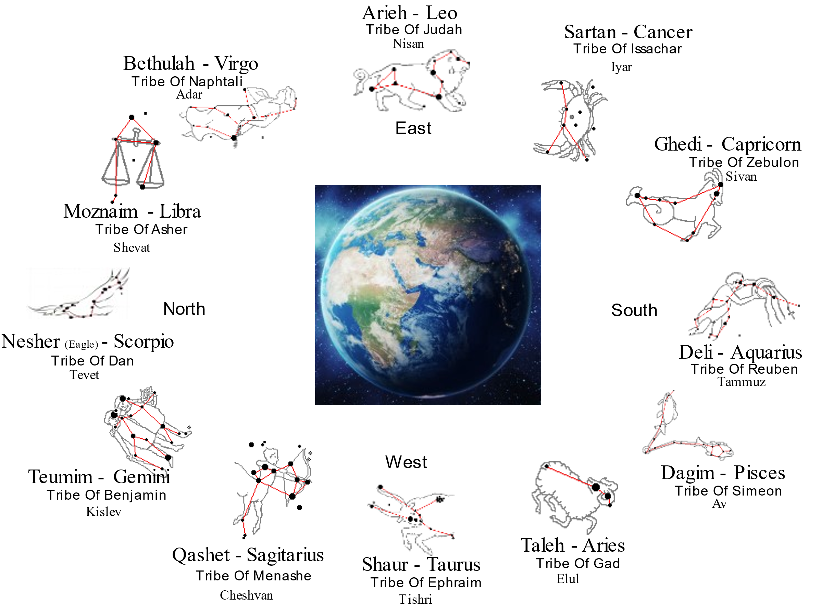

Contact Info:

* * *

This study was written by
Rabbi Dr. Hillel ben David (Greg Killian).
Comments may be submitted to:

Rabbi Dr. Greg Killian
12210 Luckey Summit
San Antonio, TX 78252

Internet address: gkilli@aol.com
Web page: https://www.betemunah.org/

(360) 918-2905

Return to The WATCHMAN home page
Send comments to Greg Killian at his email address: gkilli@aol.com

I.e., it is forbidden to expound this subject in the presence of more than two.
V. Gen. I, 1-3; J.E. vol. IV, pp. 280f,s. ‘Cosmogony’, and vol. VIII, p. 235. The term, בראשית מעשה (Work of Creation) does not include the whole Talmudic cosmogony, only its esoteric aspects. The cosmogonic details mentioned infra in the Gemara (pp. 63f), such as the ten elements, the ten agencies etc., do not form part of the secret doctrine of Ma'aseh Bere'shith, for the Mishnah expressly forbids the teaching of the creation mysteries in public. The views recorded in the Talmud regarding the work of creation seem to belong chiefly to the realm of Aggadah. As regards their origin, they cannot with certainty be connected with the theosophic and cosmogonic doctrines of the Apocrypha and Pseudepigrapha, nor with Gnosticism; nor on the other hand can the mysticism of the Geonic period (e.g., as preserved in Sefer Yezirah with reference to the heavenly halls, angelology etc.) be regarded as a direct continuation of the Talmudic doctrines.
This means, apparently, that a person is not permitted to study the mysteries of the Chariot even by himself, although the fact that he can study without the aid of a teacher shows that he is a Sage and understands of his own knowledge.
I.e.,the number refers to the pupils and does not include the teacher.
I.e., is able to speculate by himself. Such a disciple will not require to ask his teacher questions, for these mysteries may not be explained explicitly.
As related by Prof. Yonatan Grossman in https://etzion.org.il/en/tanakh/torah/sefer-bamidbar/parashat-bamidbar/bamidbar-how-good-are-your-tents-yaakov-organization
Yechezkel (Ezekiel) 1:12
Likewise in verse 9. This emphasis is repeated in the description of the relationship between the wheels and these creatures in verses 20-21.
Bamidbar (Numbers) 2:17
See, for example, Talmud Yerushalmi, Eruvin 5:5.
Yechezkel (Ezekiel) 1:24
Bereshit (Genesis) 35:13
Bereshit (Genesis) 38:13
In these verses על is translated literally ' upon ‘, as though, as it were, God rode upon them. The idea is that through the Patriarchs the knowledge of God was diffused among all peoples.
The ArtScroll Tanach Series, Bereishis, translation and commentary by Rabbi Meir, Zlotowitz, overviews by Rabbi Nosson Scherman, Published by Mesorah Publications, ltd, volume 1b, page 2194.
See Tanchuma ad loc.
Bereshit (Genesis) 49:10
A contradiction of the statement in Pir. R. El. XXXIX ab init., which asserts that in order to avoid inter-marriage with the Canaanites all Jacob's sons had married their sisters and kinswomen (Mah.). Tan. reads: ‘because there are some among them (i.e. among their children) who have married daughters of Canaan.’
Bereshit (Genesis) 50:12
Bereshit (Genesis) 50:13
‘Coffin’ and ‘ark’ are expressed by the same word in Hebrew.
The inference is drawn from the use of the expression פועלי rather than יוצרי, the former denoting ‘reward’ or ‘recompense’; cf. Lev. XIX,, and Isa. XL, 10.
Bereshit (Genesis) 49:33
Th. thinks this an error for ‘sons’, Jacob's sons themselves having married Canaanitish women (in accordance with R. Nehemiah's view, supra, LXXXIV, 21).
They were not necessarily all born from Canaanitish women, but Jacob did not wish to discriminate.
Bereshit (Genesis) 49:28
Bereshit (Genesis) 50:12
Hoshea (Hosea) 5:11
The Midrash connects ate with ziwwah ‘he charged,’ ‘commanded.’ E.V. ‘filth ’.
Vayikra (Leviticus) 24:16
Though he was not really afraid that his sons would lapse into idolatry and blasphemy, he charged them on account of their children, who might be corrupted by their Egyptian environment.
You will be grouped in the wilderness in the same order. Cf. supra. XCVII (NV), p. 911 - Num. R. II, 8.
Yechezkel (Ezekiel) 1:10 - The correlation between the pictures on the flags and the faces of the creatures in the Merkava is so complete and so clear that the Ibn Ezra seems to have solid reason for comparing the camp of Israel on the four sides of the Mishkan to the adornment of the Shekhina in the Divine Chariot by the four creatures.
It should be noted that one of the differences between the Ibn Ezra and the version in the Midrash concerns the picture on the flag of Dan. According to the midrash, the picture featured a snake, while Ibn Ezra writes "the form of an eagle" – in accordance with the description of the Divine Chariot.
It should be noted that one of the differences between the Ibn Ezra and the version in the Midrash concerns the picture on the flag of Dan. According to the midrash, the picture featured a snake, while Ibn Ezra writes "the form of an eagle" – in accordance with the description of the Divine Chariot.
Zohar I, 24a
Tehillim (Psalms) 68:18
Tehillim (Psalms) Psalm 18:11

