hline

**A Star Shall Shoot Forth out of Yaaqob**

By Rabbi Dr. Hillel ben David (Greg Killian)

hline

I. Astrology 1

Jupiter-Saturn Conjunctions 2

Israel’s sign in the Zodiac 3

II. Spheres 6

III. The Flood 6

IV. A Star Out of Yaaqob 6

PaRDeS 7

V. Bar Kokhba – Son of a Star 8

VI. The Star of Avraham 9

VII. The Bne Israel 12

VIII. Mashiach 12

The Star in the East 14

East 17

In Revelation 19

IX. The Star of Mashiach – In the Zohar 19

X. Jupiter- Saturn Conjunctions 27

Ibn Ezra 31

XI. Teli 35

XII. Mishkan - Aligning the firmament 37

XIII. In the Midrash 38

XIV. The Star of Bethlehem 39

XV. The Magi 40

XVI. NASA – Planet nine – Planet X 41

XVII. Nibiru, the planet of the Anunnaki 46

XVIII. Meroz 53

XIX. 400 Years or 2000 Years 54

XX. From the Ramchal 56

XXI. Songs 57

XXII. When will see this star? 58

hline

# I. Astrology

Changing your name causes a change in your destiny and outcome.

Michael is Israel’s arch-angel and is associated with Tzedek (**Jupiter**).

The stars are ‘indicative’ but they are not ‘predicative’.

Genesis 34:25 Shimeon and Levi

***Bereshit (Genesis) 34:13*** *And the sons of Jacob answered Shechem and Hamor his father with guile (cleverly), and spoke, because he had defiled Dinah their sister,*

Rashi explains that the third day of creation isn’t conducive to fasting because it is inherently a weak day. As a source for this idea, Rashi cites the aforementioned episode involving the townsmen killed by Shimon and Levi. Rav Yehudah Wagschal of Yeshivas Mir in Yerushalayim points out that Rashi is teaching us that the pain experienced on the third day is not due to the natural healing process as one might have assumed, but rather because brit milah (circumcision) is considered a form of creation, and somebody who has been circumcised is therefore weakest at that time.

Rav Dovid suggested that a person’s true birthday is not the day on which he is born physically, but rather the day of his bris milah, at which time he is born spiritually. Although the Gemara’s source for this teaching is Moshe, who died on the day of his birth (7 Adar), this can be explained by the fact that Moshe was born already circumcised. Rav Dovid concluded that with this new interpretation, it’s not surprising to note that HaRav Chaim Volozhiner died one week after his birthday, precisely on the day of his brit. We see from here that brit milah isn’t just a mitzvah, but as Rashi writes, it is considered the creation and birth of the person.

Abraham, on the third day of his circumcision, was eager to meet guests. Therefore, *despite* his great joy and spiritual elation, Avraham *forced himself* to be aware of the natural pain which his body was experiencing,[1] so that HaShem's covenant should penetrate the physical body.

Rashi explains that the Bne Yaakov attacked specifically on the third day after milah because on that day the pain was most intense and the people would be unable to fight back. The Rishonim[2] prove from the Gemara in Shabbat that the pain on the first two days is no less intense than on the third day. So why did Shimon and Levi wait? The Ksav v’Kabbalah answers that the key word is “koavim (pain) - כֹּאֲבִים”. What kind of pain are we talking about? A person doesn’t feel physical pain from too much knowledge -- what he/she feels is psychological pain, worry. On the third day after the milah the people of Shechem were in no more pain than on the first two days, but their attitude, their psychology, changed. They were now “koavim” because they had buyer’s remorse and regretted the whole deal. Shimon and Levi were attuned to this shift in attitude that proved the whole conversion was false, and therefore they attacked.

The city of Shechem, on the third day of their circumcision, were in great pain. From this pain, Shimeon and Levy determined that the men of Shechem had not repented and were not righteous, but rather they were rapists and murderers and deserved to die.

Ohr HaChayim: The Shulchan Aruch rules that "friends and relatives are allowed to visit a sick person immediately, whereas others must wait three days".[3] The reason for this is because the immediate presence of anyone but a friend or relative would publicly declare the person as being sick, which is not good for his mazal (fortune).

"In*Bereshit (Genesis) 34* the Torah records how Shechem, the son of Chamor the Chivite, kidnapped Dena, the daughter of Yaakov, and violated her. The sons of Yaakov heard about this violation and they were incensed. The Torah then records how Shimon and Levi, the two sons of Yaakov, slaughtered the entire city of Shechem and released Dena from captivity. It is noteworthy that in the response to Shechem and his father, the Torah states that the sons of Yaakov answered “cleverly.” Rashi cites the Targum who renders the word bimirmah, normally translated as deceitfully, to mean bichochma, with wisdom. One must wonder why the Torah did not merely use the word bichochma if the meaning of bimirmah is with wisdom. This question is also relevant regarding the episode where Yaakov received the blessings from Yitzchak, and Esav felt like he was cheated. It is said (Bereshit 27:35) vayomer ba achicha bimirmah vayikach birchasecha, but he said, “Your brother came with cleverness and took your blessing.” Rashi there also cites the Targum who renders the word bimirmah as bichochma, with wisdom. As we mentioned previously, it needs to be understood why the Torah did not merely use the word bichochma.

The blessings that Yaakov received and the punishment meted out to the city of Shechem were acts of wisdom, i.e. creation of the Jewish People.

## Jupiter-Saturn Conjunctions

Astrology had grouped the 12 zodiacal constellations into four collections called "triplicities!" or Trigons. These triplicities, and their associated "elements" are:

Aries, Leo, and Sagittarius………….......Fire  
Taurus, Virgo and Capricornus…………Earth  
Gemini, Libra and Aquarius……………..Air  
Cancer, Scorpius and Pisces …………..Water

Successive great conjunctions of Jupiter and Saturn will remain in one triplicity about 200 years (10 successive conjunctions). In other words, it will take 800 years or 40 successive great conjunctions to pass through the four triplicities once. However, in order for all the great conjunctions to return, the cycle must be repeated two more times, for a total of 2400 years.

According to Kepler, great worldly events thus took place in this manner every 800 years when great conjunctions entered a Fiery Triplicity.

|  |  |  |
| --- | --- | --- |
| CE Years | AM Years |  |
| 4000 | 1 | Adam Creato mundi |
| 3200 | 874 | Enoch Latrocinia, urbes, artes, tyrannis (Lemech II was born) |
| 2400 | 1656 | Noah Diluvium |
| 1600 | 2448 | Moses Exitus es Aegypto, Lex |
| 800 | 3205 | Isaiah Aera, Graecorum, Babyloniorum, Romanorum (10 tribes exiled) |
| 0 | 3761 | Christ Monarchia Romana Reformatio orbis |
| 800 |  | Carolus Magnus Imperium Occidentis et Saracenorum |
| 1600 |  | Rudolfus II Vita, facta et vota nostra qui haec disserimus.[4] |
| 2400 |  | Ubi tunc nos et mode florentissima nostra Germania? Et quin am sueccssores nostri? an et memores nostri erunt? Siquidem mundus duraverit. |

In relation to the fixed stars, it takes about 854 or 913 years for the event to return to a point near the start of the sequence. Some scholars have given it as 960 years.

…

Relative to the fixed stars, it usually takes about 913 years (46 conjunction intervals), or about 854 years (43 conjunction intervals).

## Israel’s sign in the Zodiac

*Dli – Aquarius[5]*

The sign of the Jewish People is the Dli (Aquarius) which means 'bucket'.[6] What is the connection between the Jewish People and a bucket? Just as the only purpose of a bucket is to be a vessel to carry water, so too the only purpose of the Jewish People is to be the 'Water Carrier' - the vessel of the living waters of the Torah. Just as a person cannot live without water, so the Jewish Pe3ople cannot survive without the Torah. When we look at our history, it is clear that what has kept us a nation during 2,000 years of diaspora has been our devotion to the Torah and our precise observance of it. Also, just as water always finds the lowest level, so the Torah can only be absorbed by someone who is truly humble.

If Aquarius is the sign of the Jewish People, how come the Talmud tells us that 'Israel has no sign'? Everything that happens in the physical world is initiated in the highest realms and then given over by the Creator to the stars to transmit to this world. Every person and every nation come under the sway of this influence. However, at any time and in any way, HaShem can choose to override this system.

When we align ourselves with the Will of the Creator by keeping His Torah, we elevate ourselves above the natural chain of command that the stars transmit. We are on a direct line to "The Boss". But when we ignore Hashem and His Torah, then He, as it were, doesn't pick up His direct line, and we have to go through the switchboard like everybody else![7]

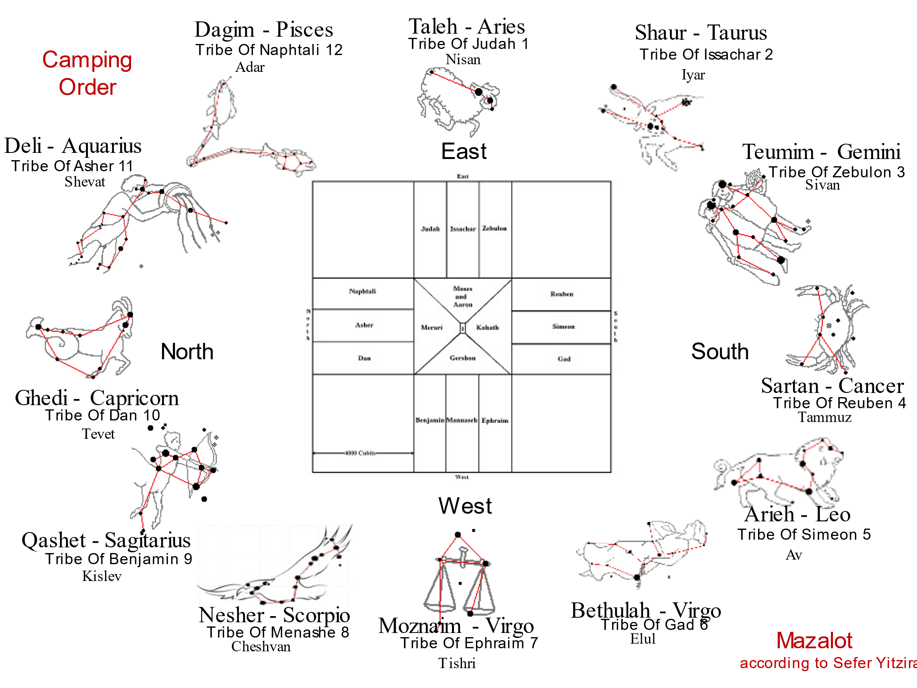

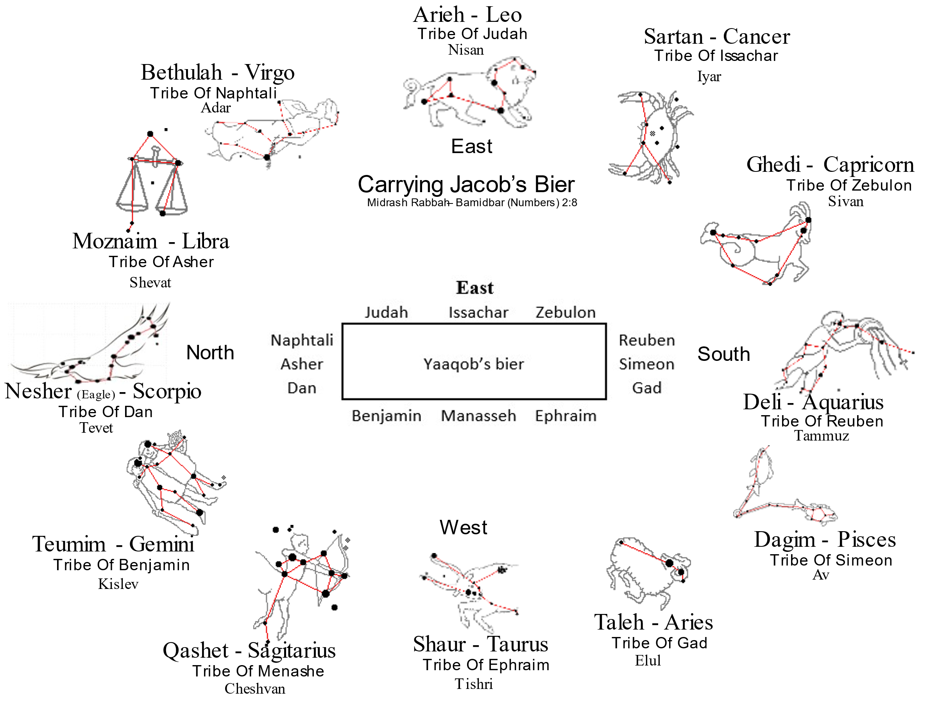

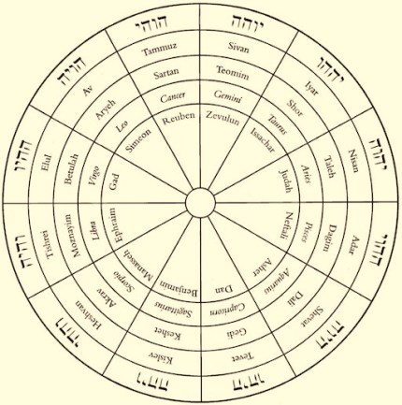

# II. Spheres

**Yesodei haTorah - Chapter Three[8]**

[**1**](https://www.chabad.org/library/article_cdo/aid/904969/jewish/Yesodei-haTorah-Chapter-Three.htm#v1) The spheres are called the heavens, the firmament, the habitation, the skies.

There are nine spheres. The closest sphere is the sphere of the moon. The second sphere, which is above it, is the sphere which contains the planet *Kochav.[9]* The third sphere, which is above it, contains [the planet] *Nogah.[10]* The fourth sphere contains the sun. The fifth sphere contains [the planet] *Ma'dim.[11]* The sixth sphere contains the planet *Tzedek.[12]* The seventh sphere contains [the planet] *Shabbtai.[13]* The eighth sphere contains all the stars which are seen in the sky. The ninth sphere is the sphere which revolves each day from the east to the west.[14] It surrounds and encompasses everything.

The planets and stars all appear to be in one sphere, even though one is higher than another. This is because the spheres are pure and refined like glass or sapphire. Therefore, the stars in the eighth sphere appear lower than the first sphere.

# III. The Flood

To cause the flood, HaShem took two stars.

***Berachoth 59a*** *What is meant by Kimah [Pleiades]?[15] Samuel said: About a hundred [ke'me-ah] stars. Some say they are close together; others say that they are scattered. What is meant by ‘’Ash [the Bear]’?[16] — Rab Judah said: Jutha. What is Jutha? — Some say it is the tail of the Ram; others say it is the hand of the Calf.[17] The one who says it is the tail of the Ram is more probably right, since it says: ‘Ayish will be comforted for her children.[18] This shows that it lacks something, and in fact it looks like a piece torn off;[19] and the reason why she follows her is because she is saying to her: Give me my children. For at the time when the Holy One, blessed be He, wanted to bring a flood upon the world, He took two stars from Kimah and brought a flood upon the world. And when He wanted to stop it, He took two stars from ‘Ayish and stopped it. But why did He not put the other two back? — A pit cannot be filled with its own clods; or another reason is, the accuser cannot become advocate. Then He should have created two other stars for it? — There is nothing new under the sun.[20] R. Nahman said: The Holy one, blessed be He, will one day restore them to her, as it says: and ‘Ayish will be comforted for her children.[21]*

# IV. A Star Out of Yaaqob

***Bamidbar (Numbers) 24:14-19*** *"And now," said Bilaam, "I am returning to my people. Let me counsel you as to what this nation shall do to your people at the end of days!" He (Bilaam) proclaimed his oracle and said: "These are the words of Bilaam son of Be'or, the words of the man with the seeing eye. This is the pronouncement of the one who heard the words of the Almighty, who knows the knowledge of the Most High, who perceived a vision of the All Powerful, falling down but with open eyes. I see him but not now, I gaze upon him but not soon. A star will shoot forth out of Yaaqob, a scepter shall rise from Yisrael, who shall crush the princes of Moab and demolish all of Shet's descendants. Edom shall be their inheritance, Se'ir their enemies shall be their inheritance, and Israel shall be triumphant. A ruler shall issue forth from Yaakov, and he shall destroy the remnant of the city…".*

**The Targum of Onkelos** translates the whole passage thus: *“I shall see him, but not now: I shall behold him, but he is not near. When a king shall arise from the house of Jacob, and the Messiah be anointed from the house of Israel, he shall slay the princes of Moab, and rule over all the children of men; And Edom shall be an inheritance, and Seir a possession of his adversaries. But Israel shall prosper in riches.One will descend from the house of Jacob, who will destroy him that escapes from the city of the peoples.”*

**The Jerusalem Targum** is a little different: *“A king shall arise from the house of Jacob, a redeemer and governor from the house of Israel, who shall slay the chiefs of the Moabites, and empty out and destroy all the children of the East”.*

The Ramban, R’ Moshe ben Nachman (1194 CE -1270 CE) states: “THERE SHALL STEP FORTH A STAR OUT OF JACOB. *Because the Messiah will gather together the dispersed of Israel from all corners of the earth, Balaam compares him [metaphorically] to a star that passes through the firmament from the ends of heaven, just as it is said about [the Messiah]: and behold, there came with the clouds of heaven, one like unto a son of man etc.”*

## PaRDeS

At the Pshat level, a star is a one of those points of light in the night sky. A star is a massive luminous sphere of plasma, an incredible thermonuclear reactor made of helium and hydrogen. A star could also be understood as a planet or any other radiant light body in space.

At the Remez level, a star is an allegory for the Bne Israel in the performance of the mitzvot.

At the Drash level, a star as is a parable of the David, the king of Israel.

At the sod level, a star mystically refers to an angel at one level, and at another level to Mashiach and His ultimate rule. Consider the following pasuk:

***Revelation 1:20*** *The mystery of the seven stars which thou sawest in my right hand, and the seven golden candlesticks. The seven stars are the angels of the seven churches:[22] and the seven candlesticks which thou sawest are the seven churches.*

Here we see stars as being angels. In the passage, above, in Bamidbar clearly speaks of the Messiah as a star that shoots forth from Jacob.

The connection between the planet Nibiru – also known as Planet X – and End of Days has been discussed with increasingly seriousness by a wide range of Jewish scholars.

The words of Rabbi Shimon bar Yochai, 2nd century sage and author of theZohar. “The task is to remain in emunah during this time. We’re going to see things happening that we don’t have any way of understanding. It’s going to be things that are beyond belief. It’s going to make the Exodus from Egypt look like nothing. Every day it’s going to be worse and we’re going to forget what it was like the day before. Whoever hasemunah at this time will merit to see the end.”

# V. Bar Kokhba – Son of a Star

I included this topic because I was wondering whether Shimon bar Kosiba was given the name “bar Kokhba” because of the star of Bethlehem. Remember that at the time of Yeshua, some 50 or 60 years earlier, there were messianic expectations:

***Mordechai (Luke) 3:15*** *And as the people were in expectation, and all men mused in their hearts of John, whether he were the Mashiach, or not;*

Shimon bar Kokhba (born Shimon bar Kosiba - שמעון בן כוסבא‎) - שמעון בר כוכבא, led a Jewish revolt against the Roman Empire in the years 132-135 CE. After the failure of the revolt, the rabbinical writers referred to bar Kokhba as "Shimon bar Kozeba" (בר כוזיבא‎, or "Son of the disappointment").

Beitar fell to the Romans on Tisha B’Ab, the ninth day of the month of Ab, in 135 CE, adding it to calamitous national tragedies of the Jewish people.[23]

It was Rabbi Akiva ben Joseph who ascribed to Shimon bar Kochba the famous messianic verse: “A star will shoot forth from Jacob” (Numbers 24:17). That is how he got the name “Kochba,” which means “star.” In essence, Rabbi Akiva crowned him the Messiah. Rabbi Akiva was so widely respected among the people that if he saw in Shimon messianic qualities then the people immediately elevated him to the level of the Messiah.

Simeon bar Kosiba was given the sobriquet *Bar Kokhba*, “Son of a Star,” was given to him in accord with:

***Bamidbar (Numbers) 24:17*** *I see him, but not now; I behold him, but not nigh; there shall step forth a star out of Jacob, and a scepter shall rise out of Israel, and shall smite through the corners of Moab, and break down all the sons of Seth.*

This was taken to refer to the messiah.

Bar Kochba accused the great sage, Rabbi Elazar, of being the spy that betrayed Beitar and executed him. He then lost the support of the rabbis completely. It eroded all chance of reconciliation. Then they began calling him, “Bar Koziba,” meaning the son of a lie; a false messiah. Their hopes were dashed.

*It was all forecast 3,300 years ago by Bilaam the gentile prophet in Parshas Balak.* ***דרך כוכב מיעקוב --*** *"When the star of Yaakov is on its pathway towards the earth" -- is that exact prediction. When the star of Yaakov is en route...then* ***קם שבט מישראל.****.. Mashiach Ben Yoseph will rise up.*

*[](https://1.bp.blogspot.com/-6aD-ALlHVRs/Vtqo8fUX5UI/AAAAAAAAL6o/N44Sy0FLVrQ/s1600/jacks.jpg)The Ramak,* ***Rabbi Moshe Cordevero****, classically and clearly explains the Zohar on this key pasuk [****Balak 212b****] in such detail that he even draws a picture of how the star will look. Remember we used to play with Jacks? That's precisely what he drew. A star with several smaller bodies surrounding it with 70 rays of light streaming out of [Nibiru] connecting itself to each body surrounding the star.*

*This display will be seen above the earth when he states that all will marvel at the following event: The rays of light will gradually [over 70 days] swallow each of the seven smaller bodies that will be absorbed into this Star [I believe this represents the seven continents].*

*The whole world will see this happen and will indeed panic but know this is from Hashem who is arranging this display because of us - Yaakov [Yisroel] since he had a family of 70 vs. the 70 nations of the world.*

*I believe scientists and astrologers may attempt to explain it away as a "natural phenomena" saying it is either turning into a black hole or going supernova - but they will try to explain it away when it is anything but a "natural " occurrence.*

*Immediately after this they will be overcome by Mashiach -- the True Star after the 70 days of viewing this heavenly display.*

*The Ramak even gives the date: the* ***25th day of the six month*** *-* [*כה׳ אלול*](http://www.chabad.org/calendar/view/day.asp?hdate=6/25&id=156820)  *[****Elul 25*** *- since that was the date of creation, so HASHEM will begin this display just prior to a briah chadasha - new creation coming.''*

**Maimonides’ Mishneh Torah,**

**Laws of Kings 11–12**

There shall shoot forth a star out of Jacob . . . (24:17)

The melech haMashiach (“anointed king”) is destined to arise and restore the kingdom of David to its glory of old, to its original sovereignty. He will build the Holy Temple and gather the dispersed of Israel. In his times, all the laws of the Torah will be reinstated as before; the sacrifices will be offered, the Sabbatical year and the Jubilee year instituted as outlined in the Torah.

Whoever does not believe in him or does not anticipate his coming, denies not only the other prophets but also the Torah and Moses. For the Torah testifies about him: “G‑d shall return your captivity. . . . He will return and gather you from all the nations amongst whom the L‑rd your G‑d has scattered you. If your outcasts shall be at the ends of the heavens, from there will the L‑rd your G‑d gather you, from there He will take you. . . . G‑d will bring you to the Land . . .” (Deuteronomy 30:3–5). These explicit words of the Torah encapsulate all that has been said (concerning Mashiach) by the prophets.

Also in the story of Balaam is it spoken of, and there it is prophesied on, the two “anointed ones”: the first Mashiach, who is David, who saved Israel from its enemies; and the last Mashiach, who shall be of his descendants, who will save Israel in the end [of the exile]. There he says:

“I see him, but not now”—this is David;

“I behold him, but he is not near”—this is the King Mashiach;

“There shall shoot forth a star out of Jacob”—this is David;

“And a scepter shall rise out of Israel”—this is the King Mashiach;

“And shall smite the corners of Moab”—this is David, as it is written (II Samuel 8:2), “He smote Moab, and he measured them with a line”;

“And rule over all the children of Seth”—this is the King Mashiach, as it is written (Zachariah 9:10), “And his dominion shall be from sea to sea” . . .

As for the books of the prophets, one need not cite references [to Mashiach], for all the books are full of this . . .

If there arises a king from the house of David, who studies the Torah and fulfills its precepts . . . who will prevail upon all of Israel to follow it and repair its breaches, and will wage the battles of G‑d—he is presumed to be Mashiach. If he did so and was successful, and he built the Holy Temple on its site and gathered the dispersed of Israel—he is certainly Mashiach. He will correct the entire world to serve G‑d together, as is written (Zephaniah 3:9): “For then I shall turn to the nations a pure tongue, that all shall call upon the name of G‑d to serve Him as one” . . .

The sages and the prophets did not crave the era of Mashiach in order to rule over the world . . . or to eat, drink and rejoice; but only so that they be free for Torah and its wisdom, and be rid of any oppressor and disrupter . . .

At that time there will be no hunger or war, no jealousy or rivalry. For the good will be plentiful, and all delicacies available as dust. The entire occupation of the world will be only to know G‑d. . . . Israel will be of great wisdom; they will perceive the esoteric truths and comprehend their Creator’s wisdom as is the capacity of man. As it is written (Isaiah 11:9): “For the earth shall be filled with the knowledge of G‑d, as the waters cover the sea.”

# VI. The Star of Avraham

In the year of Avraham’s birth, according to tradition, knowledge of HaShem was scarce among men, and certain forces in the Near East wished to keep things that way. Stories collected in medieval times, later published under the title Ma'asei Avraham Avinu (“Deeds of Abraham Our Father”), recall his birth as being marked by a star rising in the east, consuming other stars.[24]

When Abraham was born

a star rose in the east

swallowed the four stars of the four winds of heaven –

to the east

to the north

to the west

to the south

Avraham’s star

a star of the east

swallowed the four directions.

There is a tradition regarding Abraham, that at his birth, there was a star in the East…

***Beit HaMidrash 2:118-196*** *When our father Abraham was born, a star rose in the east and swallowed four stars in the four corners of heaven. Nimrod’s wizards said to him: To Terah, at this hour, a son has been born, out of whom will issue a people destined to inherit this world and the world-to-come. With your permission, let his father be given a house full of silver and gold, on condition that his newly born son be slain.[25]*

For twenty centuries darkness and desolation enveloped the earth, when the star of Avraham shone forth from the East. Who can appraise the extent of his merits?

The night before Abram was born, Nimrod’s astrologers were gathered at Terah’s house. Looking out into the night sky, they read in the constellation of the stars that the newly born child was to become the chief and the father of a mighty nation. This discovery was communicated to Nimrod, who became afraid that the new star might darken his own.[26]

Sefer HaYashar also tells us about this star:

*And in the night that Abram was born, all the servants of Terah and all the wise men and the ‎astrologers of Nimrod came, and they ate and drank in the house of Terah and they were ‎greatly rejoiced all night. And when the wise men and the astrologers left Terah's house they ‎lifted up their eyes unto heaven on that night to observe the stars; and* ***behold a very large ‎star came from the rising of the sun and ran about in the heavens and swallowed up four stars ‎from the four winds of heaven****. And the wise men and the astrologers were greatly astonished ‎at that spectacle, and the wise men reflected over the matter and they knew its meaning at ‎once. And they said to each other: This cannot be otherwise but in reference to the child that ‎was born unto Terah, that he will be great and that he will be increased and exceedingly ‎multiplied, and that he will inherit all the earth, he and his children forever, and that he and his ‎seed will slay great kings and possess themselves of their lands.*

*And all the wise men, and all ‎the astrologers, went quietly to their homes that night. And in the morning they arose, and all ‎the wise men and all the astrologers assembled in the house appointed for their meetings, ‎and they spoke among themselves saying: Behold the sight we have seen last night is not ‎known, and it hath not been communicated unto the king. And now if the king should come to ‎the knowledge of that matter at some future time, then he will say unto us: Why have ye ‎withheld from me all those things? and all of us will have to die on that account. And now ‎come and let us impart to the king all about the sight we have seen last night, as well as its ‎interpretation, so that we may be free of all responsibility. And they did accordingly, and they ‎went unto the king, and coming unto his presence, they bowed down before him to the ‎ground and saluted him saying: May the king live, may the king live!*

*We have been informed ‎that a son hath been born unto Terah thy chief commander, and we went unto his house last ‎night, and we were eating and drinking and rejoicing in his house all night. And when we, thy ‎servants, departed from the house of Terah, so that each of us should go to his home for the ‎rest of the night, we lifted up our eyes towards heaven and beheld* ***a very great star coming ‎from the side of the rising of the sun in a very swift course, and it swallowed up four great ‎stars*** *from the four winds of the heaven. And we, thy servants, were greatly astonished at that ‎strange sight which we have seen, and we were greatly terrified thereat. And we passed our ‎judgment over that strange phenomenon, and we discovered in our wisdom the ‎interpretation of that spectacle in its correctness. For this all was seen on account of the child ‎which was born unto Terah, meaning, that he would become great and very numerous, and ‎powerful, and that he would slay all the kings and inherit their lands, he and his children and ‎his seed forever. And now, oh king our lord, we have informed thee correctly of what we have ‎seen concerning that child, and if it so please the king we would say, that the king give unto ‎Terah the value of that child, and we will slay him ere he grows up and increases in the land, to ‎bring about the great evil, whereby we are all to be driven from the earth, and we, and our ‎children, and our seed perish through his wickedness. ‎*

The children of Israel are likened to stars:

***Bereshit (Genesis) 15:5-6*** *And he brought him outside and said, “Look toward heaven, and number the stars, if you are able to number them.” Then he said to him, “So shall your offspring be.” And he believed HaShem, and he counted it to him as righteousness.*

Though twinkling stars appear small, they are blazing sources of immense power. Deuteronomy says:

***Debarim (Deuteronomy) 1:10*** *HaShem your God has multiplied you, and behold, you are this day as the stars of the sky for multitude.*

**Rashi on Deuteronomy 1:10**: “But were they ( the Israelites ) on that day as ( many as ) the stars of the heavens? Were they not only six hundred thousand? What, then, is [the meaning of] “And, behold, you are today…?” [It means]-Behold, you are compared to the sun, [signifying that you will] exist forever as do the sun, the moon, and the stars (cf. Sifrei).”

According to Rashi, R’ Shlomo Yitzhaki, R’ HaShem lifted up Abraham above the stars, and told him to look down on them:

***Midrash Rabbah - Genesis XLIV:12*** *AND HE BROUGHT HIM FORTH WITHOUT- HA - HUZAH (XV, 5). R. Joshua said in R. Levi's name: Did He then lead him forth without the world, that it says, AND HE BROUGHT HIM FORTH WITHOUT? It means, however, that He showed him the streets of heaven, as you read, While as yet He had not made the earth, nor the outer spaces-huzoth.[27] [28] R. Judah b. R. Simon said in R. Johanan's name: He lifted him up above the vault of heaven; hence He says to him, LOOK (HABBET) NOW TOWARD HEAVEN, HABBET signifying to look down from above.[29]*

Rashi on Genesis 15:5 **And He took him outside:** According to its simple meaning: He took him out of his tent, outdoors, to see the stars. But according to its midrashic interpretation, He said to him, “Go out of your astrology,” for you have seen in the signs of the zodiac that you are not destined to have a son. Indeed, Abram will have no son, but Abraham will have a son. Similarly, Sarai will not give birth, but Sarah will give birth. I will give you another name, and your destiny will change.[30] Another explanation: He took him out of the terrestrial sphere and lifted him above the stars. This explains the expression of הַבָּטָה, looking down from above.[31]

***Midrash Rabbah - Numbers II:14*** *‘Which cannot be measured nor numbered.’ Having fixed a limit by saying, ‘And the number... shall be,’ why does the prophet at the next instant state that there shall be no limit to their numbers, ‘Which cannot be me measured nor numbered’? The reason is that the Holy One, blessed be He, showed Hosea a similar vision to that which he had shown Abraham, to whom He had said, ‘Look now toward heaven, and count the stars, if thou be able to count them.’ How can this thing be, ‘And count the stars if thou be able to count’? Having told him ‘and count’, why does He in the next instance say ‘if thou be able to count’? To inform you that in the first instance He showed him only a few stars; first one, then two, then three, then twelve, then seventy,and finally He showed him countless constellations. Why did He show them to him in this manner? He gave him an indication of the manner in which He would multiply them. He showed him one star, because at first he [Abraham] was alone in the world; for he was the first to seek shelter beneath the wings of the Shechinah; as it is said: Abraham was one, and he inherited the land; but we are many; the land is given us for an inheritance.[32] Next He showed him two, symbolising Abraham and Isaac. Next He showed him three, representing Abraham, Isaac, and Jacob, and then again He showed him twelve, alluding to the twelve tribes. After that, seventy; corresponding to the seventy souls that went down to Egypt,[33] and finally He showed him countless constellations, indicating that in the distant future Israel will be fruitful and multiply until they become innumerable; as it is said: And the children of Israel were fruitful, and increased abundantly.[34] So it was with Hosea. He showed him Israel with and without number; for at first they could be numbered, but afterwards they multiplied indefinitely; therefore it is stated: ‘Which cannot be measured nor numbered,’ etc.[35] Another interpretation: In this world they can be numbered, as it is said: And ye shall be left few in number, etc.,[36] but in the Messianic era ‘The children of Israel shall be as the sand of the sea which cannot be measured nor numbered’.*

# VII. The Bne Israel

From the beginning, the children of Israel were likened to stars:

***Bereshit (Genesis 15:5-6)*** *And he brought him outside and said, “Look toward heaven, and number the stars, if you are able to number them.” Then he said to him, “So shall your offspring be”. And he believed HaShem, and he counted it to him as righteousness.*

# VIII. Mashiach

Sources in our Torah heritage explain that the star to which the verse refers is an analogy for every individual Jew.

Every person is a source of positive energy, radiating light.

The Chassidic tradition fuses the two sources together, explaining that every person is a star, because every person contains a spark of Mashiach within his soul.

For the Ramban, the expression "end of days" implies the Messianic Age, and this usage is in fact documented in the books of the Prophets many times.[37] As for the metaphor of the shooting star, "…since the Messiah will gather in the dispersed people of Israel from the ends of the earth, he is referred to as a "shooting star" that traverses the sky from the ends of the heavens…".[38]

* * *

***Midrash Eikha Rabba 2:5*** *Rabbi[39] used to explain: "a star (kochav) shall shoot forth out of Yaaqob" – read not star (kochav) but rather deceiver (kozev)!" When Rabbi Akiva would see that ben Kosva he would explain: "this man is King Messiah!" Said to him Rabbi Yochanan ben Torta: "Akiva, your cheeks will have sprouted with grass and King Messiah will still not have arrived!"*

Almost all Biblical poetry utilizes couplets, paired phrases expressing a similar idea in two separate stitches that use slightly different words or images. To graphically demonstrate the principle, we might write Bilam's words as follows:

|  |  |
| --- | --- |
| **Bamidbar (Numbers) 24:14-19** | |
| I see him but not now, | I gaze upon him but not soon. |
| A star will shoot forth out of Yaaqob, | a scepter shall rise from Israel, |
| who shall crush the princes of Moav | and demolish all of Shet's descendants. |
| Edom shall be their inheritance, | Se'ir their enemies shall be their inheritance, |
| and Israel shall be triumphant. | |
| A ruler shall issue from Yaaqob, | and he shall destroy the remnant of the city…" |

Perhaps the implied parallels here are in fact pointing to TWO different leaders of Israel, both of whom will save the people from their enemies and bring victory and triumph! Might these two be none other than David and the King Messiah respectively, the very same individuals later invoked separately by Ibn Ezra and Ramban? It is actually Rashi who raises the possibility that Bilam's final prophecy refers both to David as well as to the messianic king who is his direct descendent, though admittedly Rashi comes to his conclusion from a different direction.[40]

Rashi to Bamidbar (Numbers) 24:17 –

**I see it:**I see that prominence and greatness of Jacob, but it is not at present, only at a later time.

**A star has gone forth:**As the Targum [Onkelos] renders, an expression similar to “He has bent (דָּר‏ַ) his bow” (Lam. 2:4), for a star shoots out like an arrow; in old French, destent, as if to say, his good fortune shall rise [prosper].

**and a staff will arise:**A king who rules dominantly.

**which will crush the princes of Moab:**This refers to David, of whom it says, “he laid them on the ground and measured two cord-lengths to put to death…” (II Sam. 8:2). - [Mid. Aggadah]

**and uproot:**Heb. וְקַרְקַר is a term denoting ‘digging’ as in, “I dug (קַרְתִּי)” (II Kings 19:24); “to the hole of the pit from which you were dug out (נֻקַּרְתֶּם)” (Is. 51:1); “may the ravens of the valley pick it out (יִקְּרוּהָ)” (Prov. 30:17); in French, forer.

**all the sons of Seth:**All the nations, for they are all descended from Seth, the son of Adam [lit., the first man].

Rashi to Bamidbar (Numbers) 24:19 –

**A ruler shall come out of Jacob:**There will be another ruler from Jacob.

**and destroy the remnant of the city:**Of the most prominent [city] of Edom, that is, Rome. He says this regarding the King Messiah, of whom it says, “and may he reign from sea to sea,” (Ps. 72:8),“ and the house of Esau shall have no survivors” (Obad. 1:18). - [Mid. Aggadah]

In Rashi's opinion, Bilam's final prophecy, brimming with anticipation and forward-looking optimism, must be referring to Israel's greatest moments as a nation – the reign of their first ideal king who brought them success, and the rule of their final king who will restore their fortunes as in days of old.

Rabbi Moses ben Maimon (Maimonides), in commenting on the prophecy concerning the “Star of Jacob and sceptre of Israel” in Bamidbar (Numbers) 24:17 plainly refers it to the promised Messiah, as well as to David the king. The following is his paraphrase of that text:

“I shall see him, hut not now. This is David.

I shall behold him, but not nigh. This is the king, Messiah.

A star shall come out of Jacob. This is David.

And a sceptre shall rise out of Israel. This is the king, Messiah.

And shall smite the corners of Moab. This is David, as it is written in Shmuel bet (2 Samuel) 8:2: And he smote Moab, casting them down to the ground’). And he shall destroy all the kingdom of Sheth. This is the king, Messiah, of whom it is written in Tehillim (Psalms) 62:8, ‘He shall have dominion from sea to sea.’ ”

***Yerushalmi Ta’anit 4e*** *“Rabbi Akiva extrapolated from the verse: “A star rises from Jacob” — Kozba rises from Jacob. When Rabbi Akiva would see the son of Kozba, he would say: ‘This is the King Messiah’”.*

## The Star in the East

Possible dates:

April 17, 6 B.C

December 19, 6 B.C

Like Abraham’s birth, the revelation of the Messiah is connected to the Star in the East: “A star steps forth from Jacob’.[41] It is taught in the name of our Sages: the septennial cycle wherein the Son of David comes (will transpire as follows):

(in) the first (year), there will not be food for all who need it;

(in) the second (year), the ‘arrows of famine’[42] will be unleashed;

(in) the third (year), a severe famine;

in the fourth (year), neither famine nor plenty;

in the fifth (year), great plenty, and a star will emerge in the east. This is the star of the Messiah, and it will be visible in the east for fifteen days. Should it linger, it will be to Israel’s benefit.

(In) the sixth (year), noises and sounds.

(In) the seventh (year), battles. And at the end of the seventh (year), one will behold the Messiah.”

The concept of the star linking to the Messiah is an ancient thread in Jewish tradition. R’ Akiba gave Shimon bar Kozeba the name “Bar Kochva” (Son of the Star), proclaiming him the Messiah, linking him to the prophecy in Numbers 24:17. During this time, after the destruction of the Temple, Israel was battling the Roman Empire in a last stand for freedom.

The Prayer of Rabbi Shimon bar Yochai’ states:

**Tefilat Shimon Bar Yochai** “And during the sixth (year) a star shall appear from the east and on top of it a rod of fire like a spear. The Gentile nations will claim ‘this star is ours,’ but it is not so; rather, it pertains to Israel, as Scripture forecasts: ‘a star shall step forth from Jacob, etc.’.[43] The time of its shining will be during the first watch of the night for two hours. It will set (for) fifteen days in the east, and then revolve to the west and act (similarly?) for fifteen days. If it should be more (its period of shining), this is good for Israel.”

**Nistarot Shimon Bar Yochai** “And this will be the sign for you—when you see that at the beginning of one week there is rain, and in the second (week) the loosing of the ‘arrows of hunger,’ and in the third a severe famine, and in the fourth no hunger but (also) no satisfaction, and in the fifth there is great satiety. A star shall appear from the east with a rod on top of it—this is the star of Israel, as Scripture says: ‘a star shall step forth from Jacob etc.’[44] If it shines, it is for the benefit of Israel. Then the Messiah of the lineage of David shall emerge.”

The Zohar amazingly links this revelation of the Messiah to the land of Galilee,

***Zohar, Shemot 7b*** *“The glory of his majesty” refers to the Messiah when he shall reveal himself in the land of Galilee; for in this part of the Holy Land the desolation first began, and therefore he will manifest himself there first . . . and when the Messiah shall have manifested himself, a star shall come forth from the East variegated in hue and shining brilliantly, and seven other stars shall surround it, and make war on it from all sides, three times a day for seventy days, before the eyes of the whole world. The one star shall fight against the seven with rays of fire flashing on every side, and it shall smite them until they are extinguished, evening after evening. . . . After the seventy days the one star shall vanish.”*

Matthew also links Galilee to the Messiah: a prophecy from Isaiah:

***Matthew 4:13-16*** *And leaving Nazareth, he came and dwelt in Kfar Nachum, which is upon the sea coast, in the borders of Zevulon and Naftali: That it might be fulfilled which was spoken by Isaiah the prophet, saying, ‘The land of Zevulon, and the land of Naftali, by the way of the sea, beyond Jordan, Galilee of the Gentiles; The people which sat in darkness saw great light; and to them which sat in the region and shadow of death light is sprung up.*

The Midrash then notes that Gentile astrologers will recognise the star:

*And there shall be a ruler amidst Jacob ( Numbers. 24:19 ) , At first a star arose in the east, at the head of which there was a sword. Israel saw it, and said to one another, “What is that?” The other nations asked their astrologers, “What is the character of this star?” They ( the astrologers ) said to them, “This is the star of Israel. This is the king who shall yet arise for them.: As soon as Israel heard that, they approached the prophet Samuel and said to him, Give us a king to judge us, just like all the nations ( I Samuel 8.5 ) – just as the nations said. in this context it says, a star shall arise from Jacob. ( Numbers 24.17 ) And so also at the end [of days], a star shall arise in the east, and it is the star of the Messiah; as it says, and there shall be a ruler (yerd) amidst Jacob. Rabbi Yose said: In the language of the Arameans, the east is called yerd. And it spends fifteen days in the east. If it tarries even longer, it is only for the good of Israel; and then you may expect the footsteps of the Messiah.” Midrash ha-Gadol, Numbers.*

***Matityahu (Matthew) 2:1-2*** *Now when Yeshua was born in Bethlehem of Judaea in the days of Herod the king, behold, there came Magi from the east to Jerusalem, Saying, Where is he that is born King of the Jews? For we have seen his star* *in the east* (ἀνατολή anatole[45])*, and are come to worship him.*

The gifts that are brought to the Messiah are a foreshadow of the Messianic era, in which all of the non-Jews of the world will bring gifts to the King Messiah,

***Midrash Tehilim 87.6*** *“R. Judah bar Simon taught: The nations of the earth will bring gifts to the King Messiah the son of David, and to Messiah the son of Ephraim. . . the nations will bring gifts to the King Messiah. And as soon as the nations of the earth come to the King Messiah, he will ask: “Are there children of Israel among you? Bring them as gifts to me….”*

**R’ Moshe Alshich (1508–1593) says**: “I see it, but not now”,[46] he refers to the gradual arrival of redemption for Israel, the Mashiach ben Yosef to whom he refers as “there arose a tribe (rod) in Israel.”

**Pirke Mashiach** says: “And now we will celebrate the praise of the King Messiah. He is going to arrive ‘with the clouds of heaven,’ and two seraphim will be on his right and on his left, as scripture says: ‘and behold, one like a human being came with the clouds of heaven’.[47] Fiery seraphim will be sent into the palace, and stars will appear like fire in every place during the generation when the son of David comes.”

***Daniel 12:2-3*** *And many of those who sleep in the dust of the earth shall awake, some to everlasting life, and some to shame and everlasting contempt. And those who are wise shall shine like the brightness of the sky above; and those who turn many to righteousness, like the stars forever and ever.*

The Maharal of Prague[48] says: “A star shall come forth from Yaakov…” He calls the King Messiah a Star” nivdal [separate, exalted] from man, just as a star is in the firmament and man is on earth. Messiah is described as “exalted, and on high, and exceedingly lofty”,[49] such that he is called “star,” loftier than anything in the universe. The star rules over the world as it circuits the world,[50] and the extent of his domain is described by the rest of the verse. The star is not fixed, but shoots across the heavens like zikin [meteors] that leave a trailing light,[51] with great force.”

*Trigon or Triplicity in Astrology*. the division of the signs of the zodiac into four groups of three signs each, the fire signs, the earth signs, the air signs, and the water signs, with each sign separated from others within the group by 120 degrees of the ecliptic.

The meaning is that they have attained a true conception of the Deity. Now the three patriarchs lived during the earthly trigon.This matter will become clear if the following facts are borne in mind. There is first, the smaller conjunction, that is, the meeting of Saturn with Jupiter, which occurs once in approximately twenty solar years. These conjunctions continue to take place twelve times within the same trigon, covering a period of two hundred and forty years. Then conjunctions take place in the second trigon, which occur every two hundred and forty solar years. The shift to the next trigon is known as the medium conjunction. According to this calculation an interval of nine hundred and sixty years will elapse between the first and second meeting of two planets in the same point of the Zodiac.13 This is termed the great conjunction, and occurs once in nine hundred and sixty years. This is the time that must elapse between the first and second meeting of Saturn and Jupiter in the same degree of Aries. If you will calculate back, you will understand my statement above that Abraham, Isaac and Jacob as well as David lived during the earthly trigon. My purpose in going into details was to dispel any suspicion of yours that the trigon exercises any influence upon human affairs. Furthermore you write that some people have calculated the forthcoming conjunction and have determined that all the seven planets will meet in one of the constellations of the Zodiac. This forecast is untrue, for no meeting of the seven planets will occur in the next conjunction, nor in the following ones. For such an event will not happen even in ten thousand years, as is well known to those who are familiar with the astronomical law of equation.

## East

East is the direction that starts the day as the sun’s light shines from the east to the west. East is the source of light! Therefore, in the Torah, east is a spiritual direction, first and formost. It is not a physical direction.

First, I would like to mention a few of the things that happened “in the east” in order to highlight the fact that “east” is an important direction.

Those who go east are going away from HaShem.

To The East – Away from HaShem

Man expelled eastward out of the Garden

Bereshit (Genesis) 3:24.

Cain lived east in Nod ("to move"). Bereshit (Genesis). 4:16

The Tower of Bavel was built in the east.

Bereshit (Genesis) 11:2

Lot traveled FROM the east towards Sodom. Bereshit (Genesis).13:11.

Cherubim are in the east. Bereshit (Genesis) 3:24.

The ten tribes were taken eastward as captives

II Melachim (Kings) 17:6.

The two tribes were taken eastward into captivity II Melachim (Kings) 25:21.

The Shechinah Glory of HaShem withdrew eastward.

Yechezkel (Ezekiel) 10:18-19 & 11:22- 23.

The penalty for sin was east of the Temple altar. Vayikra (Leviticus) 4:1- 12, 1:16, Yechezkel (Ezekiel)43:21, Bereans (Hebrews) 13:11-12

East of the Dead Sea will be a place of foul smell and burying from the battle of Gog and Magog. Yechezkel (Ezekiel) 39:11.

To The West – Towards HaShem

Yom HaKippurim blood sprinkled eastward on mercy seat. Vayikra (Leviticus) 16:14

Tribes on the East go first. Bamidbar (Numbers) 10:5

Judah camped here. Bamidbar (Numbers) 2:3 (74,600)

Moses and Aaron camped here. Bamidbar (Numbers) 3:38

Mt. of Olives was a place where people worshipped HaShem.

2 Shmuel (Samuel) 15:30-32

The Mount of Olives (הר הזתים) – As close as we can get to HaShem

Mt. of Olives will be split on the Day of HaShem. Zechariah 14:1-5

Conversely, coming towards HaShem is depicted as Westward:

Abram was called from Ur to journey westward Bereshit (Genesis) 11:31.

The tribes returned from captivity going west

II Melachim (Kings) 17:6 & 25:21.

The Holy of Holies was in the west end of the Tabernacle, as well as the First and Second Temples, as it will be in future Third temple. Therefore, coming to the presence of God with the Ark of the Covenant was only possible by going west from the east Bamidbar (Numbers) 3:38,

Vayikra (Leviticus) 16:14, and Yechezkel (Ezekiel) 43:1-5.

Yechezkel (Ezekiel) saw the Glory of HaShem returning westward Yechezkel (Ezekiel) 43:1-5.

The wise men went west to find the baby Yeshua Matityahu (Matthew) 2:1-2.

The Mashiach will come from the east going west to enter the Temple as King of kings and Lord of lords.

Yechezkel (Ezekiel) 44:1-3 and Rev. 19:11-16.

The blood (of the bullocks used as sacrifices) was used westward in the Temple, while the flesh was burned to the east on the Mount of Olives. Vayikra (Leviticus) 4:7, 11-12, Vayikra (Leviticus) 1:16,

Yechezkel (Ezekiel) 43:21, and Heb.13:10-12.

The Red Heifer was offered on the Mount of Olives, but its ashes were taken west into the Presence of HaShem. Bamidbar (Numbers) 19 & Vayikra (Leviticus) 16:27.

The Children of Israel entered the Promised Land over the Jordan River from the east towards the west. Yehoshua (Joshua) 3.

The westerly direction in Scriptures indicates moving towards HaShem, a redemptive process. Going to the east indicates movement away from HaShem.

Mashiach ascended into heaven from the Mt. of Olives. II Luqas (Acts) 1:9-12

Red heifer burned on the Mount of Olives. Middoth 1:3

Look carefully at these examples. Notice that whenever we go to the east we are moving away from HaShem! When Adam was expelled from the garden, where he walked with HaShem, he is cast out of the presence of HaShem and moved further east, further from ‘The Light’. The Cherubim were placed at the eastern gate because when man moves towards HaShem (travelling west) he will encounter the eastern gate.

Cain killed Abel and is sent even further to the east as his crime distances him from HaShem. Rashi says that the easterly direction always offers assylum for murderers:

Rashi’s Commentary for: Bereshit (Genesis) 4:16 to the east of Eden --There his father was exiled when he was driven out of the Garden of Eden, as it is said “and He stationed at the east of the Garden of Eden, etc., to guard” the way of approach to the Garden, from which we can learn that Adam was there. And we find that the easterly direction always offers asylum for murderers, as it is said: “Then Moses separated, etc.” [three cities of refuge]in the direction of the sunrise”. Another explanation: בְּאֶרֶץנוֹד means that wherever he went, the earth would quake beneath him, and the people would say, “Go away from him; this is the one who killed his brother”.

When Lot separated from Avraham, whom HaShem loved, he moved himself to the east. He moved himself away from The One to whom HaShem spoke. He moved himself away from ‘The Light’.

When our sins forced the Shechinah to leave the Temple, the Shechinah also went east to go into exile with us.

In every case, going east means to move away from HaShem and to move away from ‘The Light’.

Going to the east is not a good thing. Those who go east are going away from HaShem.

Coming from the east, by going west, we move closer to HaShem. Going from the east, towards the west, is to move closer to HaShem.

Finally, Rashi, on Bereshit 4:16, offer the following insight into the “east”:

**to the east of Eden** --There his father was exiled when he was driven out of the Garden of Eden, as it is said (3:24) “and He stationed at the east of the Garden of Eden, etc., to guard” the way of approach to the Garden, from which we can learn that Adam was there. And we find that **the easterly direction always offers asylum for murderers,** as it is said (Deut. 4:41): “Then Moses separated, etc.” [three cities of refuge]in the direction of the sunrise”-[Mid. Devarim Rabbah, Lieberman, p.60; Tan. Buber ad loc.]. Another explanation: בְּאֶרֶץנוֹד means that wherever he went, the earth would quake beneath him, and the people would say, “Go away from him; this is the one who killed his brother” [Mid. Tan., Bereishith 9].

* * *

The star that the magi saw was in the east,[52] and they were in the east. The star took them west to Jerusalem. They were moving towards HaShem.

## In Revelation

***Revelation 1:1*** *This is the Revelation of Yeshua the Messiah, which G-d gave him to show to his servants the things which must happen soon, which he sent and made known by his angel to his servant, Yochanan*

“Angel” and “messenger” (found in some texts) are equivalent terms (Hebrew: “malakh”). This particular angel is said to be “his” – which from the text could be considered either “G-d’s angel” or “Mashiach’s angel.” The entity considered both the “angel of the Lord” and the angel of Messiah ben Yosef, is called Metatron throughout Torah literature.

Re 1:16 And he had in his right hand seven **stars**: and out of his mouth went a sharp twoedged sword: and his countenance *was* as the sun shineth in his strength.

Re 1:20 The mystery of the seven **stars** which thou sawest in my right hand, and the seven golden candlesticks. The seven **stars** are the angels of the seven churches: and the seven candlesticks which thou sawest are the seven churches.

Re 2:1 Unto the angel of the church of Ephesus write; These things saith he that holdeth the seven **stars** in his right hand, who walketh in the midst of the seven golden candlesticks;

Re 3:1 And unto the angel of the church in Sardis write; These things saith he that hath the seven Spirits of God, and the seven **stars**; I know thy works, that thou hast a name that thou livest, and art dead.

Re 6:13 And the **stars** of heaven fell unto the earth, even as a fig tree casteth her untimely figs, when she is shaken of a mighty wind.

Re 8:12 And the fourth angel sounded, and the third part of the sun was smitten, and the third part of the moon, and the third part of the **stars**; so as the third part of them was darkened, and the day shone not for a third part of it, and the night likewise.

Re 12:1 And there appeared a great wonder in heaven; a woman clothed with the sun, and the moon under her feet, and upon her head a crown of twelve **stars**:

Re 12:4 And his tail drew the third part of the **stars** of heaven, and did cast them to the earth: and the dragon stood before the woman which was ready to be delivered, for to devour her child as soon as it was born.

# IX. The Star of Mashiach – In the Zohar

**Aggadat HaMashiach** ‘A star steps forth from Jacob’.[53] It is taught in the name of our Sages: the septennial cycle wherein the Son of David comes (will transpire as follows): (in) the first (year), there will not be food for all who need it; (in) the second (year), the ‘arrows of famine’[54] will be unleashed; (in) the third (year), a severe famine; in the fourth (year), neither famine nor plenty; in the fifth (year), great plenty, and a star will emerge in the east. This is the star of the Messiah, and it will be visible in the east for fifteen days. Should it linger, it will be to Israel’s benefit. (In) the sixth (year), noises and sounds. (In) the seventh (year), battles. And at the end of the seventh (year), one will behold the Messiah.[55]

**Shemot 7a**

A pillar of fire will be seen standing from above to below 40 days. All the nations will see it. At that time Melech HaMashiach will awaken and go out from Gan Eden, from the place called Ken Tzippor, and will be revealed in the Galil. On that day that Mashiach goes out from there, the entire world will shake and all the world will hide themselves in caves and clefts in the rocks, and they won’t think to be saved. […] After 40 days that the pillar will stand from the earth to the heavens in the eyes of all the world the Mashiach will be revealed. A star will arise from the East side, flaming with all colors, and 7 other stars will go around this star and make a war with it on all sides 3 times a day for 70 days, and all the people of the world will see.

That same star will make war with them with blazes of fire and flaming and sparking on each side, and it will hit them until it swallows them each and every night, and then in the day it returns and expels them, and they make war in the eyes of the whole world.

After 70 days, that star will be concealed and Mashiach will be concealed for 12 months and the pillar of fire will return to the way it was before and in it Mashiach will be concealed and that pillar will not be seen.

* * *

Secrets of Sending Away the Mother Bird

"...כי יקרא קן-צפור לפניך בדרך בכל עץ או על הארץ אפרוחים או ביצים והאם רובצת על האפרוחים ... שלח תשלח את האם" If, along the road, you chance upon a bird’s nest, in any tree or on the ground, with nestlings or eggs, and the mother is sitting over the nestlings or on the eggs, send away the mother bird..."

Rabbi Shimon bar Yochai, zs'kl, says in the Zohar HaKadosh Parshat "Ki Tetze" regarding sending away the mother bird, "This is one of the most concealed commandments in the Torah, and we have in the enigma Torah secrets of the paths and directions for the knowledgeable ones in the group."

Rabbi Shimon bar Yochai told his son Rav Elazar, zs'kl, "Elazar, at the time when Melech HaMashiach will be aroused, miracles and signs will also be awakened in the world. Come and see: In the lower Gan Eden there is a place that is concealed and hidden and is unknown. It is embroidered in shades and inside are 1,000 Heichalot (halls) hidden and no one can enter them except the Mashiach.

Many chariots of Tzaddikim surround the entire Gan, and Mashiach stands on it. There are also multitudes and camps of Tzaddikim souls there, and on Roshei Chodashim, Chagim and Shabbats, the Mashiach enters this place to take pleasure in all the Heichalot (halls).

Inside the inner sanctum of all these Heichalot, there is one hidden and concealed place that is completely unknown and is called "Eden." No one can reach this place and Mashiach is hidden outside of it, around this place, till the "Ken Tzippor" is revealed to him. This is the place where the Tzippor awakens daily and announces in Gan Eden. This place is embroidered with the images of the rest of all the nations of the world that gather to war against Am Israel and terrorize them.

The Mashiach enters this place and sees the holy Forefathers entering to destructed Bayit of HaShem and sees Rochel Imenu, a'h, and tears are flowing on her cheeks. HKB'H comforts her but she refuses to be comforted, as it says, "מאנה להנחם על בניה". Then the Mashiach raises his voice and cries, causing the entire Gan Eden to shudder and quake. All the Tzaddikim in there bellow and cry together with him. He cries a second time and causes the heaven above Gan Eden to vibrate and tremble, including the 500,000 superior armies, till Mashiach reaches the Divine Throne. HKB'H hints to the Tzippor, and she enters her nest and sits next to Mashiach, and she reads what she reads and awakens what she awakens.

The Divine Holy Throne calls to the Ken HaTzippor and Mashiach three times, and all go up, and HKB'H swears to them to abolish the wicked kingdoms from the world thru Mashiach and revenge Am Israel's vengeance and shows them all the goodness that HKB'H will give Am Israel in the future. The Ken HaTzippor and Mashiach return to their place, and again, Mashiach is hidden in this place as before.

At the time HKB'H will arise to correct the world, His words will light in completeness, Yud in the Hey and Vav in the Hey, and it will be in one completeness. Then a Star will awaken in the center of the heaven, looking as Argaman (this is Mashiach ben Yosef), burning hot and sparkling in the daytime so the whole world can see it. A fire flame will stand on the North side inside the heaven (this is the S'M), and they will stand one against another for 40 days and all humankind will be frightened.

At the conclusion of the 40 days, the fire flame and the Star will provoke a war for everyone to observe, and the fire flame will spread in the North inside the Heaven and attempt to swallow the Star; the rulers, kings, and nations will be frightened of this. Then the Star will arise from the South (side of Chesed) and will seize control over the fire flame, and the fire flame will slowly be engulfed in heaven from the Star till it is no longer seen. Then the Star will track in the heaven for 12 days, and after the other 12 days, all people will be fiercely shocked and the sun will darken at midday, the same as it darkened on the day the Bet HaMikdash was destructed, until neither the heaven nor earth can be seen.

And a voice will be awakened in thunder and lightening, and the earth will be horrified from this voice, and armies and camps will die from it. And on that day a fire flame will awaken in the big city of Romi when it will hear the voice that awakened the earth, and the fire flame will burn skyscrapers and halls, and the skyscrapers will crumble and many princes and ministers will fall that day. No one from humanity will be able to be saved. From that day till 12 months, the kings will consult one another and they will place decrees to obliterate Am Israel and will succeed. And this is why they said,” Fortunate is the man that was there, and fortunate is the man that was not there." And the entire world will be gigantically confused.

At the end of the 12 months, a tribe of Israel will arise, this is Melech HaMashiach (Ben David), and he will awaken inside Gan Eden and all the Tzaddikim will adorn him. A voice will explode within the branches of the trees in Gan Eden and will call out: "Awaken holy Kedoshim, arise in front of Mashiach. It is time for reuniting the woman with her Husband. The Husband wants to avenge for His wife against all the nations of the world and raise her from the dust." Then everyone will arise and will adorn a weapon belt on the Mashiach as previously done; Avraham Avinu on his right, Yitzchak Avinu on his left, Yaakov Avinu in front of him, and loyal shepherd Moshe Rabenu, a'h, will dance in Gan Eden above all the Tzaddikim.

Mashiach will be prepared by the Tzaddikim in Gan Eden in "Ken HaTzippor" and he will see the image of the destructed Bet HaMikdash and all the Tzaddikim that were murdered inside it. Mashiach will take 10 clothing named, "עשרת לבושי קנאה" and will hide for 40 days and will not be revealed in any way. At the end of the 40 days, one voice will be awaken and will call from the Divine Throne to the Ken HaTzippor with Melech HaMashiach that hid inside it, and they will ascent upwards, and HKB'H will see the Melech HaMashiach dressed in the retribution garments and girdled with weapons. HaShem will take him and kiss him on his head. Then, 390 heavens will tremble and shake and HKB'H will point to one heaven that was hidden since the 6 days of creation and will remove from inside one Heichal the engraved Crown with the holy names; the crown that HKB'H placed on Him to revenge Pharaoh and his chariots when Am Israel went thru the Red Sea. HaShem will place this crown on Melech HaMashiach. Since all the Tikunim were corrected, HKB'H will again kiss Mashiach as before. Who will be able to view the holy chariots and upper camps? Those that constantly cry over the destruction of the Bet HaMikdash and they will give him a red cloak for retribution. Then HKB'H will hide Mashiach inside the Ken HaTzippor for 30 days.

After the 30 days that Mashiach was hiding in Ken HaTzippor, he will descent adorned with all the lower and higher Tikunim with holy camps surrounding him. The whole world will see one Light hanging from the earth to the heaven and it will stand for 7 days. All humanity will wonder and be terrified and will not understand these secrets, except for Chachamim, fortunate is their portion. During these 7 days the earth will be adorned in Ken HaTzippor. Where? This is the burial place of Rochel Imenu, a'h, that stands at the crossroad and he'll notify and console her, and she will accept the comfort and she''ll stand to kiss him.

After this, the Light will arise from this place and will be in Yericho (Jericho), the city of trees 'או על הארץ' or on the land, this is Yerushalayim. And the Light will be hidden in the Ken HaTzippor for 12 months. After the 12 months, the Light will stand between the heaven and the earth and will be in the land of the Galil because that's where the exile of Am Israel begun, and from there the Mashiach of the Light of Ken HaTzippor will be revealed, and he will return to his place.

And on that day, the entire world will be shaking and trembling as before, from one end of the earth to the end. And the entire world will see that Melech HaMashiach is revealed in the land of the Galil, and those that toil in the Torah will gather to him, and it will be very few. And in the merit of Tinokot shel Bet Raban (children that did not sin) they will strengthen his force and he will triumph; this is the secret of the nestlings. And if there will not be any Tinokot shel Bet Raban, there will be the babies that nurse in the mother's arms, and this are the eggs; in their merit the Divine Spirit stays in the Galut with Am Israel because there will be very few Chachamim at that time. And the meaning of "and the mother is sitting over the nestlings or on the eggs," is that Mashiach will delay for another 12 months.

After this, her Husband will come and will rise Israel from the dust, as it says, 'אקים את סוכת דוד הנופלת' I will raise the falling Succat Dovid". On that day, Melech HaMashiach will gather all the exiles from one end of the world till its end, as it says, 'אם יהיה נדחך בקצה השמים' וגו' If any of yours be driven out to the outmost parts of heaven, from there HaShem will gather you, and from there will He fetch you:

From that day on, all the miracles, powers, and signs that HKB'H displayed in Egypt, HKB'H will do the same to Israel, as it says, כימי צאתך מארץ מצרים אראנו נפלאות' As in the days when you came out from the land of Egypt, I will show you miracles"

The Zohar speak also of a star. What is profound is that the star is in the “east”, just as the Magi saw the Mashiach’s star in the “east”.

**Shemot 7b** “The glory of his majesty” refers to the Messiah when he shall reveal himself in the land of Galilee; for in this part of the Holy Land the desolation first began, and therefore he will manifest himself there first . . . and when the Messiah shall have manifested himself, a star shall come forth from the East variegated in hue and shining brilliantly, and seven other stars shall surround it, and make war on it from all sides, three times a day for seventy days, before the eyes of the whole world. The one star shall fight against the seven with rays of fire flashing on every side, and it shall smite them until they are extinguished, evening after evening. . . . After the seventy days the one star shall vanish.”[56]

**Shemot 8a**

[…] one awesome star will awaken in the middle of the firmament like Argaman flaming and sparking in the day in the eyes of the whole world. A flame of firewill arise on the North side in the midst of the firmament and these will stand one opposed to the other for 40 days and the star and the flame will make war in the eyes of all, and the flame will spread out with a burning of fire amidst the rakia from the North side. Numerous rulers and kings and nations and peoples will be terrified of this. Then a star will arise from the South sideand will take control of the flame and the flame will be consumed slowly in the firmament, in front of that star, until it won’t be seen at all. Then the star will paths in the firmament in 12 directions. These lights will stand in the firmament for 12 days. After 12 days all the people of the world will tremble and the sun will go dark for half a day, like it went dark on the day the Bait HaMikdash was destroyed, until the heavens and the earth won’t be seen.

**Balak 212b**

We have learned that in the future the Holy One will rebuild Yerushalyim and show one steady star, flashing with 70 pillars of fire, and with 70 sparks which illuminate (receive light) from it in the middle of the sky. There will be 70 other stars which are commanded and controlled from it, and they will illuminate and flame in the sky for 70 days.

On the 6th day, the 25th day of the 6th month, the star will appear. It will be gathered on the 7th day, at the end of 70 days. On the first day it will be seen in the city of Rome. On the same day, 3 supernal wallsof that city of Rome will fall and a great heichalwill fall. The ruler of that citywill die. Then the star will spread out to be seen in the world. In that time strong wars [among the goyim] will awaken in the world on all 4 sides and emunah will not be found among them.

In the middle of the world, when that star will shine in the middle of the sky, a great king will arise and rule the world, and his spirit will gain pride over all the kings and he will awaken a war on 2 sides, and he will become strong against them.

On the day that the star will be concealed, the Holy Land will quake45 miles around the place of the Bait Hamikdash, and one cave under the ground will be revealed. From this cave will come out a strong fire to burn the world. From this cave a supernal branch will grow and it will rule over the whole world, and to it will be given the malchus. The supernal holy ones will gather to it. Then Mashiach will be revealed in the entire world and malchus will be given to him.

**Vayera 119a**

At 66 years Melech HaMashiach will be revealed in the land of the Galil and when a star on the East sidewill swallow seven stars on the North side, and a flame of black fire will be hanging in the firmament 60 days, and wars will be awakened in the world on the North side, and two kings will fall in these wars, and the entire world will come together against Bas Yaakov [the Jewish nation] to push her from the world. Of this time it is written “and it is a time of trouble for Yaakov and from it he will be saved”. At that time all the souls in the treasury of souls [guf] will be finished and needing to return to be renewed, and the sign for you is all the souls that came to Yaakov from mitzrayim, etc., 66 souls.

**Terumah 172b** Moreover the light of the moon shall be as the light of the sun:

***Yeshayahu (Isaiah) 30:26*** *Moreover the light of the moon shall be as the light of the sun, and the light of the sun shall be sevenfold, as the light of the seven days, in the day that HaShem bindeth up the bruise of His people, and healeth the stroke of their wound.*

and then will this cause the seventh window to open to the entire world, hen the 7th window will open in the entire world, and its star is “kochav Yaakov”, and this is the one about which Bilaam said “a star shoots forth from Yaakov”, and this star will be luminous for 40 days and 40 nights. When Melech HaMashiach will be revealed, and all the peoples of the world will be gathered to him, then the verse will be fulfilled which states:

***Yeshayahu (Isaiah) 11:10*** *the root of Yishai, which stands as a banner for peoples, to him shall the nations inquire, and his peace shall be [with] honor.*

In the section treating of Bilaam...the prophecy in that section bears upon the two Mashiachs: the first namely, David, who saved Israel from the hand of their enemies, and the later Mashiach, a descendant of David, who will achieve the final salvation of Israel! There it is said:[57] “I see him but not now,” this refers to David; “I behold him but not nigh,[58] this refers to King Mashiach. “There shall step forth a star out of Yaakov”,[59] this refers to David; “And a sceptre shall rise out of Israel”,[60] this refers to King Mashiach. “And shall smite through the corners of Moav”[61] this refers to David, for we are told “and he smote Moav and measured them with the line”;[62] “and break down all the sons of Seth,” this refers to King Mashiach, as it is written concerning him: “and his dominion shall be from sea to sea”.[63] “And Edom shall be a possession”,[64] this refers to Dovid, as it is written: “And all the Edomites became servants to David”;[65] “And Seir shall be a possession,”[66] this refers to the days of King Mashiach, as it is written: “And saviors shall come up on Mount Zion to judge the Mount of Eisav”.[67] [68]

The prophecy of the Zohar

In the **Zohar** , the *Book of Splendor* , conceived about 1800 years ago by **Rabbi Shimon bar Yochai** and the community of his disciples, the prophecy announces "" *After which that star will become visible to the whole world. At that time terrible wars will break out in every corner of the world, and men will have no faith. When that star shines in the middle of the firmament .. "*

The prophecy also includes the announcement of the arrival of a Messiah destined to save humanity:" *Then the king Messiah will appear and the royal power will be given to him. Then humanity will suffer one calamity after another, and Israel's enemies will prevail* . "

**Midrash ha-Gadol, Numbers** “And there shall be a ruler amidst Jacob[69] At first a star arose in the east, at the head of which there was a sword. Israel saw it, and said to one another, “What is that?” The other nations asked their astrologers, “What is the character of this star?” They [the astrologers] said to them, “This is the star of Israel. This is the king who shall yet arise for them.: As soon as Israel heard that, they approached the prophet Samuel and said to him, Give us a king to judge us, just like all the nations[70] – just as the nations said. in this context it says, a star shall arise from Jacob.[71] And so also at the end [of days], a star shall arise in the east, and it is the star of the Messiah; as it says, and there shall be a ruler (yerd) amidst Jacob. Rabbi Yose said: In the language of the Arameans, the east is called yerd. And it spends fifteen days in the east. If it tarries even longer, it is only for the good of Israel; and then you may expect the footsteps of the Messiah.”[72]

***Zohar 2:7b*** *When the Holy One comes to visit the “Hind” (Israel), he will examine who it is that remains loyal to her at that time, and then woe to him who shall not be found worthy, and of whom it shall be said, “I looked and there was none to help”.[73] Many sufferings shall then befall Israel. But happy he who will be found faithful at that time! For he shall see the joy-giving light of the King. Concerning that time it is proclaimed: “I will refine them as silver is refined, and will try them as gold is tried”.[74] Then shall pangs and travail overtake Israel, and all nations and their kings shall furiously rage together and take counsel against her. Thereupon a pillar of fire will be suspended from heaven to earth for forty days, visible to all nations. Then the Messiah will arise from the Garden of Eden, from that place which is called “The Bird’s Nest”. He will arise in the land of Galilee, and on that day the whole world shall be shaken and all the children of men shall seek refuge in caves and rocky places. Concerning that time it is written: “And they shall go into the holes of the rocks and into the caves of the earth, for fear of the Lord and for the glory of his majesty, when he ariseth to shake terribly the earth”.[75] “The glory of his majesty” refers to the Messiah when he shall reveal himself in the land of Galilee; for in this part of the Holy Land the desolation first began, and therefore he will manifest himself there first, and from there begin to war against the world. After the forty days, during which the pillar shall have stood between heaven and earth before the eyes of the whole world, and the Messiah shall have manifested himself, a star shall come forth from the East variegated in hue and shining brilliantly, and seven other stars shall surround it, and make war on it from all sides, three times a day for seventy days, before the eyes of the whole world. The one star shall fight against the seven with rays of fire flashing on every side, and it shall smite them until they are extinguished, evening after evening. But in the day they will appear again and fight before the eyes of the whole world, seventy days long. After the seventy days the one star shall vanish. Also the Messiah shall be hidden for twelve months in the pillar of fire, which shall return again, although it shall not be visible. After the twelve months the Messiah will be carried up to heaven in that pillar of fire and receive there power and dominion and the royal crown. When he descends, the pillar of fire will again be visible to the eyes of the world, and the Messiah will reveal himself, and mighty nations will gather round him, and he shall declare war against all the world. At that time the Holy One shall show forth his power before all the nations of the earth, and the Messiah shall be manifested throughout the whole universe, and all the kings will unite to fight against him, and even in Israel there will be found some wicked ones who shall join them in the fight against the Messiah. Then there will be darkness over all the world, and for fifteen days shall it continu, and many in Israel shall perish in that darkness. Concerning this darkness it is written: “Behold, darkness covers the earth and gross darkness the peoples”[76].*

Planet X - Nibiru - Gog-Magog -- amazing revelations

Yuval Ovadia

***Soncino Zohar, Bereshit, Section 1, Page 119a*** *In the year sixty-six the Messiah will appear in the land of Galilee. A star in the east will swallow seven stars in the north, and a flame of black fire will hang in the heaven for sixty days, and there shall be wars towards the north in which two kings shall perish. Then all the nations shall combine together against the daughter of Jacob in order to drive her from the world. It is of that time that it is written: “And it is a time of trouble unto Jacob, but out of it he shall be saved”.[77]*

***Soncino Zohar, Shemot, Section 2, Page 7b*** *R. Simeon lifted up his hands and wept. ‘Alas,’ he said, ‘for him who will live at that time! Yet happy he who will live at that time! When the Holy One comes to visit the “Hind” (Israel), he will examine who it is that remains loyal to her at that time, and then woe to him who shall not be found worthy, and of whom it shall be said, “I looked and there was none to help”.[78] Many sufferings shall then befall Israel. But happy he who will be found faithful at that time! For he shall see the joy-giving light of the King. Concerning that time it is proclaimed: “I will refine them as silver is refined, and will try them as gold is tried”.[79] Then shall pangs and travail overtake Israel, and all nations and their kings shall furiously rage together and take counsel against her. Thereupon a pillar of fire will be suspended from heaven to earth for forty days, visible to all nations. Then the Messiah will arise from the Garden of Eden, from that place which is called “The Bird's Nest”. He will arise in the land of Galilee, and on that day the whole world shall be shaken and all the children of men shall seek refuge in caves and rocky places. Concerning that time it is written: “And they shall go into the holes of the rocks and into the caves of the earth, for fear of the Lord and for the glory of his majesty, when he ariseth to shake terribly the earth”.[80] “The glory of his majesty” refers to the Messiah when he shall reveal himself in the land of Galilee; for in this part of the Holy Land the desolation first began, and therefore he will manifest himself there first, and from there begin to war against the world. After the forty days, during which the pillar shall have stood between heaven and earth before the eyes of the whole world, and the Messiah shall have manifested himself, a star shall come forth from the East variegated in hue and shining brilliantly, and seven other stars shall surround it, and make war on it from all sides, three times a day for seventy days, before the eyes of the whole world. The one star shall fight against the seven with rays of fire flashing on every side, and it shall smite them until they are extinguished, evening after evening. But in the day they will appear again and fight before the eyes of the whole world, seventy days long. After the seventy days the one star shall vanish. Also the Messiah shall be hidden for twelve months in the pillar of fire, which shall return again, although it shall not be visible. After the twelve months the Messiah will be carried up to heaven in that pillar of fire and receive there power and dominion and the royal crown. When he descends, the pillar of fire will again be visible to the eyes of the world, and the Messiah will reveal himself, and mighty nations will gather round him, and he shall declare war against all the world. At that time the Holy One shall show forth his power before all the nations of the earth, and the Messiah shall be manifested throughout the whole universe, and all the kings will unite to fight against him, and even in Israel there will be found some wicked ones who shall join them in the fight against the Messiah. Then there will be darkness over all the world, and for fifteen days shall it continue, and many in Israel shall perish in that darkness. Concerning this darkness it is written: “Behold, darkness covers the earth and gross darkness the peoples”.[81]*

***Shemot 7a***

A pillar of fire will be seen standing from above to below 40 days. All the nations will see it. At that time Melech HaMashiach will awaken and go out from Gan Eden, from the place called Kan Tzippor, and will be revealed in the Galil. On that day that Mashiach goes out from there, the entire world will shake and all the world will hide themselves in caves and clefts in the rocks, and they won’t think to be saved. […] After 40 days that the pillar will stand from the earth to the heavens in the eyes of all the world the Mashiach will be revealed. A star will arise from the East side, flaming with all colors, and 7 other stars will go around this star and make a war with it on all sides 3 times a day for 70 days, and all the people of the world will see.

That same star will make war with them with blazes of fire and flaming and sparking on each side, and it will hit them until it swallows them each and every night, and then in the day it returns and expels them, and they make war in the eyes of the whole world.

After 70 days, that star will be concealed and Mashiach will be concealed for 12 months and the pillar of fire will return to the way it was before and in it Mashiach will be concealed and that pillar will not be seen.

***Shemot 8a***

One awesome star will awaken in the middle of the firmament like Argaman flaming and sparking in the day in the eyes of the whole world. A flame of fire will arise on the North side in the midst of the firmament and these will stand one opposed to the other for 40 days and the star and the flame will make war in the eyes of all, and the flame will spread out with a burning of fire amidst the rakia from the North side. Numerous rulers and kings and nations and peoples will be terrified of this. Then a star will arise from the South side and will take control of the flame and the flame will be consumed slowly in the firmament, in front of that star, until it won’t be seen at all. Then the star will paths in the firmament in 12 directions. These lights will stand in the firmament for 12 days. After 12 days all the people of the world will tremble and the sun will go dark for half a day, like it went dark on the day the Bais Hamikdash was destroyed, until the heavens and the earth won’t be seen.

***Balak 212b***

We have learned that in the future the Holy One will rebuild Yerushalyim and show one steady star, flashing with 70 pillars of fire, and with 70 sparks which illuminate (receive light) from it in the middle of the sky. There will be 70 other stars which are commanded and controlled from it, and they will illuminate and flame in the sky for 70 days.

On the 6th day, the 25th day of the 6th month, the star will appear. It will be gathered on the 7th day, at the end of 70 days. On the first day it will be seen in the city of Rome. On the same day, 3 supernal walls of that city of Rome will fall and a great heichal will fall. The ruler of that city will die. Then the star will spread out to be seen in the world. In that time strong wars [among the nations] will awaken in the world on all 4 sides and Emunah (Faith) will not be found among them.

In the middle of the world, when that star will shine in the middle of the sky, a great king will arise and rule the world, and his spirit will gain pride over all the kings and he will awaken a war on 2 sides, and he will become strong against them.

On the day that the star will be concealed, the Holy Land will quake 45 miles around the place of the Bais Hamikdash, and one cave under the ground will be revealed. From this cave will come out a strong fire to burn the world. From this cave a supernal branch will grow and it will rule over the whole world, and to it will be given the malchus. The supernal holy ones will gather to it. Then Mashiach will be revealed in the entire world and malchus will be given to him.

***Vayera 119a***

At 66 years Melech HaMashiach will be revealed in the land of the Galil and when a star on the East side will swallow seven stars on the North side, and a flame of black fire will be hanging in the firmament 60 days, and wars will be awakened in the world on the North side, and two kings will fall in these wars, and the entire world will come together against Bas Yaakov [the Jewish nation] to push her from the world. Of this time it is written “and it is a time of trouble for Yaakov and from it he will be saved”. At that time all the souls in the treasury of souls [guf] will be finished and needing to return to be renewed, and the sign for you is all the souls that came to Yaakov from Mitzrayim, etc., 66 souls.

* * *

# X. Jupiter- Saturn Conjunctions

The elapsed time counted by proceeding from conjunction to conjunction and back to the origin is thus 40 times 20 years = 800 years, or more precisely, 794.25 years. This represents one-third of a "rotation" of the initial trigon. Similarly, the elapsed time counted by proceeding from trigon (triplicity) to trigon, continuing around the zodiacal circle and back to the original starting point is 40 x 60 years = 2,400 years. A more accurate value for the actual elapsed time is 2,382 years.

How long does it take? The answer depends upon whether one measures in relation to the fixed stars or the precessing vernal equinox. Relative to tlte fixed stars, it usually takes about 913 years (46 conjunction intervals), or about 854 years (43 conjunction intervals). For example, the conjunction of AD 2000, near the Aries-Taurus border, fell about halfway between the conjunction of 1087 (east of a Ari) 913 years earlier, and that of 1146 ( near 13 and 14 Tau) 854 years before.

Successive Jupiter-Saturn conjunctions, slightly more than 240°apart, develop an interesting pattern as they step around the ecliptic, a rotating triangle with legs about 120°apart.

In relation to the fixed stars, it takes about 854 or 913 years for the event to return to a point near the start of the sequence. Some scholars have given it as 960 years.

Relative to a precessing co-ordinate system, it takes about 800 (794) years.

The two planets come into conjunction approximately every 20 years. Successive conjunctions form a roughly triangular pattern plotted against a diagram of the zodiac, meaning that three successive conjunctions will appear in the three zodiacal signs that form one of the trigons or triplicities—that is, the fiery signs, watery signs, earthy signs, or airy signs. Then, after approximately 12 conjunctions, the pattern will move into a new triplicity or trigon. This shift—which appears around every 240 years—was considered to be of great importance, bringing about changes in kingdoms, or in what medieval astrologers called “laws and sects”—that is, religions. After approximately 960 years, the pattern will return to the initial starting point in the zodiac, and this “greatest conjunction” was said to have the most important effects of all.

Abraham bar Hiyya

Scholars generally counted the sequence from the first conjunction in Aries, hut some Jewish scholars, at least as early as the philosopher Abraham bar Hiyya (1065?-1136), counted from the first conjunction in Pisces (Silver 1927). Europeans such as Kepler became acquainted with the concept mainly through the works of a Portuguese Jewish scholar, Isaac Abrabanel (1437-1508).

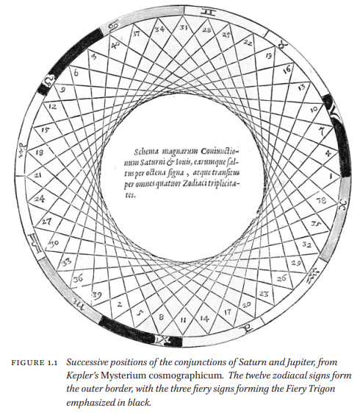

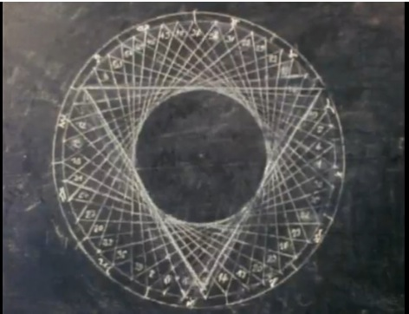

There are 4 types of Jupiter-Saturn conjunctions. The Conjunctio Minor, which takes place every 20 (19.86) years, the Conjunctio Magna which takes place every 60 years, the Conjunctio Mayor which takes place once every 240 years and finally the Conjunctio Maxima which occurs once every 800 years.[82]

Jupiter-Saturn conjunctions occur about every 20 years, thus are not uncommon. In Pisces, they are not particularly rare either. They can take place in the same zodiac sign every 59 years for about 3 to 6 times and then occur in other signs for several centuries. Some proponents of the Jupiter-Saturn theory believe that the conjunction of 7 BCE was particularly extraordinary because the two planets made three conjunctions within the same year. Such a triple conjunction is a very rare event, indeed, especially if it one wants it to occur in a particular zodiac sign.

A triple conjunction occurs when faster moving Jupiter overtakes slower moving Saturn before they reach opposition. Then as the planets retrograde, Jupiter again passes Saturn. After Jupiter begins its direct motion, it passes Saturn a third time:

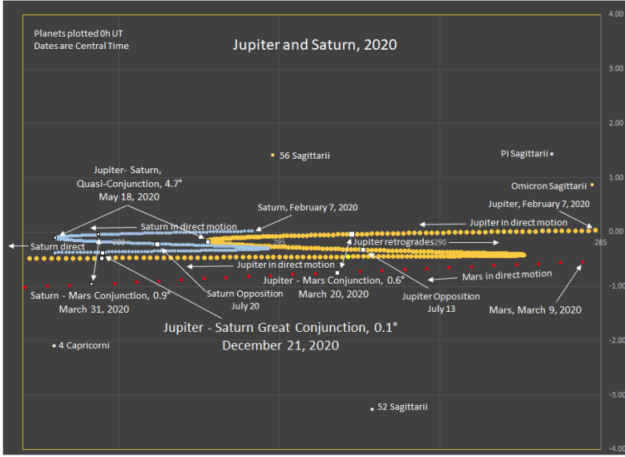

Successive Jupiter-Saturn conjunctions, slightly more than 240° apart, develop an interesting pattern as they step around the ecliptic, a rotat ing I rinngle with legs about 120° apart. In relation to the fixed stars, it takes about 854 or 913 years for the event to return to a point near the start of the sequence. Some scholars have given it as 960 years. Relative to a processing co-ordinate system, it takes about 800 (794) years.

December 21, 2020 -  2021 was initiated with a Jupiter-Saturn conjunction. This conjunction fell exactly on the midwinter solstice on December 21 at 0 degrees Aquarius. "A very rare occurrence, which has not occurred since the year 1623”. "But when that occurred, both were very close to the sun so no one could notice. So go back to the year 1226 for as close a conjunction that is also able to be seen in some dark sky."

The Austrian astronomer Konradin Ferrari d’Occhieppo in 2003 proposed that the star was the conjunction of Saturn and Jupiter in the constellation Pisces in 7-6 B.C. He wrote, “Jupiter, the star of the highest Babylonian deity (Marduke), entered its brightest phase when it rose in the evening alongside Saturn, the cosmic representation of the Jewish people.” Commenting on this finding, Ferrari d’Occhieppo posited that astronomers in Babylon (an ancient center for astronomy) would have interpreted this phenomenon as a universally significant event, namely the birth of a king in the land of the Jews who would bring salvation. I think the constellation Pisces has a significance, since Pisces represents “fish” and Our Lord said to the apostles, “Come, follow me, and I will make you fishers of men” (Mt 4:19). His work was cited by Pope Benedict XVI in his book Jesus of Nazareth, Volume I.

In Johannes Kepler’s[83] (d. 1630) day, the location of a conjunction was as important as the conjunction itself. The 12 signs of the zodiac were divided into four trigons, each made of three associated and equally spaced constellations. Pisces, Cancer, and Scorpio were the Watery Trigon while Sagittarius, Aries, and Leo were the Fiery Trigon. JupiterSaturn conjunctions occur at 20-year intervals and 117 degrees apart, and shift westward (clockwise) through the signs of a given trigon, remaining within the signs of one trigon for almost 200 years and then shifting into the adjacent trigon. After nearly 800 years (actually **794.4**) they begin a new cycle back at nearly their original position as measured with respect to the vernal equinox. The conjunction that Kepler watched had occurred in essentially the same position 800 years before and 800 years before that; Kepler believed the event had happened only eight times since the creation of the world.

There was a **triple conjunction of Jupiter and Saturn, in 7 B.C.** On **May 29**, the two planets passed a degree apart in the constellation of Pisces – a sight the Magi had seen many times before and so it probably was not too exciting. Nonetheless, they viewed Jupiter as a royal planet and Pisces as a constellation associated with the Jews. Then, on **September 29**, the two planets came together again in Pisces, moving in opposite directions but close by each other in the sky, separated by a distance a little larger than on May 29. A third time, on **December 4**, the planets converged again, separated by more than a degree from north to south. So three times in eight months, the royal planet and Saturn had met in the Jew's constellation. But what was the significance of Saturn? Herod was an old man now, hanging on to life; and perhaps Saturn, regarded as an evil planet, pointed to the demise of this detested puppet leader of Judea. The Magi must have pondered the significance of all this.[84]

Rabbi Isaac Abarvanel's belief, noted in his 15th-century commentary on Daniel,[85] that not only does a conjunction of Jupiter and Saturn foretell important events, but in Pisces this holds a special significance for Israel; and such an event might even foretell the coming of the Messiah.

Jupiter-Saturn conjunctions

http://cura.free.fr/cura2/901meira.html

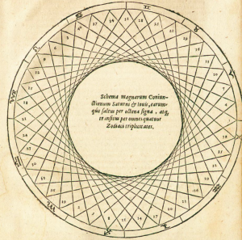

Johannes Kepler’s demonstration of the conjunction of Saturn and Jupiter traversing the signs of the zodiac, from his “Mysterium Cosmographicum” (1597).

Ibn Ezra’s *Sefer HaMahbarot* (*The Book of Conjunctions*), one of fourteen books he authored on astronomy, discusses the influence of the conjunction of the two planets in great detail.

Ibn Ezra believed that the sun and planets, together with the constellations across which they appeared to travel, influenced the fates of nations, cities, and religions. Jupiter in Aries held sway over Iraq, Saturn in Libra over Rome. Saturn held sway over Jews, the sun over Christians, and Venus over Muslims. Like all of his contemporary astronomers, Ibn Ezra paid additional attention to conjunctions, of which the most important was that of Saturn and Jupiter. These conjunctions had influenced the births of prophets and leaders, including Moses, Jesus, and Mohammed. “The conjunction [of Saturn and Jupiter] took place before the birth of the man they consider to be God” he wrote in his Sefer Olam, “and the conjunction [of Saturn and Jupiter] in the sign of Scorpio took place before the emergence of the prophet of the Muslims.”

There is a conjunction of Jupiter and Saturn in general every 20 years. The last one that was actually visible was in 1226 A.D. There was one in 1623, but it was too close to the sun to be observed.

The conjunction of the two uppermost planets [i.e., Saturn and Jupiter] in the sign of Aries takes place every 960 years, and both revolve from the sign of their conjunction to the ninth [following] sign every 20 years, and they repeat this cycle twelve times to make up 240 years. From there they repeat this cycle the same number of times and in the same manner in the earthy signs, in the airy signs, and in the watery signs…[86]

Jupiter and Saturn will come together in a “great conjunction” On 12/21/2020 in Aquarius. This happens once every 615 years.

Although there are several lengthy discussions in the Talmud about the influence of the planets on the fate of humanity, none makes any mention of conjunctions. But writing about three hundred years after the close of the Talmud, Saadia Gaon (d. 942C.E.) mentioned the belief of the terrible consequences of the Saturn-Jupiter conjunction in his introduction to the Book of Daniel.[87] He explained a belief that the twenty-year conjunction of the planets allowed for predictions to be made about individual kings. The conjunctions that occurred every 238 or 258 years could be used to make predictions about families, and those that occurred in a cycle of 944 or 964 years “influenced the governance from one nation to another.” However, he did so only to reject the notion that these conjunctions or indeed any planetary alignments were of consequence.

## Ibn Ezra

Ibn Ezra’s emphasis on the importance of the conjunction is not found only in his many esoteric works of astronomy. It is included in his commentary on the Torah, in [a long passage found on Exodus 33:21](https://www.sefaria.org/Exodus.33.21?lang=bi&with=Ibn%20Ezra&lang2=en), printed in any edition of the *Mikraot Gedolot*.

*** Ibn Ezra quote

Abraham the author states: I have already explained that the name of God, which is written but not pronounced,[88] *That is, YHVH, the tetragrammaton.* is a proper name.[89] This proper name refers to the Glory.[90] If you add up all of the letters of God’s proper name you get seventy-two.[91] The sages therefore said that it is God’s explicit name.[92] If you add the square of one, the first number, to the square of five, the true middle number,[93] you will get the numerical equivalent of God’s name.[94] This is also true regarding the five moving stars.[95] When you add up the letters that one enunciates in naming half of the letters that make up God’s name[96] you will also get the numerical equivalent of God’s name.[97] When you add up the squares of the first four square numbers[98] you get the numerical equivalent of half of God’s name.[99] When you multiply the first half of God’s name[100] by the second half of God’s name[101] you get the sum of the square of the odd numbers.[102] When you subtract the square of the first letter of God’s name[103] from the sum of the squares of the first two letters[104] of God’s name, the remainder will be equivalent to the cube of the second letter of God’s name.[105] If you subtract the square of the first two letters of God’s name[106] from the square of the first three letters of God’s name,[107] the remainder[108] will be equivalent to the cube of the third letter of God’s name.[109] This glorious God is similar to the number one which stands by itself and has no need for any number before it.[110] If you consider the role that the number one plays in a sum of numbers, you will discover that one is the first of all the numbers in any sum, and that all sums consist of ones. God similarly is the One who is all.[111] This is therefore the secret of the prayers and praises.[112] It is the meaning of *Thus will I magnify Myself, and sanctify Myself* (Ezek. 38:23)[113] and of *in whom I will he glorified* (Is. 49:3).[114] Now the One has no image. He encompasses all the images,[115] for they all came from Him. Observe, the heavenly bodies, namely, the lights and the stars, have no front or back. This is certainly the case with man’s heavenly soul. This is surely the case with those who serve on high.[116] This is beyond the shadow of a doubt the case with the Most High.[117] Now there is a vertical line between the two points.[118] The point closest to the Creator[119] is known as “the prince of the face”[120] and “the prince of power.”[121] The point which lies on the opposite end of the line marks the end of power.[122] Man moves frontward.[123] The body which is on high moves towards the right.[124] Plants grow upward.[125] Now Moses was able to know and perceive intellectually how human beings cleave to the Creator of the world[126] who is called “the back” (v. 23). It is the nature of the Glory[127] that no created being may have the power to know this.[128] This is the meaning of *for man shall not see Me and live* (Ex. 33:20). This is so because man’s soul is in a body.[129] Now, after an intelligent person dies, his soul reaches a very high stage. It is a state which it could not reach while the individual was alive. Look, Moses[130] became all-encompassing.[131] God therefore told Moses, *I know thee by name* (v. 12),[132] for only God knows the individuals and their parts in an all-encompassing manner. Man is the most important being upon the earth. Hence the form of the cherubim.[133] Israel is the most important type of human being.[134] Hence the statement regarding the knot of the *tefillin*.[135] The *Shi’ur Komah[136]* therefore[137] writes that God created all corporeal beings and all beings more glorious than corporeal beings.[138] The accidents[139] are of less significance than the corporeal beings.[140] Furthermore, Rabbi Ishmael says,[141] “Whoever knows the measure of the Creator of the world[142] is assured of a place in the world to come. I and Rabbi Akiba vouch for this.” This is the meaning of *Let us make man in our image, after our likeness* (Gen. 1:26).[143] Note, all plants, all that live on the earth, all fowl, cattle, animal, creeping thing and all human beings[144] are tied to the forty-eight forms of the sphere.[145] This is the meaning of [*and when thou seest the sun and the moon and the stars, even all the host of heaven…*] *which the Lord thy God hath allotted unto all the peoples under the whole heaven* (Deut 4:19).[146] Those who added “to give light”[147] did so to explain the verse. It is possible that they knew this[148] but did not want to reveal this secret to the students. *And that He had not allotted unto them* (Deut. 29:25)[149] is positive proof of this.[150] It is known that the seven moving stars[151] have 120 possible conjunctions.[152] The seven moving stars form the great conjunction in only one way.[153] There are twenty-one two-star conjunctions.[154] It is the same case with five-star conjunctions.[155] This number results from seven.[156] The stars can be in a three-star conjunction in thirty-five ways,[157] for this number too is a result of the conjunctions of the seven moving stars.[158] The same is true of a four-star conjunction.[159] Now the stars can be in a six-star conjunction in seven ways.[160] The influence of the conjunction which takes in all peoples of the earth[161] varies in accordance with the constellation of every one[162] which constitute the inhabited world.[163] Scripture says concerning them, *Thou hast set all the borders of the earth; Thou hast made summer and winter* (Ps. 74:17), which differ in all of the areas. Change does not come from the sun itself but because of its movement towards the north and south. Now the conjunction of the sun and moon in Aries[164] occurs every 960 years. These two turn from the constellation with which they are in conjunction to the ninth constellation[165] every twenty years. They make this cycle twelve times for a total of two hundred and forty years.[166] From there[167] they travel in the same manner and in an identical time period in the constellations of “dust,”[168] the constellations of “air,”[169] and the constellations of “water.”[170] Do not think that the four elements are in heaven[171] and that there is heat in the sun and coldness in the moon and Saturn.[172] Heaven forbid.[173] The creations that are high and above are glorious.[174] Scripture says concerning them, *For He commanded, and they were created* (Ps. 148:5). *He hath established them for ever and ever; He hath made a decree which shall not be transgressed* (Ps. 148:6).[175] They were created in this way[176] only because of those whom they affect.[177] The seven moving stars[178] cannot change their nature. They cannot violate that which God has assigned to them. The same applies to the hosts of heaven. The inhabitants of the lower world are affected by them in accordance with their[179] makeup. Hence they cannot benefit or harm. Thus they cannot help one who bows down to them, for what was decreed for him in accordance with the arrangements of the stars at the time of his birth shall befall him. He can only be saved from his fate if he cleaves to and is protected by a power that is higher and more powerful than the stars. I will explain with a worthy parable. The arrangement of the stars had it that a river would overpower a city and kill or flood its inhabitants. A prophet came and warned the people to turn to God before the arrival of the day of their calamity. The people turned to God with all their heart. Because the people cleaved unto God, God put it into their hearts to go out of the city to pray unto the Lord. They did this. On the appointed day the river suddenly overflowed, as is its nature. We have witnessed this many times. The river flooded the entire city. Now God’s decree was not altered and He saved them. Imagine the following: The seven moving stars are like horses that run along a path. They do not run with the intention of doing good or bad. They act in accordance with their nature. Now imagine that a blind man is in their path. The blind man does not know how the horses act. He does not know when they go to the right and when they go to the left. The blind man depends on a person with sight who knows the way the horses run. Now the person with sight will guard the blind man. When the horses run to one side he will lead the blind person to the other side. The course of the horse’s running does not change but the blind man is saved. It is because of this that Scripture states, [*the sun, and the moon and the stars, even all the host of heaven…*] *which the Lord thy God hath allotted* [*unto all the peoples under the whole heaven*] (Deut. 4:19); *But you hath the Lord taken…to be unto Him a people of inheritance* (Deut. 4:20). *The portion of Jacob is not like these, For He is the former of all things* (Jer. 51:19). This is the meaning of *so that we are distinguished, I and Thy people* (v. 16). This is what the rabbis mean by “Israel has no constellation”[180] as long as they keep the Torah.[181] If Israel does not keep the Torah, then the star rules over them, as has been proven, for any conjunction combined with Aquarius[182] is an evil arrangement. It results in harm befalling Israel. This is admitted by the astrologers. Now the stars were arranged in a conjunction which decreed that Israel should remain in exile in Egypt for many more years.[183] God delivered them because they cried out unto the Lord and turned to Him (Ex. 2:23). What is true for the group[184] is true for the individual.[185] Therefore *But he that keepeth the law, happy is he* (Prov. 29:18).

*** End of Ibn Ezra quote

Although there are several lengthy discussions in the Talmud about the influence of the planets on the fate of humanity, *none* make any mention of conjunctions.

# XI. Teli

According to many Kabbalists, the Teli is the imaginary axis (ecliptic pole) around which the celestial sphere rotates, or hangs, which is the secret of the “straight serpent”, or “pole serpent”.

The Draco, or the “pole serpent” surrounds[186] the “ecliptic pole” having stars in the sections of 12 Houses of the Zodiac Signs, as if the 12 Houses of the Zodiac Signs are “hanging” from the Draco, i.e. to be controlled by it, hence the name “Teli” תְּלִי.

The constellation of Draco is the male pole serpent, and the ecliptic is the female circular serpent that surrounds the pole serpent.

This is the secret of the mystic term “teli” תְּלִי referred to in the Sefer Yetzirah 6:1.

Sefar Yerirah, Gruenwald ed., 6:1 2 (para. 59). There are several understandings for the precise definition of the astrological Teli. Most often, the Teli was not con­ceived of simply as a star or a constellation. One prevalent way to conceive of the Teli was to imagine two celestial spheres, one traced by the annual apparent motion of the sun in a geocentric orbit, the other represented by the moon’s course. These spheres were seen to intersect at twro points, sometimes referred to as the two poles of the universe. These two nodes were also referred to as the head and tail of the cosmic dragon.

Teli means hanger, which is of the root “to hang” תָּלָה.

According to many Kabbalists, the Teli is the imaginary axis (ecliptic pole) around which the celestial sphere rotates, or hangs, which is the secret of the “straight serpent”, or “pole serpent”.

the sixth Chapter refers to the Teli. Usually as the dragon or the Milky Way. Those in the know say that Teli are dragons. Kaplan quotes a discussion from a book on the Chariot that says the Teli are reptilian humanoids who know the secrets of creation and other secrets and have permission to give these to humans. In exchange for what? Kaplan says that they are in a particular place called vilon which is the middle point between normal space and Dark Matter. Kaplan says that the Teli are Kings of space but not part of space. Other words for the same thing. Kaplan says the Teli are spiritual beings who are lowered to the physical and interact with the physical. Others say that the Teli are the watchers from the Book of Daniel.Teli being reptilian have a relationship to the Serafim.

Hebrew Astrology

Parashat Chukat tells a very peculiar story regarding the plague of snakes that attacked Israel: “HaShem said to Moses: ’Make yourself a Pole Serpent, and let whoever is bitten look at it and live.’ So Moses made a copper snake and put it on a pole, and whenever a snake bit a man, he would gaze upon the copper snake and live.” The Sefer Yetzirah tells us about a very mysterious word, “Teli,” which comes from the root word “talah” which means “to hang.” The word has many meanings as discussed by the Sages; such as a type of sword, a quiver of piles for arrows, or a kind of bola (a line with a ball at the end used to ensare animals). The text explains the Teli is the axis by which the heavens rotate. It is explained as if there is a line with a ball at the end, symbolizing the place by which the celestial spheres hang.

Rabbinic authorities have identified the Teli to be the “Nachash Bareach” (Pole Serpent). Interestingly, the Pole Serpent is also identified with the Leviathan, an ancient Midrash states that “the world hangs from a fin of Leviathan.” The Pole Serpent has also been associated with the constellation Draco, which means “Serpent” or “Dragon.” It is quite fascinating that its formation has stars in all of the signs of the Zodiac. The Kabbalists explain that Draco, supports all of 12 of the Zodiac constellations; in other words, all of them are “hanging” from Draco. And so Draco is also called the Teli because all the other stars hang (talah) from it. The symbol of the Teli has often been depicted as a dragon, a snake or a fish. According to the Kuzari, the Teli refers to the spiritual realms which mirror its physical demonstration of the celestial bodies.

The Bahir asks: “What is the Teli? It is the likeness before the Holy One Blessed Be He” and references Song of Songs: “His locks (peyot and beard) are hanging (taltalim).” In both Talmudic and Kabbalistic traditions, the link between these two statements are significant, in that it relates to a vision of G-d in battle, and He is seen as a Young Man with locks (peyot and a beard). It is explained that this is referring to Zeir Anpin, which is a Partzuf (personification of the Light of G-d). The link between these two statements also relates to the Torah which is closely associated with Zeir Anpin, referring to fact that the Torah contains “Teli Tela’im Chochmah” (Piles of Piles of Wisdom). The hairs of the peyot and beard are symbolized as the lines upon which the letters of the Torah are written.

Here this is speaking about the Primordial Torah which preceded Creation, not the Written Torah which was “written with black fire upon white fire.” The Sages explain each letter of the Torah is a hair on the peyot and beard of Zeir Anpin, these are not literally hairs but channels through which G-d’s wisdom Emanates from His anthropomorphic “head.” The head is the concealed wisdom which is then revealed through His “hair.” The entire the verse in the Song of Songs says: “His head is a fine treasure of gold, his locks are hanging, black like a raven.” The letters of the Torah, which are written in black ink, is the revelation of the concealed wisdom. Therefore, Zeir Anpin is from where in each “hair” hangs a universe, each of which is represented by the letters of the Torah. The Teli then is Zeir Anpin, which is the axis through which the universe revolves and Torah, which the blue print through which all of Creation is sustained.

Another astounding secret that is revealed is that the Teli is the Mashiach (Messiah), often referred to as the Holy Snake (Nachash Ha’Kodesh), as the Hebrew words “Mashiach” and “Nachash” share the same Gematria (numerical value) of 358. So the Mashiach is the Pole Serpent. Since the association of Teli has already been made with the Pole Serpent, and the Pole Serpent with Draco, and Draco with Zeir Anpin; it is now clear as to the fact that Metatr-n, the Angel who governs Zeir Anpin, is “the the likeness before the Holy One Blessed Be He.” Since Mashiach is interconnected with Angel Metatr-n, it is now also clear as to whom is depicted as the Young Man with locks (peyot and a beard), which then leads to the connection with the Primordial Torah. Referring back to the passage in Parashat Chukat, the Pole Serpent was the Mashiach who saved the Jews as they gazed upon him. Upon looking at the picture attached, you will find an illustration of the Teli which is found in a commentary written by Rabbi Eliezer Rokeach of Wormes, it will be realized when viewed upside down that it is the Young Man with locks (peyot and a beard) that are hanging as described above.

Bamidbar 21:5-9; Bereshit 1:21, 27:3; Yeshayah 27:1; Shemtov Gefen Sefer Zichron pg. 126-128; Teli Atalya pg. 27-35; Bereshit Rabbah 65:13; Targum Yonatan to Sherashim; Radak to Sherashim; Pardes Rimonim 21:8; Choker U’Mekubal 13; Zohar 1:62a, 1:125a, 2:84a, 2:114a, 2:226b, 3:127b, 3:132a; Yesod Olam pg. 16c; Bareita DeShmuel HaKatan 2:8a; Iyov 26:7, 26:13; Ibn Ezra to Iyov 26:13; Ramban to Iyov 26:13; Ohr HaShekel 4:1; Kol Yehudah on Kuzari 4:25, 56b; Targum Yeshayah 44:25; Oh Ganuz on Bahir 95; Sefer Raziel 14b, 18b, 20a; Seder Rabbah DeBereshit 17; Batey Midrashot 1:28; Yalkut Reuveni 17b; Chesed LeAvraham 2:3; Beyt HaMidrash 1:63; Bartenura to Avodah Zarah 3:3; Pirkey DeRabbi Eliezer 9:31; Bahir 106 Kehilat Ya’acov; Talmud Bavli Chagigag 14a; Shemot Rabbah 8:1; Kohilet 11:10; Mechilta on Shemot 20:2; Eytz Chayim Sha’ar Arich Anpin 5:3; Vayikra Rabbah 19:1; Shir HaShirim 5:11; Shir HaSharim Rabbah to Talmud Yerushalmi Shekalim 6:1; Tikuney Zohar 56:90b; Rokeach of Wormes pg. 12b; Sefer Yetzirah [Rabbi Aryeh Kaplan] pg. 231-239

Thus, we can definitively

conclude that the Biblical Seraphim are none other than our holy Dragons, the Teli. +

# XII. Mishkan - Aligning the firmament

The Miskan was used to align the firmaments, the planets and the stars in a very unique way. The mishkan was a portal which allowed Moshe Rabbeinu to communicate with HaShem, and dwell in His people. The mishkan literally controls the entire world. (Remember a mishkan above and a miskan below.)

The Torah teaches that when the Mishkan was set up it was filled with the glory of HaShem and had a pillar of fire over it by night and a pillar of cloud over it by day.

***Shemot (Exodus) 40:34*** *Then a cloud covered the tent of the congregation, and the glory of HaShem filled the tabernacle. 35 And Moses was not able to enter into the tent of the congregation, because the cloud abode thereon, and the glory of HaShem filled the tabernacle.*

***Shemot (Exodus) 40:38*** *For the cloud of HaShem was upon the tabernacle by day, and there was fire therein by night, in the sight of all the house of Israel, throughout all their journeys.*

According to Midrash, there was an interesting aspect to the Mishkan. The Sages describe it as a microcosm of the universe, with each of its vessels corresponding to another part of the creation: the tent of the Mishkan paralleled the firmament, the menorah paralleled the sun and moon, the laver paralleled the oceans, and so on, through the days of creation.

By describing the Mishkan as such, the Midrash is suggesting that the structure was a model of a redeemed creation. It fulfilled God’s original intention of the world as a setting for revelation. This was the nature of the Garden of Eden, and it will be the nature of the future world, when “the knowledge of God will fill the earth as waters cover the sea” (Isaiah). In the interim, the Mishkan and Temple served as loci of God’s revelation in the world.

According to the Ramban, the Mishkan was the continuation of the Sinaitic revelation into history. Just as God spoke to Moshe from the top of the mountain, so He continued to address him from out of the Mishkan. The Mishkan – and the Temple after it – was a “portable” Mount Sinai. It was a place of continual revelation, where the presence of God could be vividly felt and experienced.

The entranceways in the Mikdash are aligned from east to west: the screen of the gate of the courtyard is the easternmost, and from there one enters into the courtyard, and from there through the door of the Ohel Mo'ed to the parokhet that divides between the Holy and the Holy of Holies.

The ideal exemplification of this order was the encampment of the twelve tribes round the Sanctuary in the desert. This in turn has its ultimate prototype in the Divine Throne itself, supported by the four keruvim. This order has, therefore, timeless significance, and the scale of values revealed and reflected in it was adopted by our Sages when they set out to arrange the petition man makes in his prayer, for the good and benefits he needs. As we now proceed to describe the arrangement in detail, we shall follow the course from east to west (as did the priest on the altar) and encircle the Sanctuary. It is the same direction the firmament follows, traversing its daily course from east to west, paying homage in the immutability of its measured rhythm to its Creator.[187]

# XIII. In the Midrash

The so-called Messiah-Haggadah (Aggadoth Mashiach) opens as follows: 'A star shall come out of Jacob. There is a Baraita in the name of the Rabbis:

The heptad in which the Son of David cometh -

in the first year, there will not be sufficient nourishment;

in the second year the arrows of famine are launched;

in the third,a great famine;

in the fourth, neither famine nor plenty;

in the fifth, great abundance, and the Star shall shine forth from the East, and this is the Star of the Messiah. And it will shine from the East for fifteen days, and if it be prolonged, it will be for the good of Israel;

in the sixth, sayings (voices), and announcements (hearings);

in the seventh, wars,and at the close of the seventh the Messiah is to be expected.'

A similar statement occursat the close of a collection of three Midrashim - respectively entitled,

'The Book ofElijah,'

'Chapters about the Messiah,' and

'The Mysteries of R. Simon, the son of Jochai'

* * *

Where we read that a Star in the East was to appear two years before the birth of the Messiah. The statement is almost equally remarkable, whether it represents a tradition previous to the birth of Jesus, or originated after that event. But two years before the birth of Christ, which, as we have calculated, took place in December 749 a.u.c., or 5 before the Christian era, brings us to the year 747 a.u.c., or 7 before Christ, in which such a Stars hould appear in the East.

* * *

For the sake of their study - "Solar Obliquity Induced by Planet Nine", which was recently published in the Astrophysical Journal - the research team (led by Bailey) looked to the obliquity of the Sun.

As they state in their paper, the six-degree axial tilt of the Sun can only be explained in one of two ways - either as a result of an asymmetry that was present during the formation of Solar System, or because of an external source of gravity.

To test this hypothesis, Bailey, Batygin and Brown used an analytic model to test how interactions between Planet 9 and the rest of the Solar System would effect their orbits over the course of the last 4.5 billion years.

As Elizabeth Bailey, a graduate student at Caltech's Division of Geological and Planetary Sciences and the lead author on the paper, told Universe Today via email:

"We simulated the solar system's motion. Planet 9 forces the solar system to slowly wobble.

If Planet 9 is out there, we are in the process of wobbling right now, as we speak! But it happens very slowly, a few degrees tilt per billion years. Meanwhile the sun is not wobbling much, so it looks like the sun is tilted.

A range of Planet 9 parameters cause exactly the configuration of the sun that we see today."

In the end, they concluded that the Sun's obliquity could only be explained by the influence of giant planet with an extreme orbit, one that is consistent with the characteristics attributed to Planet 9.

In other words, the existence of Planet 9 offers an explanation for the Sun's peculiar behavior, something which has remained a mystery until now.

"Planet Nine was first 'hypothesized' because the orbits of objects in the outer reaches of the solar system are confined in physical space," said Bailey.

"Those orbits would be all over the place unless something is currently stopping them. The only explanation so far is Planet Nine. For over 150 years, people have wondered why the sun is tilted.

Personally I'd say that Planet 9 offers the first satisfying explanation.

If it exists, it tilted the sun."[188]

# XIV. The Star of Bethlehem

**It seems likely, though by no means conclusive, that the star was a supernatural event.**

In every case, going east means to move away from HaShem and to move away from ‘The Light’.

Going to the east is not a good thing. Those who go east are going away from HaShem.

Coming from the east, by going west, we move closer to HaShem. Going from the east, towards the west, is to move closer to HaShem.

The wise men went west to find the baby Yeshua.[189]

The Mashiach will come from the east going west to enter the Temple as King of kings and Lord of lords.[190]

# XV. The Magi

*Magos* is properly translated as ‘magician’, although more specifically the Magi were usually known as a class of Zoroastrian priests in Persia.

Philo of Alexandria, a Jewish philosopher and contemporary of Jesus, uses *magus* to describe the following people:

Philo specifically calls Balaam a *magos*,[191] the same term he uses to describe the “magicians” who opposed Moses in Egypt (Philo, *Life of Moses,* 1:92).

Says Philo:[192] “Among the Persians there is a body of the Magi, who, investigating the works of nature for the purpose of becoming acquainted with the truth, do at their leisure become initiated themselves and initiate others in the divine virtues by very clear explanations.”

The motive of the Magi in coming to Jerusalem tells us a great deal more about them. They wanted to worship a Jewish king. It can’t be proven from the text, but it is quite possible that some of the Magi were of Jewish descent, perhaps a Jewish remnant from Daniel’s day. This would help explain why a Jewish philosopher, Philo, would admire them, why they were watching the sky for things Jewish, why they wanted to worship a Jewish king, and why they were taken so seriously by Herod and Jewish chief priests. If they were not Jews, then they must have been most impressive magi indeed, as Jews of the time were deeply disdainful of pagans and their beliefs.[193]

It is possible that some Persian magi had Jewish ancestry. In 587 BC, Nebuchadnezzar had conquered the Jews and he took them to Babylon as prisoners of war.[194] The brightest and best of the Jewish men, which included Daniel, were then taught all the Babylonian (or Chaldean) literature and learning, which would have included astronomy, in preparation for royal service.[195] The Septuagint (the Greek translation of the Hebrew Bible) uses the word “magi” (magos) eight times to identify some of the Babylonian royal advisers.[196]

Nebuchadnezzar, king of the Babylonians, became a believer in the Hebrew God.[197] But before this, he had appointed Daniel as chief minister over all of Babylon’s sages. This meant that Daniel, the Jewish prophet, had leadership over the magi.[198] It is possible that Daniel taught Hebrew scriptures and messianic prophecies to the other sages, especially to those who were Jewish. A Jewish legend even claims that Daniel founded an order of magi and instructed them to watch for the Messiah through the generations.

Traditions name these three magi as Caspar (or Gaspar), Melchior, and Balthazar.

Were the Wise Men in Megilat Esther our Hakhamim, our Rabbis, or were they Persians?

***Ether 1:13-14*** *Then the king said to the wise men, which knew the times, (for so [was] the king’s manner toward all that knew law and judgment: And the next unto him [was] Carshena, Shethar, Admatha, Tarshish, Meres, Marsena, [and] Memuchan, the seven princes of Persia and Media, which saw the king’s face, [and] which sat the first in the kingdom;)*

Some questions:

1. Was the star of Bethlehem seen by the magi who were ‘in the east’, or were the magi in Persia seeing the star in the east (of Persia)?
2. How is it that the magi could see and recognize this star, but the Hakhamim in eretz Israel did not? (What if the star only appeared closed to dawn in Persia? This would mean that the star was obscured by the sun in eretz Israel.)
3. Did the star move so that it could later be seen in Eretz Israel? If yes, how did it do this if it was a normal star or planet which have well established routes?
4. Is the star of Bethlehem the same as Nibiru or Planet X?
5. If this star hearlds a Jewish king, did the same star appear at King David’s birth and And Adam HaRishon’s birth?

# XVI. NASA – Planet nine – Planet X

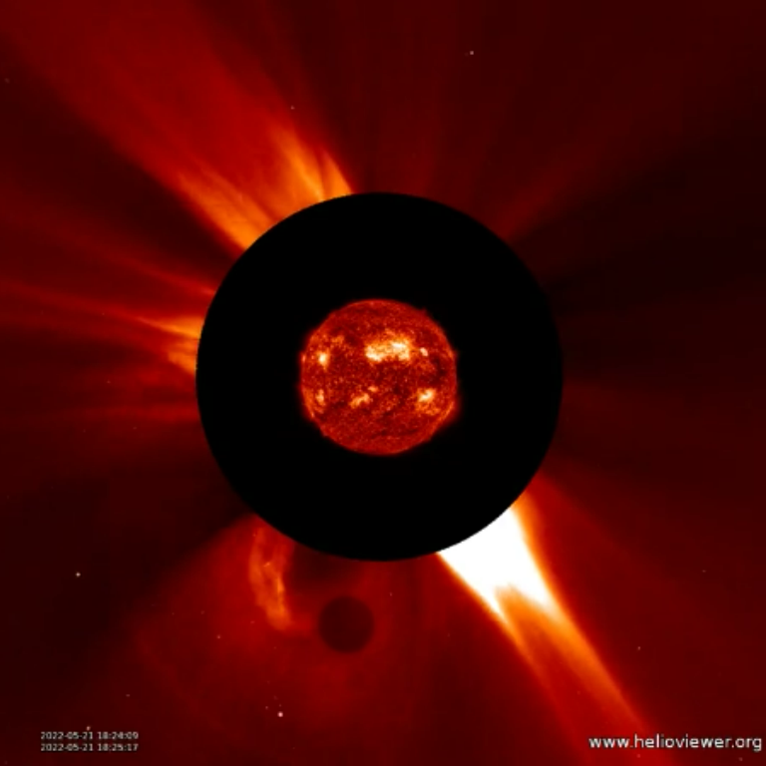

The latest image of the Stellar Core Planet X moving up through the ecliptic on 5/21/2022.

From: <https://www.jpl.nasa.gov/news/the-super-earth-that-came-home-for-dinner>

Evidence is growing for the existence of Planet 9 -- a world perhaps 10 times the mass of Earth and 20 times farther from the Sun than Neptune.

It might be lingering bashfully on the icy outer edges of our solar system, hiding in the dark, but subtly pulling strings behind the scenes: stretching out the orbits of distant bodies, perhaps even tilting the entire solar system to one side.

If a planet is there, it's extremely distant and will stay that way (with no chance -- in case you're wondering -- of ever colliding with Earth, or bringing "days of darkness").It is a possible "Planet Nine" -- a world perhaps 10 times the mass of Earth and 20 times farther from the sun than Neptune. The signs so far are indirect, mainly its gravitational footprints, but that adds up to a compelling case nonetheless.

One of its most dedicated trackers, in fact, says it is now harder to imagine our solar system without a Planet Nine than with one.

"There are now five different lines of observational evidence pointing to the existence of Planet Nine," said Konstantin Batygin, a planetary astrophysicist at Caltech in Pasadena, California, whose team may be closing in. "If you were to remove this explanation and imagine Planet Nine does not exist, then you generate more problems than you solve. All of a sudden, you have five different puzzles, and you must come up with five different theories to explain them."

Batygin and his co-author, Caltech astronomer Mike Brown, described the first three breadcrumbs on Planet Nine's trail in a January 2016 paper, published in the Astronomical Journal. Six known objects in the distant Kuiper Belt, a region of icy bodies stretching from Neptune outward toward interstellar space, all have elliptical orbits pointing in the same direction. That would be unlikely -- and suspicious -- enough. But these orbits also are tilted the same way, about 30 degrees "downward" compared to the pancake-like plane within which the planets orbit the sun.

Breadcrumb number three: Computer simulations of the solar system with Planet Nine included show there should be more objects tilted with respect to the solar plane. In fact, the tilt would be on the order of 90 degrees, as if the plane of the solar system and these objects formed an "X" when viewed edge-on. Sure enough, Brown realized that five such objects already known to astronomers fill the bill.

Two more clues emerged after the original paper. A second article from the team, this time led by Batygin's graduate student, Elizabeth Bailey, showed that Planet Nine could have tilted the planets of our solar system during the last 4.5 billion years. This could explain a longstanding mystery: Why is the plane in which the planets orbit tilted about 6 degrees compared to the sun's equator?

"Over long periods of time, Planet Nine will make the entire solar-system plane precess or wobble, just like a top on a table," Batygin said.

The last telltale sign of Planet Nine's presence involves the solar system's contrarians: objects from the Kuiper Belt that orbit in the opposite direction from everything else in the solar system. Planet Nine's orbital influence would explain why these bodies from the distant Kuiper Belt end up "polluting" the inner Kuiper Belt.

"No other model can explain the weirdness of these high-inclination orbits," Batygin said. "It turns out that Planet Nine provides a natural avenue for their generation. These things have been twisted out of the solar system plane with help from Planet Nine and then scattered inward by Neptune."

The remaining step is to find Planet Nine itself. Batygin and Brown are using the Subaru Telescope at Mauna Kea Observatory in Hawaii to try to do just that. The instrument is the "best tool" for picking out dim, extremely distant objects lost in huge swaths of sky, Batygin said.

But where did Planet Nine come from? Batygin says he spends little time ruminating on its origin -- whether it is a fugitive from our own solar system or, just maybe, a wandering rogue planet captured by the sun's gravity.

"I think Planet Nine's detection will tell us something about its origin," he said.

Other scientists offer a different possible explanation for the Planet Nine evidence cited by Batygin. A recent analysis based on a sky mapping project called the Outer Solar System Origins Survey, which discovered more than 800 new "trans-Neptunian objects," suggests that the evidence also could be consistent with a random distribution of such objects. Still, the analysis, from a team led by Cory Shankman of the University of Victoria, could not rule out Planet Nine.

If Planet Nine is found, it will be a homecoming of sorts, or at least a family reunion. Over the past 20 years, surveys of planets around other stars in our galaxy have found the most common types to be "super Earths" and their somewhat larger cousins -- bigger than Earth but smaller than Neptune.

Yet these common, garden-variety planets are conspicuously absent from our solar system. Weighing in at roughly 10 times Earth's mass, the proposed Planet Nine would make a good fit.

Planet Nine could turn out to be our missing super Earth.

* * *

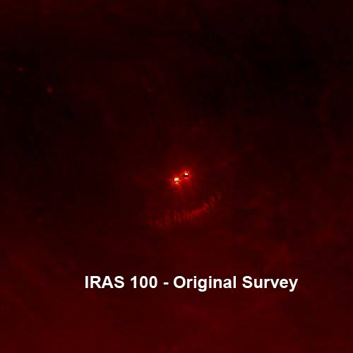

Possibly as Large as Jupiter;[199]

Mystery Heavenly Body Discovered

By Thomas O’Toole

Washington Post Staff Writer

Friday, December 30, 1983 ; Page A1

A heavenly body possibly as large as the giant planet Jupiter and possibly so close to Earth that it would be part of this solar system has been found in the direction of the constellation Orion by an orbiting telescope aboard the U.S. infrared astronomical satellite.

So mysterious is the object that astronomers do not know if it is a planet, a giant comet, a nearby “protostar” that never got hot enough to become a star, a distant galaxy so young that it is still in the process of forming its first stars or a galaxy so shrouded in dust that none of the light cast by its stars ever gets through.

“All I can tell you is that we don’t know what it is,” Dr. Gerry Neugebauer, IRAS chief scientist for California’s Jet Propulsion Laboratory and director of the Palomar Observatory for the California Institute of Technology, said in an interview.

The most fascinating explanation of this mystery body, which is so cold it casts no light and has never been seen by optical telescopes on Earth or in space, is that it is a giant gaseous planet as large as Jupiter and as close to Earth as 50 trillion miles. While that may seem like a great distance in earthbound terms, it is a stone’s throw in cosmological terms, so close in fact that it would be the nearest heavenly body to Earth beyond the outermost planet Pluto.

“If it is really that close, it would be a part of our solar system,” said Dr. James Houck of Cornell University’s Center for Radio Physics and Space Research and a member of the IRAS science team. “If it is that close, I don’t know how the world’s planetary scientists would even begin to classify it.”

The mystery body was seen twice by the infrared satellite as it scanned the northern sky from last January to November, when the satellite ran out of the supercold helium that allowed its telescope to see the coldest bodies in the heavens. The second observation took place six months after the first and suggested the mystery body had not moved from its spot in the sky near the western edge of the constellation Orion in that time.

“This suggests it’s not a comet because a comet would not be as large as the one we’ve observed and a comet would probably have moved,” Houck said. “A planet may have moved if it were as close as 50 trillion miles but it could still be a more distant planet and not have moved in six months time.”

Whatever it is, Houck said, the mystery body is so cold its temperature is no more than 40 degrees above “absolute” zero, which is 456 degrees Fahrenheit below zero. The telescope aboard IRAS is cooled so low and is so sensitive it can “see” objects in the heavens that are only 20 degrees above absolute zero.

When IRAS scientists first saw the mystery body and calculated that it could be as close as 50 trillion miles, there was some speculation that it might be moving toward Earth.

“It’s not incoming mail,” Cal Tech’s Neugebauer said. “I want to douse that idea with as much cold water as I can.”

(ITEM 123)

December 31, 1983, Saturday,

Final Edition

Then, what is it?

What if it is as large as Jupiter and so close to the sun it would be part of the solar system?

Conceivably, it could be the 10th planet astronomers have searched for in vain. It also might be a Jupiter-like star that started out to become a star eons ago but never got hot enough like the sun to become a star.

While they cannot disprove that notion, Neugebauer and Houck are so bedeviled by it that they do not want to accept it.

Neugebauer and Houck “hope” the mystery body is a distant galaxy either so young that its stars have not begun to shine or so surrounded by dust that its starlight cannot penetrate the shroud.

“I believe it’s one of these dark, young galaxies that we have never been able to observe before,” Neugebauer said.

“If it is, then it is a major step forward in our understanding of the size of the universe, how the universe formed and how it continues to form as time goes on.”

The next step in pinpointing what the mystery body is, Neuegebauer said, is to search for it with the world’s largest optical telescopes.

Already, the 100-inch diameter telescope at Cerro del Tololo in Chile has begun its search and the 200-inch telescope at Palomar Mountain in California has earmarked several nights next year to look for it.

If the body is close enough and emits even a hint of light, the Palomar telescope should find it since the infrared satellite has pinpointed its position.

(ITEM 127)

The distance from earth of a mysterious object in space was reported incorrectly in some editions yesterday. The correct figure is 50 billion miles.

Articles appear as they were originally printed in The Washington Post and may not include subsequent corrections.

* * *

From: <https://www.nytimes.com/1983/01/30/weekinreview/ideas-and-trends-clues-get-warm-in-the-search-for-planet-x.html>

SOMETHING out there beyond the farthest reaches of the known solar system seems to be tugging at Uranus and Neptune. Some gravitational force keeps perturbing the two giant planets, causing irregularities in their orbits. The force suggests a presence far away and unseen, a large object that may be the long-sought Planet X.

Evidence assembled in recent years has led several groups of astronomers to renew the search for the 10th planet. They are devoting more time to visual observations with the 200-inch telescope at Mount Palomar in California. They are tracking two Pioneer spacecraft, now approaching the orbit of distant Pluto, to see if variations in their trajectories provide clues to the source of the mysterious force. And they are hoping that a satellite-borne telescope launched last week will detect heat ''signatures'' from the planet, or whatever it is out there.

The Infrared Astronomical Satellite was boosted into a 560-milehigh polar orbit Tuesday night from Vandenberg Air Force Base, Calif. It represents an $80-million venture by the United States, Britain and the Netherlands. In the next six or seven months, the telescope is expected to conduct a wide-ranging survey of nearly all the sky, detecting sources not of ordinary light but of infrared radiation, which is invisible to the human eye and largely absorbed by the atmosphere. Scientists thus hope that the new telescope will chart thousands of infrared-emitting objects that have gone undetected - stars, interstellar clouds, asteroids and, with any luck, the object that pulls at Uranus and Neptune.

The last time a serious search of the skies was made it led to the discovery in 1930 of Pluto, the ninth planet. But the story begins more than a century before that, after the discovery of Uranus in 1781 by the English astronomer and musician William Herschel. Until then, the planetary system seemed to end with Saturn.

As astronomers observed Uranus, noting irregularities in its orbital path, many speculated that they were witnessing the gravitational pull of an unknown planet. So began the first planetary search based on astronomers' predictions, which ended in the 1840's with the discovery of Neptune almost simultaneously by English, French and German astronomers.

But Neptune was not massive enough to account entirely for the orbital behavior of Uranus. Indeed, Neptune itself seemed to be affected by a still more remote planet. In the late 19th century, two American astronomers, William H. Pickering and Percival Lowell, predicted the size and approximate location of the trans-Neptunian body, which Lowell called Planet X.

Years later, Pluto was detected by Clyde W. Tombaugh working at Lowell Observatory in Arizona. Several astronomers, however, suspected it might not be the Planet X of prediction. Subsequent observations proved them right. Pluto was too small to change the orbits of Uranus and Neptune; the combined mass of Pluto and its recently discovered satellite, Charon, is only one-fifth that of Earth's moon.

Recent calculations by the United States Naval Observatory have confirmed the orbital perturbation exhibited by Uranus and Neptune, which Dr. Thomas C. Van Flandern, an astronomer at the observatory, says could be explained by ''a single undiscovered planet.'' He and a colleague, Dr. Robert Harrington, calculate that the 10th planet should be two to five times more massive than Earth and have a highly elliptical orbit that takes it some 5 billion miles beyond that of Pluto - hardly next-door but still within the gravitational influence of the Sun.

Some astronomers have reacted cautiously to 10th-planet predictions. They remember the long, futile quest for the planet Vulcan inside the orbit of Mercury; Vulcan, it turned out, did not exist. They wonder why such a large object as a 10th planet escaped the exhaustive survey by Mr. Tombaugh, who is sure it is not in the two-thirds of the sky he examined. But according to Dr. Ray T. Reynolds of the Ames Research Center in Mountain View, Calif., other astronomers ''are so sure of the 10th planet, they think there's nothing left but to name it.''

At a scientific meeting last summer, 10th-planet partisans tended to prevail. Alternative explanations for the outer-planet perturbations were offered. The something out there, some scientists said, might be an unseen black hole or neutron star passing through the Sun's vicinity. Defenders of the 10th planet parried the suggestions. Material falling into the gravitational field of a black hole, the remains of a very massive star after its complete gravitational collapse, should give off detectable X-rays, they noted; no X-rays have been detected. A neutron star, a less massive star that has collapsed to a highly dense state, should affect the courses of comets, they said; yet no such changes have been observed.

More credence was given to the hypothesis that a ''brown dwarf'' star accounts for the mysterious force. This is the informal name astronomers give to celestial bodies that were not massive enough for their thermonuclear furnaces to ignite; perhaps like the huge planet Jupiter, they just missed being self-illuminating stars.

Most stars are paired, so it is not unreasonable to suggest that the Sun has a dim companion. Moreover, a brown dwarf in the neighborhood might not reflect enough light to be seen far away, said Dr. John Anderson of the Jet Propulsion Laboratory in Pasadena, Calif. Its gravitational forces, however, should produce energy detectable by the Infrared Astronomical Satellite.

Whatever the mysterious force, be it a brown dwarf or a large planet, Dr. Anderson said he was ''quite optimistic'' that the infrared telescope might find it and that the Pioneer spacecraft could supply an estimate of the object's mass. Of course, no one can be sure that even this discovery would define the outermost boundary of the solar system.

A version of this article appears in print on Jan. 30, 1983, Section 4, Page 20 of the National edition with the headline: IDEAS AND TRENDS; CLUES GET WARM IN THE SEARCH FOR PLANET X.

* * *

* * *

Rabbi Cohen confirmed much of what Breaking Israel News has been reporting about Nibiru since January 2016. He spoke about how “a new star has come to the neighborhood,” and said that it was first discovered 50 years ago. Rabbi Cohen asserted that the Vatican and NASA built a special telescope 30 years ago in order to acquire information about this “new star”.

* * *

Rabbi Asore said that Nibiru, which is called the Star of Jacob in rabbinic sources, “is a sign of the coming, foretelling of the coming of Mashiach (Messiah).”

# XVII. Nibiru, the planet of the Anunnaki

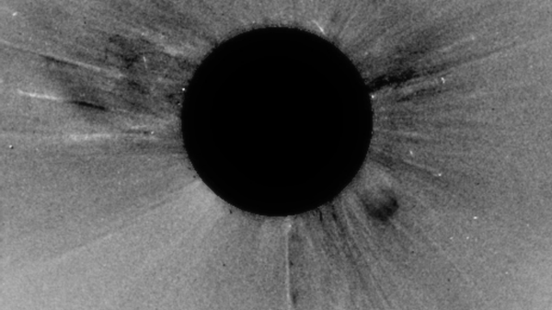

The latest images from 5/26/2022

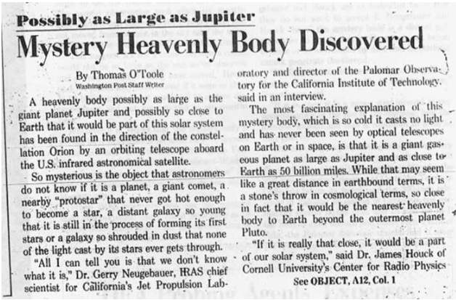Summary of The Washington Post article dated December 30, 1983, page A1 – reads:

The Absolute Truth

By: Menachem Robinson

I have been asked by the good people at Israel News Talk Radio to give a summary about one of the most important topics being discussed these days: Nibiru.  I am a retired Electronics Engineer who has studied science for about 60 years.  I also am an observant Jew, living in Israel, who has studied the word of Hashem (G-d) for about 69 years.  I know that the One Who created the Laws of Physics, the Laws of Chemistry and the Laws of Biology is the Same One who wrote the Torah and created everything that exists, including us.  That was a loaded statement that lets us know that there is no discrepancy between the Torah and science and that all of science and mathematics is in Jewish scriptures – after all it came from the same Source.  I mention this since my many decades of scientific research on the subject of Nibiru is totally corroborated by the word of Hashem.

To begin, let me give some education on the subject.  For decades astronomers believed, mostly because of gravitational anomalies on the planets in our solar system, that there was a tenth planet (after Pluto was designated as the ninth planet in our solar system).  The tenth planet was named Planet X, X being the Roman numeral for 10.  Go to Wikipedia for many more details:

[**https://en.wikipedia.org/wiki/Planets_beyond_Neptune**](https://en.wikipedia.org/wiki/Planets_beyond_Neptune)

Also for many decades (I heard about it in the 1960’s) our sun was believed to be a companion star in a binary system, two suns with two solar system’s in orbit around each other:

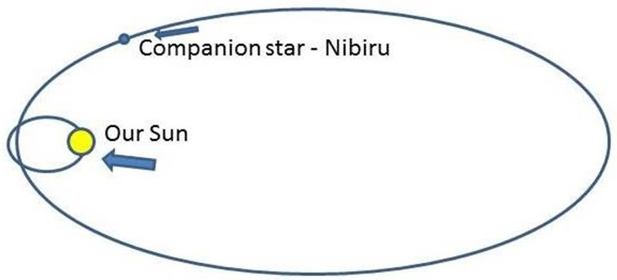

In 1982 NASA saw this dwarf star companion to our sun and started to track its entry into our solar system.  In 1983 President Reagan signed Executive Order 12356 which made it Top Secret.  The reason for the EO, which has been continued by every president up to today, is beyond the scope of my message here, but I will touch upon some details below.  The Hubble Space Telescope was put up for the purpose of tracking this dwarf star.  The true purpose of the Hubble also was kept secret; prompting the lies to the public about deep space exploration (yes, they used it for that purpose as a cover-up for the truth).

That dwarf star with its accompanying 7 planets/moons is “Nibiru.”  Its approach, the devastation that it has already caused and will cause has been kept secret by NASA and professional astronomers around the world (those who blew the whistle on this horror have mysteriously disappeared).  Before the secrecy started, NASA did release pictures of Nibiru taken when it was still far away approaching our solar system.   Here is one such picture on my [**blog**](http://absolutetruth613.blogspot.co.il/).

One of the things that helps perpetuate the confusion is that a red dwarf star, although a sun, appears more like a planet than a sun.  It does not have the approximate 10,000 degrees Fahrenheit surface temperature of our sun, but nonetheless still has a surface temperature of less than 4,000 [**K**](https://en.wikipedia.org/wiki/Kelvin)elvin (6740.33 Fahrenheit).  It also is nowhere near the luminosity level of our sun.  Although the characteristics are different between our sun and a red dwarf sun, like Nibiru, it is obviously not a planet.

The great secrecy is all about the New World Order agenda of the global elite.  They are planning a Communist one world government where the remaining population of 500 million people will be slaves to the global elite who plan to own this world.  How will they get the population reduced by 93% to result in only 500 million?  They have instituted many efforts including the planning of a nuclear world war.  But they are very much relying on Nibiru to kill most of the world population, due to the devastating effects that Nibiru has and will continue to cause.  They therefore have kept us uninformed and in harm’s way with total secrecy.  They want to ensure that there is no preparation for us, while they go into their underground cities to survive (the finer details and even all the proof is beyond the scope of this writing).  Yes, the evil ones have a world war planned in case Nibiru doesn’t meet their evil expectations.

Due to the secrecy of Nibiru, there is great confusion in the world.  Most of what we are seeing in articles and YouTube videos are from amateurs who are only guessing at what they are seeing and its effects.  Credibility is lost since they don’t even know what to call it.  Mostly, it is being called Planet X or Nibiru Planet X.  **NIBIRU AND PLANET X are two different heavenly bodies completely, and are not even in the same solar system.**  The term came about because of the secrecy of Nibiru, and the fact that only amateur sky watchers were trying to report on the subject.  Since NASA and the global elite want to pretend Nibiru doesn’t exist, they perpetuated the names, Nibiru Planet X, Planet 7X, Planet 9, Planet 9X, Nemesis, Wormwood, Destroyer, Hercalubus; anything to fool the public and keep us uninformed (and in harm’s way).

Nibiru is about fourteen times the size of Earth.  How big is [**that**](http://absolutetruth613.blogspot.co.il/)?

There is so much debate as to whether Nibiru is even real, but that can only come from individuals who ignore all the devastation Nibiru has already caused (past tense).  Its approach has already caused tremendous chaos in the world and it will increase greatly as it approaches and flies by.  It is not just the star and its planets/moons but there also are millions of miles of space debris ahead and behind Nibiru.  We have already seen asteroids, meteors, rocks falling to earth in recent months.  But the closeness to Earth is proven by the many, many additional crazy phenomena being witnessed every day.  There has been a great increase in the number of severe earthquakes (there have been 30 to 50 earthquakes daily many over 5 in intensity and they don’t even make the news), tsunamis (including a massive tsunami in Brazil recently that didn’t even make the news), more active volcanic eruptions happening in a day than we used to have each year, crazy weather (hurricanes, tornadoes, flooding, fires, hot, cold, etc), sinkholes, massive amounts of fish and birds dying, a change in the position of the moon and the sun (do you remember the Man in the Moon?  Look at him now; he is about 90 degrees clockwise of where we used to see him), the effects coming from a great change in the magnetic fields on Earth (look at a compass and see where magnetic north is now; it is in a westerly direction), a change in the axis of the Earth, an anticipation of pole shift, a change in the levels of the seas around the world (global warming which is due to the increase in magma activity under the crust of the earth, not Al Gore), warnings from countries all over the world to get ready for disaster (without one country telling what the disaster is), a new warning of impending asteroids and meteors (is this telling us how close Nibiru is?) underground cities being occupied by the evil global elite (trillions of taxpayer money to save the evil leaders and kill the taxpayers), the FEMA concentration camps (about 800 in the US alone), etc, etc, etc (the list is too long for here; that was the worst run-on sentence that I ever wrote).

With all the secrecy involved with Nibiru, how are we to answer the most important questions?  When will this occur?  What devastation is in store?  And perhaps the most important question is: How do we and our loved ones survive.  Obviously, we can’t turn to the scientific community or our leadership or even the amateur individuals whose speculation is more varied than the any other source.  Who can we turn to for answers?  Hashem, the One Who is running the show (the One Who created Nibiru)!!!!

Nibiru is encoded in the Hebrew Bible 414 times in very significant places (with a letter separation up to 200).  There is an additional 47 places to be found with a slight spelling variation of Nibiru.  We know that the codes are real since they are in verses that are very specific about the subject and the close proximity to other pertinent information (why, when, etc).  This will become clearer as we get specific and see the messages that Hashem is obviously sending us.  It is important to realize that there is no mystery about any of this.  All that is happening in the world was told to us thousands of years ago.  It isn’t until now that we can see exactly what Hashem was telling us through His prophets, and even why He is doing everything this way.

The best verse in the Torah about Nibiru is Numbers 24:17, it is Balaam prophesying the Star of Jacob that will come in the end of days (Nibiru, 5776 and other information is encoded in the verse).  The commentary for that verse and the other verses before and after tells us that this devastating star is actually the Messiah coming.  The best way to understand this in our physical world is to explain other concepts that we have always heard.  It is brought down that when all the Jews repent, the Messiah will come.  I have heard people ask for years: Really, all the Jews will repent?  For an answer we can look at the first redemption when we left Egypt and came to Mount Sinai.  History repeats itself and one who studies Torah will find that everything in the Torah is 100% prophecy – every verse, every word, every letter, even the numerical value of every letter (another very involved topic).  When we came to Mount Sinai we all said “Na’aseh v’nishma,” “We will do and we will hear.”  In other words we all repented and agreed to keep all the commandments and statutes of the Torah and then we will study them to improve our performance.  In other words, we completely submitted to the will of Hashem.  How did that really happen?  We were scared to death since Hashem held the mountain over our heads.

Fast forward to now.  Hashem is about to hang a star over our heads that, by the way will be about 40 to 50 times the size of the moon.  The ground will be shaking; everything in the world will be in such chaos, we will all look up and say one word of repentance: “HELP!!!!”  “There are no atheists in foxholes,” is the popular expression.  When everyone who is still alive realizes we cannot turn to any leaders, governments, military, police, even clergy, but only Hashem, we will all repent and the Messiah will be introduced to the world.  That is Hashem’s plan.  It was foolproof at the first redemption, and it is the only way that all will turn to Hashem and be blessed with the worldwide redemption.

I mentioned that Hashem has given us all the answers in the prophecies of Jewish scriptures.  Let us ask more of our questions and see what Hashem’s answers are.

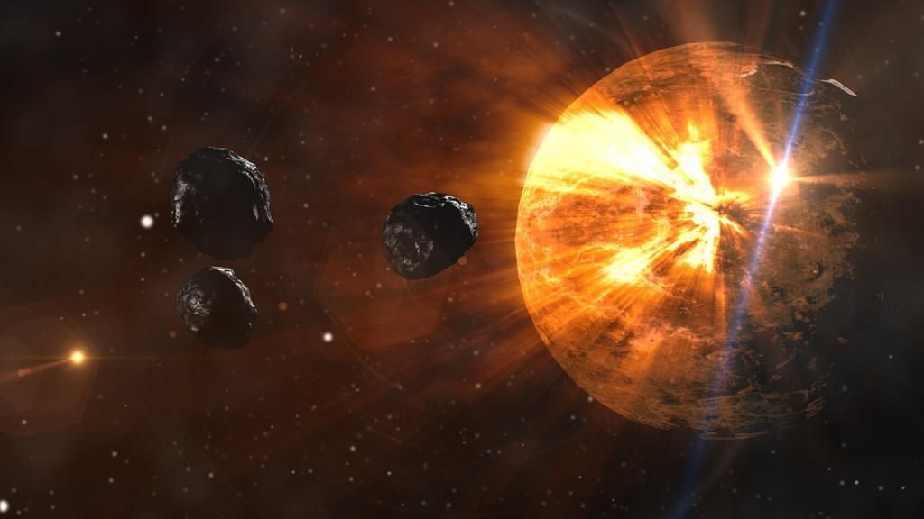

**Who will survive?** The worldwide redemption is to end this world of testing and craziness and go into a time of complete peace and love.  It will be a time of no hatred, no war, no health problems, no death, no financial problems no conflict between nations and even individuals, no problems at all.  Sounds good?  It will actually be a world so tremendous it will be beyond our comprehension now.  Hashem will not be hidden behind nature, but will be totally available to us, especially with the third and final Temple.  We will also see the return of all the Jews and the lost tribes to our land, which will be greatly increased in size.

How do we know who will experience this paradise and who will be wiped out by Nibiru?   We turn to Zechariah 13:8 which tells us that 2/3rd of the world population will be wiped out and 1/3rd will survive. This means that 2/3rd of the world population, which is about 5 billion people, will not survive the devastation coming up and 1/3rd or about 2.5 billion will survive.  How do we know who is in each group?  We refer to the prophet Malachi at the end, just before we are told that Elijah the prophet will come before that “great and awesome day of Hashem.”  The wording before tells of a Star that will come and heal the righteous and wipe out the wicked.  So the 2.5 billion are the righteous that will be worthy of Hashem’s goodness and the others will be gone.  What makes one worthy of Hashem’s goodness to survive and thrive and avoid the great devastation?  Those who turn to Hashem completely.   This is another long subject, but we know that all Jews who repent (which means making positive changes in one’s life to live as Hashem wants), pray regularly, give charity willingly, help others, study the words of Hashem, do all the commandments (for a Jew there is 613 commandments in the Torah), they are good to go to an eternity beyond belief.  Since there are about 14 million Jews in the world and we are told that 2.5 billion will survive, that means that there are over 2 billion righteous non-Jews who will reap the goodness of Hashem.  All they have to do is the list of requirements that the Jew has but only 7 commandments (the 7 Noachide categories of commandments for non-Jews; another subject too involved for here).

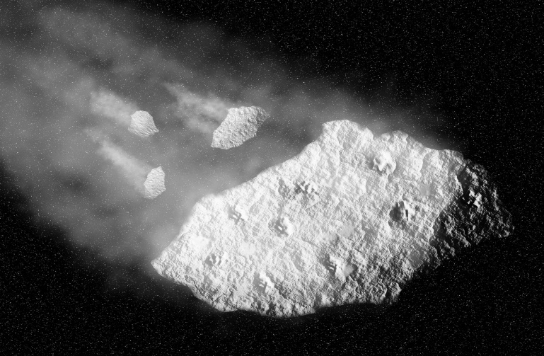For Illustrative purposes only

One problem that I have in covering this subject is that I cannot even come close to stressing the enormity of the subject the tremendous amount of proof that I have seen over decades of research.  I have hundreds of sources that are all consistent in telling us what has happened and what is coming up.  Also, with the statistical analysis idea, there is nothing that I have covered that doesn’t have a myriad of proofs behind it.  As an example, every passage that I mentioned above has Nibiru, 5776, Elul, the name of the Messiah and much more encoded in the verses and all is totally consistent with my many other sources such as Rabbis, Mekubalim (mystical Rabbis), the Facilitated Communications individuals and even what I call dot connecting.  I compare verses of prophecy to what is happening in the world to verify total validity to it all.   Since everything that has happened or is happening now was told to us thousands of years ago, I just connect the dots and see that it is all true and that what is about to happen is all consistent and valid according to the word of Hashem.  I have stated many times that I am not a prophet, but it is very easy and even obvious when you see prophecy unfolding in the world every day.  One gains complete confidence that Hashem is sending us messages of the absolute truth.

One more question to answer to which I already have alluded. When?  All of scriptures (way too many places to talk about here), all coded information, all messages from all my sources (which to me is Hashem telling us), all say 5776, this year.  The best indication that this year is valid is that Nibiru is very close and will be flying by with all its debris within weeks, if not days.  The fact that many governments around the world, who are not telling us why, are telling us to prepare for great disaster, says a lot.  Have extra food, water, medical supplies, etc.  It sounds humane but these are the same leaders who are hoping we will be in harm’s way and not survive.  A little side note: they will all be part of the 2/3rd group; it’s part of Hashem’s plan.

Do we really have less than two weeks for the world to completely be devastated and all that population gone? I hate to sound cold, but the proof is so overwhelming that one would be a fool to be skeptical and have a “wait and see” attitude.  If all you think of yourself and your loved ones as a gamble that Hashem’s messages don’t pertain to you or that all will be business as usual and nothing will happen, open up your eyes and see that it is already happening and getting worse.  This is not rocket science.   It is so obvious that the world is not the same as it was a month ago, even a week ago.  If you are willing to throw away a tremendous eternity for yourself and all who look at you for guidance on a hunch that this is not happening, you are more than a fool.  Simply turning to Hashem and following all His instructions is the ticket to survival, happiness and total success – it is guaranteed in writing.

Note: I have been covering all this and much more on my blog: “The Absolute Truth,”

[**http://absolutetruth613.blogspot.co.il/**](http://absolutetruth613.blogspot.co.il/)

and my book with the same name.  I have written over 1200 pages in close to 590 posts over the past 54 months.  I am being read in 187 countries and have a translation capability on my blog, if English is not your native language. If what I said above was not enough proof for you to want to save your life, go to my blog and read until you are confident that Hashem is the only answer to this dilemma and all of your problems.  Even though my book is available from Amazon.com and Barnes and Noble, I suggest that you go to my blog and order the electronic copy on Email directly from me; top right column of the blog page.  It is still only $5 and gives you access to my private Email to ask any question that plagues you.

\**This blog post is the opinion of the blogger and not necessarily that of Israel News Talk Radio [INTR].*

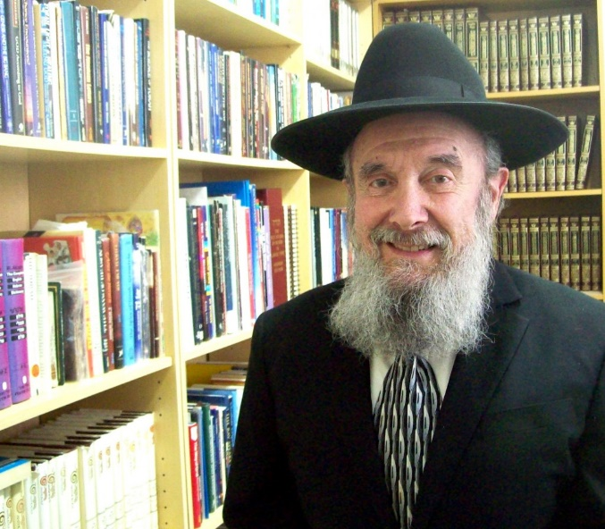**Menachem Robinson lives with his  family (wife, children and grandchildren in Israel).  He is a retired Electronics Engineer and US Army Officer who studied scriptures for 68 years and science for 59 years on three different continents.  With 16 years of full and part time college studies in Engineering, general science, Psychology, Sociology and business.  He is the author of the popular and world-wide read blog,**[**The Absolute Truth**](http://absolutetruth613.blogspot.co.il/)**.  You can order his book of the same name, from Amazon.com or an electronic copy, the best value through clicking the “Buy Now” button on the top of the right hand column on his blog**[**here**](http://absolutetruth613.blogspot.co.il/)**.**

The Sumerians called the planet NIBIRU, the “planet of crossing,” and the Babylonian version of the epic retained the following astronomical information:

Planet NIBIRU:

The Crossroads of Heaven and Earth he shall occupy. Above and below, they shall not go across; They must await him.

Planet NIBIRU:

Planet which is brilliant in the heavens. , He holds the central position; To him they shall pay homage.

Planet NIBIRU:

It is he who without tiring The midst of Tiamat keeps crossing. Let “CROSSING” be his name

—

The one who occupies the midst. These lines provide the additional and conclusive in- formation that in dividing the other planets into two

equal groups, the Twelfth Planet in “the midst of Tiamat

keeps crossing”: Its orbit takes it again and again to the site of the celestial battle, where Tiamat used to be. We find that astronomical texts that dealt in a highly sophisticated manner with the planetary periods, as well as lists of planets in their celestial order, also suggested that Marduk appeared somewhere between Jupiter and Mars. Since the Sumerians did know of all the planets, the appearance of the Twelfth Planet in “the central position” confirms our conclusions: Marduk Mercury Venus Moon Jupiter Saturn Uranus Earth Mars Neptune Pluto

Religious fanaticism manifests itself in wars, rebellions, and the slaughter of “infidels.” Armies amassed by Kings of the West are warring with Kings of the East. A Clash of Civilizations shakes the foundations of traditional ways of life. Carnage engulfs cities and towns; the high and the mighty seek safety behind protective walls. Natural calamities and ever-intensifying catastrophes leave people wondering: Has Mankind sinned, is it witnessing Divine Wrath, is it due for another annihilating Deluge? Is this the Apocalypse? Can there be—will there be—Salvation? Are Messianic times afoot?

The time—the twenty-first century A.D., or was it the twenty-first century B.C.?

The correct answer is Yes and Yes, both in our own time as well as in those ancient times. It is the condition of the present time, as well as at a time more than four millennia ago; and the amazing similarity is due to events in the middle-time in-between—the period associated with the messianic fervor at the time of Jesus.

Those three cataclysmic periods for Mankind and its planet - two in the recorded past (circa 2100 B.C. and when B.C. changed to A.D.), one in the nearing future—are interconnected; one has led to the other, one can be understood only by understanding the other. The Present stems from the Past, the Past is the Future. Essential to all three is Messianic Expectation; and linking all three is Prophecy.

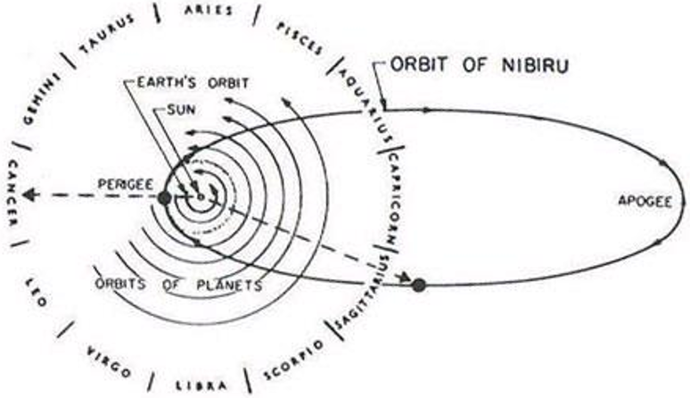

The Washington Post

By **Thomas O'Toole**

December 30, 1983

**Possibly as Large as Jupiter**

The distance from earth of a mysterious object in space was reported incorrectly in some editions yesterday. The correct figure is 50 billion miles.

A heavenly body possibly as large as the giant planet Jupiter and possibly so close to Earth that it would be part of this solar system has been found in the direction of the constellation Orion by an orbiting telescope aboard the U.S. infrared astronomical satellite.

[www.washingtonpost.com...](https://www.washingtonpost.com/archive/politics/1983/12/30/possibly-as-large-as-jupiter/1075b265-120a-4d40-9493-a8c523b76927/?utm_term=.fb9e46c26984)

So, more evidence appears that this mysterious, and massive object was spotted twice at least back in 1983. Both, the article from 1983 and the new evidence suggest whatever this object is, at aphelion it is located on the general location of Orion and Taurus constellations.

* * *

<https://www.nasaspaceflight.com/2016/12/yir-v-planet-nine-boundaries-solar-system/>

n 2016, our understanding of our cosmic home might have taken its most significant leap forward since the discovery of Uranus shattered our then perception of a six-planet system and expanded the solar system for the first time. This year, in January came the announcement of a mathematical and orbital-characteristic inferred “discovery” – more a prediction based on evidence – of a massive, super-Earth, ice giant in a 200 x 1,200 AU orbit that, if confirmed, would represent the ninth planet in our solar system.

**‘Planet Nine’ – a hypothetical find beyond the Scattered Disc:**

First proposed in 2014 by Chad Trujillo and Scott S. Sheppard, who inferred the existence of a yet-unknown massive body from strikingly similar oddities in the orbits of two Trans-Neptunian Objects (Sedna and 2012 VP113), Planet Nine was thrust firmly into the public and planetary spotlight on 20 January 2016.

**\* * \***

Returns every 4127 years. Last seen at the time of the flood in the days of Noach.

**Earth changes:**

Pole shift at an accelerating rate.

Earthquake and volcanic activity increasing.

***Marqos (Mark) 13:8*** *For nation shall rise against nation, and kingdom against kingdom: and there shall be* ***earthquakes*** *in divers places, and there shall be famines and troubles: these are the beginnings of sorrows.*

***Luqas (Luke) 21:11*** *And great* ***earthquakes*** *shall be in divers places, and famines, and pestilences; and fearful sights and* ***great signs shall there be from heaven****.*

***Matitiyahu (Matthew) 27:54*** *Now when the centurion, and they that were with him, watching Jesus, saw the* ***earthquake****, and those things that were done, they feared greatly, saying, Truly this was the Son of God.*

Fireball sightings are increasing.

|  |  |  |  |  |  |  |  |  |  |  |  |
| --- | --- | --- | --- | --- | --- | --- | --- | --- | --- | --- | --- |
| **Fireball Sightings reported to the American Meteor Society**[[42]](https://en.wikipedia.org/wiki/Meteoroid#cite_note-AMS-Fireballs-42) | | | | | | | | | | | |
| **Year** | **2008** | **2009** | **2010** | **2011** | **2012** | **2013** | **2014** | **2015** | **2016** | **2017** | **2018** |
| **Number** | 724 | 668 | 941 | 1,653 | 2,172 | 3,556 | 3,778 | 4,233 | 5,371 | 5,470 | *4,301*[[45]](https://en.wikipedia.org/wiki/Meteoroid#cite_note-45) |

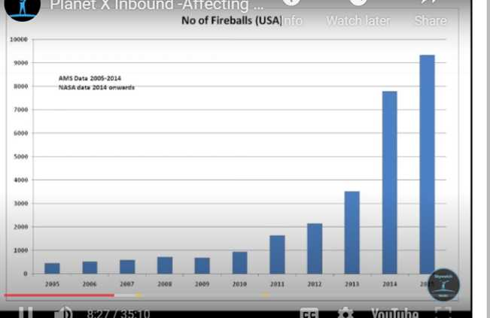

* * *

As far as I'm concerned, those seven planets are the ''seven moons'' orbiting Nibiru - the Kochav Yaakov - as described by Rabbi Moshe Cordovero.

I'm not the only one who thinks this is actually the Nibiru system. ''*And, strangely enough, they look like planets we have been photographing close to earth!''*

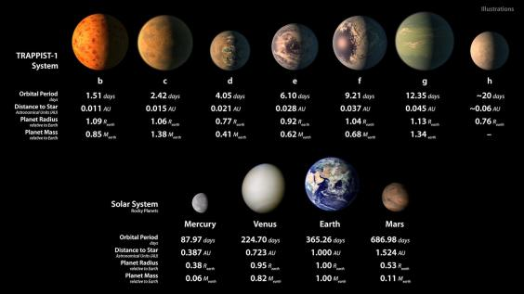

* * *

Rabbi Daniel Travis – Mishle Chapter 5 Verse 19 Planet X

Rabbi Yosef Berger

Rabbi Yaakov Yitzchak Biderman

Yuval Ovadia

'***'God will ‘change’ planet earth seven times before Mashiach comes [according to the Pirkei d’Rabbi Eliezer 18] - and we have one big ‘change’ left to come before the End of Days.''***

# XVIII. Meroz

In the book of Judges, chapter 5, the prophetess Deborah sang a song in praise of G-d for helping Barak win the battle against his enemy Sisera. In verse 20 she sings: “The stars in their course fought against Sisera.” And then in verse 23 she continues: “Curse ‘Meroz!’, said the angel of the Lord, curse bitterly its inhabitants, because they did not come to the help of the Lord…against the mighty men.”[200]

Who or what is this ‘Meroz’? According to one opinion in the Talmud, Meroz is either an individual or a celestial body. Accordingly, the ‘inhabitants’ of ‘Meroz’ could imply life on another planet. (cf. tractate Moed Katan page 16a) whose inhabitants did not come to Barak’s aid. The Talmud gives two explanations, one of them being that Meroz is a star or planet. The heavenly bodies had also come to help the Israelites, as Deborah stated just one verse earlier, “From the heavens they fought, the stars from their orbits . . .” This star, however, which was the dominant star of Sisera, apparently did not come to their aid. And so, General Barak penalized Meroz—and its inhabitants.

***Moed Katan 16a*** *Some say that Meroz was [the name of] a great personage;[201] others say that it was [the name of] a star,[202] as it is written [there]: They fought from Heaven, the stars in their courses fought against Sisera.[203]*

It says about the war of Sisera involving Yael that 100,000 generals came, and that each one was in charge of 40,000 soldiers (others says that 40,000 generals were in charge of 100,000 soldiers.) 100,000 times 40,000 is four billion people. But you can’t wipe out four billion people, that’s impossible!

**So what happened? Stars came down from the sky (and made the soldiers hot, they went down to the river and the river swept them away and they drowned.)**

This is what is says: “From the sky, the stars fought.”,[204] they left their course and they fought. But one star didn’t want to come, and that star turned black and this is what is says:

***Shoftim (Judges) 5:20*** *“CURSED IS MEROZ [THE NAME OF THE STAR] SAID THE ANGEL OF HASHEM.*

Who said this? [This is in the middle of ‘the Song of Devorah’.] The angel of HaShem said this, Devorah didn’t say it. The angel came and said ‘*oru Meroz’*, cursed is Meroz and it became a dark star.

Based on a verse in Ezekiel (48:35), the Talmud (Avodah Zara 3b) records that “God flies through 18,000 worlds,”. The mystical Tikunei Zohar suggests that these 18,000 worlds are planets ruled by tzadikim, righteous individuals. Another Talmudic source (Sanhedrin 92b) claims that these righteous people are given wings to travel from planet to planet.

# XIX. 400 Years or 2000 Years

How often does Nibiru make a return trip?

In Rashi's comments on Debarim 10:10, he notes that Aharon died after 40 years in the desert. What is the significance of 40 years?

Bamidbar (Numbers) 14:34 "Following the number of days in which you spied out the land - forty days - for every day, you shall bear your sins for a year - forty years."

These forty years represent yet another kind of rebirth - the rebirth of an entire generation that would be worthy of eventually entering the Promised Land. We see that the number forty represents the process of birth. As we have said, it is related to the measure of man. This also explains the forty Seah of water that the Mikveh must contain. The Mikveh also represents the womb, and therefore, these forty Seah parallel the forty days during which the embryo is formed.

By the same token we can understand that the flood, which to took place in 1656A.M. took place after 4 X 400 years. After the flood, the world and man had been reborn.

After 5 X 400 years (2023A.M.) Abraham moved to the Promised land and a new history of our relationship with HaShem began.

3 X 400 years between the Akeida (2084A.M.) and Yeshua's death (3790A.M.).

After 6 X 400 years (2406A.M.) Yehoshua was born to begin the process of facilitating the rebirth of Eretz Israel.

It was 400 years from the covenant between the parts (2018A.M.) till the exodus (2448A.M.).

It was 400 years from the exodus (2448A.M.) till the end of the period of the Judges (2882A.M.).[205]

It was 400 years for the period of the Kings of Israel. (2882A.M. - 3338A.M.)[206]

The Talmud in Zevachim 118: cited above, states that the “Mishkan” was at Gilgal for 14 (2488A.M.) years, at Shiloh for 369 years, and at Nob and Givon, together for another 57 years. Thus the Presence of HaShem was with the Jewish People, in “Eretz Israel” before the building of the “Beit HaMikdash,” for some 400+ (2920A.M.) years.[207]

The first Temple stood for 400 years (2935A.M. - 3338A.M.)[208]

There were 400 years between the last Prophets (3488A.M.) and Yeshua's death (3790A.M.).

The second Temple stood for 400 years (3412A.M. - 3829A.M.).[209]

It was 400 years from the Zerrubbabel's return to Eretz Israel till the death of yeshua (3390A.M. - 3790A.M.).[210]

It was 400 years from Yeshua's death (3790A.M.) till the completion of the Talmud (4235A.M.)

The Talmud was completed over a period of 400 years (3834A.M. - 4235A.M.).

The period of the Geonim, so named after the title of the heads of the great academies in Babylonia (Gaon, meaning “pride” or “splendor” [or in later usage, “genius”]), spanned about 450 years, starting from Rabbi Chanan of Ashkaya, who is considered the first Gaon, in 589, to Rabbi Hai Gaon (d. 1038), who is considered the last Gaon.

From the first Adam to the second Adam was 4000 years.

From the second Adam to the Olam HaBa will be 4000 years.

|  |  |  |
| --- | --- | --- |
| **Event** | **A.M. Year** | **B.C.E Year** |
| Creation | 1 | -3761 |
| Noach’s Flood[211] | 1656 | -2105 |
| Yehoshua’s Boulders and Long Day[212] | 2503 | -1258 (847) |
| Stars Fight Sisera[213] [214] | 2674 | -1087 (171) |
| Uzziah’s Earthquake[215] | 3001 | -760 (327) |
| Hezekiah’s Sun Goes Back[216] | 3213 | -548 (212) |
|  |  |  |

* * *

Pirkei Avot: The world will exist for six thousand years; two thousand years of void, two thousand years of Torah dissemation and two thousand years of the Messianic era. “For one thousand years in Your eyes are like a passing day.” (Psalms 9():4) Each of the first six days of creation represents one thousand years; the years spent by man throughout the millenia to work and create, parallel the six days of God’s creation at the beginning of the world. The seventh day, the Sabbath, the day of rest, corresponds to the day of eternal rest, the day which is totally Sabbath— the World to Come. (Sanhedrin 97a)

# XX. From the Ramchal

*[](https://1.bp.blogspot.com/-6aD-ALlHVRs/Vtqo8fUX5UI/AAAAAAAAL6o/N44Sy0FLVrQ/s1600/jacks.jpg)The Ramak,* ***Rabbi Moshe Cordevero****, classically and clearly explains the Zohar on this key pasuk [****Balak 212b****] in such detail that he even draws a picture of how the star will look. Remember we used to play with Jacks? That's precisely what he drew. A star with several smaller bodies surrounding it with 70 rays of light streaming out of [Nibiru] connecting itself to each body surrounding the star.*

Ramchal

Chapter 7: The Influence of the Stars – Paragraph 1

This section is dedicated to the influence the stars and constellations have on the world.[217]

As Ramchal already explained,[218] everything material is ultimately rooted one way or another in the Transcendent Forces.[219] But then that phenomenon needs to somehow be transported downward[220] and be “brought down to earth”, so to speak, and to assume one thing or another.[221]

That’s the function that the stars and constellations serve.[222] It’s thanks to them and everything associated with them[223] that the spiritual phenomena are transported downward from their spiritual state to our material world in a form.[224]

Now, the number of stars, their relative status, and their differences was devised by the highest wisdom so as to best and most elegantly bring about this transport downward.

The ability of physical things to go on[225] is thanks to the influence of the stars, given explicitly that they transfer phenomena from their sources in the highest heavens to their earthly role.

The Way of G-d

Part 2: Divine Providence

Chapter 7: The Influence of the Stars - Paragraph 2

1. On the influence of the stars upon events.[226]

G-d instilled yet another factor upon the stars, which is that all of the events experienced by physical things and their outcomes would originate up above,[227] but would then be drawn downward by the stars[228] in the form they’d need to assume.[229]

So for example, things touching on one’s life, income, wisdom, offspring, and the like,[230] are initiated up above in the celestial roots but then they’re transported downward by the stars to the branches in an appropriate form.[231]

That happens through certain sub-divisions and combinations within the star system, particular groupings of them, and the well-known orbits assigned to them.[232]

2. Everything that occurs to physical things is assigned to a particular star. Thus, all physical things were placed under their control.

Thanks to their arrangements, all things come about as a result of the emanation from the star system through its connection to every individual.[233]

End of the Ramchal

# XXI. Songs

דרך כוכב מיעקב אל תירא עבדי יעקב

''A star will emerge from Yaakov Fear not, My servant Yaakov''

God said to Yaakov / Fear not, My servant Yaakov

God chose Yaakov / Fear not, My servant Yaakov

**A star will emerge from Yaakov / Fear not, My servant Yaakov**

In Days to come Yaakov will strike roots / Fear not, My servant Yaakov

A ruler will arise from Yaakov / Fear not, My servant Yaakov

Remember these things for Yaakov / Fear not, My servant Yaakov

Delight will come with the salvations of Yaakov / Fear not, My servant Yaakov

Your tents are good Yaakov / Fear not, My servant Yaakov

They shall teach your ordinances to Yaakov / Fear not, My servant Yaakov

For there is no sorcery in Yaakov / Fear not, My servant Yaakov

He perceives no wrong in Yaakov / Fear not, My servant Yaakov

Who can count the dust of Yaakov / Fear not, My servant Yaakov

God made a vow to Yaakov / Fear not, My servant Yaakov

Please forgive the transgression of Yaakov / Fear not, My servant Yaakov

Bring back Yaakov from captivity now / Fear not, My servant Yaakov

God has redeemed Yaakov / Fear not, My servant Yaakov

Command salvation for Yaakov / Fear not, My servant Yaakov

The voice is the voice of Yaakov / Fear not, My servant Yaakov

Sing and be joyous for Yaakov / Fear not, My servant Yaakov

God has brought back Yaakov from captivity / Fear not, My servant Yaakov

Grant truth to Yaakov / Fear not, My servant Yaakov

# XXII. When will see this star?

Rabbi Isser Weisberg suggests that the ‘abomination’ spoken in Daniel was the Dome of the rock.

The Dome of the Rock was built between **AD 685 and 691** by the caliph 'Abd al-Malik ibn Marwan, not as a mosque for public worship but rather as a mashhad, a shrine for pilgrims.

***Daniel 12:11-12****And from the time that the continual burnt-offering shall be taken away, and the detestable thing that causes appalment set up, there shall be a thousand two hundred and ninety days.* ***12****Happy is he that waiteth, and cometh to the thousand three hundred and five and thirty days.*

Following Rabbi Weisberg’s study, we should see the Mashiach in the windaw between 1981 and 2027:

1290 years + 691 AD = 1982AD = 5742AM

1335 years + 691 AD = 2027 = 5787AM

* * *

Rabbi Pinchas Winston has written the following about when Techiyat HaMaitim will occur, based on the Zohar:

*“The Zohar (Midrash Ne’elam - Toldot 140a), says that Techiyat HaMaitim, “Resurrection of the Dead,” will begin no later that 210 years before the year 6000 from creation -- i.e. 5790, corresponding to 2030 CE. Though other predictions have already passed, Kabbalists seem to accept this date as the final and real one. (see “Leshem Shevo v’Achlamah” - Drushei Olam HaTohu, Part 2, Drush 4, Section 12:9)”*

*“The Zohar (Midrash Ne’elam - Toldot 139b) also states that this period will begin after forty years of Kibbutz Galiyot - the “Ingathering of the Exiles” from the Diaspora to the Land of Israel. Thus, according to this calculation, Kibbutz Galiyot began in the year 5750 -- corresponding to 1990, just about the time the Soviet Union “mysteriously” collapsed and allowed one million Jews to finally emigrate after decades of trying.”*

*“Kabbalists say that the Messianic Era must occur in advance of Techiyat HaMaitim, specifically sometime within the forty years of Kibbutz Galiyot. As of this writing, that would mean Mashiach must come and prepare mankind for Resurrection of the Dead, and all Jews must return to Israel -- over the next 28 years. (see Leshem - Drushei Olam HaTohu, Part 2, Drush 4, Section 12:10)”*

*In other words, the end of Jewish history perfectly mirrors the beginning of Jewish history in the time of Moses. We began with 210 years of life in Egypt, meant to bring us back to the level of Adam before the sin (though just the opposite resulted), and then, we “wandered” outside the Land of Israel for forty years. So too, at the end of history, we may experience a process of returning to the land over the course of forty years, followed by a 210-year period necessary to return to the level of Adam before his sin.*

* * *

From the Gemara in Sanhedrin 97a:

*The Sages taught in a baraita: With regard to the seven-year period, i.e., the Sabbatical cycle, during which the Messiah, son of David, comes:*

*During the first year, this verse will be fulfilled: “And I will cause it to rain upon one city and cause it not to rain upon another city” (Amos 4:7).*

*During the second year of that period, arrows of famine will be shot, indicating that there will be famine only in certain places.*

*During the third year there will be a great famine, and men, women, children, the pious, and men of action will die, and the Torah is forgotten by those who study it.*

*During the fourth year there will be plenty but not great plenty.*

*During the fifth year there will be great plenty and they will eat, and drink, and rejoice, and the Torah will return to those who study it.*

*During the sixth year, heavenly voices will be heard. During the Sabbatical Year, wars, e.g., the war of Gog and Magog, will be waged involving the Jewish people.*

*During the year after the conclusion of the Sabbatical Year, the son of David will come.*

The Gemara teaches that we can expect the Mashiach in the first year after the shmita year. So when in the shmita year? We have learned that every year evenly divisible by seven (7) is a shmita year. For example, the year 5782 is a shmita year. It began in September of 2021 and will end in September of 2022. 5782 / 7 = 826. 5789 will be the next shmita year. That makes 5790 the probable year of the Mashiach.

**\* * \***

This study was written by

Rabbi Dr. Hillel ben David (Greg Killian).

Comments may be submitted to:

Rabbi Dr. Greg Killian

12210 Luckey Summit

San Antonio, TX 78252

Internet address: [gkilli@aol.com](mailto:gkilli@aol.com)

Web page: <https://www.betemunah.org/>

(360) 918-2905

Return to [The WATCHMAN](https://www.betemunah.org/) home page

Send comments to Greg Killian at his email address: [gkilli@aol.com](mailto:gkilli@aol.com)

1. Ibn Ezra says that on the third day the pain of the circumcision was at it height. The way it appears from what he says, is that the trauma and pain builds up to a maximum by the third day and then the healing process starts in earnest.
2. e.g. see the Tur
3. Yoreh De'ah 335:1
4. http://uofgts.com/Magi.html
5. In the Nazarean Codicil, Mashiach literally refers to Aquarius, as the water bearer. He tells his disciples that he wishes to have dinner together, and that in order to find the place, when they see a man who is carrying a water jug they must follow him. There, a little later, the last supper will take place.
6. Bnei Yissaschar, Ruach Hachaim;
7. Derech Hashem II,7, Tractate Shabbat 158a, Tos. ad loc.
8. By Rabbi Moshe ben Maimon ("Maimonides"); translated by Eliyahu Touger
9. In translation, this word means "star" or "planet." It refers to the planet Mercury.
10. In translation, this word means "shining." It refers to the planet Venus.
11. In translation, this word means "reddening." It refers to the planet Mars.
12. In translation, this word means "justice." It refers to the planet Jupiter.
13. In translation, this word means "the Sabbatical." It refers to the planet Saturn.
14. *Sanhedrin* 91b states that the *Shechinah* (Divine Presence) is in the west. Hence, the movement of this sphere in this direction can be considered an act of service to God.
15. Iyov (Job) 9:9.
16. Iyov (Job) 9:9.
17. This constellation follows that of the Ram.
18. Ibid. 32. E.V. ‘or canst thou guide the Bear with her sons’.
19. And then stuck on artificially.
20. Kohelet (Ecclesastes) 1:9.
21. Iyov (Job) 38:32. E.V. ‘or canst thou guide the Bear with her sons’.
22. “angels are like the soul of each star” (Abarbanel in Deuteronomy 18:14). “The Name of each star corresponds to the many angels” (Bereshit Rabbah 78:4).
23. Taanit 4:6
24. The discovery of God : Abraham and the birth of monotheism / David Klinghoffer.
25. Beit HaMidrash 2:118-196 cited in Sefer HaAggadah, Schocken Books
26. The Life of Our Forefather Abraham, By Jacob Isaacs, Published and copyrighted by Kehot Publication Society
27. Mishle (Proverbs) 8:26
28. By contrast, huzoth is understood to mean the heavens; E.V. ’ the fields’. ‘Ha- huzah’ and huzoth are both derived from the same root
29. Hence thou art now above thy fate, and canst ignore it.
30. Ned. 32a, Gen. Rabbah 44:10
31. Genesis Rabbah 44:12
32. Yehezchel (Ezekiel) 33:24
33. Cf. Bereshit (Genesis) 46:27.
34. Shemot (Exodus) 1:7
35. Hoshea (Hosea) 2:1
36. Debarim (Deuteronomy) 4:27
37. see Devarim 4:30, 31:29; Yeshayahu 2:2; Yirmiyahu 30:34; Yechezkel 38:16.
38. Ramban’s commentary to Bamidbar (Numbers) 24:17.
39. Yehuda the Prince – redactor of the Mishna
40. See Rashi’s commentary to Bamidbar (Numbers) 24:17,19.
41. Bamidbar (Numbers) 24:17
42. cf. Yehexchel (Ezekiel) 5:16
43. Bamidbar (Numbers) 24:17
44. Bamidbar (Numbers) 24:17
45. Definition: 1. a rising (of the sun and stars), 2. the east (the direction of the sun's rising). To the ancient Greeks, “in the east” is a translation of “en te anatole”, as the description of a planet, or star, which would rise in the east just before sunrise. Greek astrology also referred to this as the “helical rising” of a planet.
46. re. Bamidbar (Numbers) 24:17
47. Daniel 7:13
48. R’ Judah Loew ben Betzalel (1520CE – 1609CE)
49. Yeshayhu (Isaiah). 52:13
50. Debarim Rabbah 1:14
51. Rashi, Ber. 58b
52. Lit. at it’s rising. Stars always rise in the eastern sky.
53. Bamidbar (Numbers) 24:17
54. cf. Yehezchel (Ezekiel) 5:16
55. Aggadat HaMashiach, Trajectories in Near Eastern Apocalyptic, Translated by John C. Reeves
56. Zohar, Volume II, Shemot 7b, Soncino Press Edition, pg. 21
57. Bamidbar (Numbers) 24:17
58. ibid
59. Ibid.
60. Ibid.
61. Ibid.
62. Shmuel bet (II Samuel) 8:2
63. Zechariah 9:10
64. Bamidbar (Numbers) 24:18
65. Shmuel bet (II Samuel) 8:14
66. Ibid.
67. Ovadiah 1:21
68. Rambam Laws of Kings 11:1
69. Bamidbar (Numbers) 24.19
70. Shmuel alef (I Samuel) 8.5
71. Bamidbar (Numbers) 24.17
72. Midrash ha-Gadol, Numbers, Yemenite Midrash, translated by Yitzchak Tzvi Langerman, HarperCollins, pg. 175-176
73. Yeshayahu (Isaiah) 62:23
74. Zechariah 13:9
75. Yeshayahu (Isaiah) 2:19
76. Yeshayahu (Isaiah) 62:2
77. Yirmiyahu (Jeremiah) 30:7
78. Yeshayahu (Isaiah) 62:23
79. Zechariah 13:9
80. Yeshayahu (Isaiah) 2:I9
81. Yeshayahu (Isaiah) 60:2
82. Conjunctio Minor is the ordinary Jupiter-Saturn conjunction, which occurs every 20 years, regardless of the sign in which the planets are in. Conjunctio Magna is the J-S conjunction that falls back into the same sign after 60 years. For example, the current conjunction is now falling 0 degrees Aquarius and in 60 years (2080) it falls again in Aquarius, at 11 degrees. The Conjunctio Mayor is about the element in which the J-S falls. These conjunctions fall during about 240 years in the same element. We call it a Conjunctio Mayor when, after 240 years, it moves from one element to another, as is now more or less the case. Conjunctio Maxima is the conjunction in the first degrees of Aries, which occurs about 794 years, the last was in 1702 .
83. Imperial astronomer for Rudolph II of Germany.
84. Kidger, p. 255-56.
85. Yeshu’ot Meshicho - M’ainay HaYeshua
86. Ibn Ezra
87. The work is only known is manuscript form from the Cairo Genizah, with sections held in libraries in the Antonin Collection at the Russian National Library and Cambridge University. The reconstructed text was published in a 2004 paper in *Aleph*.  See Haggai Ben-Shammai, "Saadia’s Introduction to Daniel: Prophetic Calculation of the End of Days Vs Astrological and Magical Speculation," *Aleph* 4 (2004).
88. That is, *YHVH*, the tetragrammaton.
89. See I.E. on Ex. 3:15.
90. It refers to God Himself (Weiser).
91. *Yod =10; heh =5; vav = 6. If we arrange God’s name as Y(10), YH (15), YHV(21), YHVH (26), we get 72.*
92. That is, the sages of the Talmud therefore refer to God’s name as the 72-letter name of God.
93. Between one and nine. I.E. refers to five as the true middle number because some schools of thought taught that there are only nine basic numbers. See chapter 11 of I.E.’s *Yesod Mora*.
94. 1 squared + 5 squared = 26. *YHVH* = 26.
95. Saturn, Jupiter, Mercury, Venus, and Mars. The five moving stars can be in conjunction with each other in 26 ways. For these 26 ways, see Krinsky.
96. *Yod, heh. Yod* is spelled *yod* (10), vav (6) *dalet* (4). *Heh* is spelled *heh* (5), *alef* (1).
97. *YHVH* = 26. Thus *yod, heh* spelled out = *YHVH*.
98. 2, 4, 6, 8. Their squares 4 + 16 + 36 + 64 = 120.
99. *Yod, heh = 15. Adding 1+ 2+ 3 +4 + 5 +6 + 7 + 8 + 9 + 10 + 11 + 12 + 13 + 14 + 15 = 120.*
100. *Yod, heh, that is, 15.*
101. *Vav, heh, that is, 11. Multiplying 15 by 11 = 165.*
102. *The first five odd numbers, 1, 3, 5, 7, 9. Their squares 1 + 9 + 25 + 49 + 81 = 165.*
103. *Yod. Yod (10) squared = 100.*
104. *Yod, heh (15). 15 squared = 225.*
105. *The heh. Heh (5) cubed = 125. 225 – 100 = 125.*
106. *Yod, heh (15); 15 squared = 225.*
107. *Yod, heh, vav. Yod, heh, vav = 21. 21 squared = 441. 441 – 225 = 216.*
108. *216.*
109. *Vav. Vav cubed = 216.*
110. *All numbers have a number before them; i.e., if a person says I have five books then what he is saying in effect is I have one book, two books, three books, four books, five books. Thus five assumes the numbers that precede it. However, 1 does not depend on any number before it. It stands by itself. This is the case with God. God stands by Himself. He is not dependent on any being that came before Him.*
111. *So Meijler.*
112. *The purpose of all prayers is to praise God as One, and the One from whom all existence comes.*
113. *Ezek. 38:23 reads: Thus will I magnify Myself, and sanctify Myself, and I will make Myself known in the eyes of many nations; and they shall know that I am the Lord.*
114. *Is. 49:3 reads: Thou art My servant, Israel, in whom I will be glorified. God will be glorified by Israel’s proclaiming His oneness.*
115. *All shapes and forms owe their existence to God (Weiser).*
116. *The angels.*
117. *Thus and thou shalt see My back; but My face shall not be seen (v. 23) is not to be taken literally.*
118. *The upper and lower worlds form two opposite poles. There is, at it were, a line connecting them (Weiser).*
119. *Hebrew, ha-po’el. Motot interprets this as referring to the active intellect.*
120. *The prince of the face refers to the angel who sees God’s face. It may also refer to the tenth sphere (I. Levin, Yalkut Ibn Ezra, p. 195).*
121. *The reference might be to the ninth sphere, the sphere which propels the other spheres. See I. Levin, p. 195.*
122. *The end of God’s power, for there is nothing beneath the lowest world. See Weiser.*
123. *Towards his creator.*
124. *The spheres in which the fixed and moving stars are embedded appear to move from right to left (west to east) to one facing north. (Motot, quoted by I. Levin, p. 195). Thus the spheres aspire to move towards the “right” of God. See Weiser.*
125. *Even plants aspire to move towards the source of their being.*
126. *Moses was able to perceive the manner in which human beings are connected to God.*
127. *Of God.*
128. *“This” refers to Moses’ request, Show me, I pray Thee, Thy glory.*
129. *The body and its lusts hinder man’s soul from reaching its full potential.*
130. *After seeing God’s back.*
131. *God knows the individual as part of the whole. See I.E. on Gen. 18:21 and the notes thereto. By seeing God’s back, Moses was able to know the whole. According to I.E. ultimate knowledge is knowledge of the general category and not of the individual parts. For the individual perishes while the species endures. See chapter 10 of the Yesod Mora.*
132. *Moses now stood out more than he ever had before.*
133. *The cherubim in Ezekiel’s vision had human forms. See Ezek. 1:5.*
134. *See Book II of Judah Ha-Levi’s Kuzari.*
135. *See note 89. The Rabbinic statement expresses God’s love for Israel. See Berakhot 6a, “Rabbi Nachman bar Yitzchak said to Rabbi Chiyya bar Avin, What is written in the tefillin of the Master of the universe? He answered, who is like Thy people Israel, a nation one in the earth (I Chron. 17:21).”*
136. *Measurement of Stature, a mystical work giving the dimensions of God. Most scholars believe it to have been composed in the Geonic period. However, Saul Lieberman believes it to be a Tannaitic Midrash on Song of Songs.*
137. *Because all things have their origin in God.*
138. *Angels and souls (Weiser).*
139. *Hebrew, mikrim. An Aristotelian term for that which is incidental, e.g., white. That the house is white is an accident. Accidents are the opposite of substance. They have no independent existence. They exist only in another being. Accidents are in a state of flux, while substance remains the same.*
140. *In other words, incorporeal beings are superior to corporeal beings. However, the accidents are inferior to the corporeal beings. Man should choose to cleave to that which is above him rather than to that which is below him.*
141. *In the Shi’ur Komah.*
142. *A grossly anthropomorphic statement. I.E. apparently interprets this to mean that whoever knows the manner in which God encompasses all things is assured of a place in the world to come.*
143. *Man can attain immortality like his creator.*
144. *With the exception of Israel.*
145. *The stars of the eighth sphere (the sphere bearing the constellations) are arranged in 48 forms. See I.E. on Ex. 20:3 and the notes thereto.*
146. *That is, all people are under the dominion of the stars.*
147. *That is, the 70 scholars who translated the Torah into Greek. These sages rendered Deut. 4:19 as follows: which the Lord thy God hath allotted to give light to all the peoples under the whole heaven. See Megillah 9b.*
148. *That “all plants, all that live on the earth; all fowl, cattle, animal, creeping thing and all human beings are tied to the forty-eight forms of the sphere.”*
149. *According to I.E., Deut. 29:25 deals with the worship of the hosts of heaven. Its meaning is that God did not place Israel under the dominion of the stars. Nevertheless, Israel worshipped the stars.*
150. *For here, had not allotted cannot be interpreted as meaning, had not allotted to give light, for Deut. 29:25 deals with idol worship, that is, the worship of the stars (Meijler).*
151. *The Sun, Moon, Mercury, Venus, Mars, Jupiter and Saturn. In the notes which follow, the aforementioned will be referred to as follows: Sun/su., Moon/mo, Mercury/me, Venus/v, Mars/ma, Jupiter/j, and Saturn/sa.*
152. *I.E. then goes on to list these 120 conjunctions.*
153. *The seven moving stars can be in simultaneous conjunction in only one way.*
154. *The seven moving stars can be in a two-star conjunction in 21 ways. They are: sa/j, sa/ma, sa/su, sa/v, sa/me, sa/mo; j/ma, j/s, j/v, j/me, j/mo; ma/su, ma/v, ma/me, ma/mo; su/v, su/v, su/mo, v/me, v/mo, me/mo.*
155. *The seven moving stars can form 21 five-star conjunctions. They are: sa/j/ma/su/v; sa/j/ma/su/me, sa/j/ma/su/mo, etc.*
156. *So Weiser. The 21 possible conjunctions result from the seven moving stars.*
157. *Sa/j/ma, sa/j/su, sa/j/v, sa/j/me, sa/j/mo, etc.*
158. *So Weiser.*
159. *The seven moving stars can be in a four-star conjunction in 35 ways, i.e., sa/j/ma/su, sa/j/ma/v, sa/j/ma/me, etc.*
160. *These are: sa/j/ma/su/v/me, sa/j/ma/su/me/mo, sa/j/ma/su/v/mo, etc.*
161. *That is, the above-mentioned great conjunction. See note 140.*
162. *Each one of these seven areas is under the influence of a given constellation.* of the seven sections167 *The inhabited world was believed to be divided into seven sections. See I.E. on Gen. 1:2.*
163. *Literally, the conjunction which takes in all peoples of the earth in accordance with the constellation of every one of the seven sections that constitute the inhabited world.*
164. *Which is part of the constellations of “fire.” There are four elements: dust, fire, air, and water. Three of the 12 constellations correspond to each one of these four elements. Aries, Leo, and Sagittarius form the fire constellations.*
165. *Sagittarius.*
166. *20 × 12 = 240.*
167. *Form the constellation of fire.*
168. *Taurus, Virgo, and Capricorn.*
169. *Gemini, Libra, and Aquarius.*
170. *The sun and the moon travel in each one of the group of constellations for 240 years; 4 × 240 = 960.*
171. *That is, that the heavenly bodies are made out of the four elements.*
172. *The sun was believed to be hot and dry, the moon cold and wet, and Saturn cold and dry. See chapter 4 of I.E.’s Reshit Chokhmah.*
173. *According to medieval science the sun itself was not hot. However, it heated the earth because of the earth’s composition. See Book II of Judah Ha-Levi’s Kuzari: “We say that the rays of light belong to the sun itself, although in reality this is not so: it is the terrestrial bodies which, being opposite to it, are affected by it, and reflect its light.”*
174. *They are not made out of the four elements which belong to the lower world. Hence they cannot share its properties; i.e., they cannot be hot, cold, dry, or wet.*
175. *If the heavenly bodies were made out of the four elements they would eventually come to an end. See I.E. on Ps. 148:5.*
176. *To be hot and dry, cold and wet, cold and dry. See note 177.*
177. *That is, to have this effect on earth. That is, the sun is said to be hot and dry because it has this effect on the earth.*
178. *Literally, the ministers.*
179. *The reference is to the inhabitants of the world.*
180. *Sabbath 156a; Nedarim 32a.*
181. *“As long as they keep the Torah,” is not part of the Rabbinic statement. It is I.E.’s interpretation of “Israel has no constellation.”*
182. *Aquarius is Israel’s constellation. See I.E. to Ex. 31:18.*
183. *Than they actually were.*
184. *The people of Israel.*
185. *The individual Israelite. As long as an Israelite clings to God he is not under the dominion of the stars.*
186. Yirmiyahu (Jeremiah) 31:21
187. see Nechemya 9:6; Bava Batra 25a). (The World of Prayer, vol. 1, pp. 123-125
188. https://bibliotecapleyades.net/hercolobus/esp_hercolobus_127.htm
189. Matityahu (Matthew) 2:1-2.
190. Yechezkel (Ezekiel) 44:1-3 and Rev. 19:11-16.
191. Philo, *Life of Moses,*1:276
192. at QUOD OMN. PROB. (74)
193. Tacitus, The Histories, Book V: “...among themselves (the Jews) are inflexibly honest and ever ready to show compassion, though they regard the rest of mankind with all the hatred of enemies.”
194. Yirmiyahu (Jeremiah) 25:11-12
195. Daniel 1:3-7
196. e.g., Daniel 2:2, 10, 27
197. See Daniel 4:34-37
198. Daniel 2:48b
199. <https://www.bibliotecapleyades.net/hercolobus/esp_hercolobus_76.htmhttps://www.bibliotecapleyades.net/hercolobus/esp_hercolobus_76.htm>
200. Shevuot 36a; Moed Katan 16a. See also Rashi on in Judges ad loc.
201. Or hero, who gave his name to the city ‘Meroz’. V. Gen. IV, 17, Num. XXXII, 41-42; also cf. Alexandria, Antioch, Caesarea, Constantinople.
202. A planet, like Mars, Mercury, Jupiter; or a constellation, like Perseus or Orion.
203. Shoftim (Judges) 5:20.
204. Shoftim (Judges) 5:20
205. II Luqas (Acts) 13:20 (450 years)
206. 430 years for the Davidic dynasty.
207. The first Beit Mikdash, Holy Temple, in Jerusalem, was built by King Solomon **about 440 years** after the Mishkan's original construction and initial use.
208. 410 years
209. 420 years
210. 430 years
211. Bereshit (Genesis) 7:11-24
212. Yehoahua (Joshua) 10:11-14
213. Shoftim (Judges) 5:20
214. Rabbi Yuval Ovadia says that the Nibiru star was seen in the war of Devorah and Sisera and will be seen again at the End of Days.
215. Amos 1:1
216. Yeshayahu (Isaiah) 38:8; Melachim bet (II Kings) 20:8-11
217. It’s ironic that we in modernity are more thunderstruck by the lights on the ground when our plane descends at night over a city than by the sight of millions of stars in the sky. The ancients, though, were nonplussed by the galaxies over them. They realized their power while we simply don’t. Hence, the modern aversion to the influence of the stars.

     The truth of the matter is that not every traditional thinker accepted the influence of the stars. See Rambam’s remarks about that in his comments to Mishna *Avodah* *Zara*(which is puzzling knowing that he attributed *soul*, *intelligence*, and *understanding* to them – see *Yesodei* *HaTorah* 3:3; and see where he remarks that they are “means of governing His created beings” {Guide 2:5:3}!

     See *Sefer* *Haikarim* 4:4 for arguments for and against.
218. See 1:5:2.
219. Which are themselves rooted in G-d’s will.
220. See 1:5:3 and 2:1:2 above.
221. Those Forces are exceedingly sublime, so a number of steps must be taken to reach down here.
222. See 1:5:1 above.
223. Like angels, for example.
224. See *Shabbat* 156a, *Da’at* *Tevunot* 174, Ramban to Deuteronomy 18:10, and *Zohar* *Chadash* 92c.
225. See *Ma’amar* *Haikkurim*, “*Beruchaniyim”.*
226. Ramchal wrote about the influence of the stars elsewhere: see *Da’at Tevunot*pp. 198-199, *Ginzei Ramchal*p. 123, *Derech Eitz Chaim*p. 144, *Adir Bamarom*p. 235, and elsewhere.
227. In the higher heavens.
228. In the middle heavens.
229. That’s to say that the raw, inchoate and deepest elements are found above, lying in potential in those higher heavens; their somehow physical-yet-spiritual elements are brought closer to earth by the stars; and their solid, rank material bodies then assume concrete forms.
230. See *Shabbat* 156a.
231. See 1-5-2, 10 above which speaks of the role the angels play in this as well. The Zohar cites both stars and angels at various points.
232. See *Moed Kattan*28a. This is referring to constellations and zodiac signs.
233. But the stars and planets don’t only transmute this information from Heaven as a matter of course. Each one lends a particular hue and tone to whatever it affects. Thus, each element of our life is affected by a particular star or planet with its own makeup, character, and idiosyncrasies as well as by the combination of stars and planets in the cosmos.