The Timing of Sefer Ruth
By Rabbi Dr. Hillel ben David (Greg Killian)

Our Sages teach us that Ruth and Naomi left Moab on Pesach. The trip from Moab took two days, and they arrived on Nisan 16. They began their travels on the Yom Tov of Pesach. This should not surprise us given that redemption always begins on Pesach (Passover). Just as our redemption from Egypt, in the time of Moshe, began on Pesach, so also did the redemption of the Bne Israel, through Ruth, begin on Pesach.

The following map shows that Moab about sixty miles from Bethlehem. This would be a good two day journey for Naomi and Ruth who made the trip barefoot.
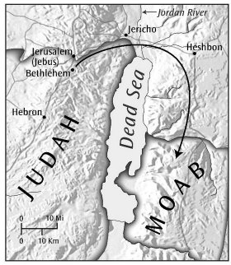
To put this journey into perspective, it is instructive to examine some of the other events that began on Passover:

- Abram leaves Haran. Exodus 12:40-41, Genesis 12:1-10
- Lot and his daughters flee Sodom. Genesis 19:1, 18:14
- Jacob and sixty-nine descendants enter Egypt. Exodus 12:40-42
- The Exodus form Egypt begins! Exodus 12:48-51

When we look at these events we notice that the Yaaqov and his family went to exile in Egypt because of a famine. In the same way, Elimelech and his family went to exile in Moab because of famine. The Midrash also connects these two famines:

Midrash Rabbah - Ruth I:4 THAT THERE WAS A FAMINE IN THE LAND. Ten famines have come upon the world. One in the days of Adam, one in the days of Lamech, one in the days of Abraham, one in the days of Isaac, one in the days of Jacob, one in the days of Elijah, one in the days of Elisha, one in the days of David, one in the days when the judges judged, and one which is destined still to come upon the world. One in the days of Adam, as it is said, Cursed is the ground for thy sake (Gen. III, 17); one in the days of Lamech, as it is said, From the ground which the Lord hath cursed (ib. V, 29); one in the days of Abraham, as it is said, And there was a famine in the land; and Abram went down into Egypt (ib. XII, 10); one in the days of Isaac, as it is said, And there was a famine in the land, beside the first famine (ib. XXVI, 1); one in the days of Jacob, as it is said, For these two years hath the famine been in the land (ib. XLV, 6); one in the days of Elijah, as it is said, There shall not be dew nor rain these years (I Kings XVII, 1); one in the days of Elisha, as it is said, And there was a great famine in Samaria (II Kings VI, 25); one in the days of David, as it is said, And there was a famine in the days of David three years (II Sam. XXI, 1); one in the days of the judges, as it is said, THERE WAS A FAMINE IN THE LAND; and one which is destined to come to the world, as it is said, That I will send a famine in the land, not a famine of bread, nor a thirst for water, but of hearing the words of the Lord (Amos VIII, 11).

We see that this is also the time of the year when Abram left Ur and Lot left Sodom. This suggests that this is the time of the year for new beginnings. As the spiritual world begins to bloom, so also does the physical world.

What time of year did Yaaqov and his family go down to Egypt? The Torah tells us that they came out on the very day they went in:

Shemot (Exodus) 12:40-41 Now the sojourning of the children of Israel, who dwelt in Egypt, was four hundred and thirty years. 41 And it came to pass at the end of the four hundred and thirty years, even the selfsame day it came to pass, that all the hosts of HaShem went out from the land of Egypt.

Since we know that the exodus began on Pesach, we know that Yaaqov and his family went to Egypt on Pesach.

What makes this interesting, for comparison purposes, is that Naomi and Ruth left Moab on Pesach and arrived in Bethlehem on Nisan 16. Why did they leave Moab on Nisan 15? The text tells us that they left because they heard that the famine was over:

Ruth 1:6-7 Then she arose with her daughters in law, that she might return from the country of Moab: for she had heard in the country of Moab how that HaShem had visited his people in giving them bread. 7 Wherefore she went forth out of the place where she was, and her two daughters in law with her; and they went on the way to return unto the land of Judah.

Why did Naomi hear at this time of the year? Why did Yaaqov know about the famine at this time of year?

Since the barley harvest begins on Nisan 16, by Adar, we know if we are having a good crop or a poor crop. That is why Yaaqov knew that the famine would continue. That is why Elemelech knew that the famine would continue, and that is why Naomi knew that the famine was over.

I have heard it said, by Rabbi Yosef Gavriel Bechhofer, that Naomi returned from Moab on the very day that they arrived in Moab! This concords with what happened when Yaaqov went down to Egypt and his descendants left Egypt on the selfsame day. It is also sevara, logical, that they should leave when they see the famine coming, and return when they see the famine leaving.

Our Sages teach us that Ruth and Naomi arrived in Beit Lechem in Nisan 16, when the Omer is reaped. This is the first day of a forty-nine day period known as Sefirat HaOmer, the counting of the omer.

Midrash Rabbah - Ruth III:6 SO THEY TWO WENT (Ruth 1:19). R. Samuel b. Simon said: That day was the day of the reaping of the Omer, as we have learnt elsewhere: All the towns near by assembled together that it might be reaped with great ceremony.

Midrash Rabbah - Ruth IV:2 SO NAOMI RETURNED, AND RUTH THE MOABITESS HER DAUGHTER-IN- LAW WITH HER, WHO RETURNED OUT OF THE FIELD OF MOAB (Ruth 1:22). [People pointed to her saying] ‘This is the one who returned from the field of Moab!’ AND THEY CAME TO BETHLEHEM IN THE BEGINNtNG OF THE BARLEY- HARVEST (ib.). R. Samuel b. Nahman said: Wherever the words barley-harvest occur in Scripture, they refer to the harvest of the Omer. Wherever the words wheat- harvest occur, it refers to the Two Loaves. If it states simply harvest it may be applied to both.

Finally, the intimate scene between Boaz and Ruth on the threshing floor, in Megillat Ruth chapter three, takes place on Shavuot (the Feast of Weeks). On this same day Boaz marries Ruth. What makes this so interesting is that on Shavuot we know that Israel was betrothed to HaShem. This is the day of the ultimate betrothal.

Midrash Rabbah - Ruth VII:2 AND HE SAID: BRING THE MANTLE THAT IS UPON THEE (ib. 15). BRING (HABI) is written habah, teaching that he addressed her in the masculine, that none should notice her. AND HOLD IT. teaches that she girded her loins like a man. AND HE MEASURED SIX MEASURES OF BARLEY, AND LAID IT ON HER. R. Simon said: Bar Kappara expounded in Sepphoris: Is it then the custom of a king to betroth a wife with six grains of barley? Or is it the custom of a woman to be betrothed with six se'ah of barley?

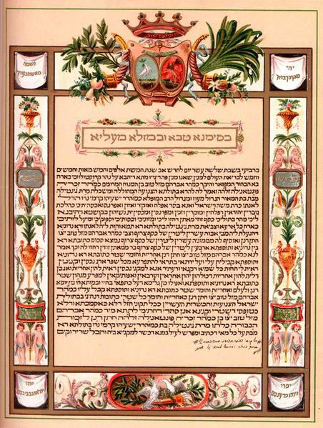
In many Sephardic congregations, prior to the Torah reading on the first day of Shavuot a ketubah le-Shavuot (marriage certificate for Shavuot) is read as a symbolic betrothal of HaShem and His people Israel. There are various versions of such piyyutim (religious poems), nearly all similar in terminology to the traditional t'naim [literally "conditions"] the premarital document specifying the conditions agreed upon between the two parties) or the ketubah (certificate the bridegroom presents to the bride at the wedding ceremony).

* * *

This study was written by
Rabbi Dr. Hillel ben David
(Greg Killian).
Comments may be submitted to:

Rabbi Dr. Greg Killian
12210 Luckey Summit
San Antonio, TX 78252

Internet address: gkilli@aol.com
Web page: http://www.betemunah.org/

(360) 918-2905

Return to The WATCHMAN home page
Send comments to Greg Killian at his email address: gkilli@aol.com

The two loaves which were waved on Shavuot.
The Scriptural text reads literally: And he measured six barleys. Bar Kappara holds that he gave her this in order to betroth her, and therefore observes: If it means literally six grains of barley, ‘surely a king (i.e. Boaz, who was a chief) would not betroth a woman with six grains of barley.’ If it means six measures (as E.V.), then the ordinary unit of measure was a se'ah, but six se'ah was a very heavy load.

