The Significance Of The Number Twelve
By Rabbi Dr. Hillel ben David (Greg Killian)

In this study I would like to examine the significance of the number twelve (שתי עשר). It is important to understand numbers and their meanings since they constantly appear in all parts of the TaNaK. In general, when the Torah uses a number, like twelve, it is connecting that particular item with all other ‘twelves’ in the Tanak.

The meaning of the number twelve is the meaning of maximum number of parts in a system. Twelve represents the borders, or supports of the world. As we explore the number twelve, try to picture how this particular ‘twelve’ represents the border or the constraints of an item.

Twelve is the number of maximal differentiation. It is the number of lines that border a cube, and according to Chazal, all of reality. HaShem and His Oneness is manifested via twelve channels to the world we live in. Twelve is the level where the oneness is manifested in the world. It is why we associate government with twelve. There are twelve who govern the many. All of physical reality is constrained and restrained (as in government) by the 12 lines that mark the edges of the physical world.

Look carefully at the following picture of the lines that outline a cube. Notice that there are twelve lines.

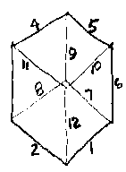

The fact that the 12 are all connected in the center is the thirteenth. Thirteen is the number that bonds multiplicity into oneness. For example: There are twelve tribes that are bonded into their father Israel (Yaaqov). Israel is the thirteenth. The number twelve is associated with the concept of rule or government in that a government is the oneness which bonds the multiplicity of parts.

In Kabbala and Chasidut, it is explained that the thirteenth mazal (constellation) transforms the entire set of mazalot (pl. constellations) into attributes of mercy. This is because numerically, twelve is a closed, rigid, perfect system; reflected in the physical world by the twelve lunar months and the twelve signs of the zodiac; in the Jewish people, by the twelve tribes; in the spiritual realm, by the twelve permutations of the letters of the Divine Name Havaya, and so on. In each of these sets, however, there is a (sometimes hidden) thirteenth element that adds the flexibility and adaptive quality that makes the set alive, pliable and viable. This is perhaps most clearly evident with regard to the twelve lunar months. In the Jewish calendar, a thirteenth month is added in seven out of every nineteen years in order to align the lunar year with the solar year. Here, the thirteenth lunar month makes the twelve original ones into an empathic system that can coexist with its solar “mate.” Similarly, the thirteenth tribe, Levi, officiates at the Temple, reconciling the twelve tribes of the Jewish people with their “mate,” HaShem.

The number twelve never stands alone. It is always associted with a thirteen. Thus every list of the twelve tribes contains exactly twelve names, yet, the one who looks carefully always sees that they are the sons of Israel – the thirteenth.

This is also seen in the twelve months that are bonded into oneness by being the parts of a solar year.

Twelve is itself also composed of a number of smaller parts. For example, each of the twelve tribes had many family members. Each of the constellations was composed of many stars.

In Space

There are three dimensions to physical space, which is typically represented by a cube. It takes twelve lines to draw a cube, just as the year has twelve months.

As we mentioned before, twelve is the number of maximal differentiation. It is the number of lines that border a cube, and according to Chazal, all of reality. All of physical reality is constrained and restrained (as in government) by the twelve lines that mark the edges of the physical world.

Not only are their twelve tribes, but there are twelve precious stones on the breastplate of the High Priest. There are also twelve loaves of bread on the table of shewbread in the Temple.

We find that the land of Israel was divided into twelve parts.

The Midrash recounts how Bne Israel crossed the Red Sea via twelve different paths separated by towers of water. Although each tribe had its own private path, each tribe could see with perfect clarity every other tribe during the passage. The Midrash recounts how the experience was frightening and being able to see each other conforted the tribes.

Midrash Rabbah - Exodus XXIV:1 AND MOSES LED ISRAEL ONWARD (XV, 22). It is written, Do you thus requite the Lord? (Deut. XXXII, 6). R. Shasha, son of R. Abba, used to write the he below, and the lamed above, implying: Alas! ’Do you thus requite the Lord’ after all the miracles He hath performed for you, dividing the sea for you into twelve portions and drowning the Egyptians in the sea, drowning them with one hand and saving you with the other, as it says, Thy right hand, O Lord, glorious in power, Thy right hand, O Lord, dasheth in pieces the enemy (Ex. XV, 6)?

Twelve stones

When the Bne Israel entered the land of Israel in the days of Joshua, they set up a monument of twelve stones.

Sotah 35b In consequence [of what is related in the Scriptures], you must conclude that there were three sets of stones: one which Moses caused to be erected in the land of Moab, as it is said: Beyond Jordan, in the land of Moab, began Moses to declare etc., and elsewhere it states: Thou shalt write upon the stones all the words of this law [very plainly], and the inference is drawn from the use of the analogous word [that as in the latter passage stones were employed, they were similarly employed in connection with what is narrated in the first passage]. The second set was that which Joshua caused to be erected in the midst of the Jordan, as it is said: And Joshua set up twelve stones in the midst of Jordan. The third set was that which he caused to be erected in Gilgal, as it is said: And those twelve stones which they took.

The twelve stones that Yaaqov placed under his head, on his way to Charan, fused into one stone. Whether on a conscious or unconscious level, the fact that Yaaqov gathered twelve stones alludes to the twelve tribes that he will bring into the world as a result of his marriage in Charan. More specifically, the fusion of the twelve stones alludes to the fusion of the twelve tribes. This unification of the twelve sons of Yaaqov occurred just prior to his death. Surrounding Yaaqov's bed, his twelve sons proclaimed as one:

“Hear O Israel (Jacob's name) HaShem is our God, HaShem is One”

Midrash Rabbah - Genesis LXVIII:11 AND HE TOOK OF2 THE STONES OF THE PLACE (XXVIII, 11). R. Judah said: He took twelve stones, saying: ‘The Holy One, blessed be He, has decreed that twelve tribes should spring forth. Now neither Abraham nor Isaac has produced them. If these twelve stones cleave to one another, then I know that I will produce the twelve tribes.’ When therefore the twelve stones united, he knew that he was to produce the twelve tribes.

Elijah used twelve stones to build an altar on Mt. Carmel:

I Melachim (Kings) 18:29 And it came to pass, when midday was past, and they prophesied until the time of the offering of the evening sacrifice, that there was neither voice, nor any to answer, nor any that regarded. 30 And Elijah said unto all the people, Come near unto me. And all the people came near unto him. And he repaired the altar of HaShem that was broken down. 31 And Elijah took twelve stones, according to the number of the tribes of the sons of Jacob, unto whom the word of HaShem came, saying, Israel shall be thy name: 32 And with the stones he built an altar in the name of HaShem: and he made a trench about the altar, as great as would contain two measures of seed.

In Time

Twelve is an integral part of time. The solar year is composed of twelve lunar months. In seven out of nineteen years we add a thirteenth month.

Jupiter (Tzedek) takes twelve years (144 months) to circle the sun.

The ecliptic (zodiac) contains twelve constellations that divide the night and day into twelve parts.

Our night consists of twelve hours, and our day consists of twelve hours. Thus we see that time seems to be bounded by twelve.

The flood lasted 12 months.

Midrash Rabbah - Genesis XXXIII:7 YEAR, IN THE FIRST MONTH, THE FIRST DAY OF THE MONTH. We learned: The judgment of the generation of the Flood lasted twelve months. How is this deduced? (i) In the six hundredth year of Noah's life, in the second month, on the seventeenth day of the month... the windows of heaven were opened (Gen. VII, 11); and it is written, (ii) And the rain was upon the earth forty days and forty nights (ib. 12): this embraces the rest of Marheshwan and Kislew; (iii) And the waters prevailed upon the earth a hundred and fifty days (ib. 24): this covers Tebeth, Shebat, Adar, Nisan, and Iyar; (iv) And the ark rested in the seventh month, on the seventeenth day, upon the mountains of Ararat (ib. VIII, 4): that means Siwan, the seventh month from the descent of the rain. For sixteen days the water diminished at the rate of a cubit per four days, which is one and a half handbreadths per day. You may thus infer that the Ark was eleven cubits in the water, and it all drained off in sixty days. Thus you read, And the waters decreased continually until the tenth months (ib. 5): that is Ab, the tenth from the descent of the rain. Another interpretation: (v) And it came to pass in the six hundred and first year, in the first month [i.e. Tishri], on the first day of the month, the waters were dried up from off the earth (ib. VIII, 13): it became like a marsh. (vi) And in the second month, on the seven and twentieth day of the month, was the earth dry (ib. VIII, 14): it became like parched soil, which they sowed, but nothing would grow. Why was that? Because it [the Flood] had come as a curse, and a curse cannot turn into a blessings; so they waited until the next rainfall and then they sowed. Now should not Scripture have said, ‘On the sixteenth day of the month was the earth dry‘: why then is it stated, ’And in the second month, on the seven and twentieth day of the month, was the earth dry'? Because of the eleven days by which the solar year exceeds the lunar year. R. Simeon b. Gamaliel said: If you wish to prove for yourself that the solar year exceeds the lunar year by eleven days, make a mark on a wall on the day of the summer solstice; the following year at that season the sun will not reach it until eleven days later, and from this you may know that the solar year exceeds the lunar year by eleven days.

* * *

The twelve are always divided into four sets of three.

The 12 sons of Israel (Yaaqov) are bonded into oneness in their Father Israel. When they buried their father, Israel, there were three tribes on each o the four sides of the bier, in exactly the same order as they camped in the wilderness as tribes.

Midrash Rabbah - Numbers XIV:18 R. Phinehas b. Yair observed: The twelve silver dishes, the twelve silver basins, the twelve golden pans, the twelve bullocks, the twelve rams, the twelve he-lambs, and the twelve he-goats corresponded to the twelve constellations, the twelve solar months, the twelve lunar months, the twelve tribes, the twelve princes, the twelve controllers of life, and the twelve loaves of shewbread on the table.

Thus the Midrash makes the following connections between the gifts of the Princes and the other twelves:

twelve silver dishes = twelve constellations
twelve silver basins = twelve solar months
twelve golden pans = twelve lunar months
twelve bullocks - twelve tribes
twelve rams = twelve princes
twelve he-lambs = twelve controllers of life
twelve he-goats = twelve loaves of shewbread

The 12 Tribes are bonded into the oneness of the nation of Israel. There are three tribes to the north, south, east, and west of the Tabernacle. See picture below.

The 12 constellation on the ecliptic (zodiak) are bonded into oneness on the ecliptic. The constellations are divided into four sets by the vernal equinox, the summer solstice, the autumnal equinox, and the winter solstice.

The 12 months are bonded into oneness in a solar year. The months are divided into three sets of four by the seasons: spring, summer, autumn, and fall.

The 12 Apostles are bonded into oneness as Apostles.

The 12 Loaves of showbread are bonded into oneness on the table of showbread.

The 12 gates in the New Jerusalem are bonded into the oneness of the wall. There were three gates in each of the four walls of the city.

The 12 Daylight hours are bonded into the oneness of a day. There are four watches in a day.

The 12 Nighttime hours are bonded into the oneness of a night. There are four watches in a night.

The 12 Stones on the brestplate of the Kohen Gadol, the High Priest.

The only other instance in the TaNaK of stones fusing together is when King David kills Goliath. In I Samuel 17:40. David takes five stones to put in his slingshot. Verse 49 describes him as killing Goliath with the one stone in his slingshot. Here too, the five stones fused into one.

The numbers of these stones reflect a beautiful mathematical phenomenon that sheds a new light on the inner meaning of these two fusion events. There is an important mathematical relation between 12 and 5. 12 squared equals 144, while 5 squared equals 25. 144 plus 25 equals 169, which is 13 squared. 13 is the numerical value of the word echad ("one"). This reflects the plurality of the many stones becoming one.

The word echad is spelled alef (1), chet (8), dalet (4). Together, the chet and dalet represent the twelve tribes. They combine with their father, Israel, represented here by the alef, in their proclamation that HaShem is One. The 12 sons combine with their one father to manifest the unity of echad (13).

The twelve are always divided into four sets of three.

* * *

Twelve is the age of a Bat Mitzva woman.

* * *

There are twelve notes of the chromatic musical scale (piano's 7 white keys + 5 black keys), which are not arbitrary but based on the continual subdivision of a vibrating string by two-thirds, producing the "spiral of fifths".

* * *

Yeshua chose twelve apostles to carry on His ministry:

Matityahu (Matthew) 10:1 And when he had called unto him his twelve disciples, he gave them power against unclean spirits, to cast them out, and to heal all manner of sickness and all manner of disease.

* * *

There were twelve minor prophets: Hoshea, Yoel, Amos, Obadiah, Yonah, Micah, Nahum, Habakkuk, Zephaniah, Haggai, Zechariah, Malachi.

* * *

The Arizal explains that numbers have their origins in the supernal spiritual worlds. Single digit numbers correspond to the physical realm Asiyah, the sefirat Malkhut. Tens correspond to the angelic realm Yetzirah, the sefirat Tiferet. Hundreds correspond to the Neshama realm Beriah, the sefirat Binah, Imma. Being that hundreds emanate from the realm of Imma, they are the source of blessing. Therefore, all offerings are the rectification of 100% of the produce offered.

* * *

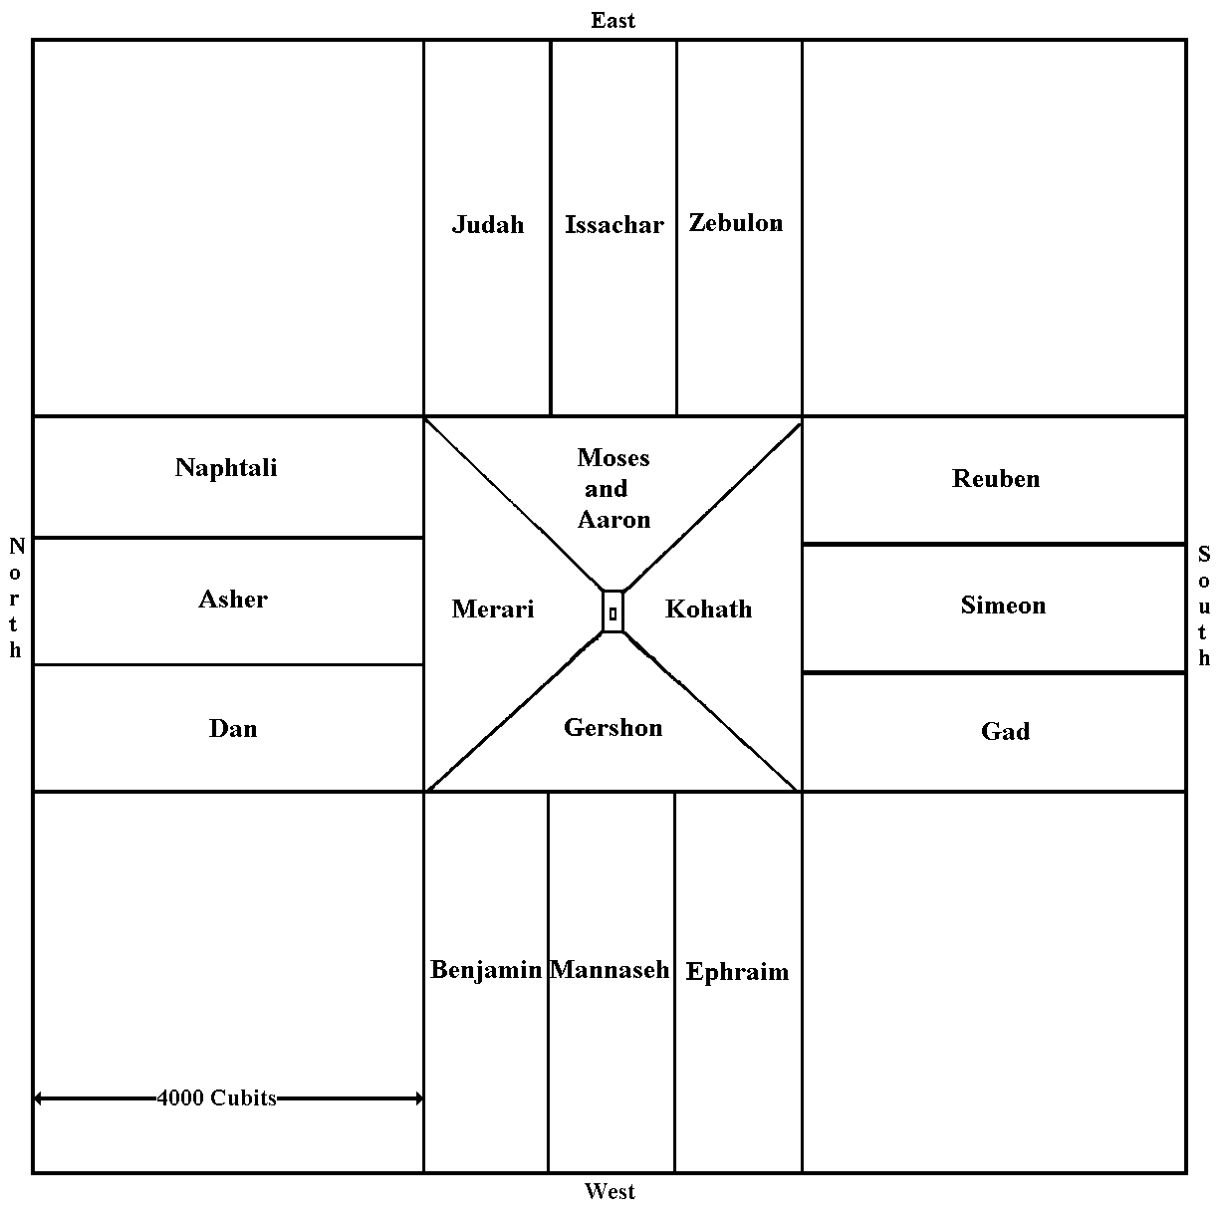

* * *

This study was written by
Rabbi Dr. Hillel ben David
(Greg Killian).
Comments may be submitted to:

Rabbi Dr. Greg Killian
12210 Luckey Summit
San Antonio, TX 78252

Internet address: gkilli@aol.com
Web page: http://www.betemunah.org/

(360) 918-2905

Return to The WATCHMAN home page
Send comments to Greg Killian at his email address: gkilli@aol.com

Tanakh is an acronym for Torah (law), Neviim (Prophets), and Ketuvim (Writings) which are the major divisions that Christians call the “Old Testament”.
The Torah is most often used when referring to the first five books of the Bible: Genesis (Bereshit), Exodus (Shemot), Leviticus (Vayikra), Numbers (Bamidbar), and Deuteronomy (Devarim).
Chazal is an acronym for the Hebrew "Chachameinu Zichronam Livracha", (חכמינו זכרונם לברכה), literally "our sages of blessed memory". In rabbinic writings this generally refers to the sages of the Talmud and of other rabbinic literature.
Kabbalah (Hebrew: קַבָּלָה‎, lit. "receiving") is a discipline and school of thought concerned with the mystical aspect of Judaism. It is a set of esoteric teachings meant to explain the relationship between an infinite, eternal and mysterious Creator and the finite and mortal universe of His creation.
Chasidut (Hebrew: חסידות) are the teachings, interpretations of Judaism, and mysticism articulated by the modern Hasidic movement.
The yod hay vav hay name of HaShem.
The Children of Israel
This concept was originally spoken by Rabbi Yitzchak Ginsburgh.
Bereshit (Genesis) chapters 48 and 49.

